40.list all employees with sal < BLAKE sal and salary > MILLER sal

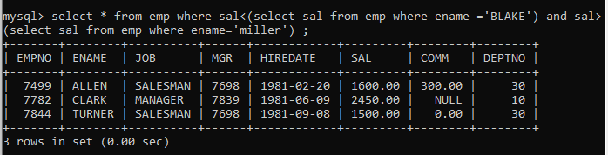­­­

41. select all employees working in alan's departme

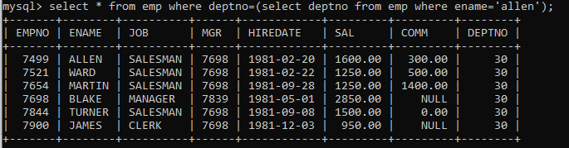

42. change salary of Alan to the salary of Miller.

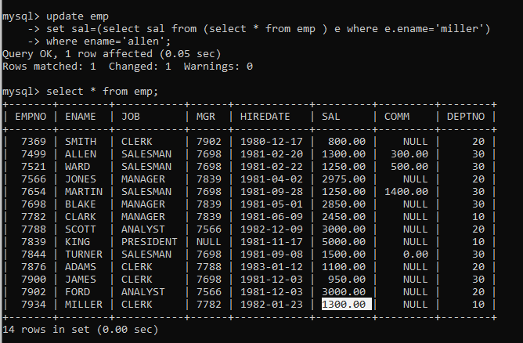

43. change salary of all emplees who working in Wall's department to the salary of Miller.

