1. All Employee’s with the desg as ‘CLERK’ are now called as (AO) Administrative Officers.

Update the Employee collection for this.

--- > db.employee.updateMany({desg:'engineer'},{$set:{desg:'AO'}})

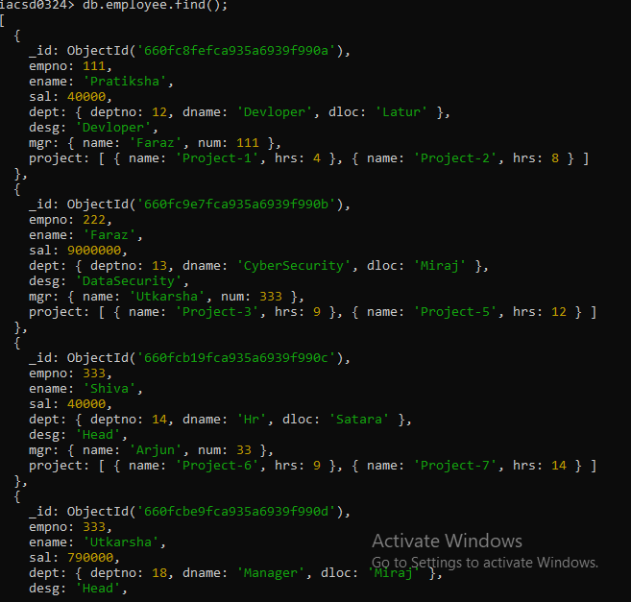

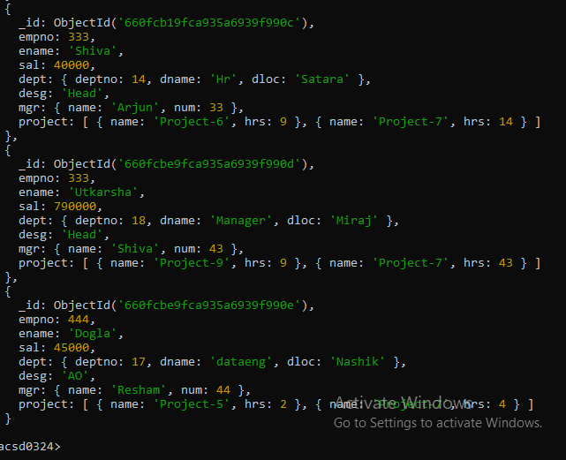

Q2) Change the number of hours for project-1 to 5 for all employees with designation analyst.

Q4) Add bonus rs 2000 for all employees with salary > 50000

--- > db.employee.updateMany({sal:{$gt:50000}},{$set:{Bonus:2000}});

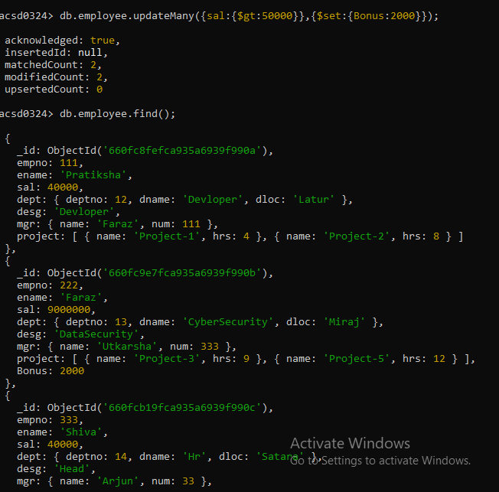

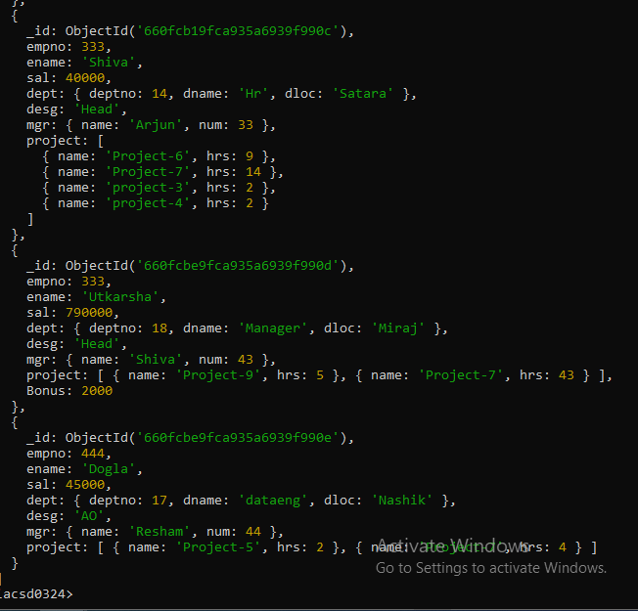

Q5) db.employee.updateMany({sal:{$lt:50000,$gt:30000}},{$set:{Bonus:2000}});

