25. Write a MongoDB query to arrange the name of the restaurants in decending order along

with all the columns

db.restaurent.find().sort ({name:-1})

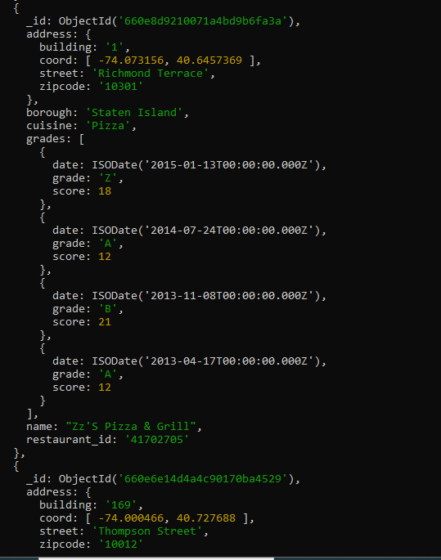

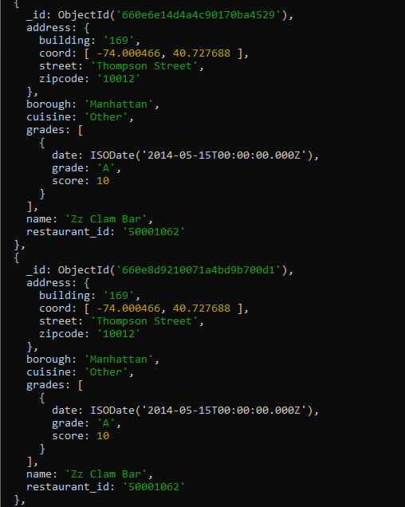

26. Write a MongoDB query to arrange the name of the restaurants in accending along with

all the columns.

---- > db.restaurent.find().sort({name:1})

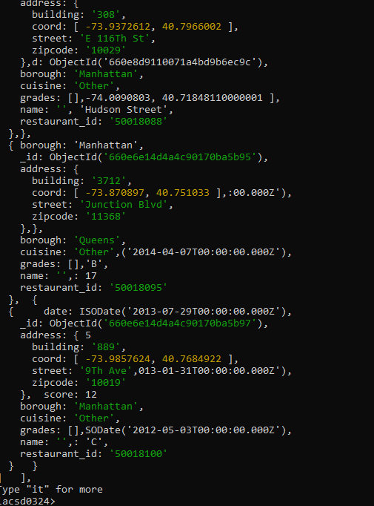

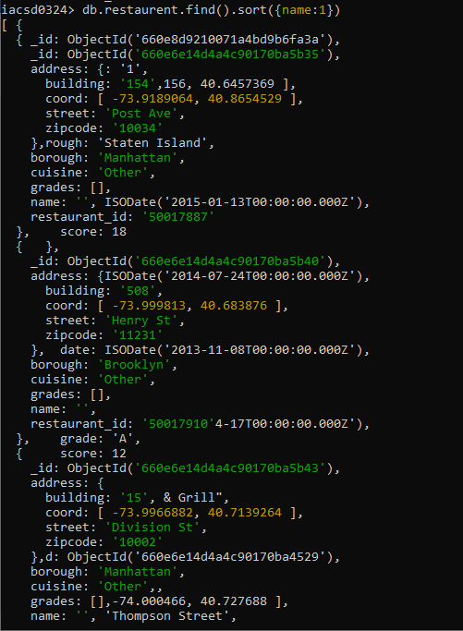

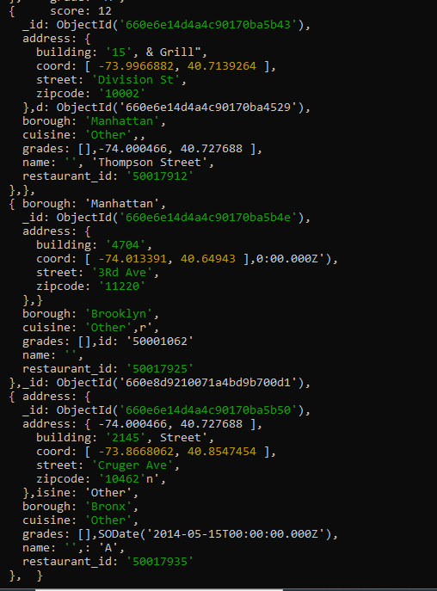

28. Write a MongoDB query to know whether all the addresses contains the street or not.

---- > db.restaurent.find({'address.street':{$exists : true}}).count()

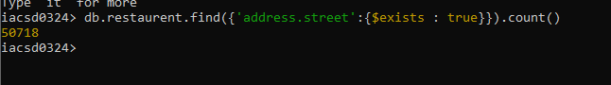

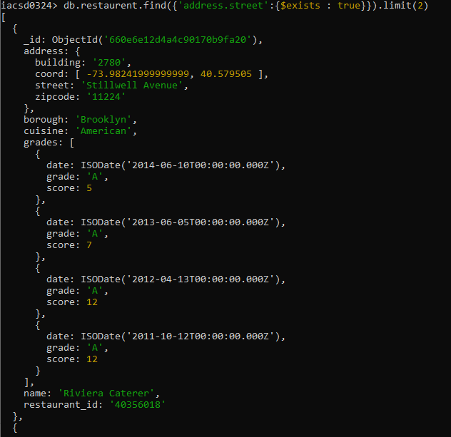

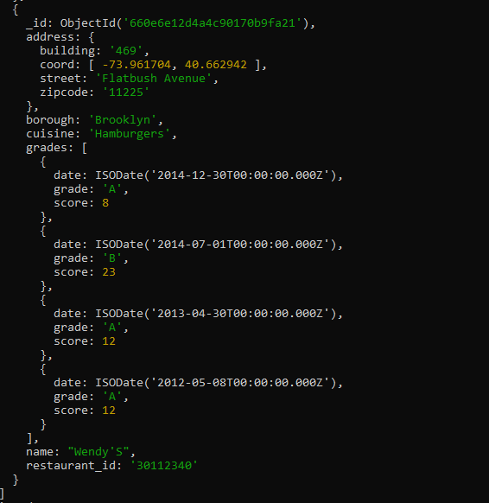

29. Write a MongoDB query which will select all documents in the restaurants collection

where the coord field value is Double.

db.restaurent.find({'address.coord':{$type:1}})

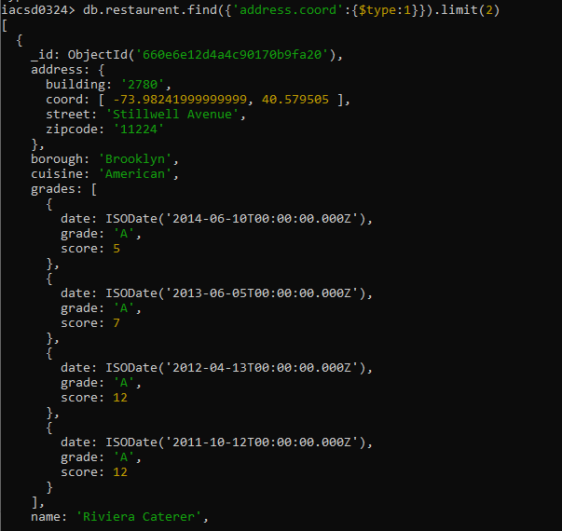

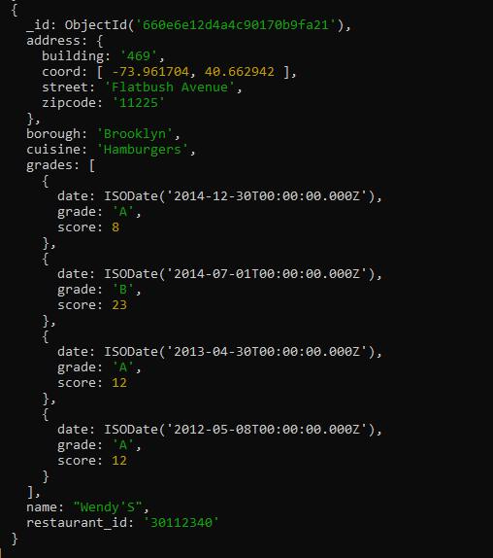

30. Write a MongoDB query which will select the restaurant Id, name and grades for those

restaurants which returns 0 as a remainder after dividing the score by 7.

---- > db.restaurent.find({'grades.score':{$mod:[7,0]}},{'restaurant_id':1, name:1, 'grades.grade':1})

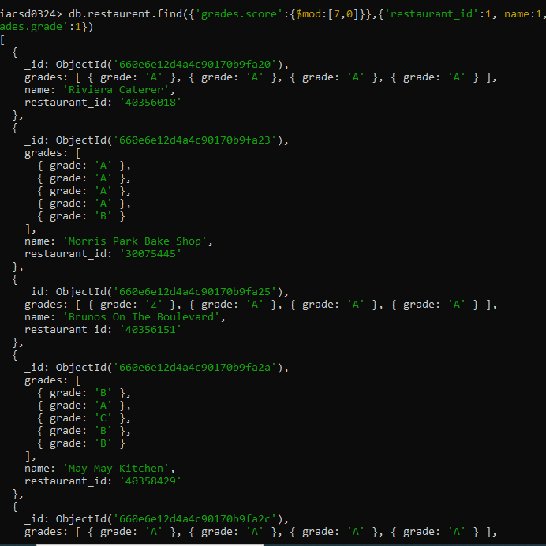

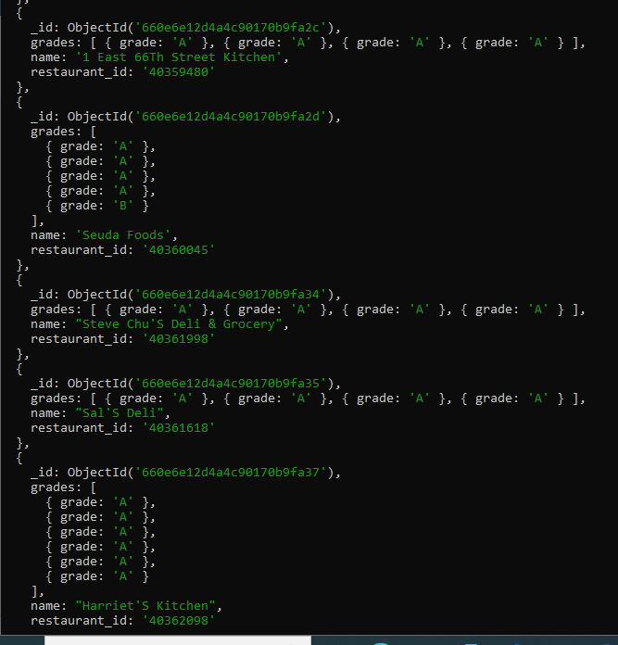

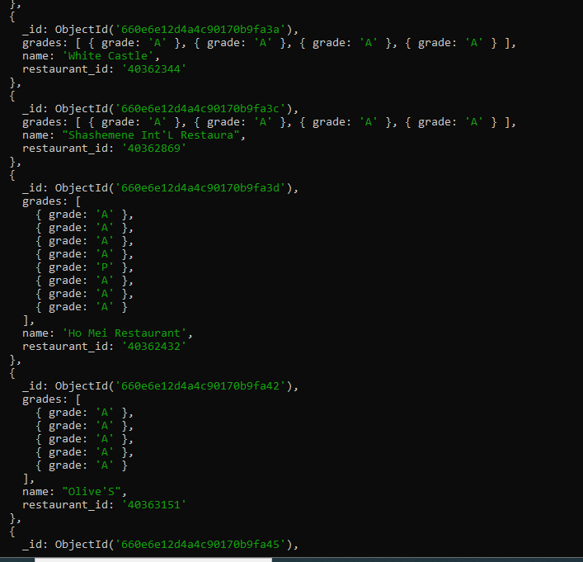

31. Write a MongoDB query to find the restaurant name, borough, longitude and attitude and

cuisine for those restaurants which contains 'mon' as three letters somewhere in its name.

---- > db.restaurent.find({name:/.*mon.*/},{name:1, borough:1,'address.coord':1,_id:0})

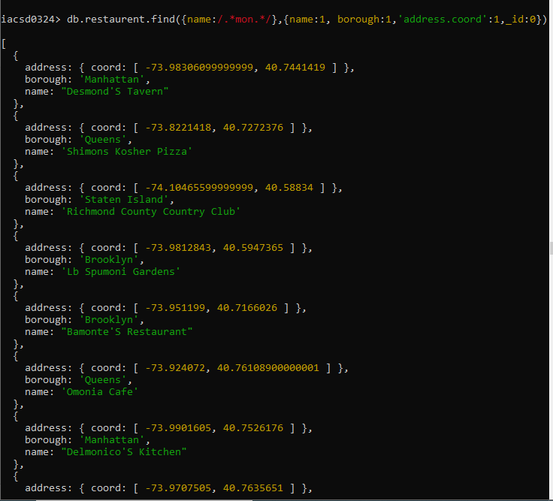

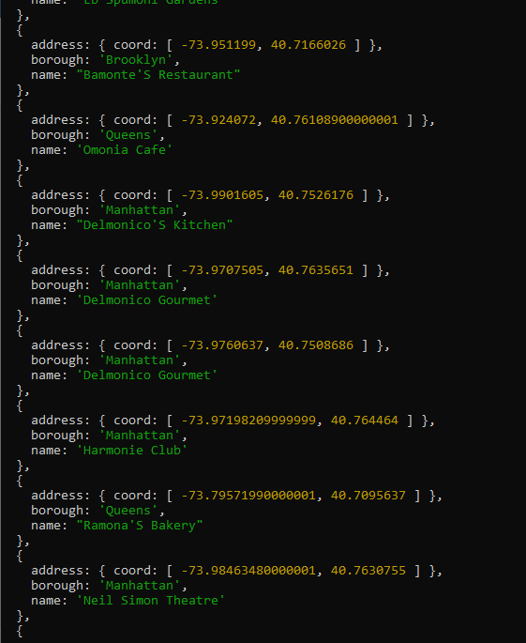

32. Write a MongoDB query to find the restaurant name, borough, longitude and latitude and

cuisine for those restaurants which contain 'Mad' as first three letters of its name.

---- > db.restaurent.find({name:/.*mad.*/},{name:1, borough:1,'address.coord':1,_id:0})

