

Comparison: Minitest vs Rspec

|  |  |
| --- | --- |
| Document name | Comparison : Minitest vs Rspec |
| Version no. | 1.0 |
| Release date |  |

|  |
| --- |
|  |

# Table of Contents

Table of Contents 2

1. Introduction 3

1.1 Minitest 3

1.2 Rspec 3

2. Comparison 4

3. Screen-Shots 5

3.1 Minitest 5

3.2 Rspec 8

# Introduction

## Minitest

Minitest is much closer to Ruby. It's a simple framework that provides a nice set of primitives that you can use to build out a test suite quickly and efficiently. minitest provides a complete suite of testing facilities supporting TDD, BDD, mocking, and benchmarking.

## Rspec

RSpec is a Behaviour-Driven Development tool for Ruby programmers. BDD is an approach to software development that combines Test-Driven Development, Domain Driven Design,and Acceptance Test-Driven Planning.

RSpec does one thing better than Minitest , I would like to say that the command line UI easily outshines Minitest.

# Comparison

|  |  |  |  |
| --- | --- | --- | --- |
| **Sr.no** | **Parameters** | **Minitest** | **Rspec** |
| 1 | Latest Version | 5.8.4 | 3.5.0.beta1 |
| 2 | Setup | Easier | Complicate |
| 3 | Test case Language | Same like Ruby | DSL |
| 4 | Code Size | Significantly Smaller | More than Rspec |
| 5 | Execution Time | Slower | Faster as Compared to Minitest |
| 6 | UI Interface | Simple as compare with Rspec | Nice |
| 7 | Description and solution of failed test case | Not provided | Provided with possible code. |

# Screen-Shots

## MINITEST

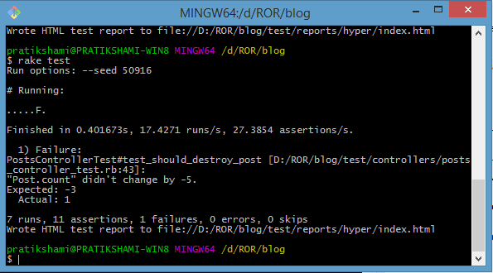

1. Command line output (fail test cases)

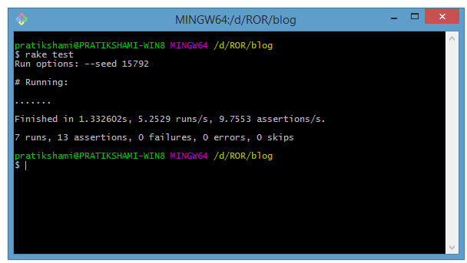

1. Command line output.(pass test case)

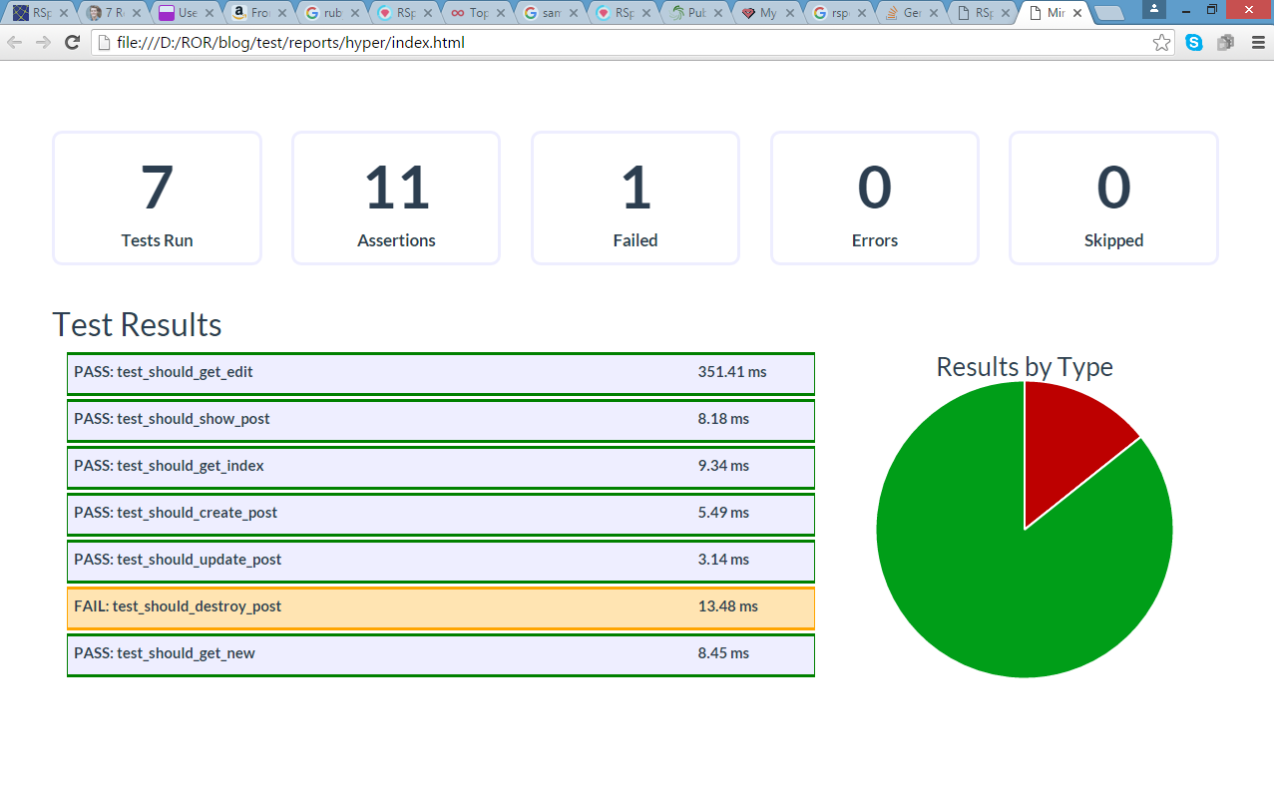

1. Dashboard output in html format(fail test cases)

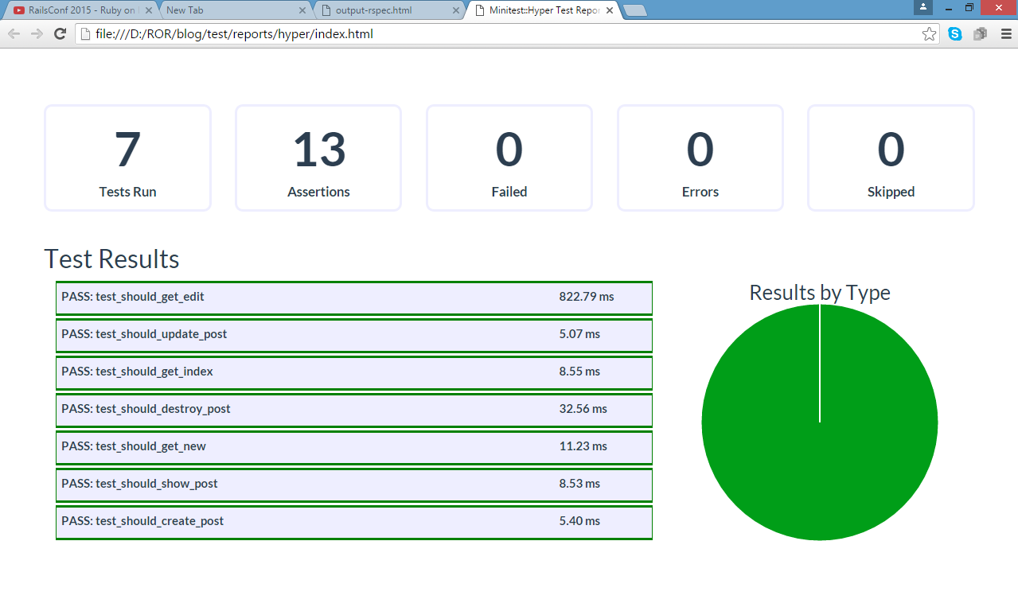

1. Dashboard output in html format(pass test case)

## Rspec

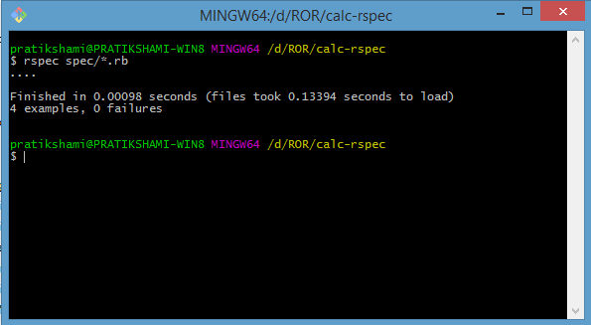

1. Command line output(pass test cases)

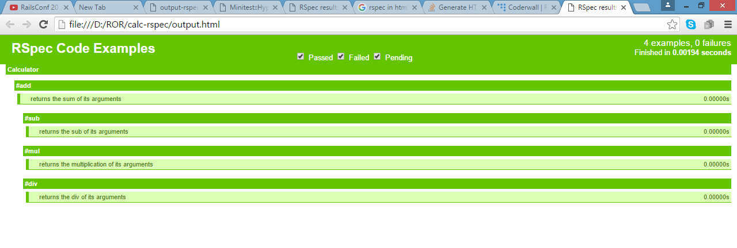

1. Dashboard output in html format

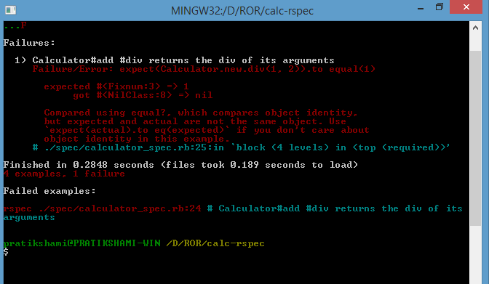

1. Command line output(fail test cases)

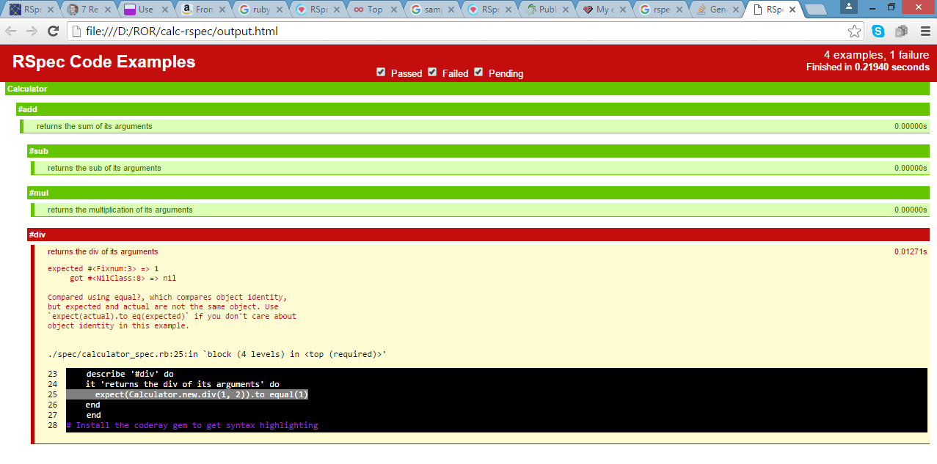

1. Dashboard output in html format(fail test cases)