

Comparison: Minitest vs Rspec

|  |  |
| --- | --- |
| Document name | Comparison : Minitest vs Rspec |
| Version no. | 1.0 |
| Release date |  |

|  |
| --- |
|  |

# Table of Contents

Table of Contents 2

1. Introduction 3

1.1 Minitest 3

1.2 Rspec 3

2. Comparison 4

3. Screen-Shots 5

3.1 Minitest 5

3.2 Rspec 8

# Introduction

## Minitest

## Rspec

# Comparison

|  |  |  |  |
| --- | --- | --- | --- |
| **Sr No** | **Points of comparison** | **Ruby Critic** | **Rubocop** |
| 1 | Current version | 2.8.0 | 0.37.2 |
| 2 | Combination of : | Wrap around Reek, Flay and Flog | Include different cops, metrics and style guide |
| 3. | Sins covered as per sonar stanadard | 1) Code Duplication by Flay  2) Bad distribution of complexity ,Spaghetti Design by Flog  3) Coding standard, Comments by Reek | 1) Coding Standard  2) Code comments  3) Bugs and Error |
| 4 | Report format supported | Html (default), JSON, Console | Progress (default), simple, json, emacs, fuubar, files, |
| 5 | Rake Integration | require "rubycritic/rake_task"  Rubycritic::RakeTask.new | require 'rubocop/rake_task'  RuboCop::RakeTask.new then running rake –T will generate report |
| 6 | Browser avoidance | Use --no-browser option | Use –o option |
| 7. | Config file support | No | Yes you can specify all configuration needed inside .rubocop.yml |
| 8 | Rating is done using | Based on score card using rubycrtic based on churn, complexity, code smells, and duplications | Offenses found by rubycop based on styles, convention, comments |
| 9 | Inclusion/Exclusion of file | No option but you can give directory path | Yes using –exclusion option through command line or via config file provided |
|  |  |  |  |

# Screen-Shots

## MINITEST

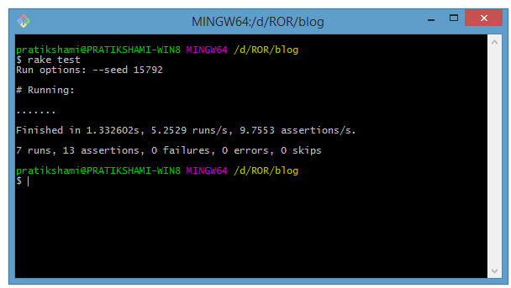

1. Command line output

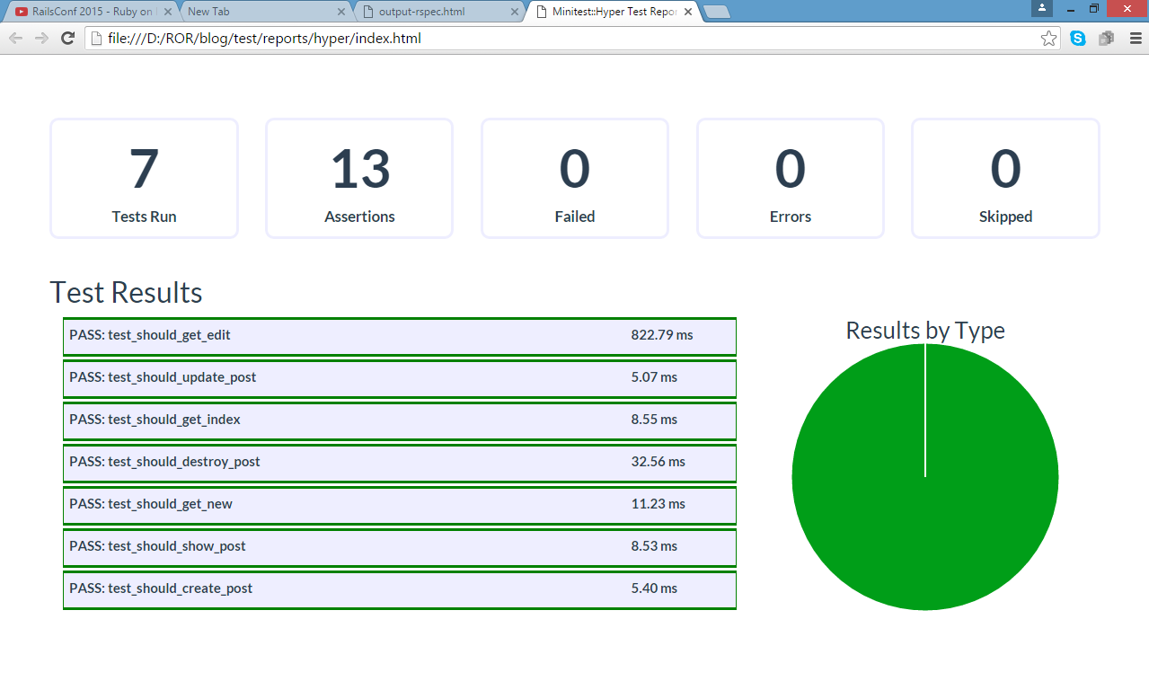

1. Dashboard output in html format

## Rspec

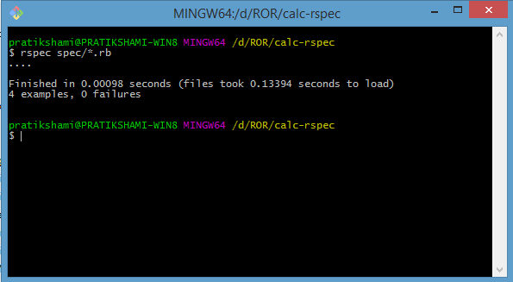

1. Command line output

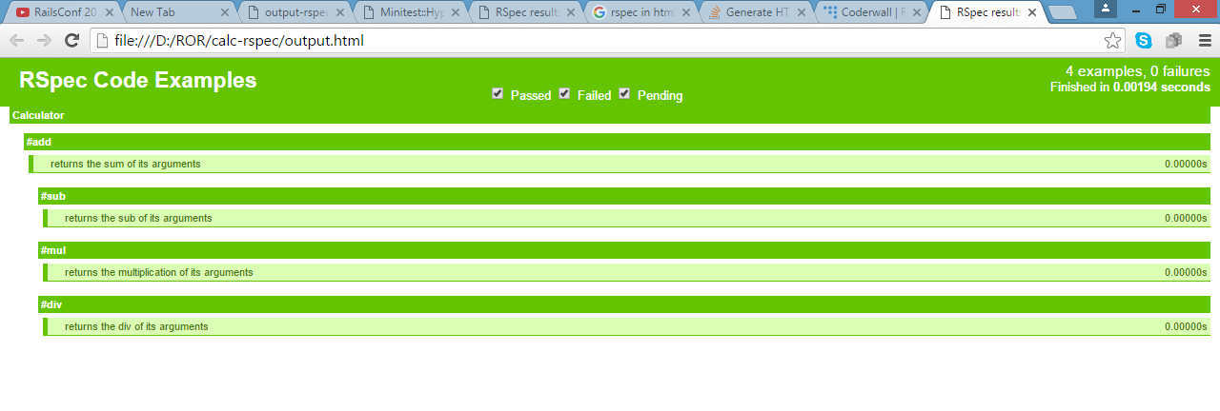

1. Dashboard output in html format