Global level configuration

Step 1:

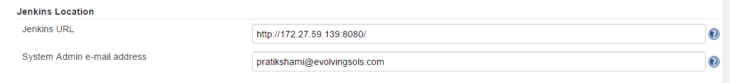

STEP:2

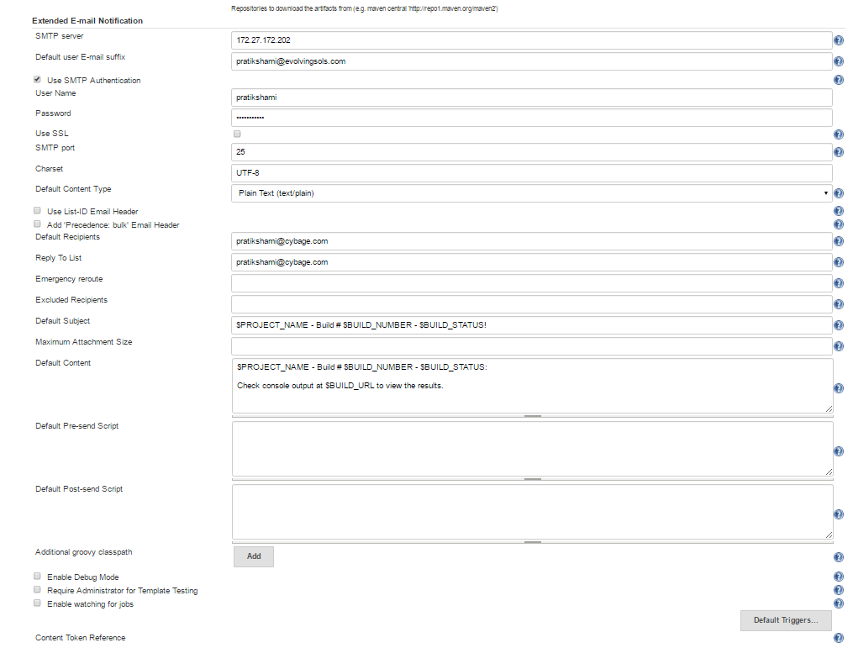

STEP 3:

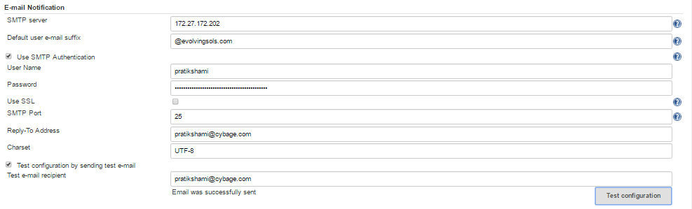

JOB LEVEL CONFIGURATION :

STEP 1

