Task_5 : Documentation – About Us & Contact Us Pages

1. Introduction
This task involves creating a static website with two pages:
- Page 1: About Us
- Page 2: Contact Us
Both pages use a common Navbar (Header) and Footer to maintain a consistent layout across the website.
The pages are developed using only HTML and CSS, without any backend or database.

2. Common HTML Structure
<html lang="en">
- Root element of the webpage.
- lang="en" improves accessibility and screen reader support.
<head>
- Contains metadata, title, and internal CSS.
<meta charset="UTF-8">
- Ensures correct display of characters and symbols.
<title>
- Displays the page title on the browser tab
  - About Us for About page
  - Contact Us for Contact page
<style>
- Contains all CSS for layout and styling.
- Same color theme used on both pages for consistency.
<body>
- Holds all visible content such as navbar, main sections, and footer.

3. Reusable Navbar (Header Section)
HTML Structure
<header>
<nav>
<div class="logo">Vision Institute</div>
<div>
<a href="about.html">About Us</a>
<a href="contact.html">Contact Us</a>
</div>
</nav>
</header>
Explanation
- <header> defines the top section of the page.
- <nav> represents navigation links.
- .logo shows the institute name.
- <a> tags enable navigation between pages.
CSS Features
- Flexbox used for horizontal alignment.
- Shadow and background blur for modern UI.
✔ Same navbar used on both pages
✔ Ensures consistent navigation

4. Page 1 – About Us Page
Purpose
To introduce the institute and provide information about its services, mission, and location.

Sections Included
a) Who We Are
<section>
<h2>Who We Are</h2>
<p>...</p>
</section>
- Brief introduction about the organization.
- Explains what the institute does.

b) Our Services
<section>
<h2>Our Services</h2>
</section>
- Displays list of services such as training and workshops.
- Styled using CSS Grid.

c) Why Choose Us (Optional Section)
- Highlights key strengths like:
  - Experienced faculty
  - Practical learning
- Uses badge-style UI for better visibility.

d) Mission & Vision
<section class="highlight">
- Mission explains current goals.
- Vision explains future objectives.
- Highlighted using gradient background for emphasis.

e) Our Location
<iframe src="https://www.google.com/maps?..."></iframe>
- Embedded Google Map.
- Shows institute location visually.

5. Page 2 – Contact Us Page
Purpose
Allows users to get in touch with the institute by submitting their details or using contact information.

a) Contact Form Section
HTML Structure
<form>
<input type="text">
<input type="email">
<textarea></textarea>
</form>
Form Fields Included
- First Name
- Last Name
- Email
- Phone Number
- “How can we help you?” (Textarea)
- Submit Button
Features
- CSS Grid used for alignment.
- Inputs styled with padding and rounded corners.

b) Contact Information Section
<section class="info">
- Displays:
  - Address
  - Phone number
  - Email ID
- Allows users to contact without filling the form.

6. CSS Overview (Common for Both Pages)
body {
font-family: "Segoe UI", Arial, sans-serif;
background: linear-gradient(...);
}
CSS Highlights
- CSS variables used for color consistency.
- Flexbox used in navbar.
- Grid layout used for main content and forms.
- Card-style sections with shadows and rounded corners.

7. Reusable Footer Section
HTML Structure
<footer>
© 2025 Vision Institute. All Rights Reserved.
</footer>
Explanation
- <footer> is a semantic HTML tag.
- Displays copyright information.
- Same footer used on both pages.

8. Output Screenshot
About Us
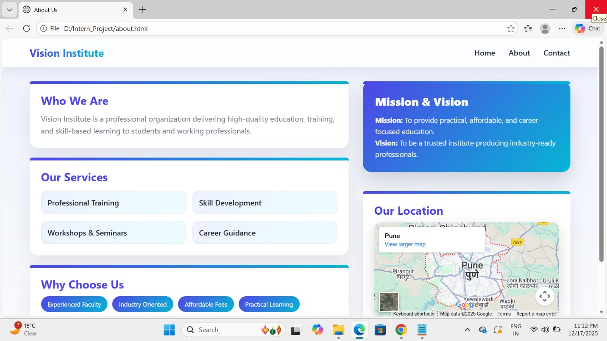
Contact Us
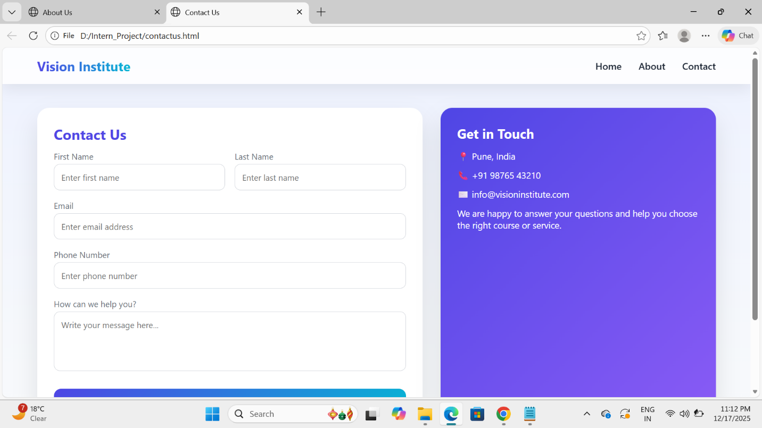

9. Conclusion
This task successfully demonstrates:
- Use of semantic HTML tags
- Creation of reusable navbar and footer
- Page navigation using links
- Form creation and styling
- Clean and responsive layout using CSS
The About Us and Contact Us pages together form a professional static website built using only HTML and CSS, without backend or database integration.

