1.Aim
The aim of this project is to create a simple Sign Up page using HTML and CSS.
This page is used to collect user details like name, email and password.

2. Tools Used
HTML – to create structure of the page
CSS – to make the page attractive
Web Browser – to view the output

3. Description of the Page
This sign up page:
Has a white signup form box
Is placed at the center of the screen
Uses a green gradient background
Contains input fields and a submit button

4. HTML Tags Used
<html> – main tag of the page
<head> – contains title and CSS
<title> – shows page title in browser
<style> – used to write CSS
<body> – visible part of page
<div> – used as a container
<form> – holds input fields
<label> – shows field name
<input> – takes user input
<button> – submits the form
<a> – link for login page

5. CSS Used
Flexbox is used to center the signup box
Background gradient is used for good look
Padding and margin give proper spacing
Border-radius makes corners rounded.
Box-shadow adds depth to the form

6. Validation
required attribute is used
User must fill all fields before submitting

7. Output
The output shows:
Create Account heading
Input fields for name, email, password
Sign Up button
Login link below the form
- Output Sceenshots
Login Page
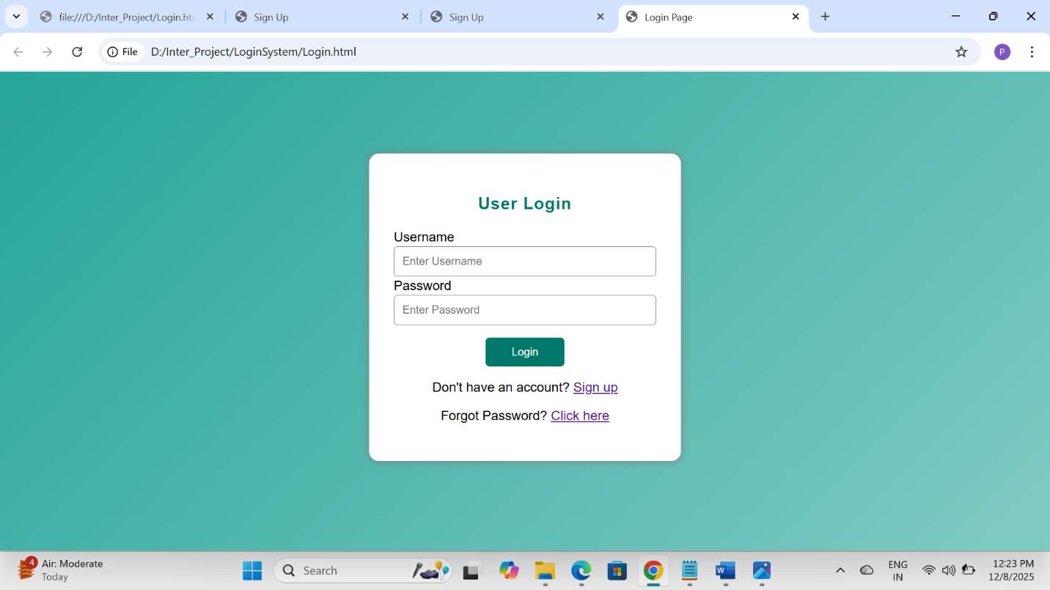
Sign_Up Page
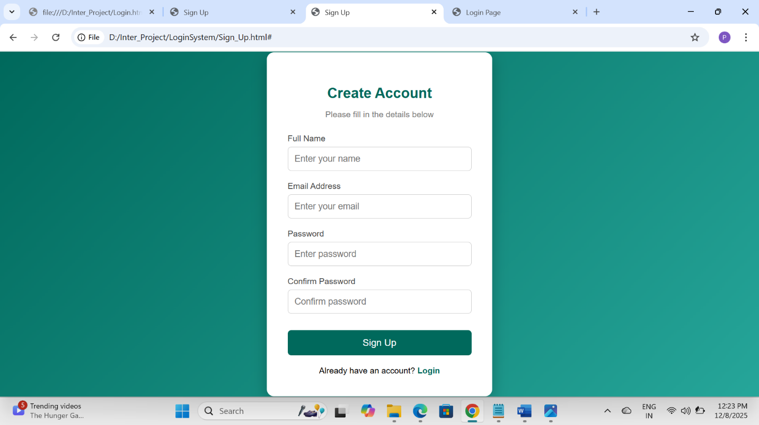

8. Conclusion
This project helps in understanding basic HTML form elements and CSS styling.
It is useful for beginners to learn how to create a simple and clean Sign Up page.

