Task_3 : Documentation: Dashboard UI (table.html)
1. Introduction
A single HTML file that shows a small Dashboard UI consisting of:
- Part A: Feature Cards (Users, Reports, Analytics, Settings)
- Part B: A compact, responsive User Records table
This dashboard is created using only HTML and CSS, without any backend or database.

2. HTML Structure
- <html lang="en">
The root element of the page.
lang="en" improves accessibility and helps screen readers.
- <head>
Contains page information such as title, meta tags, and CSS styles.
- <style>
All CSS is written here for simplicity and ease of understanding.
- <body>
Contains all visible content including heading, cards, and table.
<meta charset="UTF-8">
Ensures correct display of characters, letters, and symbols.
<title>Dashboard</title>
Displays the page title on the browser tab.

3. CSS Overview (inside <style>)
body {
font-family: Arial, sans-serif;
background-color: #f4f6f8;
margin: 0;
padding: 12px;
}
- Sets a clean and readable font.
- Applies a light background color.
- margin: 0 removes default browser spacing.
- padding: 12px adds space around the content.

Main Heading
h1 {
text-align: center;
font-size: 22px;
margin-bottom: 20px;
}
- Centers the dashboard title.
- Adds spacing below it for better layout.

4. PART A – Feature Cards Section
HTML Structure (Example: Users Card)
<div class="card">
<img src="...">
<h3>Users</h3>
<p>Manage user accounts and roles.</p>
<button>View Details</button>
</div>
- Each .card represents one feature.
- Contains an icon, title, short description, and action button.

5. CSS for Cards
.cards-container {
display: flex;
gap: 12px;
justify-content: center;
flex-wrap: wrap;
margin-bottom: 30px;
}
- Uses Flexbox to arrange cards side-by-side.
- flex-wrap: wrap allows cards to move to the next line on smaller screens.
.card {
background-color: white;
width: 200px;
padding: 14px;
border-radius: 10px;
box-shadow: 0 3px 6px rgba(0,0,0,0.12);
text-align: center;
transition: transform 0.2s, box-shadow 0.2s;
}
- Creates clean, compact cards.
- Adds rounded corners and shadow for visual depth.
.card:hover {
transform: scale(1.03);
box-shadow: 0 6px 12px rgba(0,0,0,0.18);
}
- Adds hover effect with slight zoom and stronger shadow.
.card img { width: 40px; margin-bottom: 6px; }
.card h3 { font-size: 16px; margin: 6px 0; }
.card p { font-size: 13px; color: #555; margin: 6px 0; }
- Controls icon size and text spacing.
.card button {
margin-top: 10px;
padding: 7px 12px;
font-size: 13px;
border: none;
background-color: #00796b;
color: white;
border-radius: 5px;
cursor: pointer;
}

.card button:hover {
background-color: #005f56;
}
- Styles buttons and adds hover color effect.

6. PART B – User Records Table
HTML Structure
<div class="table-container">
<table>
<thead>...</thead>
<tbody>
<tr>
<td>101</td>
<td>Pratiksha</td>
</tr>
</tbody>
</table>
</div>
- <thead> contains column headers.
- <tbody> contains table rows.
- Each row uses <tr> and each cell uses <td>.

7. CSS for Table
.table-container {
width: 92%;
margin: auto;
overflow-x: auto;
}
- Makes the table responsive.
- Enables horizontal scrolling on small screens.
table {
width: 100%;
border-collapse: collapse;
background-color: white;
}
- Removes double borders.
- Keeps layout clean.
th, td {
padding: 6px 8px;
font-size: 12px;
border: 1px solid #ddd;
}
- Reduces row height.
- Keeps table compact and readable.
thead {
background-color: #00796b;
color: white;
font-size: 12.5px;
}
- Adds header background and contrast.
tbody tr:nth-child(even) {
background-color: #f2f2f2;
}
- Applies zebra striping for better readability.
tbody tr:hover {
background-color: #d7ece8;
}
- Highlights a row on hover.

8. Output Screenshot
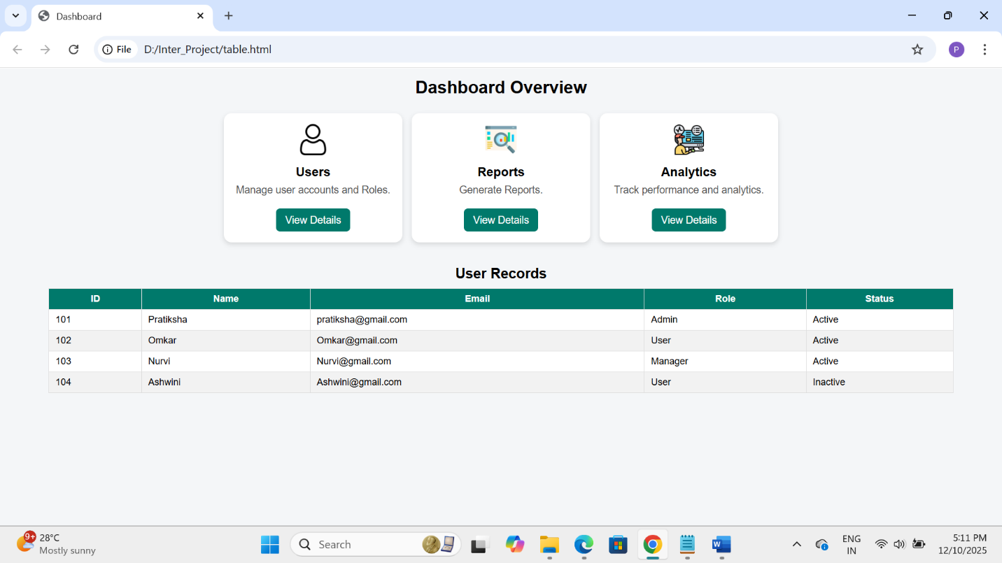

9. Conclusion
This page displays a simple Dashboard Overview with feature cards and a user records table.
Feature cards use Flexbox for layout and include hover interactions.
The records table is designed to be compact, responsive, and readable, using zebra striping and hover effects.
The entire UI is implemented using only HTML and CSS, without any backend or database connectivity.

