Project - High Level Design
On
IaC Provisioning for Telecom System
  - Course Name: DevOps

Institution Name: Medicaps University – Datagami Skill Based Course

Student Name(s) & Enrolment Number(s):
Sr no | Student Name | Enrolment Number
01 | PRATIKSHA PANCHOLI | EN22ME304071
02 | VIPIN PATEL | EN22CS3011087
03 | KHUSHI RAM | EN22ME304053
04 | ANUBRATA MALAKAR | EN22ME304012
05 | YOGESH PATIL | EN22CS3011121

Group Name: 06D10
Project Number: DO-19
Industry Mentor Name:
University Mentor Name: Anvesh oshi
Academic Year:2022-2026

Table of content
- Introduction.
  - Scope of the document.
  - Intended Audience
  - System overview.
- System Design.
  - Application Design
  - Process Flow.
  - Information Flow.
  - Components Design
  - Key Design Considerations
  - API Catalogue.
- Data Design.
  - Data Model
  - Data Access Mechanism
  - Data Retention Policies
  - Data Migration
- Interfaces
- State and Session Management
- Caching
- Non-Functional Requirements
  - Security Aspects
  - Performance Aspects
- References

- Introduction. This project demonstrates Infrastructure as Code (IaC) based provisioning of a Telecom application using Docker, Terraform, GitHub Actions, and Kubernetes. The system automates containerized application deployment and ensures repeatable, scalable, and error-free infrastructure setup.
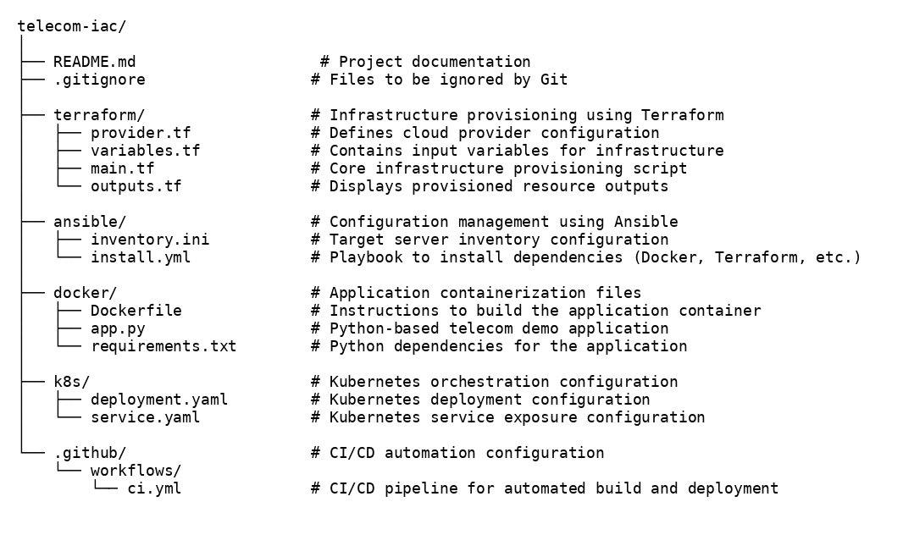
Figure:1 Add GitHub repository screenshot there

Detailed Folder Structure of Telecom IaC System with Component Descriptions
The image shows the organized repository layout including Terraform (IaC), Ansible (Configuration Management), Docker (Containerization), Kubernetes (Orchestration), and GitHub CI/CD workflow.

1.1 Scope of the Document
This document describes:
- Infrastructure automation using Terraform
- Containerization using Docker
- CI/CD pipeline using GitHub Actions
- Kubernetes-based deployment configuration
- System architecture and execution flow

1.2 Intended Audience
This document is intended for:
- Project evaluators
- Faculty members
- DevOps learners
- System architects
- Developers

1.3 System Overview
The system demonstrates automated infrastructure provisioning for a telecom service using Infrastructure as Code (IaC).

The project includes:
- Git for version control
- Docker for containerization
- Terraform for infrastructure provisioning
- GitHub Actions for CI automation
- Kubernetes for scalable deployment configuration
- Docker Desktop as local runtime environment
The telecom application is a Flask-based service that runs inside a Docker container. Infrastructure provisioning and deployment are fully automated using Terraform and CI/CD workflows.

- System Design.
2.1 Application Design
The system follows a layered architecture:
- Development Layer – Source code and infrastructure code are stored in a GitHub repository.
- CI/CD Layer – GitHub Actions automatically builds the Docker image on every code push.
- Infrastructure Layer – Terraform provisions Docker resources using Infrastructure as Code.
- Container Layer – Docker packages the telecom application and its dependencies into an image.
- Orchestration Layer – Kubernetes manages container replicas for scalable deployment.

2.2 Process Flow
The high-level workflow is:
Developer → Git Push → GitHub Actions → Docker Image Build → Terraform Provisioning → Docker Container Created → Telecom Application Running
If Kubernetes is enabled:
Developer → Git Push → CI → Docker Image → Kubernetes Deployment → Telecom Pods Running
This pipeline eliminates manual server setup and ensures consistent deployments.

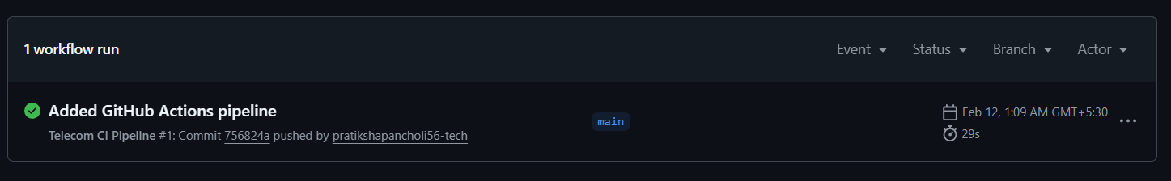
Figure 2:GitHub Actions CI Pipeline Successful Execution

The screenshot shows the successful execution of the CI pipeline triggered automatically on code push. The pipeline builds the Docker image, validating the automated deployment process and eliminating manual build steps.

2.3 Information Flow
User → Browser → http://localhost:5000 → Docker Container → Flask Application → Response
The application processes HTTP requests and returns a simple telecom service response.
No persistent database is used in the current implementation.

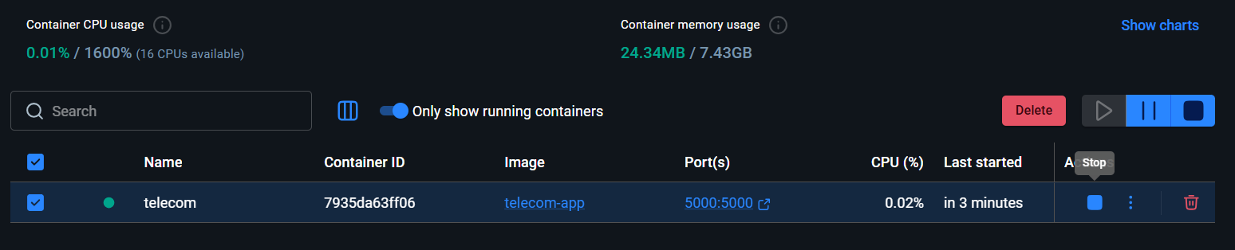
Figure 3:Running Telecom Container in Docker Desktop

The above screenshot shows the running Docker container named “telecom,” which was provisioned automatically using Terraform. The container uses the telecom-app image and exposes port 5000, making the telecom service accessible via browser. The green indicator confirms successful runtime deployment.

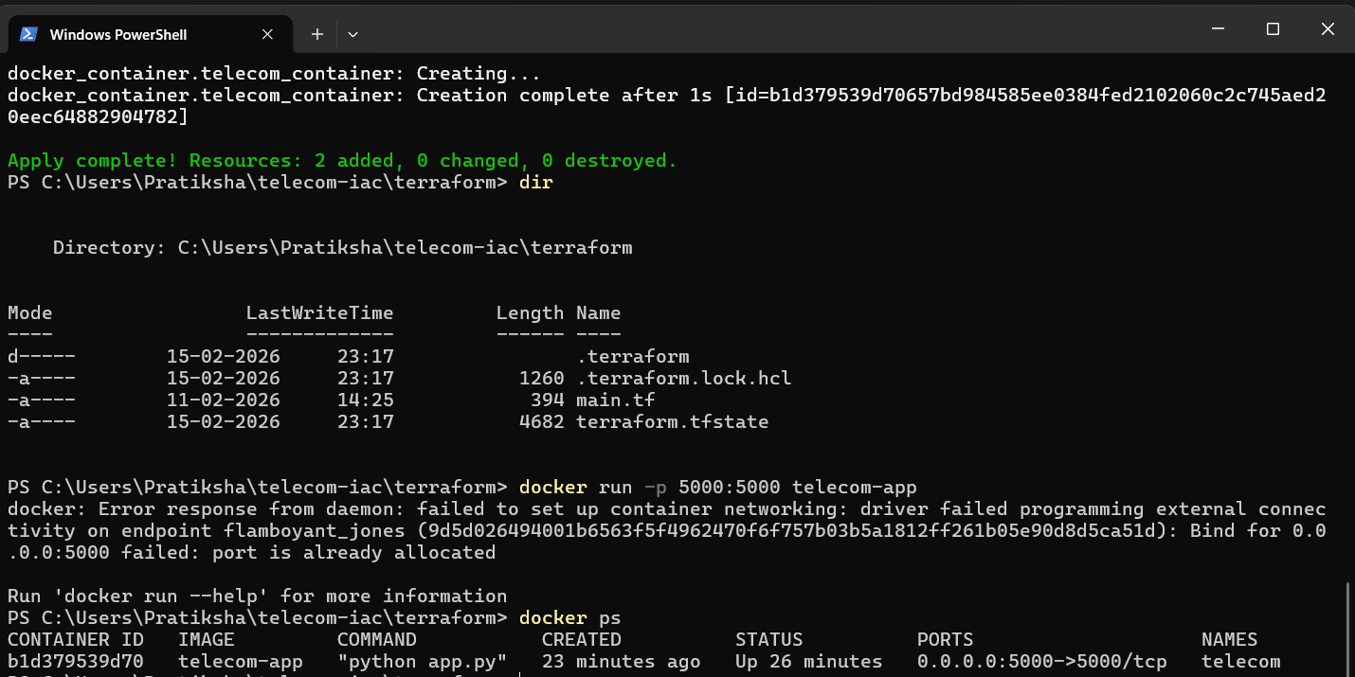
Figure 4:Terraform Infrastructure Provisioning Success Output

The above screenshot shows that Terraform successfully provisioned Docker resources using Infrastructure as Code. The output confirms automatic creation of two resources: the Docker image and the container.

2.4 Component Design
The system consists of the following components:
- GitHub Repository– Stores all infrastructure and application code.
- Docker– Builds the telecom application image from Dockerfile.
- Terraform – Provisions Docker image and container using Infrastructure as Code.
- GitHub Actions – Automates Docker image build on code push.
- Kubernetes – Manages container replicas for scalable deployment
- Docker Desktop – Acts as the local container runtime and Kubernetes cluster provider.

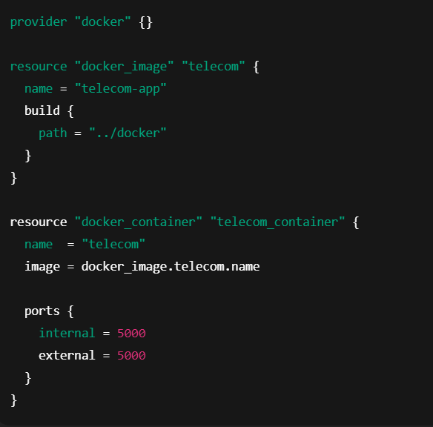
Figure 5:Terraform Infrastructure Configuration

The above configuration shows how Terraform provisions the Docker image and container using Infrastructure as Code. It automatically builds the telecom-app image and deploys a container mapped to port 5000, ensuring repeatable and automated setup.

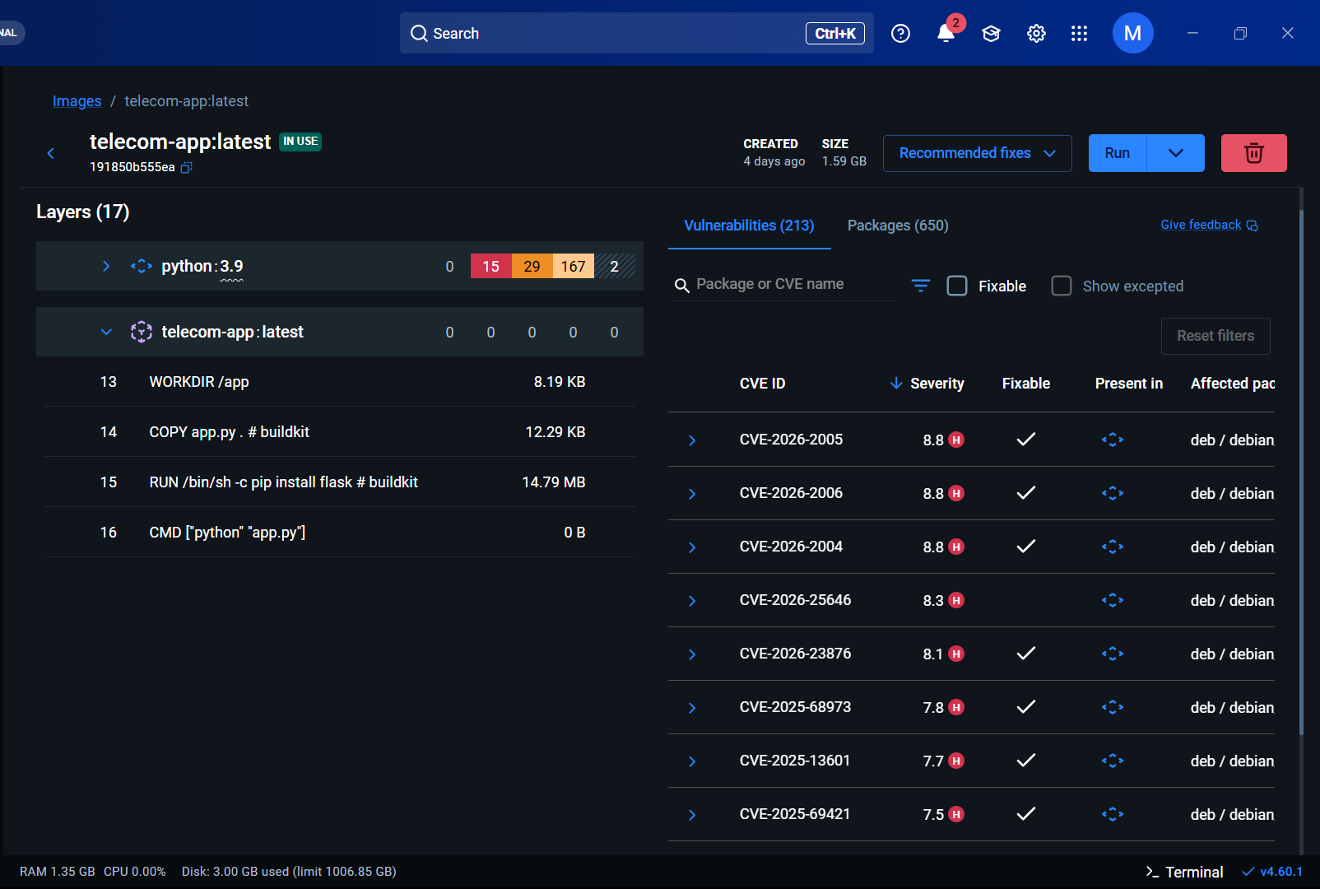
Figure 6:Docker Image telecom-app Built from Dockerfile (In Use)

The above screenshot shows the Docker image telecom-app built from the Dockerfile. It contains the application code, dependencies, and runtime configuration. The image is currently in use by the running container.

2.5 Key Design Considerations
- Automation over manual setup
- Infrastructure defined in code
- Container-based deployment
- Modular architecture
- Scalability via Kubernetes
- Reproducibility across environments

2.6 API Catalogue
The telecom application exposes a REST endpoint:
GET /
Response:
"Telecom System Running!"
The application is implemented using Flask and listens on port 5000.
No external APIs or cloud APIs are used in the current implementation.

- Data Design.

3.1 Data Model
The current implementation does not use a persistent database.

The application is stateless and processes HTTP request-response interactions.
3.2 Data Access Mechanism
The Flask application handles user requests directly. No database layer is integrated.
3.3 Data Retention Policies
Not applicable, as no persistent user data is stored.

3.4 Data Migration
Not applicable in the current implementation. Infrastructure updates are handled via Terraform, and container updates are managed via Kubernetes rolling updates.

- Interfaces
System interfaces include:
- Git ↔ GitHub
- GitHub ↔ GitHub Actions
- GitHub Actions ↔ Docker
- Terraform ↔ Docker Provider
- Kubernetes ↔ Docker Engine
- User ↔ Browser ↔ Telecom Container

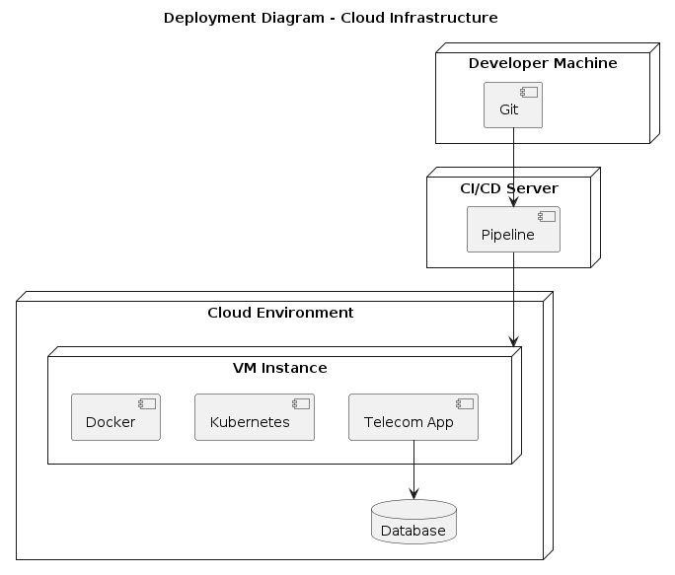
Figure 7
- State and Session Management
The telecom application is stateless.
Each request is independently processed, enabling horizontal scaling in Kubernetes without session dependency issues.

- Caching
Caching is not implemented in the current scope of the project. The architecture allows future integration of caching mechanisms such as Redis if required.

- Non-Functional Requirements
7.1 Security Aspects
- Container isolation via Docker
- Controlled IaC provisioning via Terraform
- Version-controlled infrastructure
- Secure GitHub repository management
- Kubernetes RBAC (if cluster enabled)
7.2 Performance Aspects
- Containerized lightweight runtime
- Automated CI/CD reduces deployment time
- Kubernetes supports horizontal scaling
- Repeatable deployment ensures reliability

- References
- Terraform Documentation – https://developer.hashicorp.com/terraform/docs
- Docker Documentation – https://docs.docker.com
- Kubernetes Documentation – https://kubernetes.io/docs
- GitHub Actions Documentation – https://docs.github.com/actions

