Instructions to install the project-

1. Create a Maven Project in Eclipse IDE.
2. Copy the src folder and verify package names.
3. Verify plugin for Java 1.8 in pom.xml.
4. Update Maven Project.
5. Run as Java application.
6. For testing in Junit, run the ‘TestDiameterOfGraph’ test class as Junit Test.
7. We can edit graphs in text file in resources folder of main and test.
8. Make sure that resources folder for both main and test are added as source in build path.

Screenshots of outputs-

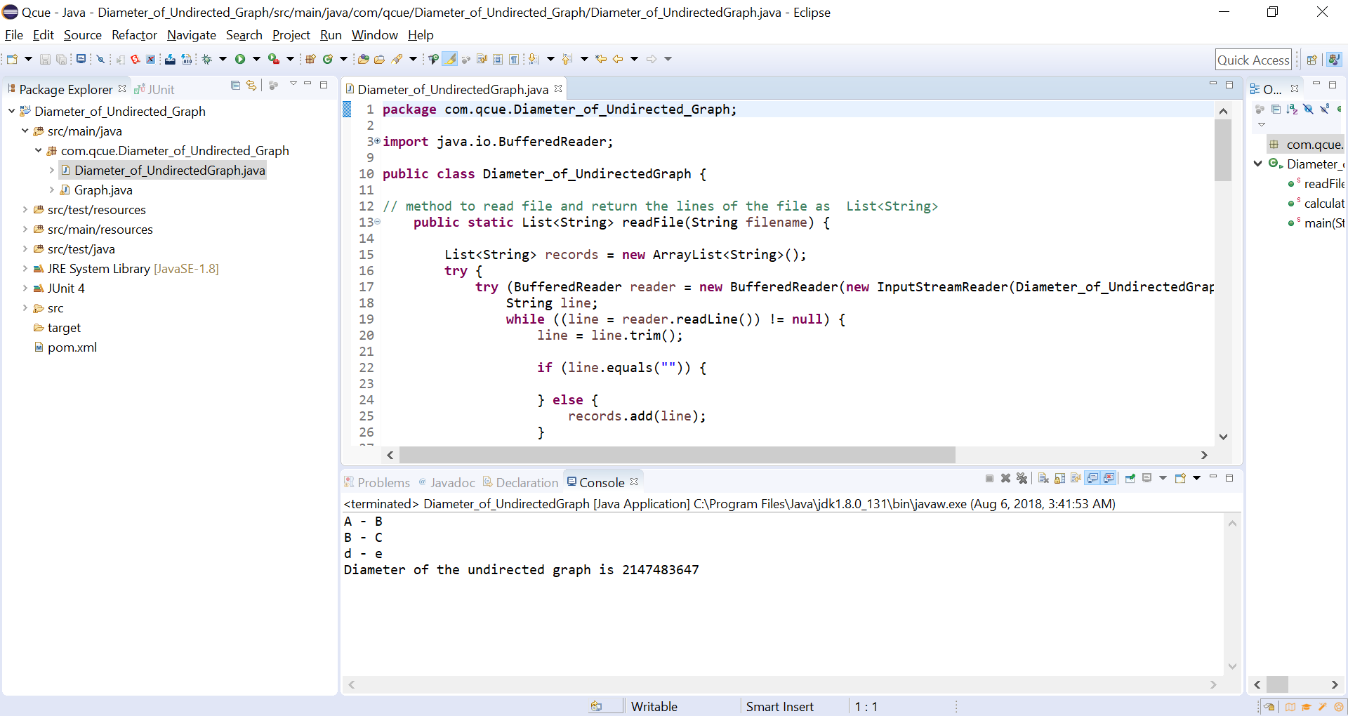

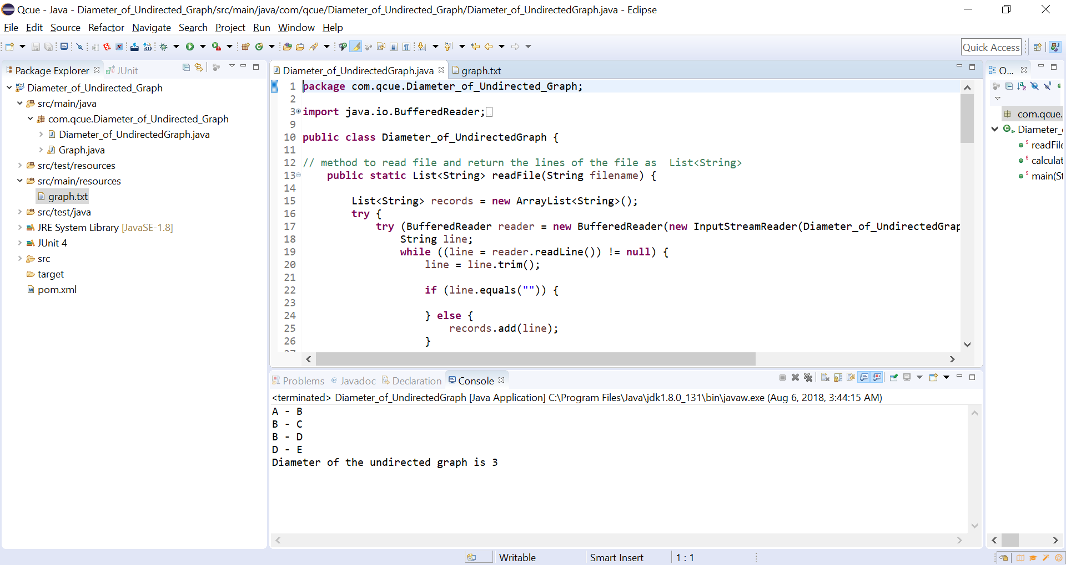

Junit Testing-

