Que1. Write a program to read a file and count how many vowels are present in its content.
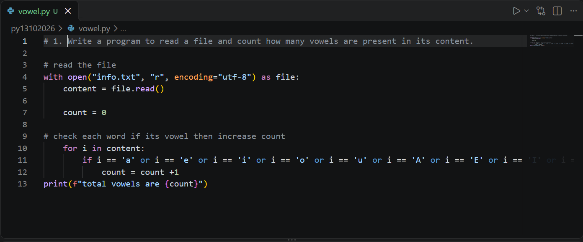
Output:
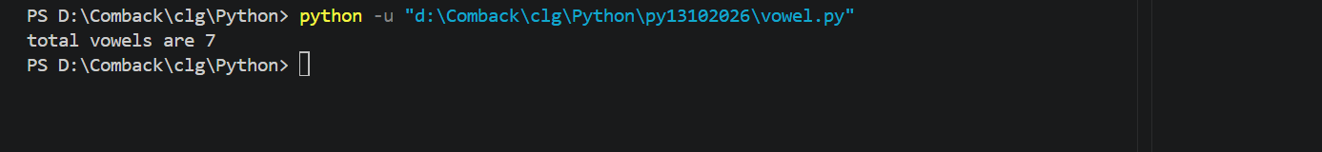

Que2. Read all lines from a file into a list. Print the total number of lines and display the 2nd and 4th line.
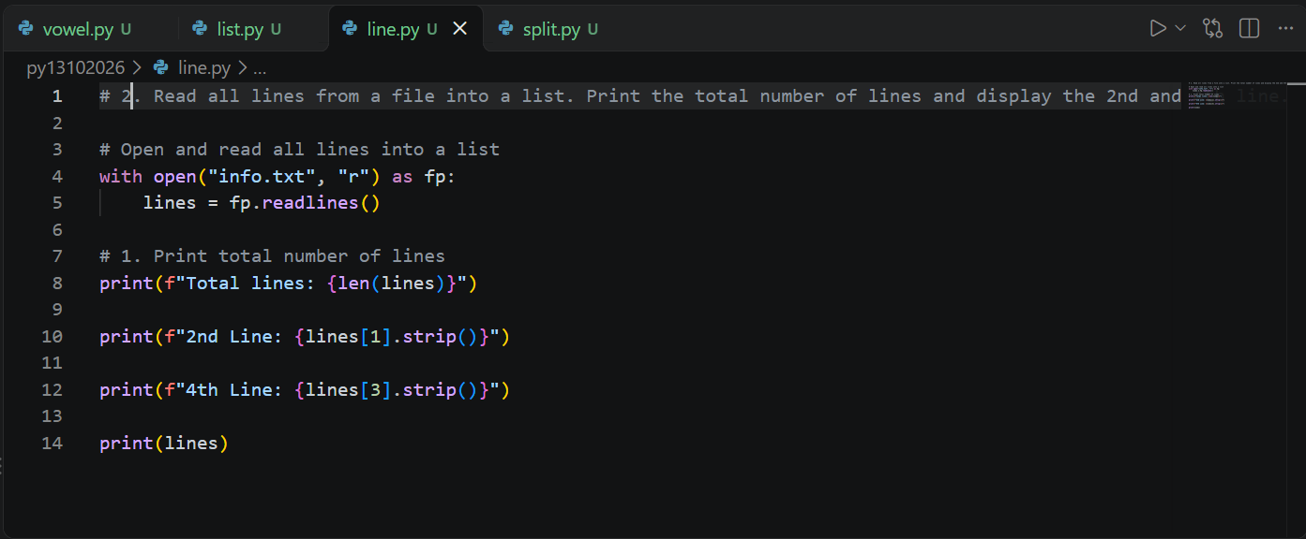
Output:
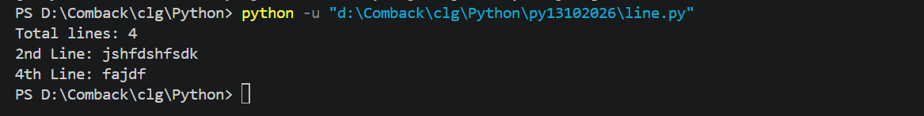
Que3. Take a sentence from the user, split it into words, and store them in a list. Print the longest word.
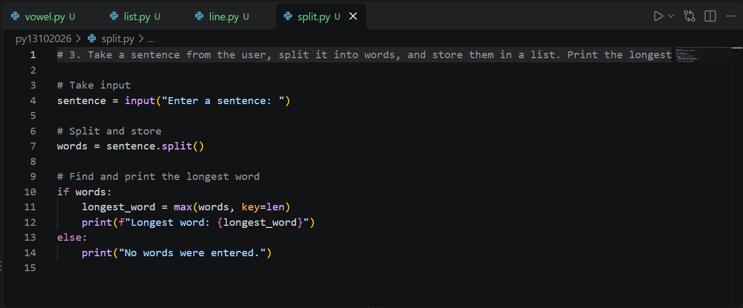
Output:

Que4. Read a file, split its content into words, and store them in a list.
a. Print the total number of words.
b. Print all unique words.
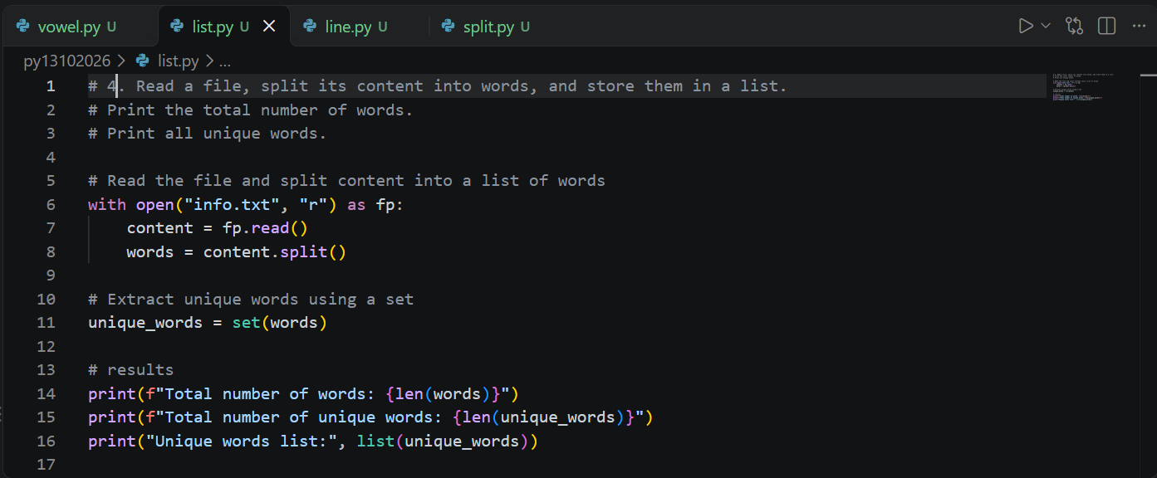
Output:
