OpenWeatherMap
Current Weather API
Reference Guide
Endpoint: GET /data/2.5/weather

Version: 2.5.0
Date: April 2026
Prepared by: Pratik Jadhav

Table of Contents
1. Overview 1
2. Getting Started 2
2.1 Obtain an API Key 2
2.2 Make the First API Call 2
2.3 Test Using Postman 2
3. Authentication 4
4. Endpoint Reference 5
4.1 Endpoint 5
4.2 Parameters 5
4.3 Request Format 5
4.4 Response Format 5
4.4.1 Response Fields 6
4.5 Response Codes 7
4.6 Error Response Format 8
5. Code Examples 9
5.1 Python 9
5.2 JavaScript (Fetch API) 10
6. Error Handling 12
7. Use Cases 13
7.1 Travel Application 13
7.2 Agriculture Dashboard 13

1. Overview
The OpenWeatherMap Current Weather API is a REST API that returns real-time weather data for a specified location. The API accepts an HTTP GET request with a city name and returns a JSON response containing current temperature, humidity, wind speed, atmospheric pressure, and sky conditions.

This document describes version 2.5 of the API and covers a single endpoint:
GET https://api.openweathermap.org/data/2.5/weather

Target audience: Application developers integrating weather data into web or mobile applications, and technical writers documenting REST APIs.

Base URL: https://api.openweathermap.org

API version path: /data/2.5/

2. Getting Started
This section describes how to obtain an API key and make the first API call.

2.1 Obtain an API Key
- Navigate to https://openweathermap.org and create a free account.
- After logging in, select API Keys from the account dashboard.
- Copy the default API key, or select Generate to create a new one.
- Wait up to two hours for the key to activate before making requests.

2.2 Make the First API Call
Construct the request URL using your API key and a city name. The following example retrieves current weather data for Nashik, India:

https://api.openweathermap.org/data/2.5/weather?q=Nashik,IN&appid=YOUR_API_KEY&units=metric

Paste the URL into a web browser. A successful request returns a JSON response with a 200 OK status code.

2.3 Test Using Postman
Postman is a REST API client that allows you to construct requests, inspect responses, and manage API keys securely using environment variables.

To test the request URL in Postman:

- Open Postman and create a new Workspace named OpenWeatherMap Docs.
- Create a new Collection named Current Weather API.
- Select Environments and create a new environment named OWM Environment.
- Add a variable named api_key and paste your API key into the Value field.
- Create a new GET request with the following URL:

https://api.openweathermap.org/data/2.5/weather

- In the Params tab, add the following query parameters:

Key | Value
q | Nashik,IN
appid | {{api_key}}
units | metric

- Select Send. Verify that the response returns a 200 OK status code and a JSON body.

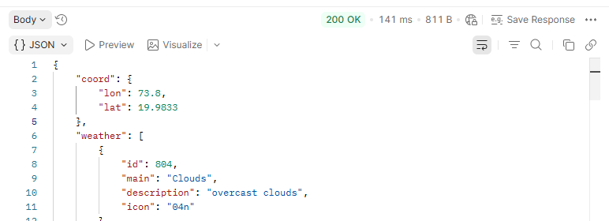
Figure 1. Postman showing a 200 OK response from the /data/2.5/weather endpoint.

3. Authentication
The Current Weather API uses API key authentication. You must include your API key as the appid query parameter in every request.

Authentication method | Location | Parameter name
API key | Query string | appid

The following example shows a correctly authenticated request:

GET https://api.openweathermap.org/data/2.5/weather?q=Nashik,IN&appid=your_api_key_here&units=metric

4. Endpoint Reference

4.1 Endpoint
GET https://api.openweathermap.org/data/2.5/weather

This endpoint retrieves current weather conditions for a specified city. The response includes temperature, humidity, pressure, wind speed, cloud coverage, and geographic coordinates.

4.2 Parameters
All parameters are passed as query string parameters appended to the base URL.

Parameter | Type | Required | Description
q | String | Yes | City name. Append a country code to avoid ambiguity. Example: Nashik,IN or London,GB.
appid | String | Yes | Your unique API key.
units | String | No | Unit system for temperature values. Accepted values: metric (Celsius), imperial (Fahrenheit), standard (Kelvin).

4.3 Request Format
The endpoint accepts HTTP GET requests only.

Sample request:
GET https://api.openweathermap.org/data/2.5/weather?q=Nashik,IN&appid=your_api_key_here&units=metric

4.4 Response Format
A successful request returns a 200 OK status code and a JSON response body. The following is a sample response for Nashik, India:

{
"coord": {
"lon": 73.8,
"lat": 19.9833
},
"weather": [
{
"id": 804,
"main": "Clouds",
"description": "overcast clouds",
"icon": "04n"
}
],
"base": "stations",
"main": {
"temp": 24.52,
"feels_like": 25.25,
"temp_min": 24.52,
"temp_max": 24.52,
"pressure": 1009,
"humidity": 85,
"sea_level": 1009,
"grnd_level": 936
},
"visibility": 10000,
"wind": {
"speed": 4.93,
"deg": 251,
"gust": 9.07
},
"clouds": {
"all": 99
},
"dt": 1782501254,
"sys": {
"country": "IN",
"sunrise": 1782520061,
"sunset": 1782568061
},
"timezone": 19800,
"id": 1261731,
"name": "Nashik",
"cod": 200
}

4.4.1 Response Fields
The following table describes each field in the response body.

Field | Type | Description
coord.lon | Number | Longitude of the city.
coord.lat | Number | Latitude of the city.
weather[0].id | Integer | Weather condition code assigned by OpenWeatherMap.
weather[0].main | String | Weather condition group. Example: Clouds, Rain, Clear.
weather[0].description | String | Detailed weather condition. Example: overcast clouds.
weather[0].icon | String | Weather icon code used to retrieve the corresponding icon image.
base | String | Internal data source identifier. Not required for integration.
main.temp | Number | Current temperature. Unit depends on the units parameter.
main.feels_like | Number | Perceived temperature. Unit depends on the units parameter.
main.temp_min | Number | Minimum temperature at the time of calculation.
main.temp_max | Number | Maximum temperature at the time of calculation.
main.pressure | Integer | Atmospheric pressure at sea level, in hPa.
main.humidity | Integer | Humidity percentage.
main.sea_level | Integer | Atmospheric pressure at sea level, in hPa.
main.grnd_level | Integer | Atmospheric pressure at ground level, in hPa.
visibility | Integer | Visibility in metres. Maximum reported value: 10,000.
wind.speed | Number | Wind speed. Unit depends on the units parameter.
wind.deg | Integer | Wind direction in meteorological degrees. 0 = North, 90 = East.
wind.gust | Number | Maximum wind gust speed. Unit depends on the units parameter.
clouds.all | Integer | Cloud coverage percentage.
dt | Integer | Time of data calculation expressed as a Unix UTC timestamp.
sys.country | String | Country code for the city. Example: IN, GB, US.
sys.sunrise | Integer | Sunrise time expressed as a Unix UTC timestamp.
sys.sunset | Integer | Sunset time expressed as a Unix UTC timestamp.
timezone | Integer | Shift in seconds from UTC. Example: 19800 = UTC+5:30 (IST).
id | Integer | OpenWeatherMap city identifier.
name | String | City name as matched by the API.
cod | Integer | Internal API response code. Mirrors the HTTP status code in most cases.

4.5 Response Codes
The API returns standard HTTP status codes. The following table describes each possible response code for this endpoint.

HTTP status code | Meaning | Cause
200 OK | Success | Request processed successfully. Weather data returned.
401 Unauthorized | Authentication failed | The API key is invalid, missing, or not yet active. Allow up to two hours after key creation.
404 Not Found | City not found | The value passed to the q parameter does not match any known city. Verify spelling or append a country code.
429 Too Many Requests | Rate limit exceeded | The free-tier request limit has been reached. Review usage on the OpenWeatherMap dashboard.

4.6 Error Response Format
When the API returns a non-200 status code, the response body contains a message field describing the error.

401 Unauthorized — sample error response:
{
"cod": 401,
"message": "Invalid API key. Please see https://openweathermap.org/faq#error401 for more info."
}

404 Not Found — sample error response:
{
"cod": "404",
"message": "city not found"
}

5. Code Examples
The following examples demonstrate how to call the endpoint and parse the response in commonly used programming languages. Replace your_api_key_here with your actual API key before running the code.

5.1 Python
import requests

url = "https://api.openweathermap.org/data/2.5/weather"
params = {
"q": "Nashik,IN",
"appid": "your_api_key_here",
"units": "metric"
}

response = requests.get(url, params=params)

if response.status_code == 200:
data = response.json()
print("City :", data["name"])
print("Temperature :", data["main"]["temp"], "°C")
print("Humidity :", data["main"]["humidity"], "%")
print("Condition :", data["weather"][0]["description"])
else:
print("Error:", response.status_code, response.json()["message"])

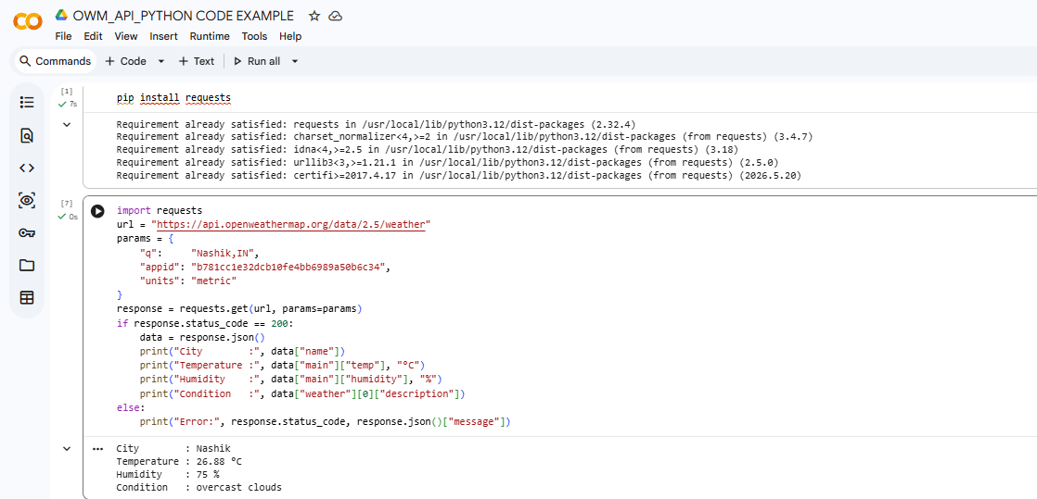
Figure 2. Python script output showing a successful response from the /data/2.5/weather endpoint.

5.2 JavaScript (Fetch API)
const apiKey = "your_api_key_here";
const city = "Nashik,IN";
const url = `https://api.openweathermap.org/data/2.5/weather`
+ `?q=${city}&appid=${apiKey}&units=metric`;

fetch(url)
.then(response => {
if (!response.ok) {
throw new Error(`HTTP error: ${response.status}`);
}
return response.json();
})
.then(data => {
console.log("City :", data.name);
console.log("Temperature:", data.main.temp, "°C");
console.log("Condition :", data.weather[0].description);
})
.catch(error => console.error("Request failed:", error));

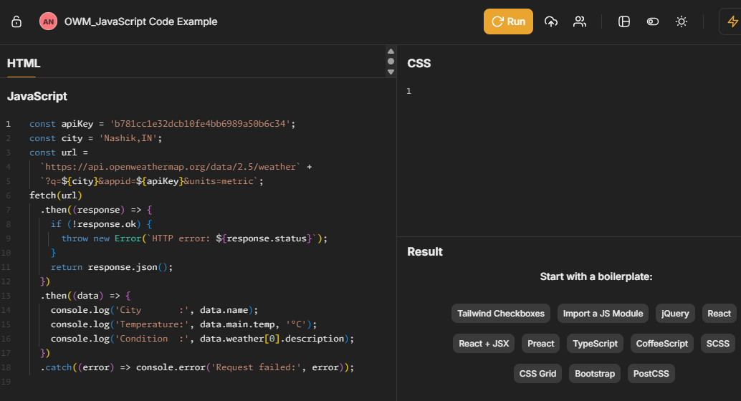
Figure 3: JSFiddle JavaScript panel showing the code

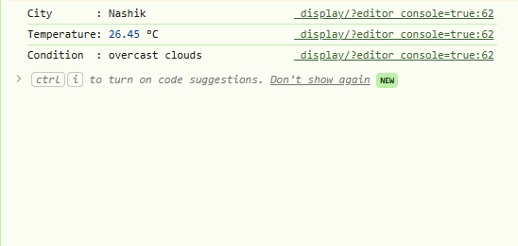
Figure 4. JavaScript Fetch API output in the browser console showing temperature and weather condition for Nashik.

6. Error Handling
All error responses from the API include a cod field and a message field in the JSON body. Applications must evaluate the HTTP status code and handle each error condition explicitly.

Error | cod value | Common cause | Recommended action
401 Unauthorized | 401 (integer) | Invalid or missing API key | Verify the appid parameter value. Confirm the key is active in your account dashboard.
404 Not Found | "404" (string) | Unrecognised city name | Check spelling. Append the country code. Example: Nashik,IN.
429 Too Many Requests | 429 | Free-tier rate limit exceeded | Reduce call frequency. Upgrade to a paid plan if sustained throughput is required.
500 Internal Server | 500 | Server-side error | Retry the request after a short delay. If the error persists, consult the OpenWeatherMap status page.

7. Use Cases

7.1 Travel Application
A travel application can call this endpoint before a user's scheduled departure to display current conditions at the destination city. The application passes the destination name to the q parameter and renders the main.temp and weather[0].description fields as the primary display values.

Relevant response fields:
- main.temp — current temperature at the destination
- weather[0].description — human-readable condition string
- weather[0].icon — icon code for visual rendering

7.2 Agriculture Dashboard
A farming operations dashboard can use this endpoint to assess whether field conditions are suitable for equipment operation. The application evaluates humidity, wind speed, and visibility thresholds and presents an advisory to the operator.

Relevant response fields:
- main.humidity — soil moisture proxy
- wind.speed and wind.gust — equipment safety thresholds
- visibility — operational visibility for machinery

