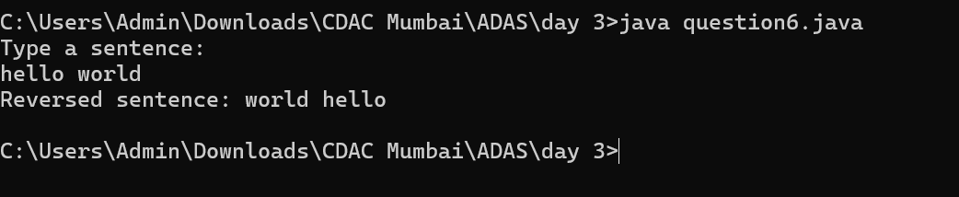  
  
time and space complexity  
0(n)  
  
 Start

|

v

Type a sentence (Read input `sentence`)

|

v

Call `reverseWords` method with `sentence`

|

v

Split `sentence` into words

|

v

Initialize `StringBuilder` sb

|

v

For each word in reverse order

|

v

Append word to sb

|

v

Is it the last word?

| |

No Yes

| |

Append " " | End loop

|

v

Return `sb.toString()`

|

v

Print reversed sentence

|

v

End