Family size dynamics in wintering geese
Pratik R. Gupte^{1,2} – Andrea Kölzsch¹ – Kees Koffijberg³ – Gerhard Müskens⁴ – Martin Wikelski^{1,5} – OTHERS
1 Dept. of Migration and Immuno-ecology, Max Planck Institute for Ornithology, Am Obstberg 1, 78315 Radolfzell, Germany.
2 Kiel School of Sustainability, c/o Dept. of Geography, Christian-Albrechts-Universität zu Kiel, Hermann-Rodewald-Str. 9, 24118 Kiel, Germany.
3 SOVON
4 Uni Wageningen?
5 Uni Konstanz?
Animals living in families obtain the benefits of group living, but must still reckon with the costs. Families of migratory species on their non-breeding grounds have to additionally balance social life and the environmental conditions they encounter, leading to the development of spatio-temporal patterns in their distribution. Hypotheses of interactions between family size, flock size, foraging site, and age-ratio of wintering geese Anserini have emerged from field observations in western Europe, but are not well tested. We gathered long-term observation data on wintering flocks of an abundant species, white-fronted geese Anser albifrons albifrons, from the Netherlands and northern Germany, and tracked a total of 13 families over three winters (2013, 2014, 2016) with GPS transmitters. Taking into account effects carried over from the summer, we explored how the distance of the wintering site from breeding grounds on Kolguyev Island (69°N, 49°E), number of juveniles in a family, number of individuals in a flock, and the age-ratio of flocks develop over time. We related the probability of a family splitting to the number of times, and the distance that it flew. Families with more juveniles winter farther west after the first 60 days following autumn arrival, where flocks are smaller. The number of juveniles in a family, flock size, age-ratio and the number of families in flocks were well correlated with the number of days since arrival. Families that undertook more flights in winter were more likely to split. Our data suggest that juvenile white-fronted geese separate from their parents during the winter, and that this species is differentially migratory by age and social class in both autumn and spring.

Introduction
Living in groups entails both costs and benefits for animals. Group members benefit from more social interactions, and from the increased sensory and physical capabilities of the group (Krause and Ruxton 2002). For instance, birds in larger flocks spend less time on the lookout for predators and have more time to feed (Roberts 1996). Among the costs of group living is the increased competition for limited resources in larger groups (Krause and Ruxton 2002). Living in families offers all the benefits of groups, while costs are shared with relatives. Individuals may lose some direct fitness in family groups, but this is offset by the inclusive fitness gained from related group members (Hamilton 1964, Rodman 1981). Thus animal societies composed of one or more families are common across taxa, from eusocial insects (Crozier and Pamilo 1996) to large herbivores (Archie et al. 2006), and cooperative carnivores (Van Horn et al. 2004).
Many waterbirds, such as geese Anserini, live in groups composed of families. This is most apparent in winter, when families gather to form foraging and migratory flocks (Elder and Elder 1949). Maintaining family bonds within flocks confers benefits since families are dominant over pairs and individuals. Family dominance rank increases with the number of members, for example in Canada geese Branta canadensis (Hanson 1953), snow geese Anser caerulscens (Gregoire and Ankney 1990), and barnacle geese B. leucopsis (Loonen et al. 1999). This allows larger families to occupy optimal foraging positions in flocks at lesser cost, and win access to better resources (Black et al. 1992). Both parents and offspring benefit from family bonds maintained across seasons, as juveniles gain access to more uninterrupted feeding in winter, and parents gain dominance rank (Black and Owen 1989). Parents of some species benefit in summer from the presence of nest-attending sub-adults (Fox and Stroud 1988); barnacle geese that are associated with their young through a winter and thence into the following spring and summer, for example, are more likely to return with a brood the following winter (Black and Owen 1989).
From the summer breeding season, through autumn migration, on the wintering grounds, and often up to and beyond the return spring migration, goose family bonds are affected by a number of factors. A combination of weather conditions and levels of summer predation on the breeding grounds plays an important role in the success of a pair hatching and fledging young (Summers 1986, Dhondt 1987, Summers and Underhill 1987, Bêty et al. 2004). The effect of summer predation linked to the abundance, or lack thereof, of lemmings and voles Arvicolinae has historically been significant enough in some species to be detectable at the population level in winter (Summers and Underhill 1987, Jongejans et al. 2015). Autumn migration takes a further toll in long-distance migrants, especially on yearling birds (Owen and Black 1989, Francis et al. 1992). In spring, juvenile geese become independent of parents (Prevett and MacInnes 1980, Johnson and Raveling 1988, Black and Owen 1989). However, some juveniles may remain associated with parents through the spring migration and on the breeding grounds, where they help fend off predators and competitors (Ely 1979).
The development of family bonds in winter, however, is not fully understood, and appears to be variable. Small species, such as Ross’ geese A. rossii, show weak family bonds in winter, perhaps because these confer no dominance benefit against much larger snow geese with which they form mixed flocks (Jónsson and Afton 2008). Similarly, cackling geese B. hutchinsii grazing in large, dense flocks show weak pair and family associations in winter which strengthen as they move to areas with fewer geese (Johnson and Raveling 1988). In contrast, larger taxa such as giant Canada geese B. canadensis maxima and Greenland white-fronted geese A. albifrons flavirostris show strong, extended family bonds (Warren et al. 1993). In general, small species tend to dissolve families in winter (Johnson and Raveling 1988), while large species tend to maintain them longer (Warren et al. 1993, Kruckenberg 2005).
The question of what space-use and movement decisions families make on the wintering grounds has also not been well explored, especially in the context of accompanying juveniles. Some effect is expected, since the flight of dark-bellied brent geese Branta b. bernicla on autumn migration is affected by the presence of juveniles (Green and Alerstam 2000). Like other birds, geese can be differentially migratory with different population classes occupying different wintering areas (Cristol et al. 1999). For example, the white and blue morphs of snow geese show longitudinal separation during migration (Cooke et al. 1975). Further, more juveniles of Pacific black brent geese B. b. nigricans winter closer to the breeding grounds (Schamber et al. 2007). However, how the number of juveniles in a family influences where it winters is not well understood.
Though the maintenance of family bonds in geese is beneficial, separation of juveniles from parents is the norm. The mechanistic causes underlying family separation are not well studied. In wintering snow geese, family separation is held to be caused by a lack of coordination between members during chaotic take-offs in large flocks, and is thus seen as accidental (Prevett and MacInnes 1980). Juveniles may also be chased off by their parents in some species prior to spring migration (Black and Owen 1989, Poisbleau et al. 2008). Separated geese may make a considerable effort to rejoin their families, and this behaviour is observed across taxa: in Canada geese (Elder and Elder 1949), and snow geese (Prevett and MacInnes 1980). Investigating the role of flight events in family size dynamics requires accurate, fine-scale knowledge of individual positions, and obtaining such data for whole families of highly mobile species has historically presented challenges.
Greater white-fronted geese Anser albifrons albifrons, hereafter white-fronted geese, are among the most abundant geese wintering in continental western Europe (Madsen et al. 1999), and offer an interesting opportunity to investigate the wintertime dynamics of goose families. Accounts suggest that in the Baltic-North Sea flyway population of white-fronted geese (Philippona 1972), larger families winter farther west than smaller ones. Further, these families are observed in smaller flocks, but this may be an artefact of smaller flocks being observed farther west. Family bonds reportedly weaken within winters, contrary to the trend for families of large taxa to stay together through the winter, and sometimes beyond (Warren et al. 1993, Kruckenberg 2005). We draw on long-term field observations and high frequency GPS tracks of whole families of white-fronted geese from their wintering grounds in the Netherlands and northern Germany (Mooij 1991, Madsen et al. 1999, Fox et al. 2010) to test the hypotheses that: 1. Larger families winter to the west, farther from the breeding grounds 2. Larger families winter in smaller flocks, 3. Families decrease in size over the winter, 4. Family size in winter shows effects carried over from summer predation and autumn migration, and 5. Family separation is predicted by flight related disturbances.

Methods

Observation data
We censused flocks of wintering white-fronted geese on their wintering grounds in western Europe by direct counts using field scopes. Observers counted the total number of birds (flock size), and identified first winter juveniles (juveniles) among them from plumage characteristics (dataset A). Families were identified by characteristic behaviours, and were defined as pairs with at least one associated juvenile (successful families). The number of juveniles associated with a pair, and the number of families of each size were recorded in a subset of censused flocks (dataset B). Censuses occurred at both fixed points and ad hoc sites. Observers further reported sightings of individual geese marked with numbered plastic neckbands, including their position and social class (determined by the presence of a partner and juveniles, if any), online (geese.org, dataset C). These data included records of single geese (no partner or juveniles) and pairs without accompanying juveniles (unsuccessful families). To estimate the effect of migration mortality, we censused geese on the breeding grounds on Kolguyev Island (ca. 69°N, 49°E) in August 2016, approximately 1 month prior to the autumn migration, noting the size and social composition of all groups of geese seen (dataset D). Both successful and unsuccessful families were recorded.
Winter data were filtered to exclude records outside the spatial (2 - 10°E, 50 - 54°N) and temporal (autumn 2000 - spring 2017, breeding years 2000 - 2016) limits of our study. Records of unpaired neckbanded geese without juveniles were also removed. We obtained 7,149 flock counts from 75 observers at 123 geocoded sites (automated using Kahle and Wickham 2013). Of these, 1,884 flocks counted by 17 observers at 65 sites held 51,037 successful families. A further 10,635 marked individuals, excluding single geese, were observed at 8,416 sites. Observations of marked geese did not include details on habitat type, flock size and observer. We obtained 116 records of goose families from Kolguyev Island.

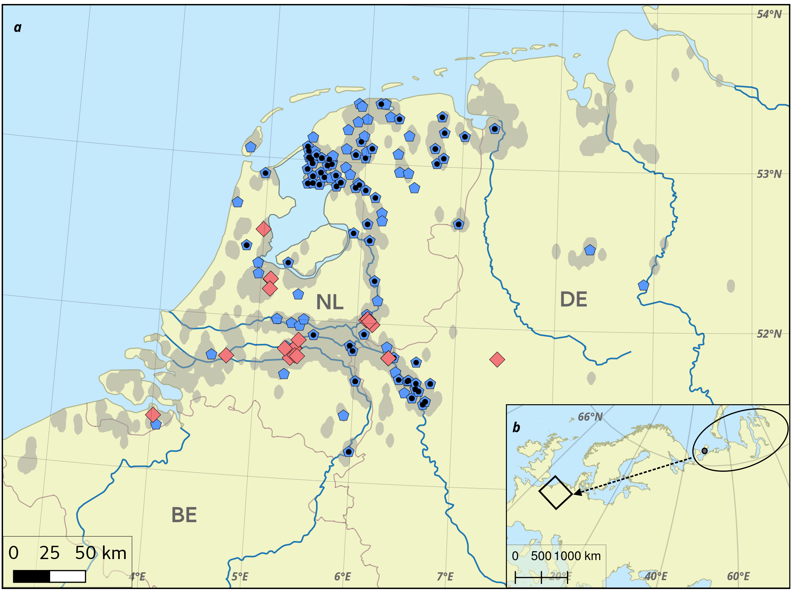Fig. 1: a. Wintering grounds of greater white-fronted geese Anser a. albifrons in the Netherlands and northern Germany, with 123 sites (pentagons) where 7,149 flocks were counted, and a subset of 65 sites (dots) where 1,884 flocks with 51,037 successful families were recorded. 21 splits (diamonds) were observed in 13 GPS tracked families. Shaded area bounds 10,635 observations of marked geese. Observations correspond well with major rivers and waterbodies, marked in blue. Data were collected from 2000 - 2017. b. Breeding grounds in Russia (ellipse) with Kolguyev Island (dot) and general direction of migration (arrow) to wintering area (rectangle).

Family tracking
We also collected half-hourly positions of a total of 13 goose families (13 adult pairs, 38 juveniles) fitted with GPS transmitters in the Netherlands (2013, n = 3, 2014, n = 4: e-obs GmBH, m = xx g, & 2016, n = 6: madebytheo, m = xx g) (dataset E). In addition, 2016 transmitters collected short 0.5 Hz bursts of position data from take-off events. Families fitted with GPS transmitters were tracked within the study site (2 - 10°E, 50 - 54°N) in winter (pre-April 01) for 78 days on average (range: 34 - 135). This large range was due to families being tagged either in early (November) or late (January) winter. A reference bird was identified in each family as the parent with the greater number of GPS fixes within the study period, which was the male in all cases except one. For all families, we identified the day and position where splits were first detected as a decrease in the number of birds within a 250m radius of a designated reference bird (see Fig. 1). We then classified each day a family was tracked as a success or failure (1 or 0) depending on whether a split occurred on that day or not, in order to fit a binomial distribution. We defined ‘flights’ as displacements of greater than 1km over the 30 minute sampling interval, and counted their number and daily frequency. For 2016 families, we identified the half-hourly position and time at which a split was recorded. From the GPS tracks, we isolated take-off bursts for the reference birds of these families as high- frequency (0.5 Hz) GPS fixes which also had a GPS measured ground speed above 2 m/s. We obtained the times at which these bursts occurred, and then calculated the time in minutes between each regular half-hourly fix and the most recent take-off.

Context data
To relate observation data to migration timing, we collected daily records (n = 6,266) of flock flight intensity pooled over 84 spring and 180 autumn (overlap = 72) sites (Van Turnhout et al. 2009) in the Netherlands. We excluded flight activity records from sites close to night roosts, and records which did not match the direction of migration appropriate to the season. We used these data to find the beginning and end of each goose winter across the study period. We took the goose winter to begin with the first mass arrival of geese in autumn, and to end with the last mass departure in spring.
Following previous studies (Jongejans et al. 2015) we estimated an index of summer predation for the breeding grounds of this population from rodent abundance data (arcticbirds.net). We calculated a pooled mean of 0 - 2 (low - high) lemming indices from sites in the region, taking care to include a value of 0 in each year to reflect absence of a lemming cycle in the core breeding area on Kolguyev Island. The index takes into account the cyclical change in lemming abundance, with higher values when lemming abundance had decreased from the previous year reflecting the increased predation pressure on Arctic birds from abundant predators switching to alternative prey (see Dhondt 1987).

Analyses
We first tested whether (1.) the number of juveniles, which determines family size, was correlated with the distance from the breeding grounds at which families were observed. Here, we used datasets B and C. Using dataset B, we tested whether (2.a.) the number of juveniles in a family, and (2.b.) the total number of successful families was explained by a combination of flock size, the number of days since the arrival of geese in autumn, and the level of summer predation. We also tested whether (2.c) the number of juveniles in families was different 1 month prior, and up to 2 months after autumn migration in 2016 using datasets B, C and D.
To place these results in context, we examined (3.) the effect on flock size (from dataset A) of distance from the breeding grounds, the number of days since arrival, and summer predation, and examined whether (4.) the proportion of juveniles in flocks (from dataset A) was explained by the flock size, distance from the breeding grounds, number of days since arrival, and summer predation (see Tab. A1).
Further, using dataset E we examined whether (5.a.) the split probability (no-split or split, binomial distribution) each day was predicted by the number of days since arrival, the number of flights on that day, the cumulative number of flights since the beginning of the tracking period until that day, the distance travelled that day, the cumulative distance travelled since the beginning of tracking until that day, and the family size on that day. For the 2016 families we tested (5.b.) the half-hourly split probability in relation to the time since the last take-off and the distance travelled in the previous half hour (see Tab. A2).
All analyses were performed in the R environment (R Core Team 2017) (see Tab. A1). We used a simple Poisson-error generalised linear model to test 2.c. We used Poisson lme4 (Bates et al. 2015) generalised linear mixed models (GLMMs) to test 1, 2.a, and 3, and binomial-error GLMMs for 5.a and 5.b. In 2.b and 4, we used mgcv (Wood 2013) Poisson (2.b) and binomial (4) generalised additive mixed models (GAMMs) to include smooth functions of the flocksize (in 2.b) and the number of days since winter (in 4) as predictors. We included the breeding year, the observer identity, the goose identity when know, and the habitat type as independent random effects. Effects included in models were dependent on their availability in the datasets used (see Tab. A1). We assessed the importance of each predictor using Type II Wald χ² tests, and model effect sizes using Cohen’s f² (see Appendix 2).

Results

Data filtering
Flock count data from 16 breeding years and subsequent winters yielded a mean 420 flock counts per year (range: 67 (2001) - 672 (2005)). Except one record in August 2016, spring (Aprils, n = 24) and early autumn (Septembers, n = 76) had the fewest records, with most observations from winter (October - January, 81%, n = 5,785). Observations declined over February (11%) and March (6.8%).
The mean flock size was 712 (range: 2 - 20,000), with a mean proportion of first-winter birds of 0.18 (range: 0 - 0.87). Flocks in which families were counted held on average 540 birds (range: 3 - 11,000), with an average of 27 families (range: 1 - 333) accompanied by a mean of 1.78 juveniles (range: 1 - 10).
On average, marked geese were observed 626 times overall (range: 62 - 1143) were observed each year, accompanied by 0.59 juveniles (range: 0 - 11) (see Appendix 1, Figs. A1, A2). Families on Kolguyev Island in 2016 had a mean of 2.26 juveniles (range: 0 – 6).

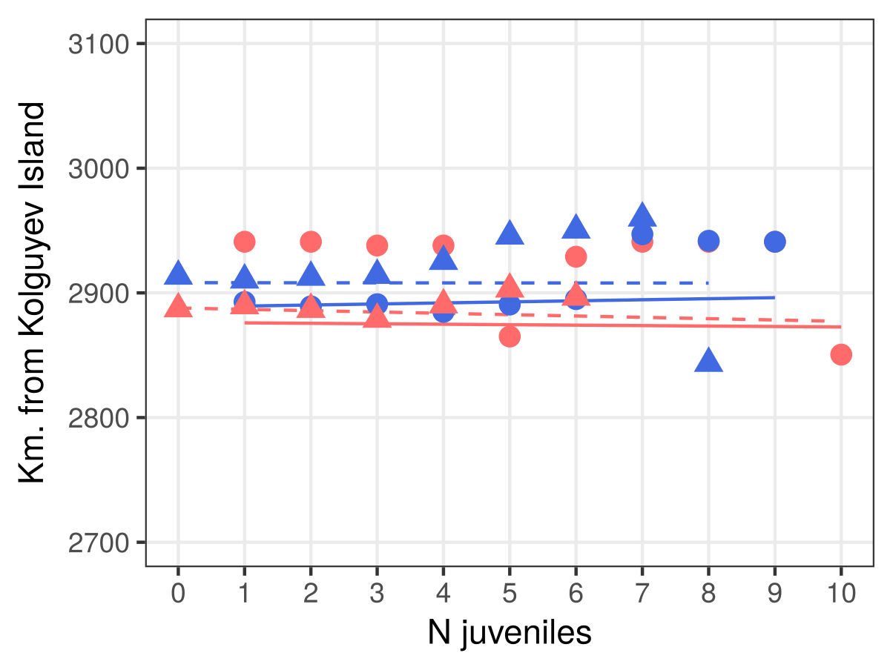Fig. 2: GLMM fits (lines), and mean distance of wintering sites from Kolguyev Island (symbols) per number of juveniles in a family. Data and fit for records from < 60 days after arrival are shown in red; data and fit for records > 60 days after arrival in blue. Triangles & dotted lines represent data from marked geese (dataset C), circles and solid lines are from family counts (dataset B).

Families fitted with GPS transmitters travelled on average 11 km each day (range: 0 - 306). At the daily scale, families travelled a distance > 1km a mean of twice per day (range: 0 - 10), and on average 98 times (range: 63 - 367) over the tracking period. In 2016 families, take-offs occurred on average 5 times (range: 1 - 15) a day, and 470 times (range: 328 - 659) over the tracking period. 21 family splits occurred in the 13 families tracked and were not restricted to juveniles.
Flock flight intensity reached the 90th percentile for autumns between September 26 and October 30, and was at the 90th percentile for the last time between March 03 and April 01. Representing the arrival and departure of geese, respectively, this resulted in a mean goose winter of 165 days. Lemming abundance from the breeding grounds transformed into a predation index ranged between 1.17 and 1.9, with very low variance between years (σ² = 0.048).

Juveniles and wintering site choice
We found no influence of the number of juveniles in a family on how far from the breeding grounds a family wintered in the first sixty days after arrival (dataset B: successful families in flocks, and C: families of marked geese, model 1, χ² B = 1.135, p B = 0.286, χ² C = 2.007, p C = 0.157, see Fig. 2). Later in the winter, larger families from dataset B (successful families in flocks) wintered farther west (χ² = 4.194, p = 0.041), while dataset C (families of marked geese) did not reveal any influence of juvenile number on wintering site (χ² = 0.27, p = 0.6033).
We investigated whether these trends could be explained by the sampling method used for each dataset. We implemented model 1 for early and late winter as before with the following data subsets: 1. Only successful pairs from dataset C, 2. Equal samples of families with 1 – 6 juveniles from dataset B, and 3. Equal samples of families with 0 – 5 juveniles from dataset C.
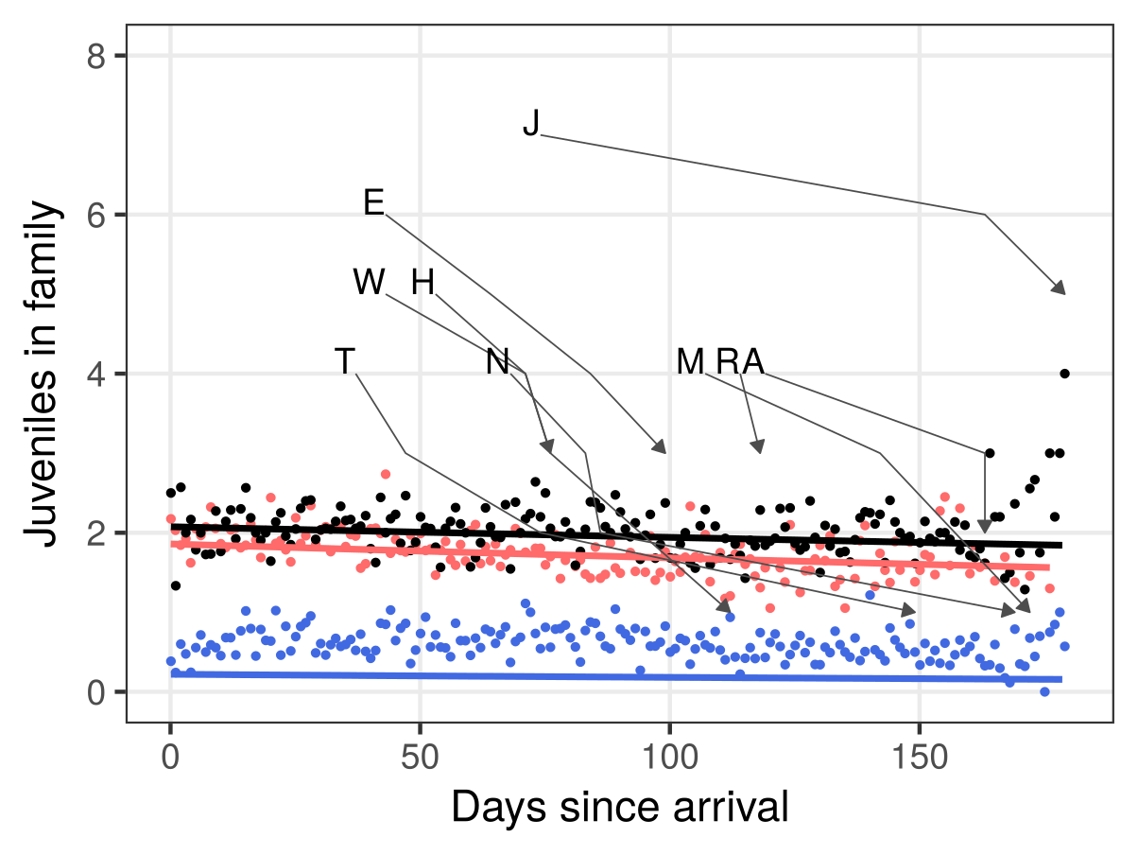Fig. 3: GLMM fits (lines) and mean number of juveniles per family on each day since goose autumn arrival pooled across years (dots). Successful families in flocks (dataset B) are shown in red (dots and line), families of marked geese including unsuccessful pairs (dataset C) are shown in blue, only successful pairs of marked geese are shown in black. Arrows show development of size of 9 GPS tracked families that underwent splits.
We found that none of the subsets revealed an effect of the number of juveniles on family size choice (1. successful families dataset C: < 60 days: χ² = 0.28, p = 0.598, > 60 days: χ² = 1.20, p = 0.273; 2. equal samples dataset B: < 60 days: χ² = 1.805, p = 0.179, > 60 days: χ² = 0.256, p = 0.613; 3. equal samples dataset C: < 60 days: χ² = 0.221, p = 0.638, > 60 days: χ² = 0.274, p = 0.601). We further used datset C to test whether the proportion of successful pairs was related to the distance of their wintering site from the breeding grounds, and found no effect (χ² = 1.071, p = 0.301).

Family size in winter
The number of juveniles in a family (dataset B: successful families in flocks, model 2.a) decreased through the winter (χ² = 74.166, p < 0.001, see Fig. 3), but was insensitive to flock size (χ² = 0.270, p = 0.6033) and summer predation (χ² = 0.337, p = 0.562, see Fig. A3). Family sizes of marked geese (dataset C: families of marked geese, model 2.a adapted) decreased over time (χ² = 19.936, p = < 0.001, see Fig. 3). However, they showed an increase of with the level of summer predation, with on average 0.78 more juveniles per family per unit rise in the predation index (χ² = 12.935, p < 0.001, see Fig. A3).
We ran further tests to determine whether the effects contradictory effects obtained were data artefacts. First, we tested whether the exclusion of unsuccessful pairs from family counts in flocks biased the data by similarly excluding such records from observations of marked geese. We confirmed this bias in sampling method by failing to find any effect of summer predation after excluding unsuccessful pairs from data C (χ² = 0.1321, p = 0.716, see Fig. A3). We then corrected for the over-representation of marked geese with no juveniles (unsuccessful pairs) and implemented model 2.a adapted using equal numbers of observations of pairs with between 0 and 5 juveniles, with only the the first record of each marked goose in each breeding year being considered. We failed to find an effect of summer predation on the number of juveniles using this stratified approach (χ² = 0.003, p = 0.955). Finally, using only the first records of marked geese within breeding years, we ran a GLM to examine whether the proportion of successful pairs among marked geese was influenced by the level of summer predation, and found no effect (χ² = 0.002, p = 0.961).
The number of successful families in flocks ( model 2.b) increased with flock size (χ² = 7162, p < 0.001), and the number of days since goose arrival in autumn (χ² = 171.3, p < 0.001, see Fig. 4), but was unaffected by summer predation (χ² = 0, p = 0.98). Further, there were more successful families in flocks farther from the breeding grounds (χ² = 12.73, p = 0.0004, see Fig. 5).
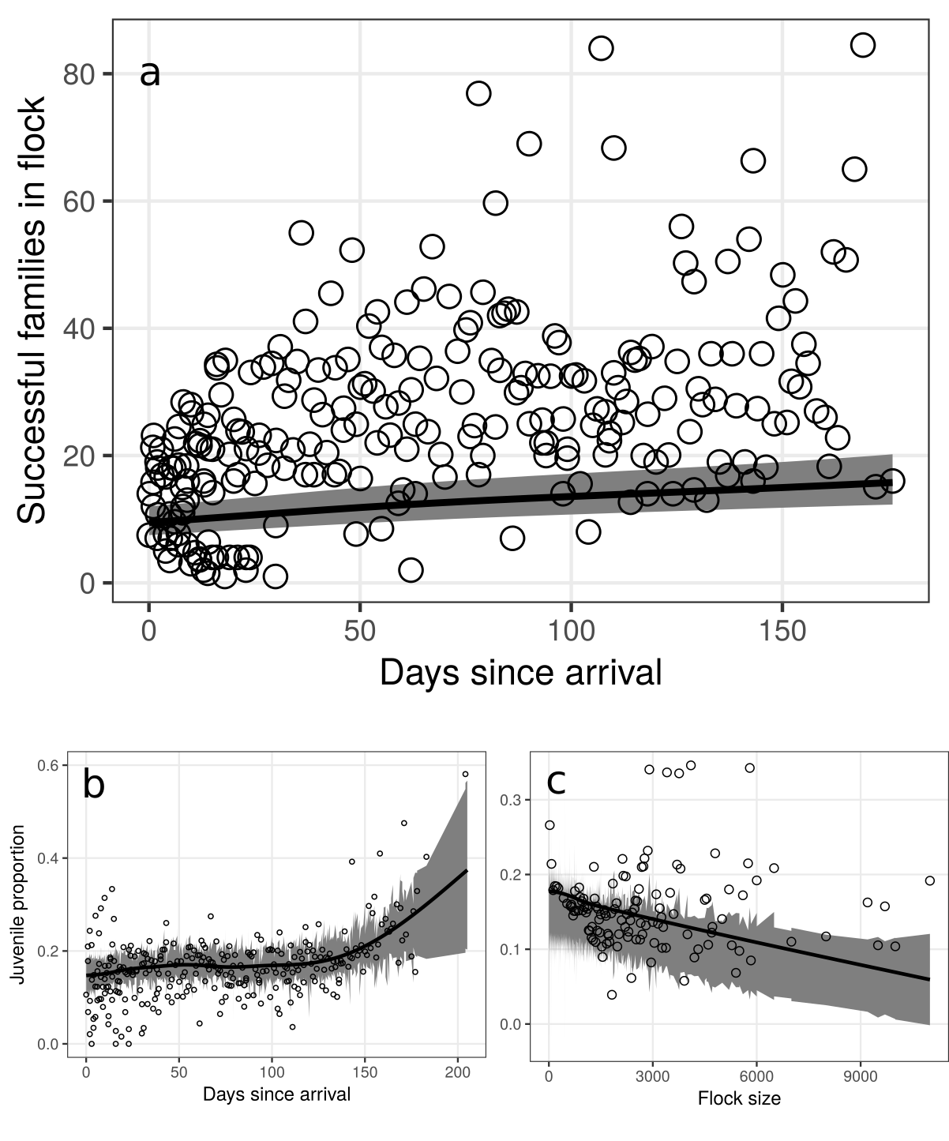Fig. 4: a. GAMM partial fit (line) and mean number of successful families in white-fronted goose flocks on each winter day, pooled across all winters (circles). 95% confidence interval is shaded grey.
b. GAMM partial fit (line) and mean proportion of first-winter juveniles in white-fronted goose flocks on each winter day, pooled across all years (circles). Note that days since arrival was modelled as a smoothed covariate using thin plate splines, and 4 knots. 95% confidence interval is shaded grey.
c. GAMM fit (line) and mean juvenile proportion of flocks in increments of 25 individuals (circles). Larger flocks have a lower proportion of juveniles, and lower variance in the poroportion. 95% confidence interval is shaded grey.

Family size and autumn migration
Families of geese observed approximately one month pre-migration on Kolguyev Island (dataset D) had significantly more juveniles than successful families (dataset B) in flocks (GLM, z = -4.285, p < 0.001) and families of marked geese (dataset C) (GLM, z = -14.511, p < 0.001) recorded in the first two months following the population’s arrival on the wintering grounds (model 2.c).

Flock size in winter
Flocks (model 3) were significantly smaller farther from the breeding grounds (χ² = 66599, p = < 0.001, see Fig. A5), and grew slightly over the winter (χ² = 4975, p < 0.001). Within flocks, juvenile proportions increased through the winter (χ² = 19.43, p = 0.001, see Fig. A4), and decreased with increasing flock size (χ² = 5.921, p = 0.015, see Fig. A6), but did not show any effect of distance from the breeding grounds (χ² = 1.015, p = 0.314), or of summer predation (χ² = 0.021, p = 0.883).

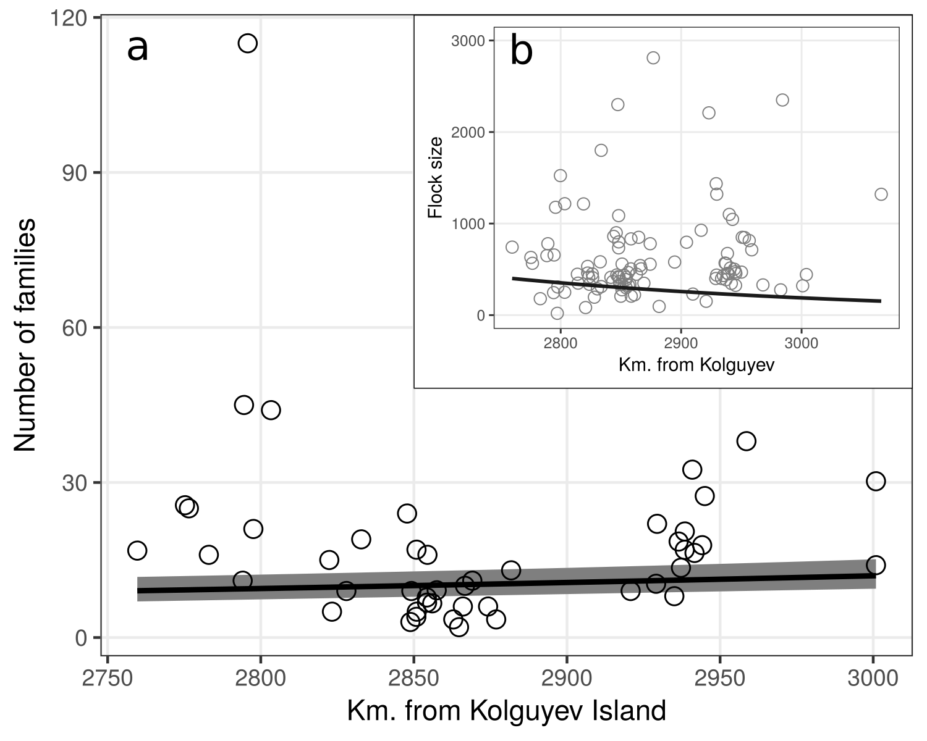Fig. 5: GAMM fit (line) and mean number of successful families in white-fronted goose flocks at each site (circles, n = 49) as a function of its distance from Kolguyev Island. 95% confidence interval is shaded grey. b. GLMM fit (line) and mean size of flocks at each site (circles, n = 111) as a function of its distance from Kolguyev Island. Sites to the north-east of the study site are approximately 500 km nearer to Kolguyev than sites in the south-west.

Probability of family splits
The daily probability of families separating (model 5.a, see Fig. 6) was significantly lower later in the winter (χ² = 8.314, p = 0.004), and lower in larger families (χ² = 11.41, p < 0.001). There was no effect of the daily number of flights (χ² = 0.018, p = 0.893), nor the daily distance moved (χ² = 2.99, p = 0.083). Split probability was higher in families that made cumulatively more flights in the period between the beginning of tracking and the split (χ² = 143.23, p < 0.001), but decreased in families that moved a shorter cumulative distance in the period between the start of tracking at the split (χ² = 182.63, p < 0.001). At the half-hour scale (model 5.b), split probability increased with time since the previous take-off (χ² = 6.07, p = 0.014), but was not related to the distance travelled in the previous half hour (χ² = 0.389, p = 0.533).

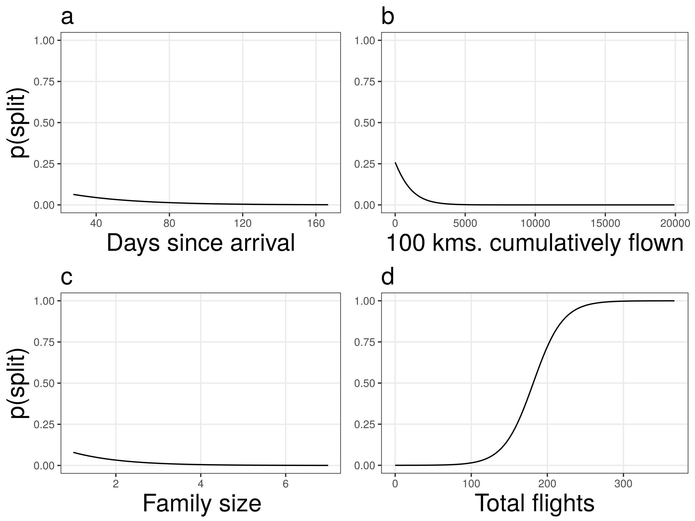Fig. 6: GAMM partial fits (lines) for (a) days since arrival, (b) cumulative number of flights over winter, (c) number of juveniles, and (d) cumulative number of displacements of more than 1000 km.

Discussion
We studied how the size of white-fronted goose families is related to where, when and with how many flockmates they are seen in the wintering grounds. We found no support for the effect of the size of successful families on how far they winter from the breeding grounds. While the number of successful families in flocks was higher in the west, there was no change in the proportion of successful pairs of marked geese across the study site. We confirmed that family size decreases over the winter, but found that it is insensitive to flock size, and shows no response to summer predation. Families are less likely to split later in winter, and with increasing family size. We found little evidence that flights are responsible for family splits in winter. We showed that flocks are smaller farther from the breeding grounds, and found that they increase in size over the winter. Though larger flocks have more successful families, their proportion of first year birds is lower, but increases as winter progresses.
Social class has been found in previous studies to influence geese’s selection of wintering sites, with dominant social units displacing subordinate ones from optimal wintering locations (Vangilder and Smith 1985, Schamber et al. 2007). Our finding that family size is not a factor in the selection of wintering site is contrary to that of Jongejans et al. (2015). However, since Arctic geese have become tolerant of human disturbance and have acclimatised previously deterrent structures such as wind turbines, they can exploit most of the highly productive landscape in Europe (Madsen and Boertmann 2008, Fox and Madsen 2017), calling into question whether optimality with respect to resources varies significantly across the study area. Geese have earlier been noted to respond to conditions that impede foraging, such as snow and ice cover coupled with strong winds (Philippona 1966, Lok et al. 1992). However, such movements are not sufficient to affect the numbers of geese in the Netherlands, where they are super-abundant, but rather serve to increase those in more southerly Belgium, where they are low in mild winters (Lok et al. 1992). Further, with a warming planet, extreme winters have become rare within the study period, and this could explain why geese no longer seem to show a relation between social class and their wintering site.
Since energy reserves and water balance especially determine how far and how fast a bird can fly, metabolic constraints on flight activity determine where it must stop-over, and thus by extension, where it terminates migration (Klaassen 1996). Our finding that flocks are smaller to the west of the wintering area (approx. 3 - 4°E) fit well in this context, and it is to be expected that fewer geese would choose to winter farther west when climatically suitable and similarly agricultural sites can be found to the east. Our results that larger flocks had a lower proportion of first-year birds must be considered in the context of the previous outcome that flocks are smaller in the west, where they have more successful families. This likely results in a higher juvenile proportion from small flocks, producing the trend we see. Consequently, one would expect a higher proportion of juveniles in westerly regions, as reported previously at the country scale (Jongejans et al. 2015), but we did not find that flock juvenile proportion varies over the study site. Since goose families selecting for optimal sites are suggested to drive variation in juvenile proportion between wintering areas, it is likely that the lack of variation in family size over the study site is partially responsible for the absence of a pattern in juvenile proportion (eg. Schamber et al. 2007). Further, independent juveniles observed in wintering flocks (eg. Hanson 1953, Gregoire and Ankney 1990, Loonen et al. 1999) may dampen any variation.
Juvenile independence has been reported across goose taxa (eg. Prevett and MacInnes 1980, Johnson and Raveling 1988, Black and Owen 1989) as being concurrent with the arrival of spring. Previous studies have shown that spring copulation in the breeding pair triggers juvenile departure (Fischer 1965, Prevett and MacInnes 1980). We find support for the hypothesis that the number of juveniles with adults decreases through the winter. The dissociation of juveniles from parents should result in some pairs losing the single juvenile associated with them, thus reducing the number of successful families counted in flocks over the winter. Our finding that the number of families seen in flocks increases as winter progresses contradicts this expectation. An explanation could be that social class predicts variation in spring migration timing, with families leaving later than pairs without juveniles. This is already known from the autumn migration, with families arriving later than non-breeding birds (Jongejans et al. 2015). However, previous studies have not found such an effect in grey geese in spring (Madsen 2001, Bêty et al. 2004).
Summer predation, in turn driven by the cyclical abundance of Arctic rodents, is another mechanism by which the populations of Arctic-breeding birds, including geese, are suggested to be regulated prior to migration (see Summers 1986, Summers and Underhill 1987, Blomqvist et al. 2002). Recent studies however indicate that since the 2000s, the breeding success of Baltic-North Sea flyway white-fronted geese no longer seems to be correlated with summer predation (Jongejans et al. 2015). This may explain our findings that the number of juveniles in successful families is not affected by summer predation intensity. It has been suggested that more Baltic-North Sea white-fronted geese now breed on Kolguyev Island where they experience a constant level of predation, since the island lacks lemmings and associated phenomena (Kruckenberg et al. 2008). A large Arctic breeding range (45°E - 85°E, ca. 1,800km, Baltic-North Sea population) likely means that variation in predation pressure is lost due to year-wise averaging across sites. Future models could correct for this by accounting for predation at the summering site of each family observed in winter. Lemming cycles in northern Russia appear to be faltering and this could also explain why cyclicity in goose breeding success has been reduced (Nolet et al. 2013). The increase in the number of juveniles seen with marked geese during years of increased predation could suggest that facing high predation pressure, geese either fledge large families or suffer total brood failure. However, our findings that summer predation does not explain the number of juveniles seen with successful pairs, and that the proportion of successful pairs of marked geese in each year is not explained by the level of summer predation cast doubt on such an interpretation.
Migration mortality of juveniles might be a significant factor in the decoupling of family size and summer predation. It has earlier been shown to be significant in long distance migrants that make few stop-overs. Previous work has shown that nearly a third of juvenile barnacle geese migrating from Svalbard to wintering grounds in Scotland (3,500 km away) will fail to complete the trip (Owen and Black 1989). Competition for resources that results from an increased abundance of geese at summer sites is believed to be an important factor. In overexploited tundra habitats, fledging geese are suggested to be unable to accumulate the reserves necessary for successful migration over the open ocean. Similar effects are suggested in lesser snow geese (Francis et al. 1992). Our result that the number of juveniles seen in families prior to migration is higher than in the first two months on the wintering grounds is in line with this prior work. As Arctic geese reach super-abundance, reduced juvenile recruitment due to density dependent effects might help stabilise populations (Francis et al. 1992).
The result that flock juvenile proportion rises non-linearly over the winter is in line with the previous finding that the number of successful families in flocks increases with time. However, this trend is probably due in larger part to white-fronted geese being differentially migratory with respect to age and social class, with geese without young leaving the breeding grounds earlier than families and juveniles. An effect of age on spring departure timing has been unsuccessfully tested for in similar species (pink-footed geese Madsen 2001, snow geese, Bêty et al. 2004). However, in snow geese the continued influx of juveniles to the breeding grounds for some weeks after the arrival of the breeding population does suggest that independent yearling geese follow a different migration schedule from adults (Prevett and MacInnes 1980). The question of age-differential migration would ideally be resolved with age-ratios of flocks in flight on spring migration. Since the population likely does not receive a significant influx of juveniles towards the end of winter, we must conclude that juveniles do leave later than adults in spring.
Finally, our exploration of the mechanistic causes underlying family separation is among the first to synthesise tracking data from individuals to infer group level dynamics. Our findings that the daily probability of families losing individuals decreases with the distance travelled, and is reduced later in winter are thus novel. They contradict the consensus that geese are likelier to become independent towards spring (Prevett and MacInnes 1980, Johnson and Raveling 1988, Black and Owen 1989, Scheiber et al. 2013). Given that we did not differentiate between juvenile separation, juvenile death, and separation of the breeding pair in our analysis, this coupled with our low sample size of 13 families could have biased the results. Nonetheless, our results that the number of flights undertaken by a family were a good predictor of whether it would split are in accordance with the idea that flights are disruptive events that contribute to family separation (Prevett and MacInnes 1980). As we have found, one would expect that in such scenarios larger families are easier to locate and cohere to.
Our results add significantly to the extant knowledge of geese in Europe. White-fronted goose families likely do not need to leverage their dominance on wintering grounds which are uniformly optimal. They undergo a steady reduction in the number of associated juveniles, and our findings show that young split off earlier than previously thought in a species in which families are reported to remain together through the winter, and sometimes longer than a year (Ely 1979, Warren et al. 1993, Kruckenberg 2005). Families and independent juveniles remaining on the wintering grounds later than other social classes make this population differentially migratory by both age and social class. Previous authors (Madsen 2001, Bêty et al. 2004) have failed to find such an effect, and we present it as a novel finding. At the policy level, this provides support for the continued yearly cessation of wild goose hunting in January, especially since families and juveniles tend to cluster and are already over-represented in autumn hunting bags (Madsen 2010). As goose populations grow and temperate areas are colonised as breeding grounds by Arctic geese (van der Jeugd et al. 2009), we may expect the dynamics described here to be affected, highlighting the continued importance of intensive long-term monitoring both by direct observation and bio-telemetry.
Acknowledgements - We thank the many observers who entered data on geese.org and counted flocks, Yke van Randen who provided geese.org data, the Dutch Association of Goose Catchers who caught geese for tagging, and Gerhard Müskens and Peter Glazov who led the 2016 Kolguyev expedition. PRG was financially supported by the European Commission through the program Erasmus Mundus Master Course - International Master in Applied Ecology (EMMC-IMAE) (FPA 532524-1-FR-2012-ERA MUNDUS-EMMC).

References
Archie, E. A. et al. 2006. The ties that bind: Genetic relatedness predicts the fission and fusion of social groups in wild African elephants. - Proceedings of the Royal Society of London B: Biological Sciences 273: 513–522.
Bates, D. et al. 2015. Fitting linear mixed-effects models using lme4. - Journal of Statistical Software 67: 1–48.
Bêty, J. et al. 2004. Individual variation in timing of migration: Causes and reproductive consequences in greater snow geese (Anser caerulescens atlanticus). - Behavioral Ecology and Sociobiology 57: 1–8.
Black, J. M. and Owen, M. 1989. Parent-offspring relationships in wintering barnacle geese. - Animal Behaviour 37: 187–198.
Black, J. M. et al. 1992. Foraging dynamics in goose flocks: The cost of living on the edge. - Animal Behaviour 44: 41–50.
Blomqvist, S. et al. 2002. Indirect effects of lemming cycles on sandpiper dynamics: 50 years of counts from southern Sweden. - Oecologia 133: 146–158.
Cohen, J. 1988. Statistical Power Analysis for the Behavioral Sciences. - NJ: Lawrence Earlbaum Associates.
Cooke, F. et al. 1975. Gene flow between breeding populations of Lesser Snow Geese. - The Auk 92: 493–510.
Cristol, D. A. et al. 1999. Differential migration revisited. - In: Current Ornithology. Springer, ppp. 33–88.
Crozier, R. H. and Pamilo, P. 1996. Evolution of Social Insect Colonies. - Oxford University Press, Oxford, UK.
Davies, J. C. et al. 1988. Body-size variation and fitness components in Lesser Snow Geese (Chen caerulescens caerulescens). - The Auk: 639–648.
Devos, K. and Kuijken, E. 2010. Aantallen en trends van overwinterende ganzen in Vlaanderen. - De Levende Natuur 111: 10–13.
Dhondt, A. A. 1987. Cycles of lemmings and Brent geese Branta b. bernicla: A comment on the hypothesis of Roselaar and Summers. - Bird Study 34: 151–154.
Elder, W. H. and Elder, N. L. 1949. Role of the family in the formation of goose flocks. - Wilson Bull 61: 133–140.
Ely, C. R. 1979. Breeding biology of the white-fronted goose (Anser albifrons frontalis) on the Yukon-Kuskokwim delta, Alaska.
Fischer, H. 1965. Das Triumphgeschrei der Graugans (Anser anser). - Ethology 22: 247–304.
Fox, A. D. and Stroud, D. A. 1988. The breeding biology of the Greenland White-fronted Goose (Anser albifrons flavirostris). - Kommissionen for Videnskabelige Undersøgelser i Grønland.
Fox, A. D. and Madsen, J. 2017. Threatened species to super-abundance: The unexpected international implications of successful goose conservation. - Ambio 46: 179–187.
Fox, A. D. et al. 2010. Current estimates of goose population sizes in western Europe, a gap analysis and assessment of trends. - Ornis Svecica 20: 115–127.
Francis, C. M. et al. 1992. Long-term changes in survival rates of lesser snow geese. - Ecology 73: 1346–1362.
Green, M. and Alerstam, T. 2000. Flight speeds and climb rates of brent geese: Mass-dependent differences between spring and autumn migration. - Journal of Avian Biology 31: 215–225.
Gregoire, P. E. and Ankney, C. D. 1990. Agonistic behavior and dominance relationships among lesser snow geese during winter and spring migration. - The Auk: 550–560.
Hamilton, W. 1964. The genetical evolution of social behaviour. I. - Journal of Theoretical Biology 7: 1–16.
Hanson, H. C. 1953. Inter-family dominance in Canada geese. - The Auk 70: 11–16.
Hornman, M. et al. 2015. Watervogels in Nederland in 2014/2015. - SOVON Rapport in press.
Johnson, J. C. and Raveling, D. G. 1988. Weak family associations in Cackling Geese during winter: Effects of body size and food resources on goose social organization. - Waterfowl in Winter: 71–89.
Jongejans, E. et al. 2015. Naar een effectief en internationaal verantwoord beheer van de in Nederland overwinterende populatie Kolganzen. - SOVON Vogelonderzoek Nederland.
Jónsson, J. E. and Afton, A. D. 2008. Lesser Snow geese and Ross’s geese form mixed flocks during winter but differ in family maintenance and social status. - The Wilson Journal of Ornithology 120: 725–731.
Kahle, D. and Wickham, H. 2013. Ggmap: Spatial visualization with ggplot2. - The R Journal 5: 144–161.
Klaassen, M. 1996. Metabolic constraints on long-distance migration in birds. - Journal of Experimental Biology 199: 57–64.
Krause, J. and Ruxton, G. D. 2002. Living in groups. - Oxford University Press.
Kruckenberg, H. 2005. Wann werden “die Kleinen” endlich erwachsen? Untersuchungen zum Familienzusammenhalt farbmarkierter Blessgänse Anser albifrons albifrons. - Vogelwelt 126: 253.
Kruckenberg, H. et al. 2008. White-fronted goose flyway population status. - Angew. Feldbiol 2: 77.
Lok, M. et al. 1992. Numbers and distribution of wild geese in the netherlands, 1984-89, with special reference to weather conditions. - Wildfowl 43: 107–116.
Loonen, M. J. J. E. et al. 1999. The benefit of large broods in barnacle geese: A study using natural and experimental manipulations. - Journal of Animal Ecology 68: 753–768.
Madsen, J. 2001. Spring migration strategies in Pink-footed Geese Anser brachyrhynchus and consequences for spring fattering and fecundity. - Ardea 89: 43–55.
Madsen, J. 2010. Age bias in the bag of pink-footed geese anser brachyrhynchus: Influence of flocking behaviour on vulnerability. - European Journal of Wildlife Research 56: 577–582.
Madsen, J. and Boertmann, D. 2008. Animal behavioral adaptation to changing landscapes: Spring-staging geese habituate to wind farms. - Landscape ecology 23: 1007–1011.
Madsen, J. et al. 1999. Goose populations of the Western Palearctic. - National Environmental Research Institute, Denmark; Wetlands International, Wageningen, The Netherlands.
Mooij, J. H. 1991. Numbers and distribution of grey geese (genus Anser) in the Federal Republic of Germany, with special reference to the Lower Rhine region. - Ardea 79: 125–134.
Nolet, B. A. et al. 2013. Faltering lemming cycles reduce productivity and population size of a migratory Arctic goose species. - Journal of Animal Ecology 82: 804–813.
Owen, M. and Black, J. M. 1989. Factors affecting the survival of barnacle geese on migration from the breeding grounds. - Journal of Animal Ecology 58: 603–617.
Philippona, J. 1966. Geese in cold winter weather. - Wildfowl 17: 3.
Philippona, J. 1972. Die Blessgans: Zug und Überwinterung in Europa und Südwestasien. - Ziemsen.
Poisbleau, M. et al. 2008. Dominance relationships in dark-bellied brent geese Branta bernicla bernicla at spring staging areas. - Ardea 96: 135–139.
Prevett, J. P. and MacInnes, C. D. 1980. Family and Other Social Groups in Snow Geese. - Wildlife Monographs: 3–46.
R Core Team 2017. R: A language and environment for statistical computing. - R Foundation for Statistical Computing.
Roberts, G. 1996. Why individual vigilance declines as group size increases. - Animal behaviour 51: 1077–1086.
Rodman, P. S. 1981. Inclusive fitness and group size with a reconsideration of group sizes in lions and wolves. - The American Naturalist 118: 275–283.
Schamber, J. L. et al. 2007. Latitudinal variation in population structure of wintering Pacific Black Brant. - Journal of Field Ornithology 78: 74–82.
Scheiber, I. B. et al. 2013. The Social Life of Greylag Geese. - Cambridge University Press.
Sedinger, J. S. et al. 1995. Environmental influence on life-history traits: Growth, survival, and fecundity in black brant (Branta bernicla). - Ecology 76: 2404–2414.
Summers, R. 1986. Breeding production of dark-bellied brent geese Branta bernicla bernicla in relation to lemming cycles. - Bird Study 33: 105–108.
Summers, R. and Underhill, L. 1987. Factors related to breeding production of Brent geese Branta b. bernicla and waders (Charadrii) on the Taimyr Peninsula. - Bird Study 34: 161–171.
Thompson, S. C. and Raveling, D. G. 1987. Incubation Behavior of Emperor Geese Compared with Other Geese: Interactions of Predation, Body Size, and Energetics. - The Auk 104: 707–716.
van der Jeugd, H. P. et al. 2009. Keeping up with early springs: Rapid range expansion in an avian herbivore incurs a mismatch between reproductive timing and food supply. - Global Change Biology 15: 1057–1071.
Van Horn, R. C. et al. 2004. Behavioural structuring of relatedness in the spotted hyena (Crocuta crocuta) suggests direct fitness benefits of clan-level cooperation. - Molecular Ecology 13: 449–458.
Van Turnhout, C. et al. 2009. Veranderingen in timing van zichtbare najaarstrek over Nederland: Een pleidooi voor hernieuwde standaardisatie van trektellingen. - Limosa 82: 68.
Vangilder, L. D. and Smith, L. M. 1985. Differential distribution of wintering brant by necklace type. - The Auk 102: 645–647.
Warren, S. M. et al. 1993. Extended parent-offspring relationships in Greenland White-fronted geese (Anser albifrons flavirostris). - The Auk 110: 145–148.
Wood, S. N. 2008. Fast stable direct fitting and smoothness selection for generalized additive models. - Journal of the Royal Statistical Society: Series B (Statistical Methodology) 70: 495–518.
Wood, S. N. 2013. Generalized additive models: An introduction with R. - Chapman; Hall/CRC.

Appendix 1
Here we provide representations of the distribution of filtered observation data over yearly and monthly scales. Arctic geese are expected to begin arriving at the eastern end of the study site by late September, and are present on Dutch and northern German sites by early - mid October. The heatmaps shown reflect this pattern.

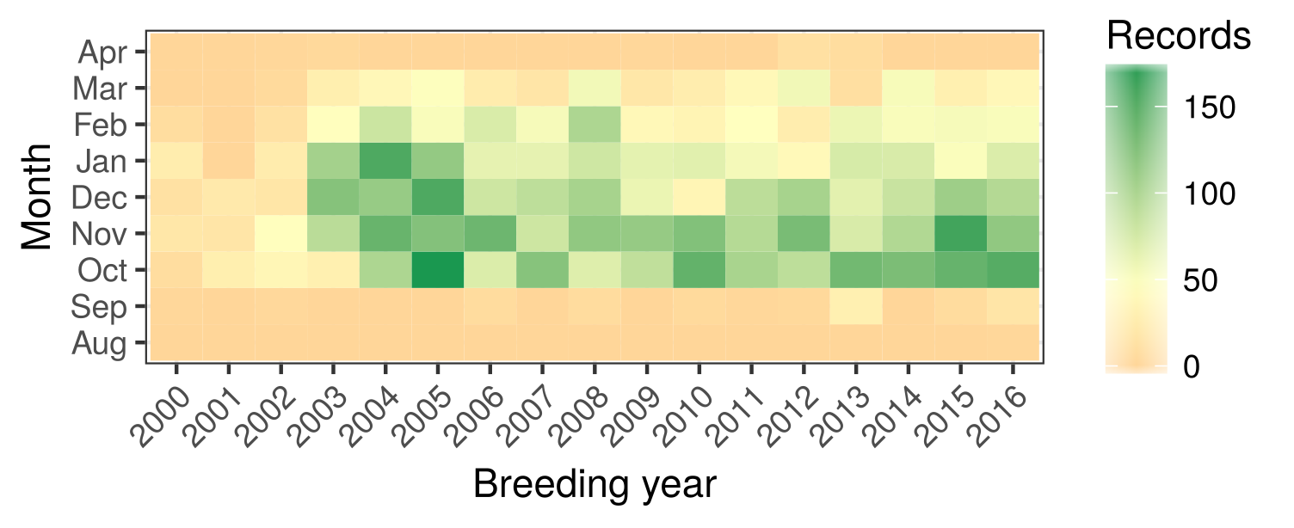Fig.A 1: Heatmap of number of flock counts per month in each calendar year. Data are sparse from the early 2000s. Data density is higher in the first three winter months (Oct, Nov,Dec) than the following ones (Jan, Feb, Mar). A mean of 47 flocks are censused per month (range: 0 - 177).

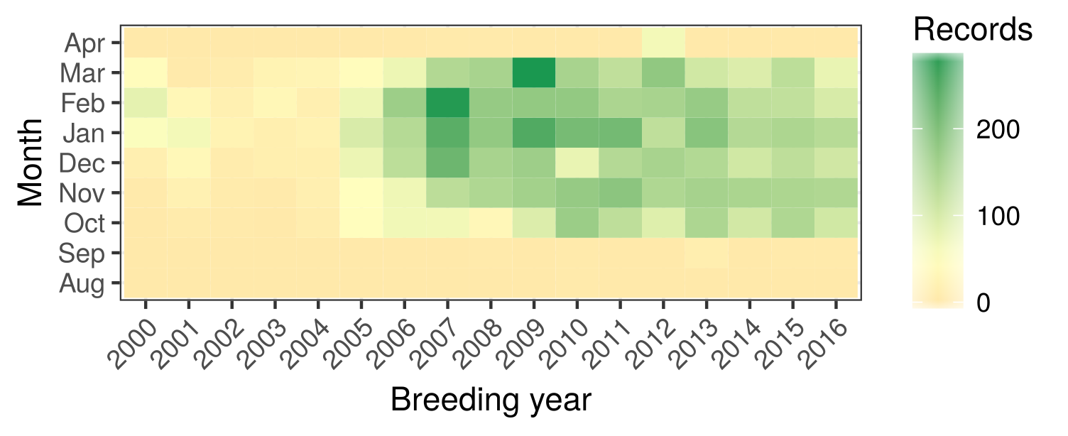Fig.A 2: Heatmap of number of observations of geese marked with numbered neckbands per month in each calendar year. Data are sparse until the mid 2000s. Marked geese are sighted in the study area earlier and later than censused flocks. On average, 49 marked geese are seen each month (range: 0 - 294).

Appendix 2
We provide tables (Tabs. A1, A2) summarising model structures used in the analysis. This table includes Cohen’s f² effect sizes that are based on the variance explained. Cohen’s f² was calculated for each model thus:
where R² is the coefficient of determination (Cohen 1988). We calculated pseudo- for our models as the R² of a linear model taking the model response of a null generalised mixed model as the response, and the generalised mixed model fit as the predictor. These values corresponded closely with pseudo- R² provided by the mgcv package for generalised additive models and were considered reliable as indicators of the variance explained by the model. Cohen’s f² values of 0.02, 0.15, and 0.35 are respectively considered small, medium, and large. Models with a Cohen’s f² greater than 1 have an R² greater than 0.5.
All models assumed idependent and identically distributed normal (iid) random effects. GLMMs implemented these through their inbuilt function. GAMMs (models 2.b and 4) implemented random effects as parametric categorical terms penalized by a ridge penalty (see Wood 2008, 2013).

Tab. A1: Models and inputs based on observation data.
Model | Type | Dataset | Response | Fixed effects | Random effects | Records used | Cohen’s f²
1 | GLMM | B | 6 | 1, 5 | 8, 9, 10 | 20,160ª; 14,018^{b} | 3.22ª; 4.74^{b}
1 | GLMM | C | 6 | 1, 5 | 8, 11 | 3,289ª; 7,320^{b} | 4.87ª; 4.43^{b}
2.a | GLMM | B | 1 | 3, 5, 7 | 8, 9, 10 | 34,179 | 0.09
2.a | GLMM | C | 1 | 5, 7 | 8, 11 | 10,426 | 7.72^{c}; 0.62^{d}
2.b | GAMM | A | 2 | 3, 5, 7 | 8, 9, 10 | 837 | 9.36
2.c | GLM | D, B, C | 1 | Dataset | – | 2,615 | 0.163
3 | GLMM | A | 3 | 5, 6, 7 | 8, 9, 10 | 5,700 | 0.199
4 | GAMM | A | 4 | 5, 6, 7 | 8, 9, 10 | 5,659 | 0.52
Effects: 1: Number of juveniles per family, 2: Number of families, 3: Flock size,
4: Proportion of juveniles, 5: Days since autumn arrival,
6: Distance to breeding grounds, 7: Predation index, 8: Breeding year,
9 Observer, 10: Habitat type, 11: Goose identity
a: ≤ 60 days after arrival, b: ≥ 60 days after arrival, c: All families, d: Only successful families
Tab. A2: Models and inputs based on GPS tracking data.
Model | Type | Response | Fixed effects | Random effects | Records used | Cohen’s f²
5.a | GLMM | 1 | 2, 3, 4, 5, 6, 7 | 9 | 1,009ª | 0.08
5.b | GAMM | 1 | 3, 8 | 9 | 21,271^{b} | 0.0004
Effects: 1: Split occurrence , 2: Family size, 3: Days since autumn arrival,
4: Daily number of flights, 5: Cumulative number of previous flights,
6: Daily distance travelled, 7: Cumulative distance previously travelled,
8: Time since last take-off, 9: Family identity
a: Daily positions, b: Half-hourly position

Appendix 3
Here we provide a figure showing the relation of the number of juveniles seen with families in flocks, and with only successful pairs of marked geese, and with both successful and unsuccessful pairs of marked geese , with the summer predation index calculated from the lemming index.

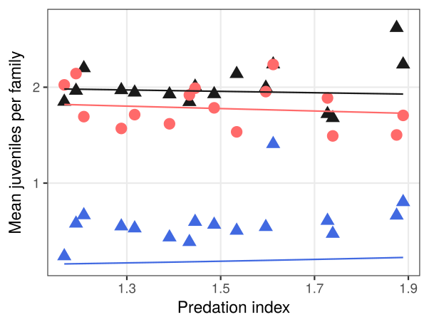Fig.A 3: GLMM fits (lines) and mean number of juveniles per family at each unique level of pooled summer predation index(symbols) using two datasets: blue, all families of markedgeese (dataset C); red, successful families cointed in flocks(dataset B); black, successful families only of marked geese(subset of C).

