Family size dynamics in wintering geese

Pratik R. Gupte^{1,2} – Kees Koffijberg³ – Gerhard J.D.M. Müskens⁴ – Martin Wikelski^{1,5} – Andrea Kölzsch^{1,5}

1 Deptartment of Migration and Immuno-Ecology, Max Planck Institute for Ornithology, Am Obstberg 1, 78315 Radolfzell, Germany.
2 Kiel School of Sustainability, c/o Dept. of Geography, Christian-Albrechts-Universität zu Kiel, Hermann-Rodewald-Str. 9, 24118 Kiel, Germany.
3 Sovon Vogelonderzoek, Natuurplaza, Toernooiveld 1, Nijmegen, The Netherlands
4 Alterra Wageningen-UR Team Molecular Ecology, Ecotoxicology and Wildlife Management, Wageningen, The Netherlands
5 Department of Biology, University of Konstanz, Konstanz, Germany

Juveniles of almost all animal species receive parental care by one or both parents during the first part of their life. In many large migrants such families often stay together throughout the first autumn migration, the first winter or even longer up to several years. How the social status of families, pairs and single animals influences their migration timing and space use is not yet well understood. Here we focus on family size dynamics of greater white-fronted geese Anser a. albifrons in their wintering grounds, We gathered 17 years of observation data on foraging flocks of wintering geese in the Netherlands and northern Germany, and tracked 13 complete families with GPS transmitters. Taking into account effects carried over from the summer, we explored how the distance of the wintering site from the breeding grounds, number of juveniles in a family, number of individuals in a flock and the age-ratio of flocks develop over time. We related the probability of a family splitting to the number of times and the distance that it flew. After 60 days of first autumn arrivals, families with more juveniles wintered farther west, where flocks were smaller. The number of juveniles in a family, flock size, age-ratio and the number of families in flocks were correlated with the number of days since first arrival. Families that undertook more flights in winter were more likely to split. Our data suggest that many juvenile white-fronted geese separate from their parents during the winter, and that this species is differentially migratory by age and social class in both autumn and spring. These findings are important for further considerations of the influence of climate and habitat change on large migrants that subsist in families long after hatching and their conservation and management.

Introduction
In all animal species young receive direct or indirect parental care , which improves their own survival and provides inclusive fitness gains to their relatives (Hamilton 1964). Mostly such care is provided by the parents in the forms of food, shelter and protection (REF). How long this is provided varies strongly between and within species (REF). Large migrants often stay in family groups throughout the first or more migration events (see Warren et al. 1993, Kruckenberg 2005), which has direct survival and fitness benefits not only for the young but also for the parents in terms of shared vigilance and higher social status within larger groups (Black and Owen 1989, Roberts 1996). Thus, animal groups composed of one or more families are common across taxa, from eusocial insects (Crozier and Pamilo 1996) to large herbivores (Archie et al. 2006) and cooperative carnivores (Van Horn et al. 2004).

Many large waterbirds, such as geese Anserini, live in groups composed of families throughtout or during parts of the year. This is most apparent in winter, when goose families gather to form foraging flocks (Elder and Elder 1949). Maintaining family bonds within flocks confers benefits since larger social units are dominant over smaller ones, and dominance rank increases with the number of members in the unit (e.g. in Canada geese Branta Canadensis; Hanson 1953, and barnacle geese B. leucopsis; Loonen et al. 1999), which allows larger families to occupy optimal foraging positions in flocks at less cost and win access to better resources (Black et al. 1992; Black and Owen 1989). In addition, parents of some species benefit in summer from the presence of nest-attending sub-adults (Fox and Stroud 1988). Barnacle geese that are associated with their young through a winter and thence into the following spring and summer, for example, are more likely to return with a brood the following winter (Black and Owen 1989).
From the summer breeding season, through autumn migration, on the wintering grounds and often up to and beyond the return spring migration, goose family bonds are affected by a number of factors. A combination of weather conditions and levels of summer predation on the breeding grounds plays an important role in the success of a pair hatching and fledging young (Dhondt 1987, Summers and Underhill 1987, Bêty et al. 2004). The effect of summer predation linked to the abundance, or lack thereof, of lemmings and voles Arvicolinae has historically been significant in some species to be detectable at the population level in winter (Summers and Underhill 1987, Jongejans et al. 2015). Autumn migration takes a further toll in long-distance migrants, especially on yearling birds (Owen and Black 1989, Francis et al. 1992). In spring, juvenile geese often become independent of parents (Prevett and MacInnes 1980, Johnson and Raveling 1988, Black and Owen 1989). However, some juveniles may remain associated with parents through the spring migration and on the breeding grounds, where they help fend off predators and competitors (Ely 1979).
The development of family bonds in winter appears to be variable between species and populations (REF). Some species, such as Ross’ geese A. rossii, show weak family bonds in winter, perhaps because these confer no dominance benefit against snow geese with which they form mixed flocks (Jónsson and Afton 2008). Similarly, cackling geese B. hutchinsii grazing in large, dense flocks show weak pair and family associations in winter which strengthen as they move to areas with fewer geese (Johnson and Raveling 1988). In contrast, giant Canada geese B. canadensis maxima and Greenland white-fronted geese A. albifrons flavirostris show family bonds that can often extend until the next breeding season (Warren et al. 1993). In general, it seems that smaller species that are observed in mixed flocks tend to dissolve families in winter (Johnson and Raveling 1988), while larger species tend to maintain them longer (Warren et al. 1993, Kruckenberg 2005).
It has been suggested that space-use and movement decisions families make on the wintering grounds can be influenced by the presence of accompanying juveniles. So, for example, dark-bellied brent geese Branta b. bernicla might migrate more slowly in autumn, when they are accompanied by slower juveniles, than in spring, when juveniles have matured sufficiently to keep pace(Green and Alerstam 2000). Like other birds, geese can be differentially migratory with different population classes occupying different wintering areas (Cristol et al. 1999). This has been found in snow geese, the white and blue morphs of which show longitudinal separation during migration (Cooke et al. 1975). Further, more juveniles of Pacific black brent geese B. b. nigricans winter closer to the breeding grounds (Schamber et al. 2007). Previous studies have noted a change in goose distribution in winter in response to severe cold (Philippona 1966, Lok et al. 1992 ). This serves as a convenient starting point for an examination of climatic factors affecting spatial patterns in goose flocks and families, especially in light of drastic changes observed in the spatial and migration ecology of similar species sharing the wintering site (van der Jeugd et al. 2009).
Though the maintenance of family bonds in geese is beneficial until the young are able to reproduce themselves, earlier separation of juveniles from parents is the norm. The mechanistic causes underlying family separation might be of accidental nature or deliberate by the young or parents. In wintering snow geese, family separation is held to be caused by a lack of coordination between members during chaotic take-offs in large flocks, and is thus seen as accidental (Prevett and MacInnes 1980). Juveniles may also be chased off by their parents in some species prior to spring migration (Black and Owen 1989, Poisbleau et al. 2008). Separated geese have been noted to make a considerable effort to rejoin their families, and these behaviours, which are usually to return to sites where the family was last seen, and to visually and vocally search nearby flocks , are observed across taxa: in Canada geese (Elder and Elder 1949), and snow geese (Prevett and MacInnes 1980). Investigating the role of flight events in family size dynamics requires accurate, fine-scale knowledge of individual positions, and obtaining such data for whole families of highly mobile species has historically presented challenges.
Greater white-fronted geese Anser a. albifrons, hereafter white-fronted geese, are among the most abundant geese wintering in continental Western Europe (Madsen et al. 1999), and offer an interesting opportunity to investigate the wintertime dynamics of goose families. Accounts suggest that in the Baltic-North Sea flyway population of white-fronted geese, larger families winter farther west than smaller ones. Further, these families are observed in smaller flocks, but this may be an artefact of flocks observed farther west being smaller. Family bonds reportedly weaken within winters, contrary to the trend for families of large taxa to stay together through the winter, and sometimes beyond (Warren et al. 1993, Kruckenberg 2005). We draw on long-term field observations and high frequency GPS tracks of whole families of white-fronted geese from their wintering grounds in the Netherlands and northern Germany (Mooij 1991, Madsen et al. 1999, Fox et al. 2010) to test the hypotheses that: 1. Larger families winter to the west, farther from the breeding grounds 2. Larger families winter in smaller flocks, 3. Families decrease in size over the winter and 4. Family separation is triggered by flight related disturbances.

Methods

Observation data
We censused flocks of wintering white-fronted geese on their wintering grounds in western Europe by direct counts using field scopes. Observers counted the total number of birds (flock size) and identified first winter juveniles (juveniles) among them from plumage characteristics (dataset A). Families were identified by characteristic behaviours, and were defined as pairs with at least one associated juvenile (successful families). The number of juveniles associated with a pair, and the number of families of each size were recorded in a subset of censused flocks (dataset B). Censuses occurred at both fixed points and ad hoc sites. Observers further reported sightings of individual geese marked with numbered plastic neckbands, including their position and social class (determined by the presence of a partner and juveniles, if any) online (geese.org, dataset C). These data included records of single geese (no partner or juveniles) and pairs without accompanying juveniles (unsuccessful families). To estimate the effect of migration mortality, we censused geese on the breeding grounds on Kolguyev Island (ca. 69°N, 49°E) in August 2016, approximately 1 month prior to the autumn migration, noting the size and social composition of all groups of geese seen (dataset D). Both successful and unsuccessful families were recorded.
Winter data were filtered to exclude records outside the spatial (2 - 10°E, 50 - 54°N) and temporal (autumn 2000 - spring 2017) limits of our study. Records of unpaired neckbanded geese without juveniles were also removed. We obtained 7,149 flock counts from 75 observers at 123 geocoded sites (dataset A). Of these, 1,884 flocks counted by 17 observers at 65 sites held 51,037 successful families (dataset B). A further 10,635 marked individuals, excluding single geese, were observed at 8,416 sites (dataset C). Observations of marked geese did not include details on habitat type, flock size and observer. We obtained 116 records of goose families from Kolguyev Island (dataset D).

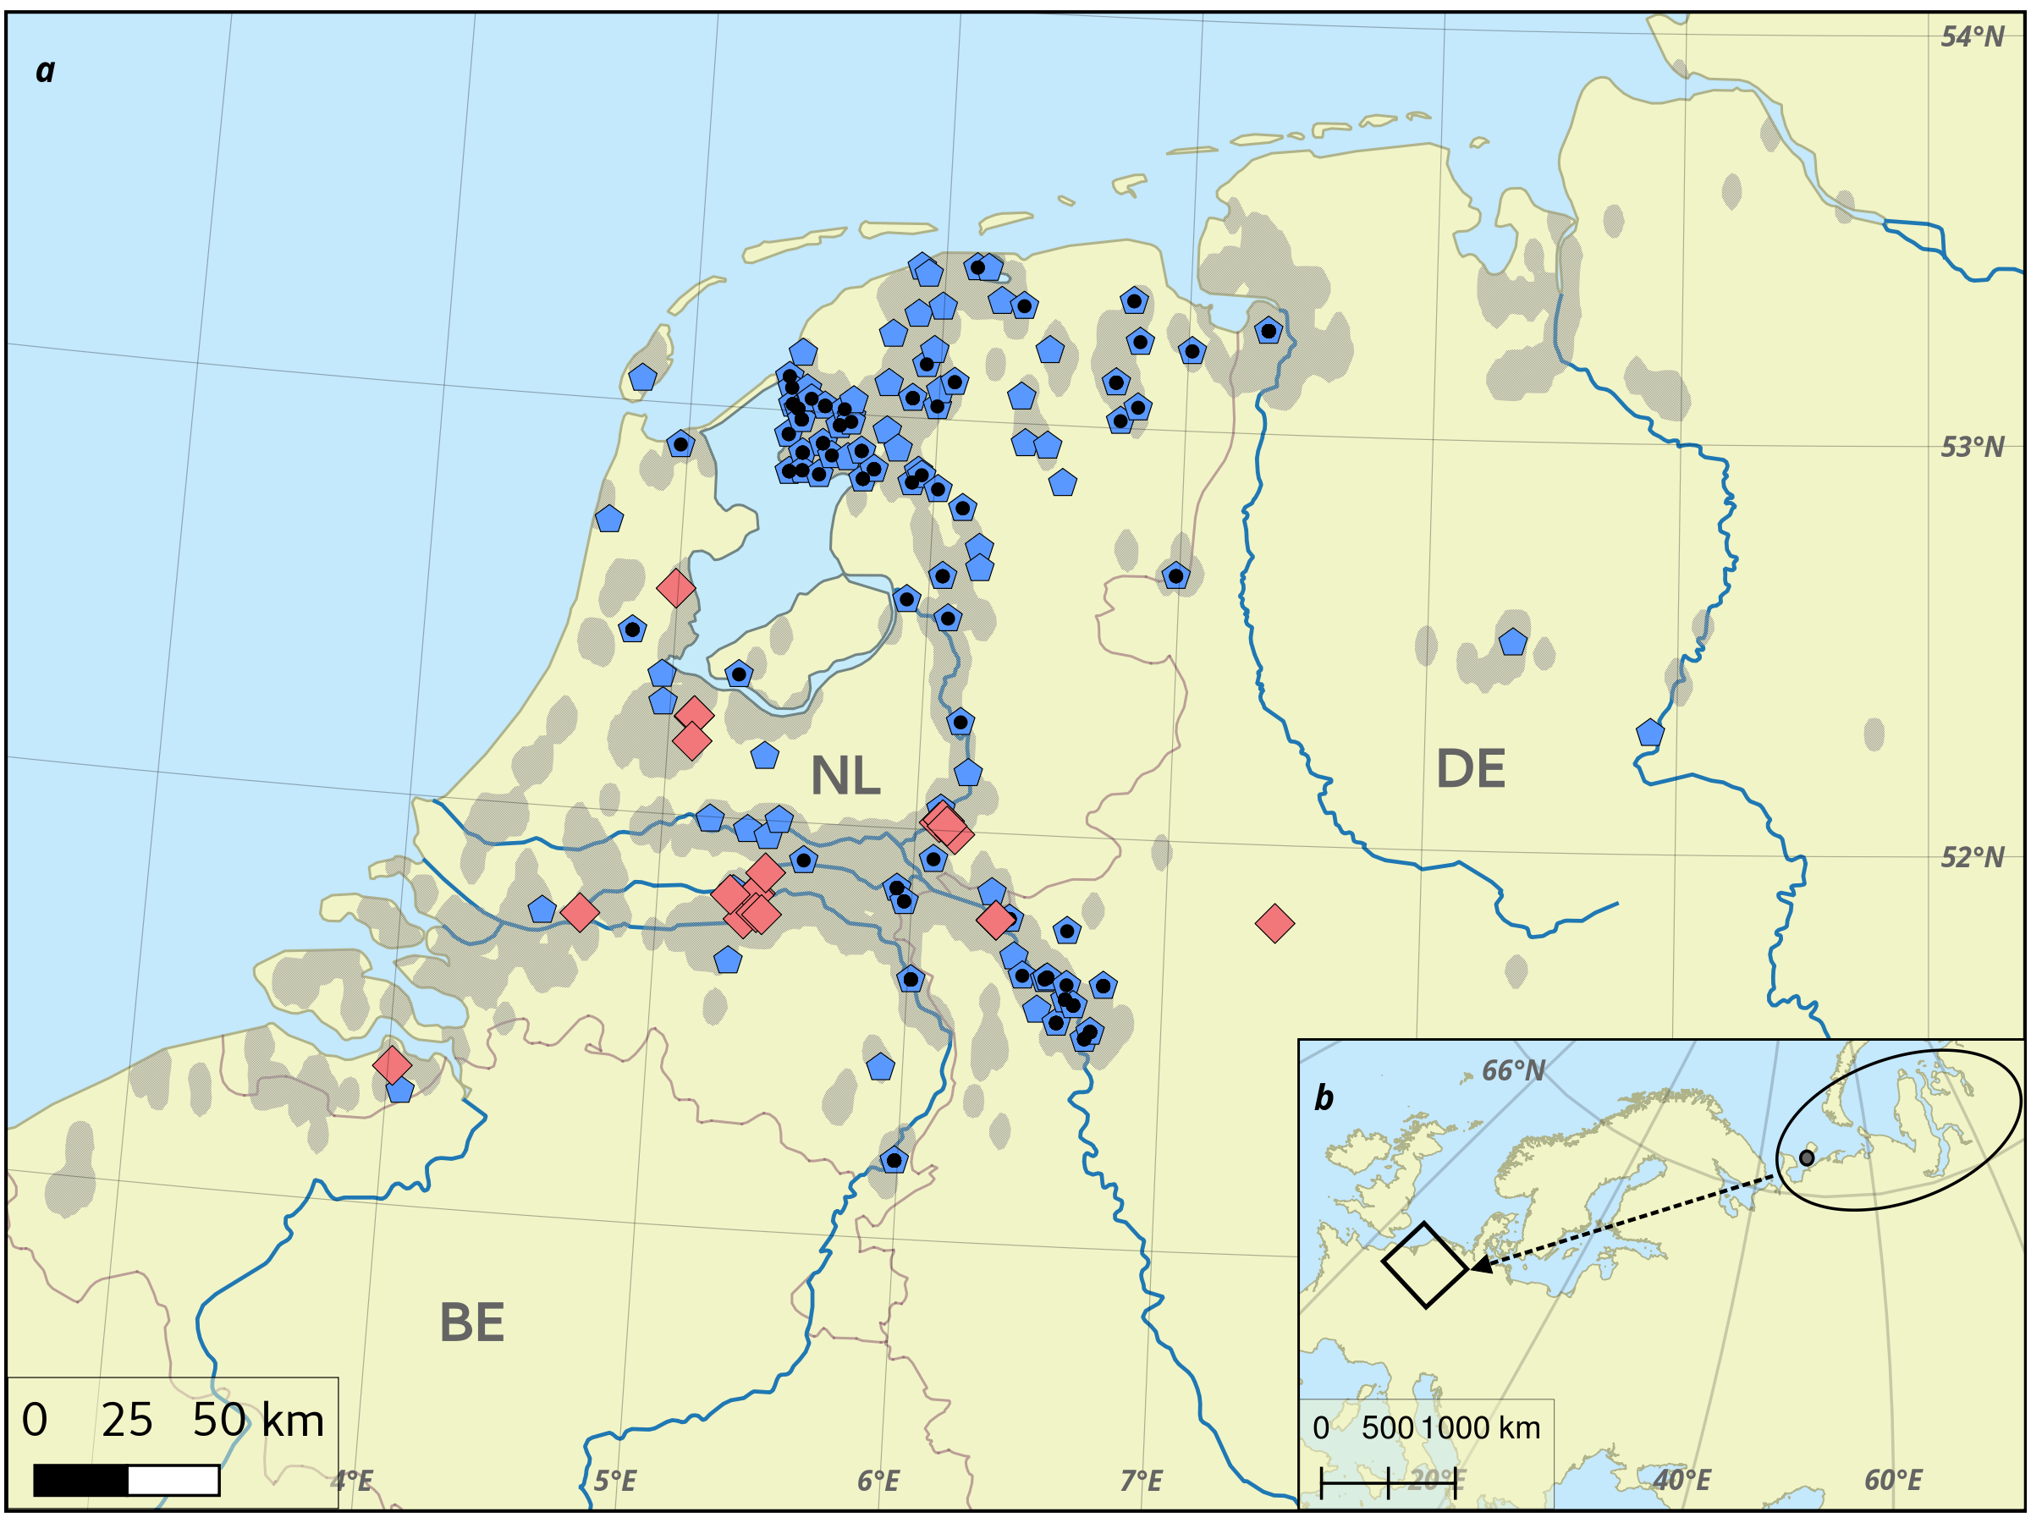Fig. 1: a. Wintering grounds of greater white-fronted geese Anser a. albifrons in the Netherlands and northern Germany. Dataset A: 123 sites (blue pentagons) where the size and age composition of 7,149 flocks were determined, Dataset B: a subset of 65 sites (black dots) where 51,037 successful families were recorded in 1,884 flocks, Dataset C: Shaded area bounds 10,635 observations of marked geese, Dataset E: 21 split events (red diamonds) were observed in 13 GPS tracked families. Observations correspond well with major rivers and waterbodies, marked in blue. Data were collected from 2000 - 2017. b. Breeding grounds in Russia (ellipse) with Kolguyev Island (dot) and general direction of migration (arrow) to wintering area (rectangle).

Family tracking
We also collected half-hourly positions of a total of 13 complete goose families (13 adult pairs, 38 juveniles) fitted with GPS transmitters in the Netherlands between November and January (2013, n = 3, 2014, n = 4: e-obs GmbH, backpacks with Teflon harness, weight 45 g; 2016, n = 6: madebytheo, integrated into neckband, weight 35 g; dataset E). These selectively large families were tracked within the study site (2 - 10°E, 50 - 54°N) during winter (before 1 April) for 34 – 135 days. A reference bird was identified in each family as the parent with the greater number of GPS fixes within the study period, which was the male in all cases except one. For all families, we identified the day and position where splits were first detected as a decrease in the number of birds within a 250m radius of the reference bird (see Fig. 1). We then determined the daily split probability by a binomial fit on the classification of each day as a success or failure (1 or 0) depending on whether a split occurred or not. We defined ‘flights’ as displacements >1 km over the 30 min sampling interval, and counted their number and daily frequency.

Context data
To relate observation data to migration timing we determined the onset of migration influx and end of migration efflux from the study site for each year using daily records (n = 6,266) of flock flight intensity pooled over 84 spring and 180 autumn (overlap = 72) sites in the Netherlands (trektellen.nl; Van Turnhout et al. 2009). We excluded flight activity records from sites close to night roosts and records which did not match the direction of migration appropriate to the season. Thus, our goose winter was defined each year as the time from the first mass arrival of geese in autumn to the last mass departure in spring.
Following previous studies (Jongejans et al. 2015) we estimated an index of summer predation for the breeding grounds of this population from rodent abundance data (arcticbirds.net). We calculated a pooled mean of 0 - 2 (low - high) lemming indices for all available sites in the region, taking care to always include a value of 0 to reflect absence of a lemming cycle in the core breeding area on Kolguyev Island. The index takes into account the cyclical change in lemming abundance, with higher values when lemming abundance had decreased from the previous year reflecting the increased predation pressure on Arctic birds from abundant predators switching to alternative prey (see Dhondt 1987).
To test whether spatial patterns in this population could be explained by environmental effects, we gathered daily data from 51 sites (KNMI Netherlands, DWD Germany) for minimum temperature, total precipitation, and mean windspeed. Sites were 20km (range: 4 - 83km)from the points at which flocks were observed.

Analyses
We first tested whether (1.) the number of juveniles, which determines family size, was correlated with the distance from the breeding grounds at which families were observed. Here, we used datasets B and C. Further, using dataset B, we tested whether (2.a.) the number of juveniles in a family and (2.b.) the total number of successful families was explained by flock size, the number of days since the arrival of geese in autumn or the level of summer predation. We also tested whether (2.c) the number of juveniles in families was different 1 month prior, and up to 2 months after autumn migration in 2016 using datasets B, C and D.
To place these results in context, we examined (3.) the effect on flock size (from dataset A) of distance from the breeding grounds, the number of days since arrival, and summer predation, and examined whether (4.) the proportion of juveniles in flocks (from dataset A) was explained by the flock size, distance from the breeding grounds, number of days since arrival, and summer predation (see Tab. A1).
Further, using dataset E we examined whether (5.a.) the daily split probability was predicted by the number of days since arrival, the number of flights on that day, the cumulative number of flights since the beginning of the tracking period until that day, the distance travelled that day, the cumulative distance travelled since the beginning of tracking until that day, and the family size on that day (see Tab. A2).
All analyses were performed in the R environment (R Core Team 2017) (see Tab. A1). We used Poisson lme4 (Bates et al. 2015) generalised linear mixed models (GLMMs) to test 1, 2.a, and 3, a simple Poisson-error generalised linear model to test 2.c and binomial-error GLMMs for 5.a and 5.b. In 2.b and 4, we used mgcv (Wood 2013) Poisson (2.b) and binomial (4) generalised additive mixed models (GAMMs) to include smooth functions of the flock size (in 2.b) and the number of days since winter (in 4) as predictors. We included the breeding year, the observer identity, the goose identity if known and the habitat type as independent random effects. Effects included in models were dependent on their availability in the datasets used (see Tab. A1). We assessed the importance of each predictor using Type II Wald χ² tests, and model effect sizes using Cohen’s f² (see Appendix 2).

Results

Data filtering
Flock count data from 16 breeding years and subsequent winters yielded a mean 420 flock counts per year (range: 67 (2001) - 672 (2005); dataset A). Spring (April, n = 24) and early autumn (September, n = 76) had the fewest records, with most observations from winter (October - January, 81%, n = 5,785). Observations declined over February (n = 779, 11%) and March (n = 484, 6.8%).
The mean flock size was 712 birds(range: 2 - 20,000), with a mean proportion of first-winter birds of 0.18 (range: 0 - 0.87). Flocks in which families were counted (dataset B) held on average 540 birds (range: 3 - 11,000), with an average of 27 families (range: 1 - 333) accompanied by a mean of 1.78 juveniles (range: 1 - 10).
On average, family status marked geese (dataset C) were observed 626 times each year (range: 62 - 1143), accompanied by 0.59 juveniles (range: 0 - 11) (see Appendix 1, Figs. A1, A2). The 116 observed families on Kolguyev Island in 2016 had a mean of 2.26 juveniles (range: 0 – 6).

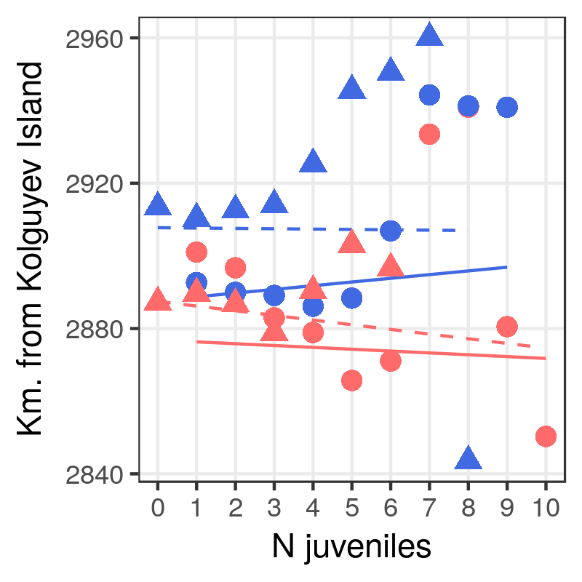
Fig. 2: GLMM fits (lines), and mean distance of wintering sites from Kolguyev Island (symbols) per number of juveniles in a family. Data and fit for records from < 60 days after arrival to the wintering grounds are shown in red; data and fit for records > 60 days after arrival in blue. Triangles & dotted lines represent data from marked geese (dataset C), circles and solid lines are from family counts (dataset B).

Families fitted with GPS transmitters travelled on average 11 km each day (range: 0 - 306). On average, they travelled a distance > 1km twice per day (range: 0 - 10) and in total 98 times (range: 63 - 367) over the tracking period. 21 family split events were recorded in the 13 families and were not restricted to juveniles.
Flock flight intensity reached the 90th percentile for autumns between 26 September and 30 October, and was at the 90th percentile for the last time between 3 March and 1 April. Representing the arrival and departure of geese, respectively, this resulted in a goose winter mean duration of 165 days. Lemming abundance from the breeding grounds transformed into a predation index ranged between 1.17 and 1.9, with very low variance between years (σ² = 0.048).

Juveniles and wintering site choice
We found no influence of the number of juveniles in a family on how far from the breeding grounds a family wintered in the first sixty days after arrival (dataset B: successful families in flocks, and dataset C: families of marked geese, model 1, χ² B = 1.135, p B = 0.286, χ² C = 2.007, p C = 0.157, see Fig. 2). Later in the winter, larger families from dataset B (successful families in flocks) wintered somewhat farther west (χ² = 4.194, p = 0.041), while dataset C (families of marked geese) did not reveal any influence of juvenile number on wintering site (χ² = 0.27, p = 0.6033). Even if selecting only the successful families of dataset C, no effect could be found (χ² = 1.20, p = 0.273). We further used dataset C to test whether the proportion of successful pairs was related to the distance of their wintering site from the breeding grounds, and found no effect (χ² = 1.071, p = 0.301).

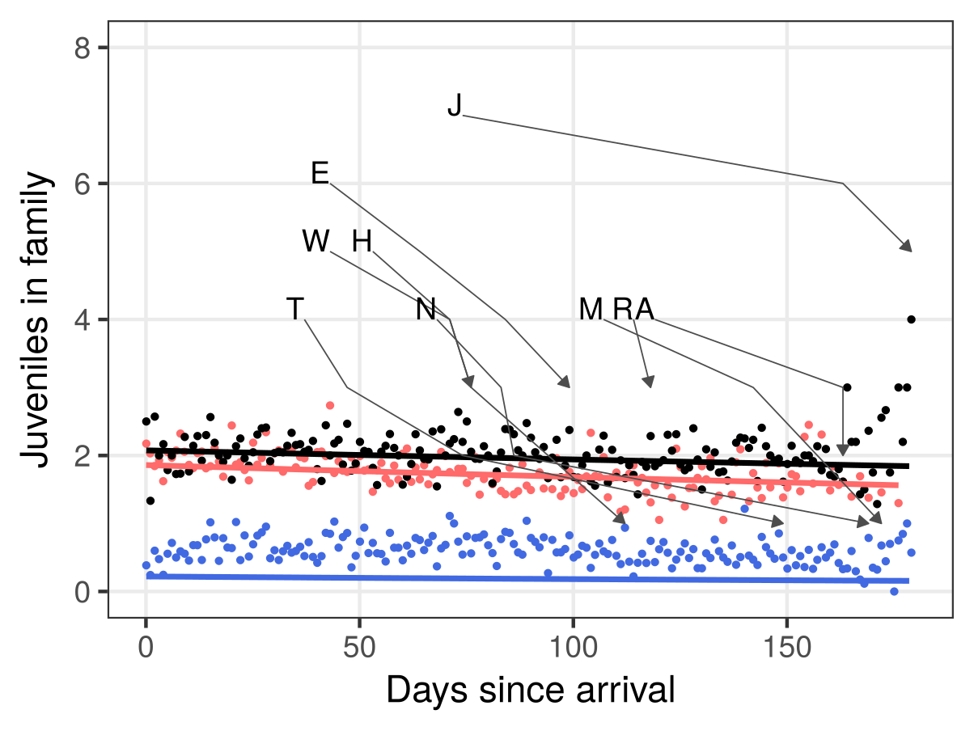
Fig. 3: GLMM fits (lines) and mean number of juveniles per family on each day since goose autumn arrival pooled across years (dots). Successful families in flocks (dataset B) are shown in red (dots and line), families of marked geese including unsuccessful pairs (dataset C) are shown in blue, only successful pairs of marked geese are shown in black. Arrows show development of size of 9 GPS tracked families that underwent split events. GLMM fit for dataset C (blue line) is lowered due to the number of unsuccessful families with no juveniles.

Family size in winter
The number of juveniles in a family (dataset B: successful families in flocks, model 2.a) decreased through the winter (χ² = 74.166, p < 0.001, see Fig. 3), but was insensitive to flock size (χ² = 0.270, p = 0.6033) and summer predation (χ² = 0.337, p = 0.562, see Fig. A3). Family sizes of marked geese (dataset C: families of marked geese, model 2.a adapted) decreased over time, as well (χ² = 19.936, p = < 0.001, see Fig. 3), but showed a surprising increase with the level of summer predation (χ² = 12.935, p < 0.001, see Fig. A3). However, this increase was very low with an effect size of on average 0.78 additional juveniles per family per unit rise in the predation index. When excluding unsuccessful pairs from dataset C, the relation with summer predation became insignificant (χ² = 0.1321, p = 0.716, see Fig. A3), indicating a qualitative rather than quantitative effect of predation on nest success.

The number of successful families in flocks ( model 2.b) increased with flock size (χ² = 7250, p < 0.001) and the number of days since goose arrival in autumn (χ² = 158.3, p < 0.001, see Fig. 4a), but was unaffected by summer predation (χ² = 0, p = 0.98). Further, there were more successful families in flocks farther from the breeding grounds (χ² = 11.253, p = 0.0008, see Fig. 5a). Further, of the climatic variables, daily minimum temperature significantly increased the number of successful families in a flock ( χ² = 7.318, p = 0.007), while precipitation ( χ² = 3.931, p = 0.047) showed a decreasing effect. Wind speed was not an important predictor ( χ² = 2.644, p = 0.104).
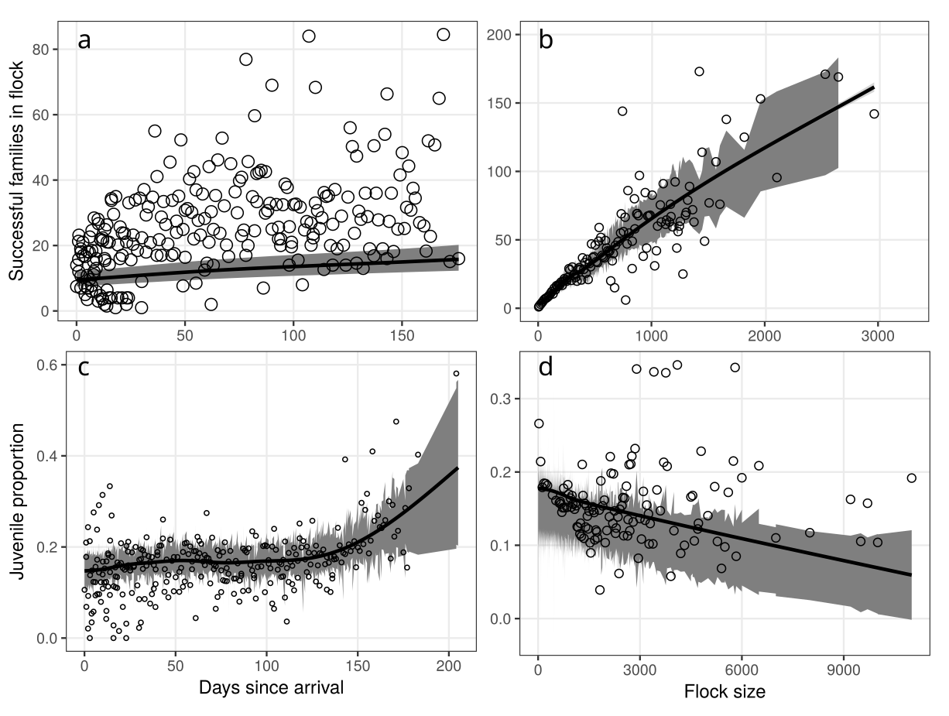
Fig. 4: GAMM partial fits (line) and (a) mean number of successful families in white-fronted goose flocks on each winter day(circles); (b) mean number of families in white-fronted goose flocks in increments of 10 individuals; (c) mean proportion of first-winter juveniles in white-fronted goose flocks on each winter day (circles); (d) mean juvenile proportion of flocks in increments of 25 individuals (circles). Mean numbers and proportions were pooled across all years. 95% confidence interval is shaded grey. Note that in (c) days since arrival was modelled as a smoothed covariate using thin plate splines, and 4 knots.
Further note that in (d) larger flocks have a lower proportion of juveniles, and lower variance in the poroportion.

Family size and autumn migration
Families of geese observed approximately one month pre-migration on Kolguyev Island (dataset D) had significantly more juveniles than successful families (dataset B) in flocks (GLM, z = -4.285, p < 0.001) and families of marked geese (dataset C) (GLM, z = -14.511, p < 0.001) recorded in the first two months following the population’s arrival on the wintering grounds (model 2.c).

Flock size in winter
Flocks (model 3) were significantly smaller farther from the breeding grounds (χ² = 66599, p = < 0.001, see Fig. A5b), and grew slightly over the winter (χ² = 4975, p < 0.001). Flock size was affected by each of the climatic predictors, and increased with falling minimum temperatures (χ² = 385, p < 0.001), but decreased with both precipitation (χ² = 3378, p < 0.001) and wind speed ( χ² = 27,079, p < 0.001). Within flocks, juvenile proportions increased through the winter (χ² = 19.43, p = 0.001, see Fig. A4b), and decreased with increasing flock size (χ² = 5.921, p = 0.015, see Fig. A4c), but did not show any effect of distance from the breeding grounds (χ² = 1.015, p = 0.314), or of summer predation (χ² = 0.021, p = 0.883).

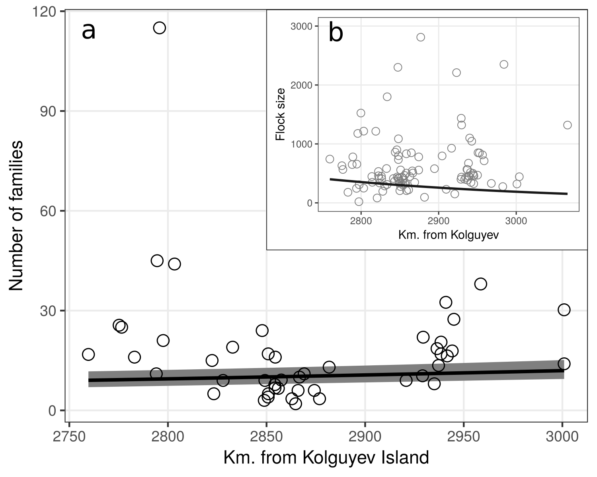
Fig. 5: GAMM fit (line) and mean number of successful families in white-fronted goose flocks at each site (circles, n = 49) as a function of its distance from Kolguyev Island. 95% confidence interval is shaded grey. b. GLMM fit (line) and mean size of flocks at each site (circles, n = 111) as a function of its distance from Kolguyev Island. Sites to the north-east of the study site are approximately 500 km nearer to Kolguyev than sites in the south-west.

Probability of family splits
The daily split probability of families (model 5.,) was significantly lower later in the winter (χ² = 8.314, p = 0.004, Fig 6a), and lower in larger families (χ² = 11.41, p < 0.001, Fig 6c). There was no effect of the daily number of flights (χ² = 0.018, p = 0.893), nor the daily distance moved (χ² = 2.99, p = 0.083). Split probability was higher in families that made cumulatively more flights in the period between the beginning of tracking and the split (χ² = 143.23, p < 0.001, Fig 6d), and increased in families that moved a longer cumulative distance in the period between the start of tracking and the split (χ² = 182.63, p < 0.001, Fig 6b).

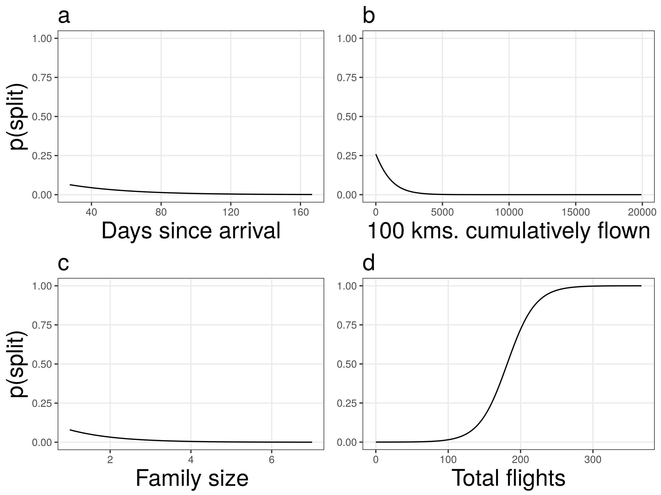Fig. 6: GAMM partial fits (lines) for (a) days since arrival, (b) cumulative number of flights over winter, (c) number of juveniles, and (d) cumulative number of displacements of more than 1000 km.

Discussion
We studied how the size of white-fronted goose families is related to where, when and with how many flock mates they are seen in the wintering grounds. We found only weak support for the effect of the size of successful families on how far they winter from the breeding grounds. Thus, differential migration and use of wintering sites according to social status is not strong in our population of white-fronted geese. We confirmed that family size decreases over the winter, but found that it is insensitive to flock size. Family size seems to relate qualitatively with summer predation, with more families failing to bring any young to the breeding grounds in high predation years. We suggest that individual families are less likely to split later in winter and with increasing family size. We found some evidence that flights are responsible for family splits in winter, them thus likely being accidental.
Arctic geese have become tolerant of human disturbance and have acclimatised to previously deterrent structures such as wind turbines, they can exploit most of the highly productive landscape in Europe (Madsen and Boertmann 2008, Fox and Madsen 2017), calling into question whether optimality with respect to resources varies significantly across the study area. Any habitat selection is thus likely to be against conditions that impede foraging, such as snow and ice cover coupled with strong winds (Philippona 1966). Geese tolerate snow depths of ca. 15cm, conditions in excess of which are not noted in the Netherlands before midwinter (Philippona 1966), and have become rare within the study period. Western areas near the North Sea coast may be expected to benefit from its moderating effect on temperature, with fewer instances of conditions that geese would avoid.
Our findings that the number of successful families in flocks is reduced by lower minimum temperatures and higher precipitation is thus well supported by this framework. An avoidance of wet and windy conditions also explains why our flocks are smaller during high precipitation and especially in strong winds. We suggest that a concentration of geese at accessible grassland on cold days, coupled with the energetic costs of flight in the cold, contribute to the observation of larger flocks when minimum temperature is lower.

In addition, our finding that family size is a determinant of wintering site selection is similar to that of Jongejans et al. (2015). Social class has been found in previous studies to influence geese’s selection of wintering sites, with dominant social units displacing subordinate ones from optimal wintering locations (Vangilder and Smith 1985, Schamber et al. 2007). White-fronted goose families likely leverage their dominance on wintering grounds to occupy climatically milder sites as winter progresses. The time dependency of this effect in our population, which is seen only towards mid-winter is likely because conditions sufficiently harsh to spur site selection do not occur until this time. A lower sample size coupled with fewer random effects (observer and habitat type) might underlie the absence of this effect in our dataset of marked goose families.

Since energy reserves and water balance especially determine how far and how fast a bird can fly, metabolic constraints on flight activity determine where it must stop over, and thus by extension, where it terminates migration (Klaassen 1996). Our finding that flocks are smaller to the west of the wintering area (approx. 3 - 4°E) fit well in this context, and it is to be expected that fewer geese would choose to winter farther west when climatically suitable and similarly agricultural sites can be found to the east. Our results that larger flocks had a lower proportion of first-year birds must be considered in the context of the previous outcome that flocks are smaller in the west, where they have more successful families. This likely results in a higher juvenile proportion from small flocks, producing the trend we see. Consequently, one would expect a higher proportion of juveniles in westerly regions, as reported previously at the country scale (Jongejans et al. 2015), but we did not find that flock juvenile proportion varies over the study site. Since goose families selecting for optimal sites are suggested to drive variation in juvenile proportion between wintering areas, it is likely that the lack of variation in family size over the study site is partially responsible for the absence of a pattern in juvenile proportion (eg. Schamber et al. 2007). Further, independent juveniles observed in wintering flocks (eg. Hanson 1953, Loonen et al. 1999) may dampen any variation.
Juvenile independence has been reported across goose taxa (eg. Prevett and MacInnes 1980, Johnson and Raveling 1988, Black and Owen 1989) as being concurrent with the arrival of spring. Previous studies have shown that spring copulation in the breeding pair triggers juvenile departure (Prevett and MacInnes 1980). We find support for the hypothesis that the number of juveniles with adults decreases through the winter. We suggest that white-fronted goose families undergo a steady reduction in the number of associated juveniles, and our findings show that young split off earlier than previously thought in a species in which families are reported to remain together through the winter, and sometimes longer than a year (Ely 1979, Warren et al. 1993, Kruckenberg 2005). The dissociation of juveniles from parents should result in some pairs losing all remaining juveniles associated with them, thus reducing the number of successful families counted in flocks over the winter. Our finding that the number of families seen in flocks increases as winter progresses contradicts this expectation. An explanation could be that social class predicts variation in spring migration timing, with families leaving later than pairs without juveniles. This is already known from the autumn migration, with families arriving later than non-breeding birds (Jongejans et al. 2015). However, previous studies have not found such an effect in grey geese in spring (Madsen 2001, Bêty et al. 2004).
Summer predation, in turn driven by the cyclical abundance of Arctic rodents, is another mechanism by which the populations of Arctic-breeding birds, including geese, are suggested to be regulated prior to migration (see Summers and Underhill 1987). Recent studies however indicate that since the 2000s, the breeding success of Baltic-North Sea flyway white-fronted geese no longer seems to be correlated with summer predation (Jongejans et al. 2015). This is in line with our findings that the number of juveniles in successful families is not affected by summer predation intensity. It has been suggested that more Baltic-North Sea white-fronted geese now breed on Kolguyev Island where they experience a constant level of predation, since the island lacks lemmings and associated phenomena (Kruckenberg et al. 2008). A large Arctic breeding range (45°E - 85°E, ca. 1,800km, Baltic-North Sea population) furthermore means that variation in predation pressure is lost due to year-wise averaging across sites. Lemming cycles in northern Russia appear to be faltering, which could also explain why cyclicity in goose breeding success has been reduced (Nolet et al. 2013). The increase in the number of juveniles seen with marked geese during years of increased predation suggests that facing high predation pressure, geese either fledge large families or suffer total brood failure.
Migration mortality of juveniles might be a significant factor in the decoupling of family size and summer predation. It has earlier been shown to be significant in long distance migrants that make few stopovers. Previous work has found that nearly a third of juvenile barnacle geese migrating from Svalbard to wintering grounds in Scotland will fail to complete the trip (Owen and Black 1989). Competition for resources that results from an increased abundance of geese at summer sites is believed to be an important factor. In overexploited tundra habitats, fledging geese are suggested to be unable to accumulate the reserves necessary for successful migration over the open ocean. Similar effects are suggested in lesser snow geese (Francis et al. 1992). Our result that the number of juveniles seen in families prior to migration is higher than in the first two months on the wintering grounds is in line with this prior work. As Arctic geese reach super-abundance, reduced juvenile recruitment due to density dependent effects might help stabilise populations (Francis et al. 1992).
The result that flock juvenile proportion rises non-linearly over the winter is in line with the previous finding that the number of successful families in flocks increases with time. However, this trend is probably due in larger part to white-fronted geese being differentially migratory with respect to age and social class, with geese without young (a) leaving the breeding grounds and arriving at the wintering sites earlier than families and juveniles and (b) adult pairs without young and opting to breed the coming season leaving the wintering grounds earlier. Such an effect of age and state on the latter spring departure timing has been unsuccessfully tested before in similar species (pink-footed geese Madsen 2001, snow geese, Bêty et al. 2004). However, in snow geese the continued influx of juveniles to the breeding grounds for some weeks after the arrival of the breeding population does suggest that independent yearling geese follow a different migration schedule from adults (Prevett and MacInnes 1980). Since our population of white-fronted geese likely does not receive a significant influx of juveniles towards the end of winter, we must conclude from the strong increase of juvenile percentage that both juveniles and families leave later than pairs or single birds in spring, and we present this as a novel result.
Finally, our exploration of the mechanistic causes underlying family separation is among the first to synthesise tracking data from individuals to infer group level dynamics. Our findings that the daily probability of families losing individuals increased with cumulative flight time and distance travelled during winter are in accordance with the idea that flights are disruptive events that contribute to accidental family separation (Prevett and MacInnes 1980). As we have found, one would expect that in such scenarios larger families are easier to locate and cohere to. However, the results that split probability is reduced later in winter contradicts the present consensus that geese are more likely to become independent towards spring (Prevett and MacInnes 1980, Johnson and Raveling 1988, Black and Owen 1989, Scheiber et al. 2013) as well as our earlier finding that family sizes of observation data reduced with time. Alikely explanation is that the 13 tracked families were selected to be large; such families might behave differently from the more abundant small families, especially given the benefits in social status accrued.
Our results add significantly to the extant knowledge of geese in Europe, where their numbers have reached levels requiring management (Fox and Madsen, 2017). While current hunting policy mandates a cessation of hunting in January, goose families and juveniles are already over-represented in autumn bags (Madsen 2010). Targeting new recruits sets up populations for slow recoveries should management or natural events cause a significant decline in numbers. Our findings of spatio-temporal patterns in the distribution and migration of social classes of geese allows for measures that would reduce the adult population while maintaining recruitment at replacement levels. However, as winters become milder with a warming climate, such patterns may weaken as geese colonise previously unsuitable areas. A uniform distribution of goose social classes across western Europe would reduce the level of discrimination possible in the spatial targeting of management measures. As geese colonise temperate areas as breeding grounds (van der Jeugd et al. 2009), we may expect the dynamics described here to be affected, highlighting the continued importance of intensive long-term monitoring both by direct observation and bio-telemetry.
Acknowledgements - We thank the many observers who observed and counted goose flocks and determined social status entered their sightings of marked geese on geese.org: Thanks to Yke van Randen who provided geese.org data, the Dutch Association of Goose Catchers who caught the goose families for tagging and Helmut Kruckenberg and Peter Glazov who majorly contributed to the 2016 Kolguyev expedition which was funded by a National Geographic Society Grant to AK (GEFNE141-15). PRG was financially supported by the European Commission through the program Erasmus Mundus Master Course - International Master in Applied Ecology (EMMC-IMAE) (FPA 532524-1-FR-2012-ERA MUNDUS-EMMC).

References
- Archie, E. A. et al. 2006. The ties that bind: Genetic relatedness predicts the fission and fusion of social groups in wild African elephants. - Proceedings of the Royal Society of London B: Biological Sciences 273: 513–522.
- Bates, D. et al. 2015. Fitting linear mixed-effects models using lme4. - Journal of Statistical Software 67: 1–48.
- Bêty, J. et al. 2004. Individual variation in timing of migration: Causes and reproductive consequences in greater snow geese (Anser caerulescens atlanticus). - Behavioral Ecology and Sociobiology 57: 1–8.
- Black, J. M. and Owen, M. 1989. Parent-offspring relationships in wintering barnacle geese. - Animal Behaviour 37: 187–198.
- Black, J. M. et al. 1992. Foraging dynamics in goose flocks: The cost of living on the edge. - Animal Behaviour 44: 41–50.
- Cooke, F. et al. 1975. Gene flow between breeding populations of Lesser Snow Geese. - The Auk 92: 493–510.
- Cristol, D. A. et al. 1999. Differential migration revisited. - In: Current Ornithology. Springer, ppp. 33–88.
- Crozier, R. H. and Pamilo, P. 1996. Evolution of Social Insect Colonies. - Oxford University Press, Oxford, UK.
- Dhondt, A. A. 1987. Cycles of lemmings and Brent geese Branta b. bernicla: A comment on the hypothesis of Roselaar and Summers. - Bird Study 34: 151–154.
- Elder, W. H. and Elder, N. L. 1949. Role of the family in the formation of goose flocks. - Wilson Bull 61: 133–140.
- Ely, C. R. 1979. Breeding biology of the white-fronted goose (Anser albifrons frontalis) on the Yukon-Kuskokwim delta, Alaska.
- Fox, A. D. and Stroud, D. A. 1988. The breeding biology of the Greenland White-fronted Goose (Anser albifrons flavirostris). - Kommissionen for Videnskabelige Undersøgelser i Grønland.
- Fox, A. D. and Madsen, J. 2017. Threatened species to super-abundance: The unexpected international implications of successful goose conservation. - Ambio 46: 179–187.
- Fox, A. D. et al. 2010. Current estimates of goose population sizes in western Europe, a gap analysis and assessment of trends. - Ornis Svecica 20: 115–127.
- Francis, C. M. et al. 1992. Long-term changes in survival rates of lesser snow geese. - Ecology 73: 1346–1362.
- Green, M. and Alerstam, T. 2000. Flight speeds and climb rates of brent geese: Mass-dependent differences between spring and autumn migration. - Journal of Avian Biology 31: 215–225.
- Hamilton, W. 1964. The genetical evolution of social behaviour. I. - Journal of Theoretical Biology 7: 1–16.
- Hanson, H. C. 1953. Inter-family dominance in Canada geese. - The Auk 70: 11–16.
- Hornman, M. et al. 2015. Watervogels in Nederland in 2014/2015. - SOVON Rapport in press.
- Johnson, J. C. and Raveling, D. G. 1988. Weak family associations in Cackling Geese during winter: Effects of body size and food resources on goose social organization. - Waterfowl in Winter: 71–89.
- Jongejans, E. et al. 2015. Naar een effectief en internationaal verantwoord beheer van de in Nederland overwinterende populatie Kolganzen. - SOVON Vogelonderzoek Nederland.
- Jónsson, J. E. and Afton, A. D. 2008. Lesser Snow geese and Ross’s geese form mixed flocks during winter but differ in family maintenance and social status. - The Wilson Journal of Ornithology 120: 725–731.
- Klaassen, M. 1996. Metabolic constraints on long-distance migration in birds. - Journal of Experimental Biology 199: 57–64.
- Krause, J. and Ruxton, G. D. 2002. Living in Groups. - Oxford University Press.
- Kruckenberg, H. 2005. Wann werden “die Kleinen” endlich erwachsen? Untersuchungen zum Familienzusammenhalt farbmarkierter Blessgänse Anser albifrons albifrons. - Vogelwelt 126: 253.
- Kruckenberg, H. et al. 2008. White-fronted goose flyway population status. - Angew. Feldbiol 2: 77.
- Loonen, M. J. J. E. et al. 1999. The benefit of large broods in barnacle geese: A study using natural and experimental manipulations. - Journal of Animal Ecology 68: 753–768.
- Madsen, J. 2001. Spring migration strategies in Pink-footed Geese Anser brachyrhynchus and consequences for spring fattering and fecundity. - Ardea 89: 43–55.
- Madsen, J. 2010. Age bias in the bag of pink-footed geese anser brachyrhynchus: Influence of flocking behaviour on vulnerability. - European Journal of Wildlife Research 56: 577–582.
- Madsen, J. and Boertmann, D. 2008. Animal behavioral adaptation to changing landscapes: Spring-staging geese habituate to wind farms. - Landscape ecology 23: 1007–1011.
- Madsen, J. et al. 1999. Goose populations of the Western Palearctic. - National Environmental Research Institute, Denmark; Wetlands International, Wageningen, The Netherlands.
- Mooij, J. H. 1991. Numbers and distribution of grey geese (genus Anser) in the Federal Republic of Germany, with special reference to the Lower Rhine region. - Ardea 79: 125–134.
- Nolet, B. A. et al. 2013. Faltering lemming cycles reduce productivity and population size of a migratory Arctic goose species. - Journal of Animal Ecology 82: 804–813.
- Owen, M. and Black, J. M. 1989. Factors affecting the survival of barnacle geese on migration from the breeding grounds. - Journal of Animal Ecology 58: 603–617.
- Philippona, J. 1966. Geese in cold winter weather. - Wildfowl 17: 3.
- Poisbleau, M. et al. 2008. Dominance relationships in dark-bellied brent geese Branta bernicla bernicla at spring staging areas. - Ardea 96: 135–139.
- Prevett, J. P. and MacInnes, C. D. 1980. Family and Other Social Groups in Snow Geese. - Wildlife Monographs: 3–46.
- R Core Team 2017. R: A language and environment for statistical computing. - R Foundation for Statistical Computing.
- Roberts, G. 1996. Why individual vigilance declines as group size increases. - Animal behaviour 51: 1077–1086.
- Rodman, P. S. 1981. Inclusive fitness and group size with a reconsideration of group sizes in lions and wolves. - The American Naturalist 118: 275–283.
- Schamber, J. L. et al. 2007. Latitudinal variation in population structure of wintering Pacific Black Brant. - Journal of Field Ornithology 78: 74–82.
- Scheiber, I. B. et al. 2013. The Social Life of Greylag Geese. - Cambridge University Press.
- Sedinger, J. S. et al. 1995. Environmental influence on life-history traits: Growth, survival, and fecundity in black brant (Branta bernicla). - Ecology 76: 2404–2414.
- Summers, R. and Underhill, L. 1987. Factors related to breeding production of Brent geese Branta b. bernicla and waders (Charadrii) on the Taimyr Peninsula. - Bird Study 34: 161–171.
- van der Jeugd, H. P. et al. 2009. Keeping up with early springs: Rapid range expansion in an avian herbivore incurs a mismatch between reproductive timing and food supply. - Global Change Biology 15: 1057–1071.
- Van Horn, R. C. et al. 2004. Behavioural structuring of relatedness in the spotted hyena (Crocuta crocuta) suggests direct fitness benefits of clan-level cooperation. - Molecular Ecology 13: 449–458.
- Van Turnhout, C. et al. 2009. Veranderingen in timing van zichtbare najaarstrek over Nederland: Een pleidooi voor hernieuwde standaardisatie van trektellingen. - Limosa 82: 68.
- Vangilder, L. D. and Smith, L. M. 1985. Differential distribution of wintering brant by necklace type. - The Auk 102: 645–647.
- Warren, S. M. et al. 1993. Extended parent-offspring relationships in Greenland White-fronted geese (Anser albifrons flavirostris). - The Auk 110: 145–148.
- Wood, S. N. 2013. Generalized additive models: An introduction with R. - Chapman; Hall/CRC.

Appendix 1
Here we provide representations of the distribution of filtered observation data over yearly and monthly scales. Arctic geese are expected to begin arriving at the eastern end of the study site by late September, and are present on Dutch and northern German sites by early - mid October. The heatmaps shown reflect this pattern.

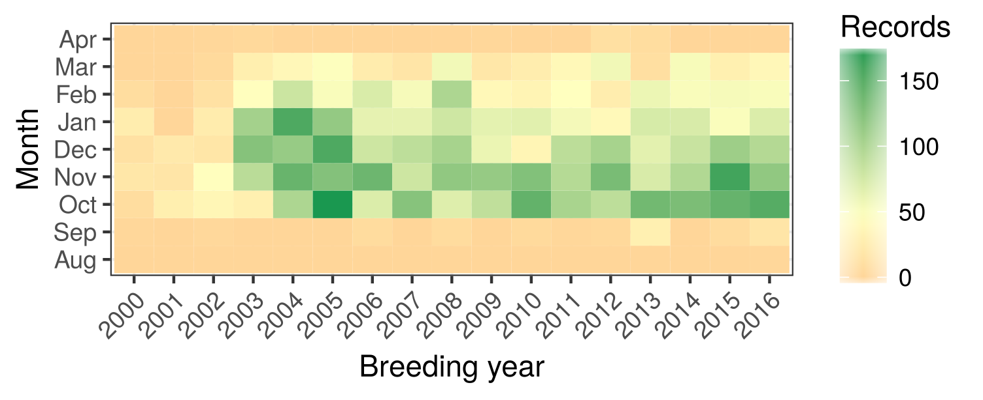Fig.A 1: Heatmap of number of flock counts per month in each calendar year. Data are sparse from the early 2000s. Data density is higher in the first three winter months (Oct, Nov,Dec) than the following ones (Jan, Feb, Mar). A mean of 47 flocks are censused per month (range: 0 - 177).

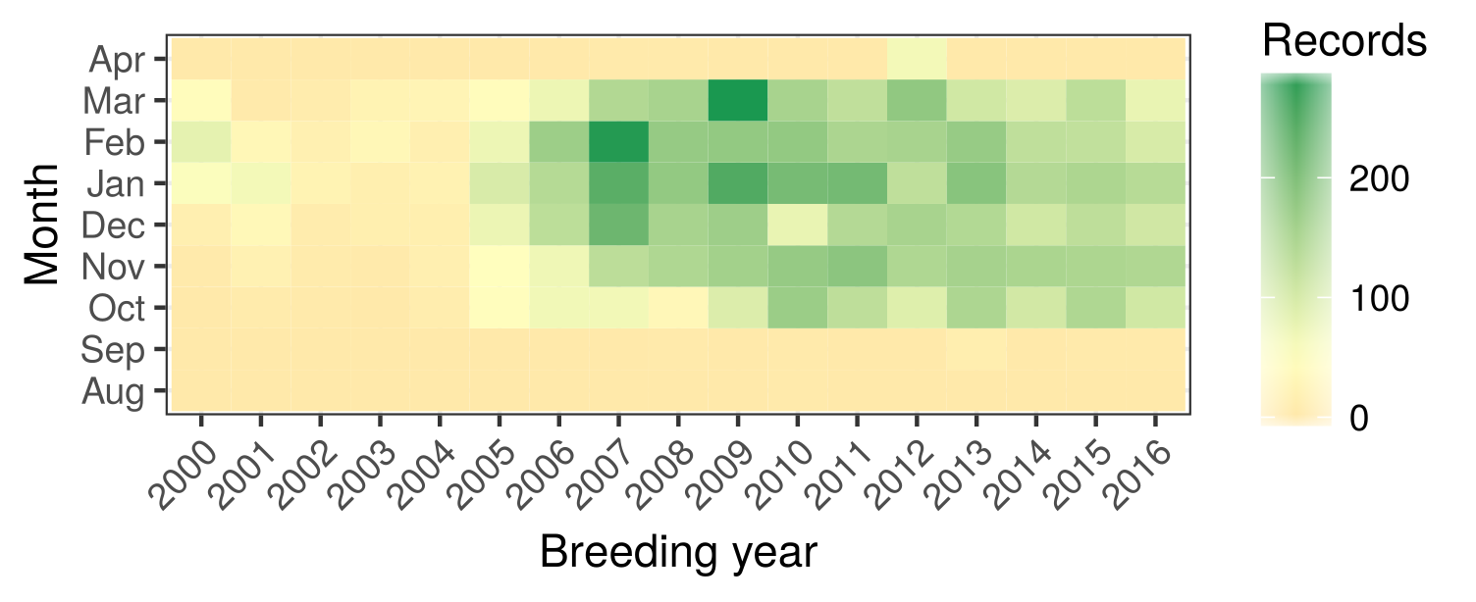Fig.A 2: Heatmap of number of observations of geese marked with numbered neckbands per month in each calendar year. Data are sparse until the mid 2000s. Marked geese are sighted in the study area earlier and later than censused flocks. On average, 49 marked geese are seen each month (range: 0 - 294).

Appendix 2
We provide tables (Tabs. A1, A2) summarising model structures used in the analysis. This table includes Cohen’s f² effect sizes that are based on the variance explained. Cohen’s f² was calculated for each model thus:
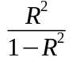
where R² is the coefficient of determination. We calculated pseud-R²- for our models as the R² of a linear model taking the model response of a null generalised mixed model as the response, and the generalised mixed model fit as the predictor. These values corresponded closely with pseudo- R² provided by the mgcv package for generalised additive models and were considered reliable as indicators of the variance explained by the model. Cohen’s f² values of 0.02, 0.15, and 0.35 are respectively considered small, medium, and large. Models with a Cohen’s f² greater than 1 have an R² greater than 0.5.
All models assumed idependent and identically distributed normal (iid) random effects. GLMMs implemented these through their inbuilt function. GAMMs (models 2.b and 4) implemented random effects as parametric categorical terms penalized by a ridge penalty (see Wood 2013).

Tab. A1: Models and inputs based on observation data.
Model | Type | Dataset | Response | Fixed effects | Random effects | Records used | Cohen’s f²
1 | GLMM | B | 6 | 1, 5 | 8, 9, 10 | 20,160ª; 14,018^{b} | 3.22ª; 4.74^{b}
1 | GLMM | C | 6 | 1, 5 | 8, 11 | 3,289ª; 7,320^{b} | 4.87ª; 4.43^{b}
2.a | GLMM | B | 1 | 3, 5, 7 | 8, 9, 10 | 34,179 | 0.09
2.a | GLMM | C | 1 | 5, 7 | 8, 11 | 10,426 | 7.72^{c}; 0.62^{d}
2.b | GAMM | A | 2 | 3, 5, 7 | 8, 9, 10 | 837 | 9.36
2.c | GLM | D, B, C | 1 | Dataset | – | 2,615 | 0.163
3 | GLMM | A | 3 | 5, 6, 7 | 8, 9, 10 | 5,700 | 0.199
4 | GAMM | A | 4 | 5, 6, 7 | 8, 9, 10 | 5,659 | 0.52
5 | GLMM | E | 12 | 13 - 19 | 20 | 1,009 | 0.08
Effects: 1: Number of juveniles per family, 2: Number of families, 3: Flock size,
4: Proportion of juveniles, 5: Days since autumn arrival,
6: Distance to breeding grounds, 7: Predation index, 8: Breeding year,
9 Observer, 10: Habitat type, 11: Goose identity, 12: Split occurrence ,
13: Family size, 14: Days since autumn arrival, 15: Daily number of flights,
16: Cumulative number of previous flights, 17: Daily distance travelled,
18: Cumulative distance previously travelled, 19: Time since last take-off,
20: Family identity

a: ≤ 60 days after arrival, b: ≥ 60 days after arrival, c: All families, d: Only successful families
Tab. A2: Models and inputs based on GPS tracking data.
Model | Type | Response | Fixed effects | Random effects | Records used | Cohen’s f²
5.a | GLMM | 1 | 2, 3, 4, 5, 6, 7 | 9 | 1,009ª | 0.08
5.b | GAMM | 1 | 3, 8 | 9 | 21,271^{b} | 0.0004
Effects: 1: Split occurrence , 2: Family size, 3: Days since autumn arrival,
4: Daily number of flights, 5: Cumulative number of previous flights,
6: Daily distance travelled, 7: Cumulative distance previously travelled,
8: Time since last take-off, 9: Family identity
a: Daily positions, b: Half-hourly position

Appendix 3
Here we provide a figure showing the relation of the number of juveniles seen with families in flocks, and with only successful pairs of marked geese, and with both successful and unsuccessful pairs of marked geese , with the summer predation index calculated from the lemming index.

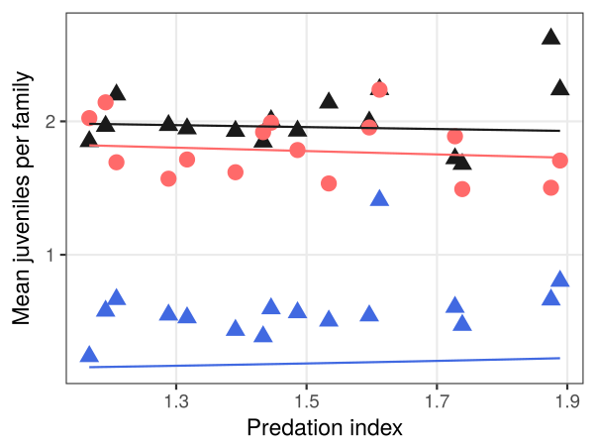Fig.A 3: GLMM fits (lines) and mean number of juveniles per family at each unique level of pooled summer predation index(symbols) using two datasets: blue, all families of markedgeese (dataset C); red, successful families cointed in flocks(dataset B); black, successful families only of marked geese(subset of C).

