Towards an individual based model of wader movement
Pratik R Gupte

Abstract
The movement ecology of waders Charadrii is of increasing importance due to their vulnerability to threats on both breeding and wintering grounds. While coarse, large scale studies have much to offer, the rise of advanced animal tracking allows the investigation of questions at finer scales. Empirical data collected at high frequencies (< 30 minute intervals) lacks convenient controls against which to test it. Null models of individual movement are recommended in this case, but frequently do not take into account changing landscapes. Here, I present a simple individual based model (IBM) of wader movement that implements agent patch leaving rules along with Bayesian updating in a regularly changing tidal landscape where patches gradually become unavailable. Further, I examine the relation between resource landscape autocorrelation range and agent movement and net intake.

Introduction
Wader Charadrii populations are in global decline, but their ecology and evolution is not well understood at large spatio-temporal scales. Species such as red knots Calidris canutus have shown surprising adapatability in the past (Piersma and Van Gils 2011), such as consistent individual differences ('personalities'; cite sih etc) in their exploratory behaviour (Bijleveld et al. 2014). The effect of variation in the landscape on movement behaviour are not well known in waders, but has implications for energy use and thus survival (J. A. van Gils et al. 2006)
The study of wader movement thus has strong impetus and is buoyed by the tide of 'movement ecology' as a field (Nathan et al. 2008), which has been enabled by advances in animal tracking technologies, which provide both large scale and high resolution individual position logging (Kays et al. 2015). Animal tracking datasets frequently require novel methods to investigate questions of interest, but the often opportunistic nature of collection means that comparing empirical tracking data against controls is difficult. The comparison of tracking data with null models is currently the state of the art (Spiegel et al. 2016). However, null models implemented as randomisations of empirical data, or as individual based models (IBM) do not take into account landscape level changes (Spiegel et al. 2016). Further, IBMs implemented in computer languages optimised for statistics such as R (Spiegel et al. 2016) are computationally inefficient, and poorly suited to simulating data comparable in size to empirical tracking (> 10⁵ positions per agent).
Here, I present a preliminary individual based model (IBM) of wader movement written in C++. The model aims to capture the essentials of the wader-mudflat system, such as that of red knots in the Dutch Wadden Sea. Here, the regular tidal cycle creates brief windows of opportunity for waders which feed on patches of buried macrozoobenthos (molluscs, worms, and arthropods). Waders locate prey in the substratum by rapidly sampling with bills that are sensitive to the pressure wave returning from buried prey, if the substrate is sufficiently waterlogged (Piersma et al. 1998). This makes tracking the tidal waterline a sound foraging strategy, since most waders are poor swimmers. Foraging waders harvest prey and reduce their numbers, leading to declines in prey abundance from summer to winter. However, the resource landscape for waders declines only locally during summer, and may yet be renewed at each high tide by inflows of prey taxa. The model is expected to fulfill two basic requirements:
- Implement regular environmental change in the form of the tidal cycle, and irregular change in the food landscape due to foraging agents,
- Implement basic patch-leaving and movement rules for agents (waders) based on internal state and environmental constraints (the tide).
The model is considered successful if agents move about the landscape while also avoiding landing in unavailable areas (flooded by the tide). Further, I aim to investigate the relation between the range of autocorrelation in the food landscape and the total distance moved and the net intake of individuals, hypothesising that agents movement is lower in more autocorrelated landscapes, while intake is higher.

Methods

Generating neutral landscapes
The tidal and resource landscapes were generated in R (R Core Team 2018) using an efficient implementation of neutral landscapes (Sciaini et al. 2018). Both landscapes were created as Gaussian random field grids (Gardner et al. 1987) of 10,000 cells (100 rows × 100 columns). Grid cell values ranged between 0 and 1 in each case. The maximum range of autocorrelation of the tidal landscape was set at 50 grid cells, while that of the resource landscape was varied between 2 and 20 grid cells, in increments of 1 unit. The mean value of the grid (mean), and the magnitude of variation in autocorrelation (nug) in each case were set at the function defaults, 0.5 and 0.2 for each parameter, respectively. Each landscape, appropriately named, was exported for use by the simulation as a csv file, using spaces as a delimiter.

The Mudflat class
Landscape values for each cell were assigned to a corresponding object of the class Mudflat, a custom class created in C++. This class holds three public variables: food, a double containing the value of the resource, height, a double holding the value of the relative height of the landscape, and open, a bool determining whether the grid cell height is greater than the height of the water or not, and thus whether the grid cell is 'open' to agents. Variables were made public so as to be accessible by agents and the input reader functions. There were 10⁴ Mudflat objects making up the landscape matrix.

The tidal waterline
The moving tidal waterline was simulated as a vector waterHeight of double values between 0 and 0.8. This cut-off at 0.8 was necessary to ensure that at the water's greatest extent, 20% of the landscape would be open for agents to occupy, preventing infinitely long land-seeking behaviour. Since the strongest feature of the tidal landscape is its cyclicity, waterHeight was populated using a loop which assigned as the i-th element the output of a quadratic function as follows:
;
and the equation was modified for this system as:
,
where is the maximum height of water (0.8), and is the user-specified duration in timesteps (here, minutes) of the time between two successive low tides. The negative value of allows for the water level to begin at its lowest (low tide; = 0.0), rise to halfway through the tidal period (high tide), and decrease again to initial values at the end of the vector.
At each timestep in a simulation (one tidal period), each grid cell's height is checked against the water height at that timestep to determine whether it is open to agents or not. Grid cells with a height ≥ 0.8 have their food values forced to 0.0 to reflect the necessity of water to the buried macrozoobenthos.

The Bird class
Waders were simulated as the custom class Bird, containing the private variables of its gridcell coordinates x and y, the double values of its intrinsic expectation (expec), its most recently sampled value (sample), its current height on the tidal landscape (height), its net 'energy' over the simulation (totalIntake), the integral value of its direction of movement (angle) and the double distance of movement (stepLength). The public functions of the class enable initialisation at a random grid cell sampling of the resource and tidal landscape at each timestep, the update of the intrinsic expectation value after sampling, movement in case expectation is higher than the sampled value, consumption of 10% of the landscape value if the grid cell value is higher than expected, and writing the agent's position to an output file.

Bird movement on the Mudflat
Agents of the Bird class are initialised at random points on the landscape, with randomly drawn values of intrinsic expectation. The ability of agents to occupy the same grid cell reflects observations that waders often forage in very close proximity, and that the spatial resolution of the empirically measured resource landscape (J. A. van Gils et al. 2006) is lower than that of tracked birds. Agents then sample the food and tidal landscape, with perfect sampling and no consumption assumed. The intrinsic expectation of food value and the most recent sample are then averaged and assigned to the new intrinsic expectation, i.e., the agent weighs intrinsic and sampled values equally. If this value is higher than the sample, the agent consumes 10% of the food value of the grid cell. If not, the agent implements a moving rule based on the difference between its updated expectation and the sample value as follows:
- Choosing a direction: Agents choose a new direction of movement with a probability inversely proportional to the difference between expectation and sample, i.e., more dissatisfied agents are likely to continue moving in the same direction as before. Agents with a low difference are more likely to choose a random direction, which is based on an 8-level switch corresponding to the 8 direct and diagonal neighbours of a grid cell.
- Choosing a distance: Agents choose a distance based on the difference between expected value and sampled value; this is done from an exponential distribution with a λ of .
The agent's new coordinates are then calculated based on the chosen distance and direction. Moves outside the bounds of the grid are prevented by implementing periodic boundaries on all sides; the underlying logic being that the landscape is sufficiently large that movements outside the grid are movements into an adjacent grid with identical properties.
The important case in which an agent is on a grid cell that is flooded by the tide in the next timestep is handled by assigning the sampled value in this time step to 0.0, allowing the agent to implement the movement rule described above. Movement to a new grid cell which is also covered by water is handled by forcing the agent to implement the step, and then implement a new step, using the intermediate position as the starting point, until a position is chosen that is not covered by water. It is only the final chosen position, where the agent is assumed to land, that is stored for the next timestep. This reflects the idea that waders do not necessarily keep track of, or perceive, which parts of a landscape are covered by water at all time, but rather travel to locations until a sutiable foraging site is found. Thus, agents pay a minute travel cost for all distances travelled, including the intermediate steps.

Results

Model operation
19 neutral landscapes with increasing autocorrelation structure ranging from 2 – 20 were generated in R, read into C++, and the food values of each grid cell assigned to a Mudflat object using functions written for this purpose (Fig. 1). A single tidal landscape was generated and read in and the height values assigned to corresponding Mudflat cells.
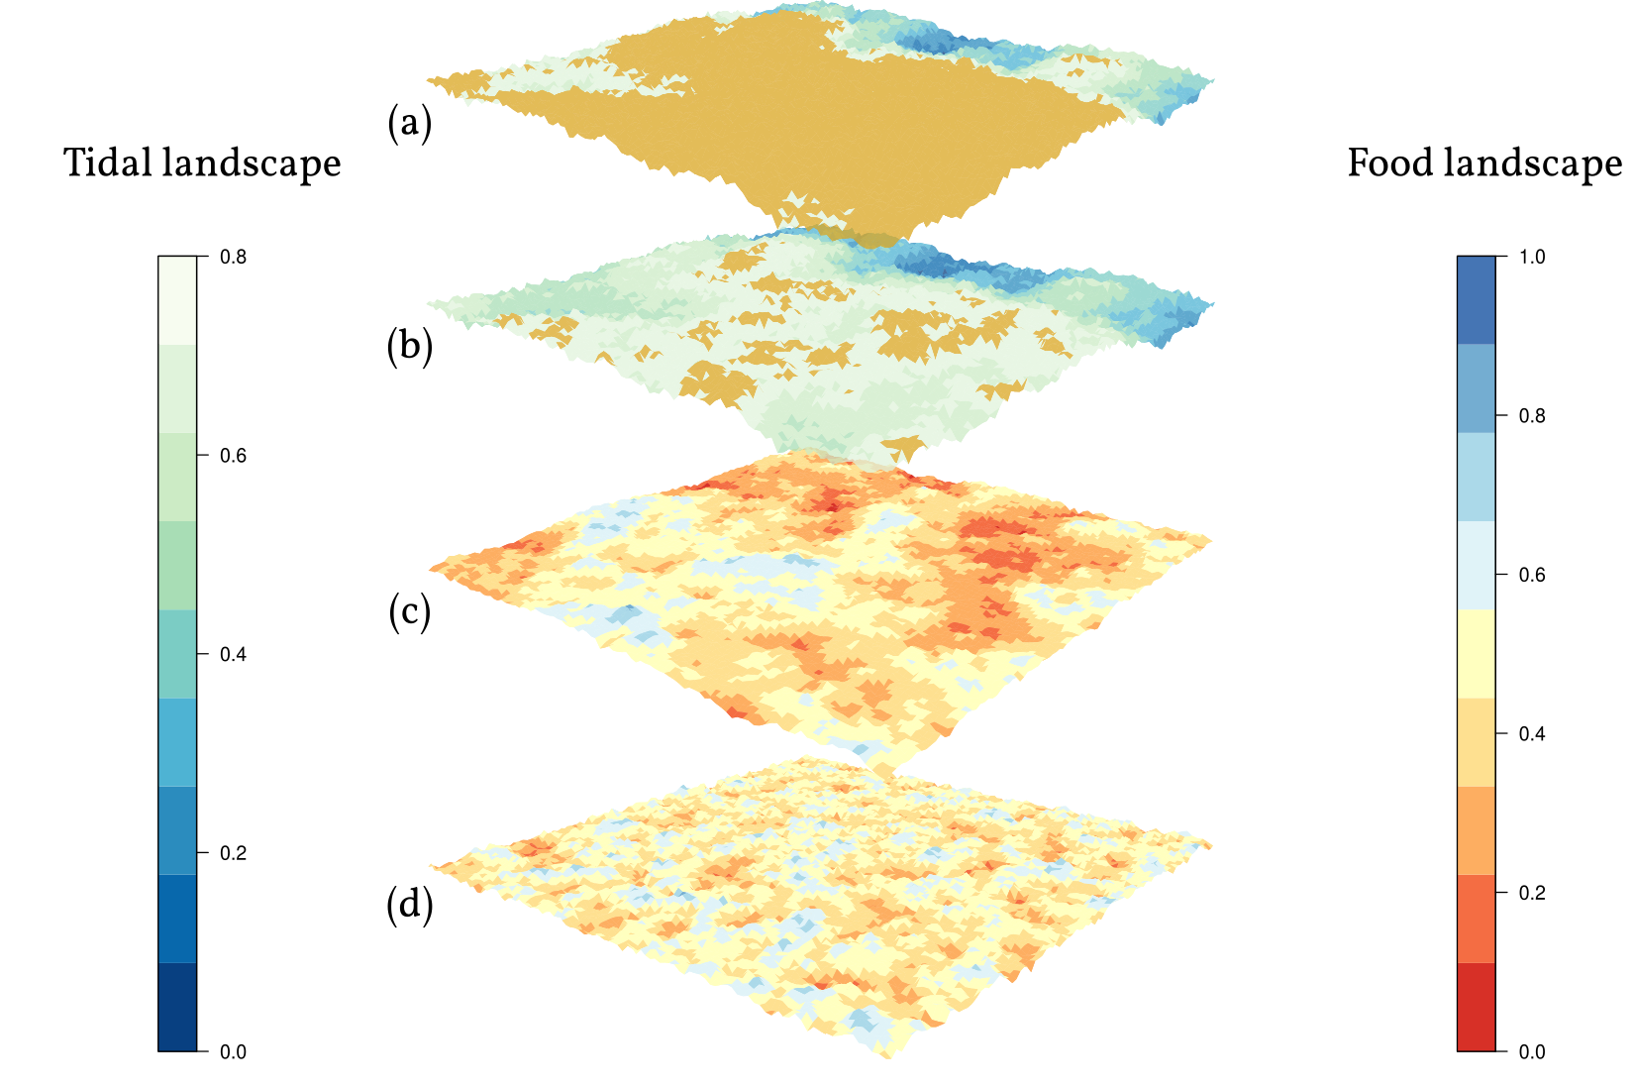
(a) Example of a tidal landscape showing surface exposed (coloured gold) at a water height of 0.6, and (b) at the maximum water height of 0.8. (c) Example of a food resource landscape with an autocorrelation range of 2 grid cells, and (d) with an autocorrelation range of 10 grid cells. Note that the food landscape at locations exposed in (b) has its value set to 0. Note also the larger autocorrelation range of the food landscape relative to the tidal landscape.
20 agents were initialised at random locations on the grid, and implemented their behaviours over 30 × 13 (390) tidal time units or timesteps; this corresponds to a an empirical tracking interval of 2 minutes between position fixes. New agents were initialised in 10 replicates each per food landscape. Overall, 2,964,000 positions were written to file for analysis.

Agent movement
Agents moved as expected in the landscape, avoiding areas covered by water (Fig. 2). Basic exploratory statistics showed that agent net intake was significantly higher, by 3 orders of magnitude, in landscapes with a higher autocorrelation range (Fig. 3a), but that total agent movement was not different among landscapes with different autocorrelation ranges (Fig. 3b).
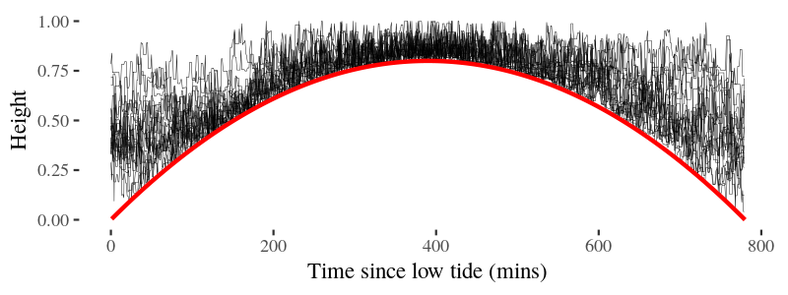
Example of elevation of 20 agents (black lines) over a simulation of one tidal period (low tide -- low tide). The height of water is marked by the solid red line. Agents restrict themselves to elevations not covered by water.
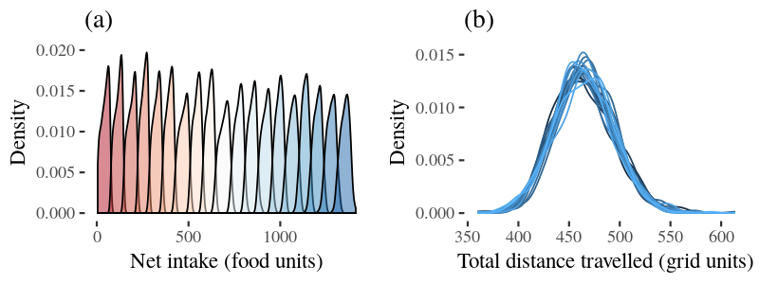
(a) Density of net agent intake. Each peak represents a separate autocorrelation range, with colours (red - white - blue = low, mid, high) representing the range of autocorrelation (2 -- 20 grid units). (b) Density of agent movement. Each peak represents a unique autocorrelation range (2 -- 20); peaks are not separated into distinct colours due to evident overlap.

Discussion
The program successfully simulated agents moving in a periodically changing landscape. While agent movement did not vary across a gradient of landscape autocorrelation range, agent net intake was significantly higher in landscapes with larger autocorrelation ranges. This is an interesting prediction but must be taken with caution, especially when considering that the total distance travelled does not vary with autocorrelation range.
One confounding factor is that the total distance travelled in measured as the final distance between two points where the agent settles, and does not take into account detours made by agents to points which were unavailable (due to the tide), necessitating travelling to another point. This is in line with animal tracking at low resolution which is unable to record movements that occur within the sampling intervals, such as short forays from a central point. The mismatch between distance and net intake is also similar to the mismatch between low resolution tracking methods and higher resolution (> 60 Hz) techniques such as tri-axial accelerometry used to measure energy expenditure.
Further, a number of parameters have been modelled in relative units, such as water height, while the tide has been assumed to advance at a constant pace. Additionally, nearly nothing is known about the movement costs of most waders, or the mechanisms by which they navigate at different spatial scales. These gaps have been bridged by assumptions for now, but require empirical data to address for certain.

References
Bijleveld, Allert I, Georgina Massourakis, Annemarie van der Marel, Anne Dekinga, Bernard Spaans, Jan A van Gils, and Theunis Piersma. 2014. “Personality Drives Physiological Adjustments and Is Not Related to Survival.” Proceedings of the Royal Society of London B: Biological Sciences 281 (1783). The Royal Society: 20133135.
Gardner, Robert H, Bruce T Milne, Monica G Turnei, and Robert V O’Neill. 1987. “Neutral Models for the Analysis of Broad-Scale Landscape Pattern.” Landscape Ecology 1 (1). Springer: 19–28.
Gils, Jan A. van, Bernard Spaans, Anne Dekinga, and Theunis Piersma. 2006. “Foraging in a Tidally Strcutured Environment by Red Knots (Calidris canutus): Ideal but Not Free.” Ecology 87 (5): 1189–1202. doi:10.1890/0012-9658(2006)87[1189:FIATSE]2.0.CO;2.
Kays, Roland, Margaret C Crofoot, Walter Jetz, and Martin Wikelski. 2015. “Terrestrial Animal Tracking as an Eye on Life and Planet.” Science 348 (6240). American Association for the Advancement of Science: aaa2478.
Nathan, Ran, Wayne M Getz, Eloy Revilla, Marcel Holyoak, Ronen Kadmon, David Saltz, and Peter E Smouse. 2008. “A Movement Ecology Paradigm for Unifying Organismal Movement Research.” Proceedings of the National Academy of Sciences 105 (49). National Acad Sciences: 19052–9.
Piersma, Theunis, Renee van Aelst, Karin Kurk, Herman Berkhoudt, and Leo RM Maas. 1998. “A New Pressure Sensory Mechanism for Prey Detection in Birds: The Use of Principles of Seabed Dynamics?” Proceedings of the Royal Society of London B: Biological Sciences 265 (1404). The Royal Society: 1377–83.
Piersma, Theunis, and Jan A Van Gils. 2011. The Flexible Phenotype: A Body-Centred Integration of Ecology, Physiology, and Behaviour. Oxford University Press.
R Core Team. 2018. R: A Language and Environment for Statistical Computing. Vienna, Austria: R Foundation for Statistical Computing. https://www.R-project.org/.
Sciaini, Marco, Matthias Fritsch, Cedric Scherer, and Craig Eric Simpkins. 2018. “NLMR and Landscapetools: An Integrated Environment for Simulating and Modifying Neutral Landscape Models in R.” bioRxiv. Cold Spring Harbor Laboratory, 307306.
Spiegel, Orr, Stephan T Leu, Andrew Sih, and C Michael Bull. 2016. “Socially Interacting or Indifferent Neighbours? Randomization of Movement Paths to Tease Apart Social Preference and Spatial Constraints.” Methods in Ecology and Evolution 7 (8). Wiley Online Library: 971–79.

