Electrical Drawing Interpretation Pipeline
Technical Documentation

Candidate Name: Pratik Shrivastava
Date: 28-08-2026

Table of Contents
1. Overall Architecture
2. Model Selection Rationale
3. Pre-processing and Post-processing Logic
4. Connectivity Extraction Approach

1. Overall Architecture

The first real struggle was localization. My initial approach leaned entirely on classical computer vision — connected-component analysis over skeletonized line art to find symbols, then DINOv2 embeddings matched against a small KiCad-sourced reference library to name them. No training, no fine-tuning, just geometry and shape matching, since I didn't want to build something that only worked on these two specific drawings.

It fell apart pretty quickly once I actually looked at the output. Roughly six out of every ten boxes the localizer drew were wrong — mostly wire bends and junctions that looked "symbol-shaped enough" to a density heuristic. It missed real components entirely, too. I could've kept tuning thresholds, but I was chasing noise, not fixing the actual problem.

So, I trained a proper detector instead — YOLO — but I generated its training data myself, by pasting the same KiCad symbols onto blank canvases and letting the labels fall out of where I placed them. Still zero manual labeling, just a better-suited tool for "is there a symbol here." That alone took the false-positive rate from ~60% to basically zero.

Then I second-guessed myself on classification. My first instinct was to let YOLO only localize and have DINOv2 make every naming decision alone, since YOLO's class head was trained on synthetic data I didn't fully trust. But comparing the two side by side, they were wrong on completely different symbols — not the same ones. Discarding either one meant throwing away real information. So classification stopped being one model's call and became a vote: YOLO, DINOv2, a couple of things I added later (a linear probe, an OCR reader, some geometry checks for symbols that kept getting confused), each only speaking when it actually has something useful to say, none of them able to override the others alone.

Wires never needed this back-and forth — skeletonizing clean line art and walking the graph just worked from day one. The one real rethink there was making sure a wire crossing isn't automatically a connection unless there's an actual junction dot drawn at it, and building that rule into the graph structure itself instead of patching it in afterward.

1.1 Objective
Given a raster image of an electrical schematic, the goal was to actually read it — find every symbol, figure out what each one is, work out how they're wired together, and hand back both a structured JSON netlist and a graph I could visualize.

1.2 Pipeline Stages
Once an image comes in, the first thing I do is clean it up — convert to grayscale, run an adaptive threshold to get a clean black-and-white version, deskew it if it's tilted, and strip out any tiny speckles of noise. I use adaptive thresholding instead of one global cutoff because the drawings don't always have perfectly even contrast across the whole page, and I use connected-component filtering instead of a simple morphological open for denoising, because I learned the hard way that even a small blur kernel erases the thin, one-pixel-wide strokes these drawings are actually made of. At this same early point, I also run OCR and look for junction dots — before localization even happens — because a piece of text or a filled-in dot looks just as "busy" to my symbol detector as a real component does, and I need to know where they are so I can tell the detector to ignore them.
Next comes finding the symbols themselves. This is where I run a YOLO model over the cleaned-up image and get back a set of candidate boxes — one per component the model thinks it sees. I built this detector myself, training it entirely on synthetic drawings I generated by scattering real KiCad-sourced symbol images across blank canvases, so it never saw a hand-labeled real drawing during training. I don't fully trust its guesses about what each box actually contains, though — only where it thinks something is. 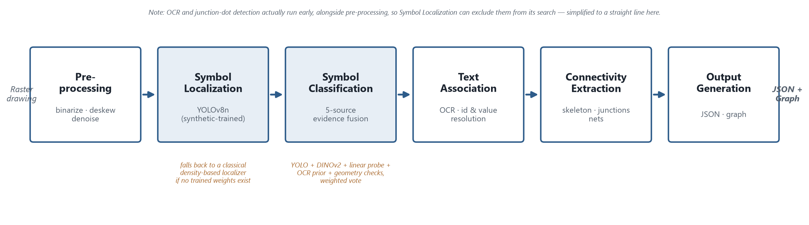
Naming each box is the part I spent the most time on, because it's the part that's genuinely hard. Rather than trusting one model, I run every candidate through several independent checks and let them vote. YOLO's own class prediction is one vote. A separate embedding-based match against a reference library of real component symbols is another. A small learned classifier trained on the same embeddings is a third. If there's readable text near the symbol — something like "R6" or a part number — I check it against known electrical-designator conventions as a fourth signal, and I only trust it when the reading actually resembles something real; garbled text doesn't get to vote at all. And for a handful of components that visually resemble each other in ways none of the above reliably catches — a battery versus a capacitor, for instance — I added small geometry checks that only kick in when the other signals are already disagreeing. Every one of these sources is allowed to simply stay quiet if it doesn't have anything confident to say, and the final answer comes from whichever class has the strongest combined support, not from whichever source happened to speak first.
While all of that is happening for each symbol, I'm also reading the text in the drawing more broadly — upscaling the image first, since some of these labels are only a few pixels tall at native resolution, and running the OCR engine at several different settings and orientations because no single configuration reads every label correctly, and merging everything it finds rather than picking one "best" reading. That text gets matched to the nearest symbol afterward, which is how the system tells R1 apart from R2, or reads that a resistor is rated at "220Ω" instead of just knowing it's a resistor.
With every symbol found and named, I turn to the wiring. I subtract the symbol regions out of the cleaned image, leaving just the wires behind, and thin them down to single-pixel-wide skeletons so I can trace them as a graph. The genuinely tricky part is deciding what happens where two wires cross on the page — because on a real schematic, two lines crossing don't necessarily mean they're electrically joined. I only treat a crossing as a real connection if there's an actual dot drawn at that point; otherwise, I split the crossing into two separate paths that pass through independently, so the two wires stay logically apart even though they touch visually. Everything that ends up joined together by this process becomes one net — not a simple pair, but a group of however many terminals actually share that one length of wire, which matters because a single rail in these drawings often touches three or four components at once, not just two.
Before I hand anything back, I run a few sanity checks — symbols with no wire touching them, wires with only one thing connected to them, terminals that never found a home — mostly to catch cases where something upstream clearly went wrong rather than to score accuracy. And then the actual output gets built: each net gets expanded into the pairwise connections the final JSON asks for, and that same JSON is what I use to build the graph, too, so the picture and the data are never two different sources of truth — one is drawn directly from the other.
Stage | Technique / Model | Purpose
- Preprocessing | Adaptive thresholding, deskew, connected-component  denoising | Clean and normalize the raw image before detection
- Symbol Localization | YOLOv8n, trained on self-generated synthetic data | Propose candidate bounding boxes for every symbol in the drawing
- Symbol Classification | 5-source evidence fusion — YOLO's own class head,  DINOv2 nearest-neighbor match, a linear probe, an OCR  designator/part-number prior, and geometry specialists for known  confusion pairs | Assign each candidate box a component type
- Text association (OCR) | Tesseract, multi-pass (3 PSM configs) and  multi-orientation, image upscaled beforehand | Resolve instance identity (R1 vs. R2) and read component values
- Wire & Connectivity Extraction | Skeletonization, junction-dot detection, crossing  decomposition | Trace wires and determine which symbols are electrically  connected, as nets
- Output Generation | Net-to-pairwise JSON expansion; NetworkX graph  (bipartite internally, projected for delivery) | Produce the structured JSON and the graph representation

1.3 Design Principles
- Never build something that can only be extended by retraining it - This is the one I mentioned already, but it shaped almost every other decision, so it's worth stating on its own. If adding a new component type meant collecting labeled examples and retraining a model, I'd effectively be building a system that only works on exactly what I'd already seen. I wanted adding a symbol to be as simple as dropping in a reference image.
- Give each stage exactly one job, and don't let it know about the others - Localization only decides where something is. Classification only decides what it is. OCR only decides which instance it is and what its value says. I could've saved myself some code by letting one model do two of these at once, but the moment something went wrong, I'd have no way of knowing which job it botched. Keeping them separate meant every mistake I found had exactly one place it could be coming from.
- Don't let one signal make the final call by itself - This came out of watching my classifier get things wrong in ways that felt avoidable — a model would be confidently wrong about something a completely different check would've caught easily. So instead of picking one source of truth, I built the system to gather opinions from several independent places and only commit to an answer once they'd actually agreed, or one of them was confident enough to outweigh the rest. And critically, any of them are allowed to just say "I don't know" rather than guess — a shaky OCR read that can't be trusted contributes nothing at all, instead of contributing a weak wrong answer.
- The pipeline should still run even when a piece of it isn't ready yet - Early on, before I'd trained anything, I still wanted to be able to run the whole thing end to end and see something come out the other end, even if it wasn't good. So, every stage that depends on a trained model or a built reference library has a fallback — an empty result, a simpler classical method, whatever keeps the pipeline from just crashing. I leaned on this constantly during development, and it's still true today: if a model file goes missing, the system degrades, it doesn't break.
- I don't get to believe a change helped until I've actually measured it - This is the principle I probably broke the most before I finally forced myself to follow it properly. More than once, I made a change that looked obviously better — cleaner logic, stronger validation numbers on the data I'd generated myself — and then found out, once I actually checked it against a real drawing, that it had made things worse. So I stopped trusting my own intuition about what "should" work and started treating every change as a claim that needed evidence before I'd keep it.

1.4 Data Flow Summary
Nothing gets passed between stages as a loose dictionary or a blob of numbers — every handoff is a proper typed object, so a stage can't accidentally misread what the previous one gave it. The image comes in, gets cleaned up, and turns into a binary version plus a list of text readings and junction-dot locations found early. Those feed the symbol finder, which hands off a list of rough bounding boxes. Each box gets turned into a fully-named symbol, complete with its own connection points, once classification and text-reading are done with it. From there, the wires get traced separately and turned into groups of terminals that all sit on the same physical conductor. And right at the end, that same set of named symbols and their groupings get read twice — once to write the JSON, once to draw the graph — so both outputs are really just two views of the same underlying data, not two things I built independently and hoped would agree. 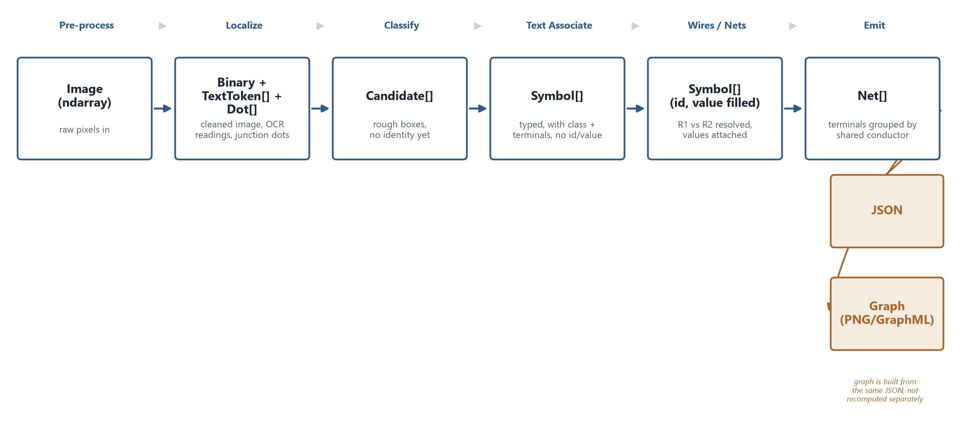

2. Model Selection Rationale

2.1 Symbol Localization
I went with YOLOv8n, trained on synthetic KiCad-rendered schematics plus procedurally generated variants, with a classical density-based localizer as a fallback if no trained weights are found. I considered a classical-only approach first — connected components and contour density — and actually shipped it early on, because it needs no training data and it's honest about not knowing what a symbol "means." It just doesn't separate touching symbols well, and it has no sense of what a resistor should look like versus noise. YOLO gave me that, and being lightweight (the "n" variant) meant I could retrain it in minutes on a laptop GPU whenever the reference library changed, which mattered a lot given how many iterations this went through. The trade-off I accepted going in, and which stayed true the whole project, is that it's only as good as its synthetic training data — it never saw a real messy scan until evaluation, so its recall on unusual real-world symbol styles is the weakest link in the whole pipeline.

2.2 Symbol Classification
This is the one I iterated on the most, and where I ended up furthest from my first instinct. I started with a single method — DINOv2 embeddings matched against a reference library by nearest neighbor — because it needed no labeled training data, just example crops of each symbol type. It worked, but it made confident, silent mistakes on visually similar symbols (capacitor vs. battery, BJT vs. potentiometer), and I had no way to know when it was guessing versus actually sure. So, I moved to combining five independent sources of evidence — the YOLO detector's own class guess, DINOv2 nearest-neighbor, a small linear probe trained on top of DINOv2 embeddings, OCR-read reference designators and part numbers, and a couple of hand-written geometry checks for the specific pairs I knew were being confused — and let them vote, weighted by how reliable each source tends to be, rather than trusting any single one blindly. Any source can abstain instead of forcing a guess, which turned out to matter more than I expected: half the fixes came from sources correctly staying quiet, not from being individually smarter. The trade-off is complexity — five moving parts is a lot more to reason about and debug than one — but I'd rather defend a system that knows when it's unsure than one that's simple and confidently wrong.
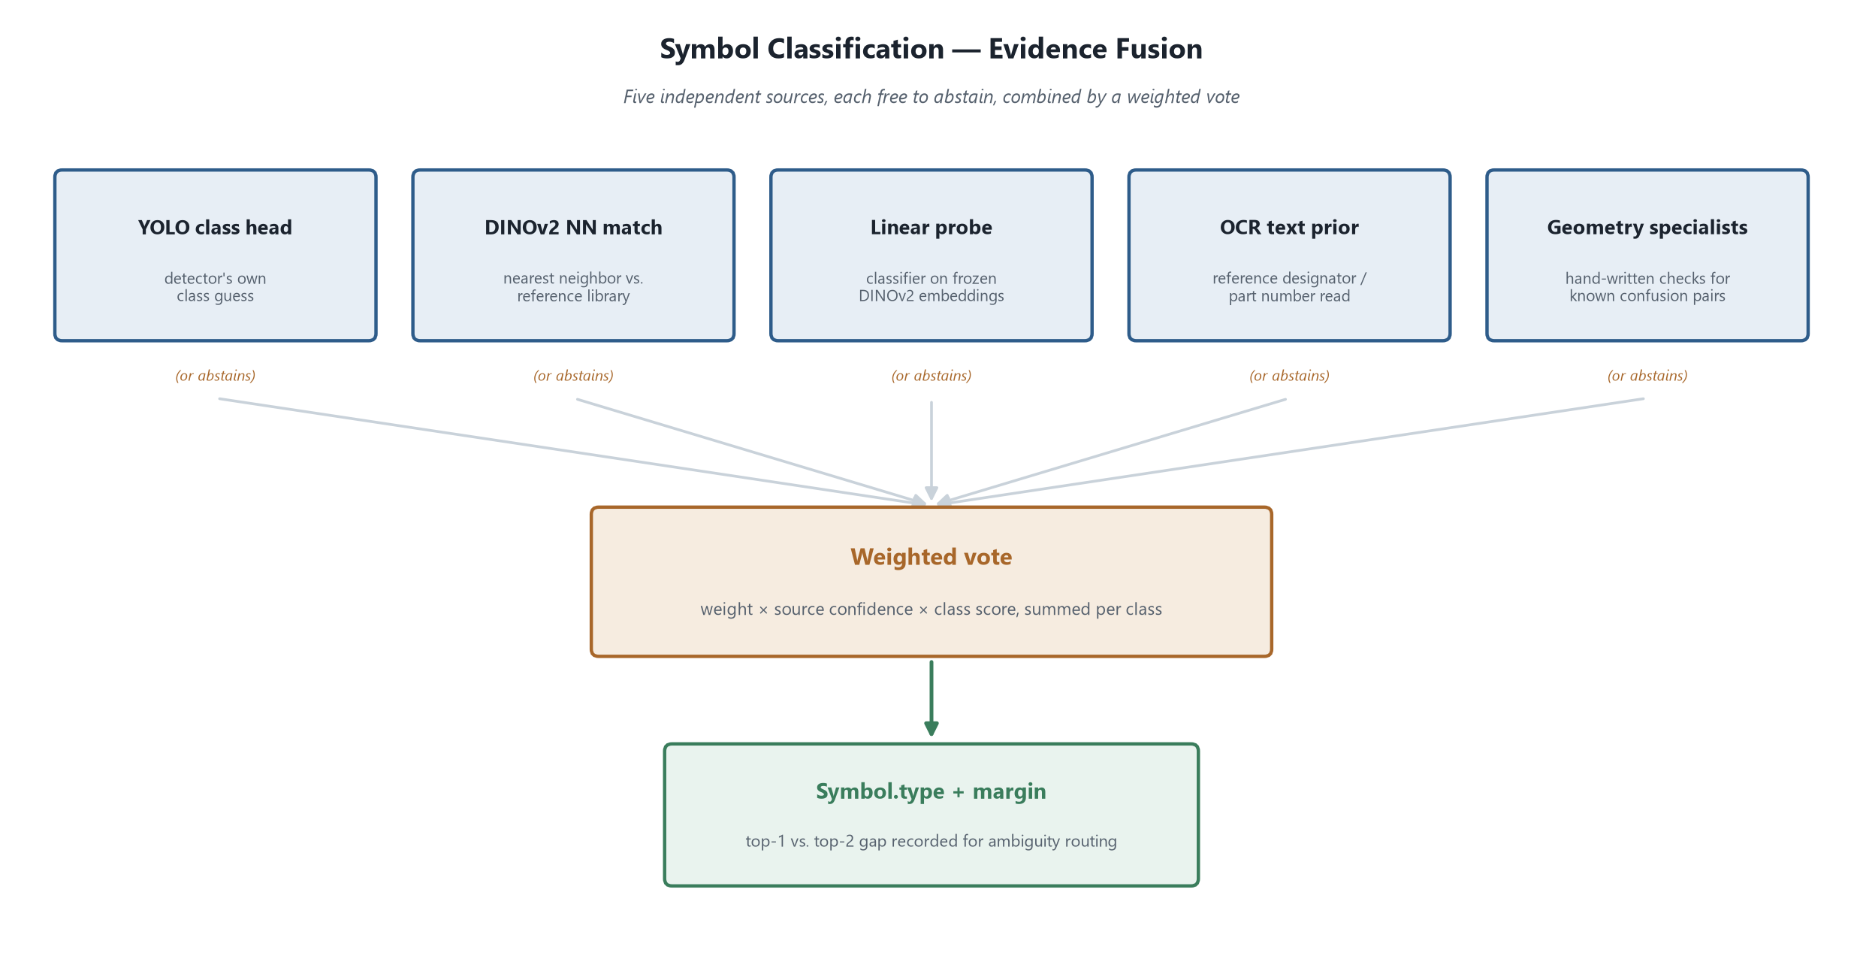

2.3 Text / OCR
I used Tesseract, run across multiple page-segmentation modes and multiple rotations per crop, rather than a single pass. My first version ran it once per detected region and called it done, and it missed anything rotated or anything Tesseract's default mode wasn't tuned for — vertical labels next to resistors were a repeat offender. Running several configurations and keeping every reading (deliberately not deduplicating down to "the most confident one") fixed that, because I found cases where the highest-confidence reading was actually the wrong one, crowding out a correct but lower-confidence read from a different pass. I considered a deep learning OCR model at one point, but Tesseract was already good enough once I stopped starving it of chances to read the text correctly, and it's fast and dependency-light. The trade-off is that multi-pass OCR is slower and noisier — I'm leaning on the downstream text-association logic to sort through duplicate and conflicting readings rather than trusting OCR to hand me one clean answer.

2.4 Connectivity / Wire Detection
I built this from a morphological skeleton of the binarized wire pixels, walked into a graph, with junction dots detected separately to decide where wires actually connect versus just visually cross. The alternative I ruled out early was trying to detect wires as another YOLO class — but wires aren't compact objects like symbols, they're long thin structures of arbitrary shape, so a bounding-box detector is the wrong tool for them. Skeletonization keeps the actual topology of the line instead of a box around it. Junction dots needed their own detection step because two wires crossing on paper often don't connect electrically — that distinction is exactly the kind of thing that's easy to get wrong silently, so I built a dedicated dot detector rather than assuming every crossing is a connection. The trade-off is that this whole stage depends on clean line segmentation upstream — if pre-processing leaves a wire broken or two wires touching where they shouldn't, the graph inherits that mistake.

2.5 Where a VLM/LLM Was — or Was Not — Used
I didn't reach for a VLM or LLM anywhere in the pipeline, and that was a deliberate call, not an oversight. Early on I looked at just prompting a vision-language model to read the whole drawing and output structured symbols and connections directly. It's tempting because it needs almost no engineering. But I couldn't get it to a place where I trusted its output — no clear notion of confidence, no way to know why it made a call, and no way to systematically improve it when it got something wrong beyond rewriting the prompt and hoping. Given that I could actually measure and iterate on a pipeline built from smaller, individually inspectable pieces, I preferred that, even though it took a lot more engineering effort. If I were extending this system, the place I actually would bring in an LLM is post-hoc — reviewing the final JSON output for a mislabeled net or an implausible component value, as a sanity-check layer rather than the core extraction mechanism.

2.6 Summary Table
Choice | Alternative Considered | Why Chosen | Trade-off Accepted
- YOLOv8 (Synthetically trained) | Classical density-based localization only | Learns real symbol shapes, still fast enough to retrain often | Only as good as synthetic training data; weak on unfamiliar real  styles
- 5-source evidence fusion for classification | Single DINOv2 nearest-neighbor match | Sources can abstain instead of guessing; catches confusions no single method  resolves alone | More moving parts, harder to debug than one method
- Multi-pass Tesseract OCR, no dedup | Single-pass OCR, confidence-based dedup | Rotation/config coverage catches reads a single pass misses; dedup was shown to discard correct reads | Slower, noisier, more conflicting readings to reconcile downstream
- Skeleton graph + separate junction-dot detection | Wire detection as a YOLO class | Wires are thin/arbitrary-shaped, not box-shaped; junctions need explicit  disambiguation | Fully dependent on clean upstream segmentation
- No VLM/LLM in the core pipeline | End-to-end VLM prompting for extraction | Needed inspectable, individually measurable, iterable components | Far more engineering effort than a single prompt-based approach

3. Pre-processing and Post-processing Logic
Before anything gets detected, the image goes through a short cleanup pipeline. After the output comes back out, there's a separate pass that checks the result actually makes sense before it's handed over. Neither side is glamorous, but I learned the hard way that skipping either one quietly breaks everything downstream.

3.1 Pre-processing Pipeline
- Grayscale + adaptive binarization - I convert to grayscale, then binarize with an adaptive threshold rather than one global cutoff for the whole image. I tried a single global threshold first, and it worked fine on a clean render but got shaky the moment lighting or background tone varied even slightly across the page — adaptive thresholding reads a local neighborhood instead of one fixed number, so it doesn't need retuning per drawing.
- Noise removal - I drop connected components below a minimum pixel area — basically erasing isolated speckles left over from thresholding, while leaving continuous strokes alone no matter how thin they are. My first instinct was a standard morphological opening, and it was a bad one: I actually rendered the binarized output and watched it erase almost every 1-pixel-wide wire and symbol line in the drawing, because a line that thin can't contain even a tiny structuring element anywhere along its length. Junction dots survived; the wiring didn't. Switching to component-area filtering fixed that — it looks at the shape's size, not its width, so a long thin wire and a tiny fleck of noise get judged correctly.
- Deskew - I estimate a skew angle from the foreground pixels and correct it, but only for small angles — a few degrees, not a general rotation-invariance step. These are digitally generated drawings, not photographed or scanned pages, so wild rotation was never really the failure mode I was solving for; the goal here is just correcting the small tilt that creeps in from how a page was exported, not building a system that can read a drawing sideways.
- Blue-layer separation - One of the two drawings I had draws some conductors in blue instead of black, so I added an optional color-mask step that pulls out blue ink as a separate signal. It's explicitly opportunistic — on a monochrome drawing it just comes back empty, and every downstream piece that touches it is written to treat "no color signal" as a normal case, not an error.

3.2 Post-processing & Validation
- Duplicate/overlap merging - Both localizers I've used — the classical density-based one and YOLO — occasionally produce two or three boxes for the same physical symbol, for different reasons: density blobs sometimes split into adjacent components, and YOLO's own internal suppression doesn't always catch near-duplicate boxes from different anchors. I merge any pair of boxes whose overlap passes a threshold, but I don't just throw away the "loser" — I keep whichever duplicate had the higher classification confidence, because I found a real case where two duplicate boxes for the same transistor scored two different classes, and the more confident one happened to be correct. Discarding blindly would have been a coin flip; this way the merge is actually informed by evidence.
- Consistency checks - After the full pipeline runs, I check the result against itself: is every symbol that has terminals actually connected to a net, or is it floating in isolation? Is every terminal on every net accounted for, or are some left dangling? Is any net down to a single terminal, which shouldn't really be possible for a real connection? None of this is checked against ground truth — I don't have that for real drawings — so I think of it as a self-consistency pass, not an accuracy score. It's meant to catch the kind of structural nonsense that would embarrass the output even if I never saw the source image.
- Confidence scoring - Every symbol carries the fused confidence from the evidence-voting step in classification, plus a margin — the gap between the top guess and the runner-up. A low margin is the system's own way of saying "I chose this, but it was close," which matters more than the raw confidence number alone.
- Handling low-confidence/ambiguous results - Symbols under a minimum confidence threshold get flagged in the validation report rather than silently passed through as if they were certain. I don't auto-discard them — a flagged, visible low-confidence symbol is more useful to a downstream reviewer than either a hidden gap or a falsely confident wrong answer.

3.3 Known Limitations of This Stage
The pre-processing side assumes digitally generated line art, not a scanned or photographed page — it doesn't handle heavy skew, perspective distortion, paper texture, or scan artifacts like shadows and creases, because that was never the input this was built against. The noise filter is tuned by a minimum-area threshold, so a genuinely tiny symbol or a very faint, broken line could get treated as speckle noise and removed along with the actual noise — I haven't hit that in practice on these two drawings, but it's a real edge case for a different drawing style. On the post-processing side, the consistency checks can only catch structural nonsense, not wrong-but-plausible output — a symbol correctly connected to the wrong net, or a confidently misclassified component, will sail through validation looking completely fine, because nothing here compares the result back against ground truth.

4. Connectivity Extraction Approach
This is the stage that turns "here's a picture with some symbols on it" into "here's what's actually wired to what," and it's the one where getting a subtle rule wrong doesn't crash anything — it just quietly produces a wrong but plausible-looking answer. That made it the stage I was most paranoid about.

4.1 Wire / Line Detection
Once symbols are classified, I subtract their bounding boxes out of the binarized image (with a small pixel margin so I don't leave a symbol's edge stroke behind), which leaves only wire pixels. I run morphological skeletonization on what's left, thinning every conductor down to a clean 1-pixel-wide line no matter how thick it was drawn. I then build a pixel-level graph over that skeleton — each foreground pixel is a node, connected to its 8 neighbors — because that gives me an actual traceable structure to walk, rather than just a mask of "wire-colored" pixels with no notion of which pixel connects to which.

4.2 Junction Disambiguation
This is the part I got wrong first and had to rebuild. My first approach found junction dots by contour shape — look for small round blobs. It quietly failed on almost everything, because a real junction dot sits directly on a wire, so the dot and the wire it's touching become one connected shape, and a circle-fit on that combined blob looks nothing like a circle. I actually counted it: only the handful of dots that happened to form their own isolated contour were found — a small fraction of what was really in the drawing. What worked instead was looking at local ink density: at every point in the skeleton where three or more strokes meet, I check how much of a small disk around that point is filled in. A plain crossing only fills the width of the two strokes passing through; an actual drawn dot fills most of the disk. That distinction is invariant to how many wires happen to be running through that point, which the contour approach never was.
Whether a crossing is "dotted" or not then does real structural work, not just tagging: at every undotted crossing with four arms, I split the graph into two independent straight-through paths before I ever look for connected components — so "two wires crossing without a dot" is disconnected by construction, not filtered out afterward. A dotted crossing (or an undotted one that isn't a clean four-way X) gets a single synthetic joining node instead, keeping everything at that point connected.

4.3 Net / Connection Construction

After that rewiring, I take connected components of the graph, and each component becomes a net — every symbol terminal in that component is electrically one node. I chose nets, not direct pairwise connections, as the primary representation, because a net is what a wire actually is: a many-way equivalence class of terminals joined by one conductor, not a chain of one-to-one links. Three components soldered to the same wire are one fact, not three separate facts that happen to agree. Pairwise connections are trivially derivable from a net afterward — any two members of the same net are connected — but going the other direction, reconstructing a net from a pile of pairwise edges, is genuinely ambiguous the moment more than two terminals share a wire. So I built the representation that's actually unambiguous, and derived the simpler one from it, rather than the reverse.

4.4 From Connectivity to JSON and Graph Output

The delivered JSON follows the shape given in the problem statement itself — each symbol has an id, type, coordinates, and a flat list of connections naming the other symbol ids it shares a net with. I compute that list by walking each net and, for every symbol in it, collecting every other symbol id in the same net — that's the pairwise projection I mentioned above, generated fresh from the net structure rather than stored separately, so it can't drift out of sync with it.

The delivered picture, on the other hand, is built directly from the same JSON that gets handed over — not recomputed independently from the internal data. I did that deliberately: I wanted the picture and the JSON to be visibly the same fact told two ways, not two independent computations that happen to usually agree, which is a much harder thing to accidentally get inconsistent.

4.5 Known Limitations of This Stage
This whole approach leans on the convention that a filled dot means "connected" and a bare crossing means "not connected" — a drawing that uses a different convention (say, always jumping the visually-behind wire with a little hop, and never using dots at all) would be read wrong, confidently. It also assumes wires are continuous strokes that skeletonize cleanly; a wire broken by a faint scan artifact, or two wires that are so close they merge into one blob under binarization, will get merged or split incorrectly, and nothing downstream would flag it since it's not a structural inconsistency, just a wrong one. T-junctions without a dot are one case I know I'm handling defensively rather than correctly — I treat them as connected by default because that's the safer assumption for these drawings, but that's a judgment call, not something derived from the drawing convention, and a drawing that actually uses undotted T-junctions to mean "not connected" would break that assumption outright.

Appendix
I kept this section honest on purpose: it's not a highlight reel, it's the actual measured numbers, including the ones that don't look as good as I'd like.

A.1 Real-drawing accuracy — the numbers that actually matter
This is the chart I'd lead with if someone only had time to look at one. It's detection F1 and classification accuracy on D4 and D5 separately, plus combined — measured against hand-verified ground truth I built myself, not synthetic validation. Detection stayed solid across both drawings (0.88–0.91 F1). Classification is where the honest story is: 81.2% on D4, but only 46.2% on D5, because D4 was the drawing I was iterating against the whole time and D5 was scored independently afterward, cold. The combined 65.5% is the number I'd actually defend, because it's the one that isn't quietly overfit to a single drawing I'd been staring at for weeks.
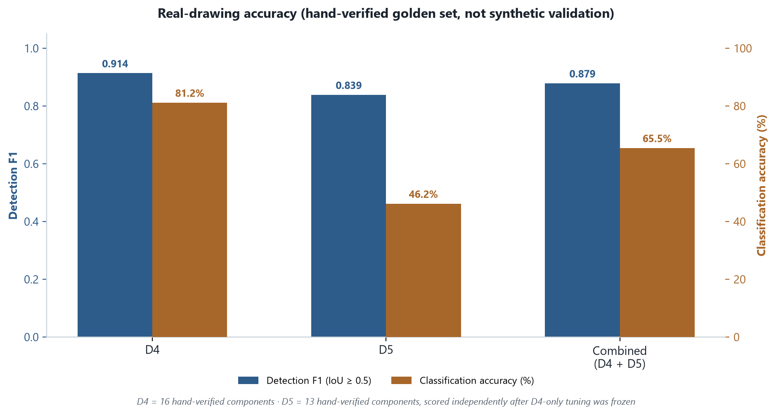

A.2 Classification accuracy over the session
This tracks the combined D4+D5 classification number through four points in the session: the original rule-based fusion, the point where D5 was hand-verified and the combined number first existed, adding a wider reference library, and general OCR robustness fixes. Every step here was a measured eval run, not a guess — and detection F1 barely moved (0.879 throughout), which is worth noting on its own: classification improved without quietly breaking detection to get there.
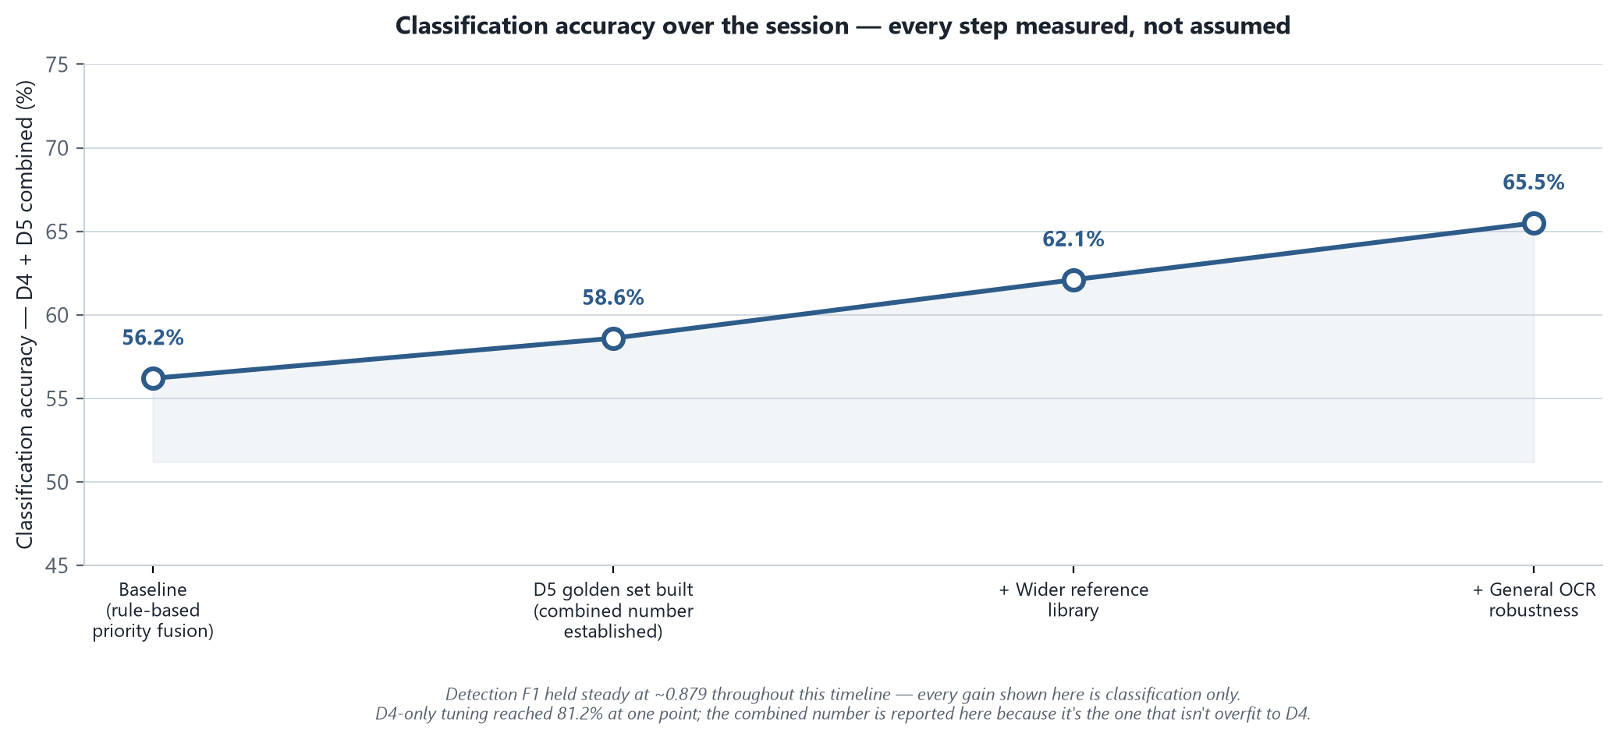

A.3 Training curves — the shipped detector
Standard YOLO training curves (box/class/DFL loss, precision, recall, mAP50, mAP50-95) for the 17-class detector that's actually shipped. Useful for showing the model converged cleanly and didn't overfit within its training budget — but I'd flag it clearly as synthetic-only training/validation, which is a different thing from the real-drawing numbers in A.1.
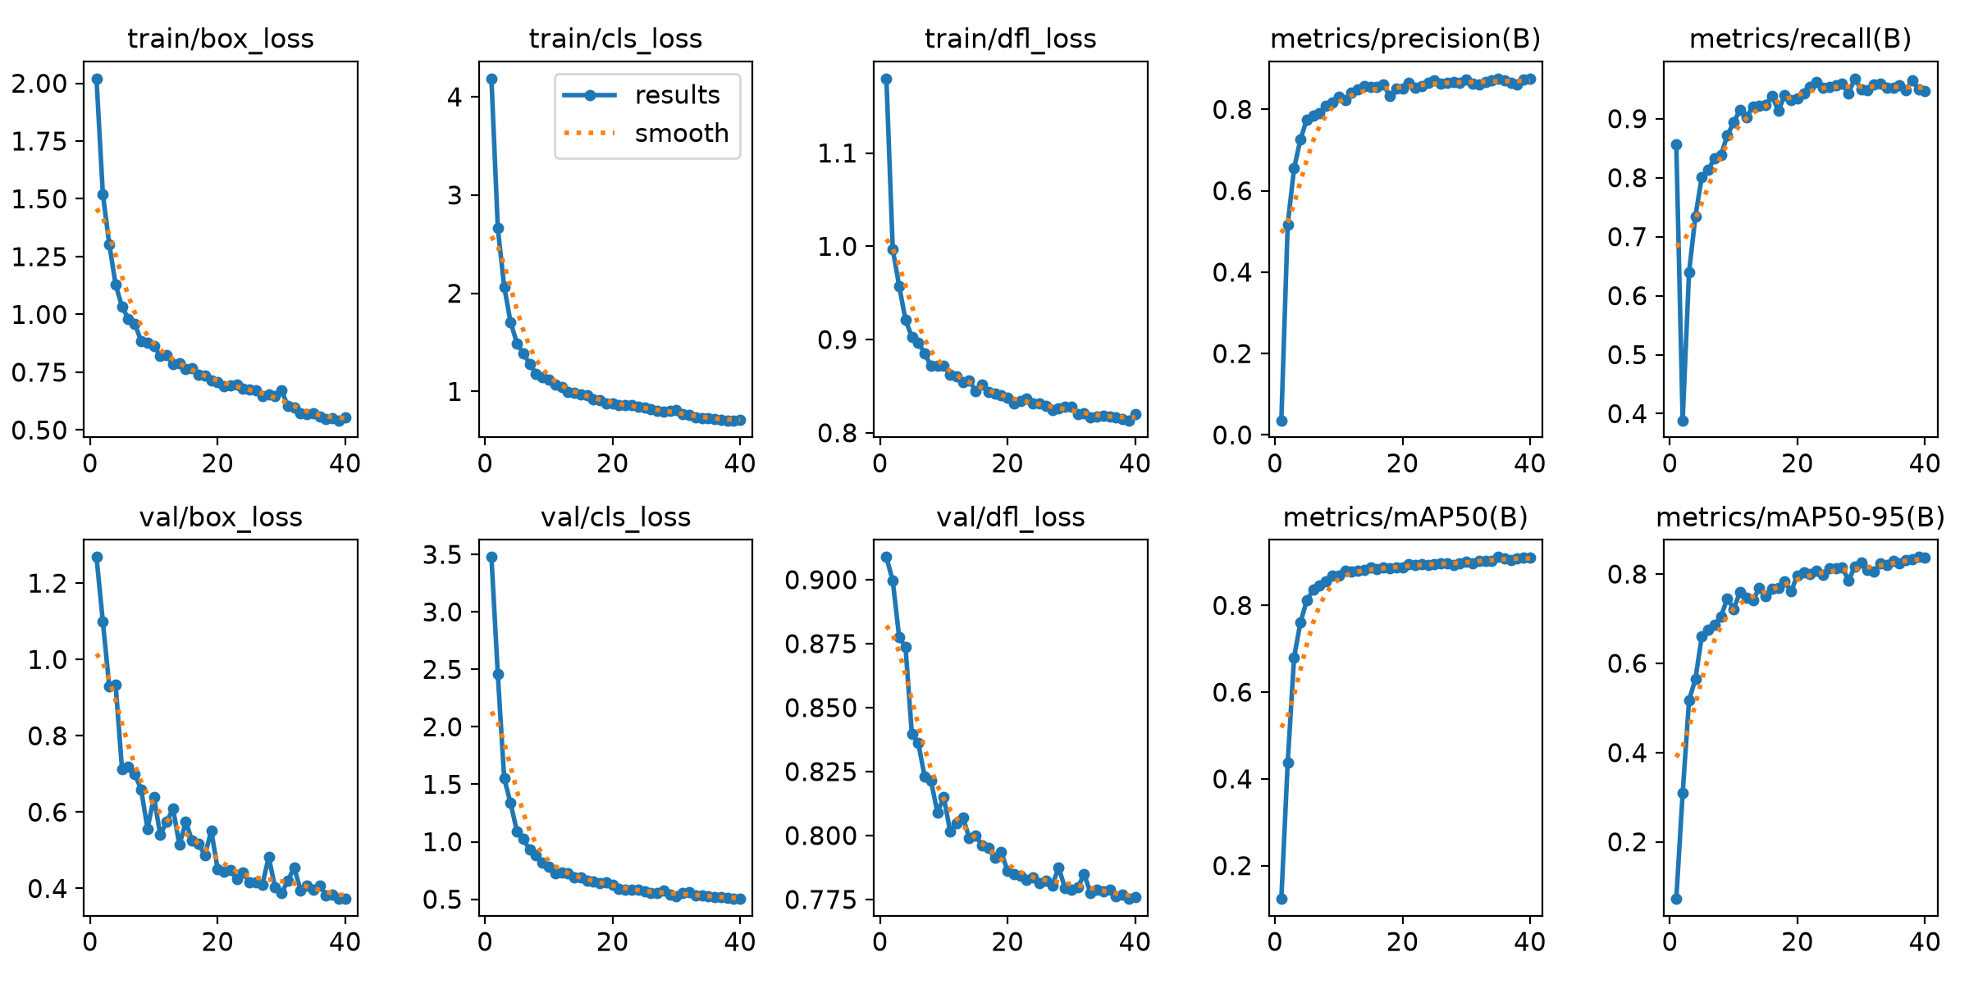

A.4 Confusion matrices — synthetic validation
These are worth including specifically because they corroborate a decision I made elsewhere in this document, not just as a routine training artifact. Even on clean synthetic data, the matrix shows real confusion between BJT_NPN/BJT_PNP and between Diode/Zener — exactly the two pairs I ended up writing dedicated geometry specialists for in the classification stage. It's independent evidence that those weren't confusions I imagined; the model itself struggles with them even under ideal conditions, which is exactly why I didn't trust a single classifier to resolve them alone.
