STUDENT’S NOTES SHARING WEB APPLICATION

By

PRATIK VORA
16BIT108
PRIYANSHI PANCHAL
17BIT164



DEPARTMENT OF INFORMATION TECHNOLOGY
Ahmedabad 382481

STUDENT’S NOTES SHARING WEB APPLICATION

Mini Project-II

Submitted in fulfilment of the requirements

For the degree of

Bachelor of Technology in Information Technology

By

PRATIK VORA
16BIT108
PRIYANSHI PANCHAL
17BIT164

Guided By
PROF. MALARAM KUMHAR
DEPARTMENT OF INFORMATION TECHNOLOGY

DEPARTMENT OF INFORMATION TECHNOLOGY
Ahmedabad 382481

CERTIFICATE

This is to certify that the Mini Project entitled “STUDENT’S NOTES SHARING WEB APPLICATION” submitted by PRATIK VORA (16BIT108) & PANCHAL PRIYANSHI (17bit164), towards the fulfilment of the requirements for the degree of Bachelor of Technology in Information Technology of Nirma University is the record of work carried out by him/her under my supervision and guidance. In my opinion, the submitted work has reached a level required for being accepted for examination.

Prof. Malaram Kumhar Dr. Madhuri Bhavsar
Assistant Professor, CSE Department, Head, CSE Department,
Institute of Technology, Institute of Technology, Nirma University, Nirma University, Ahmedabad Ahmedabad

ACKNOWLEDGEMENT

We sincerely thank our faculty guide (Prof. Malaram Kumhar) to support us in every possible way. He has been a very good mentor and have suggested us many things to make our project more and more useful in the real world. We could not have been able to develop this application by ourselves if he wasn’t present. Also thanks to Dr. Madhuri Bhavsar and Dr. Alka Mahajan for providing us this great opportunity. And thanks to Department of Information Technology to provide us proper resources and facilities. There are many people who have indirectly helped us reach this stage. The tutorials uploaded by many developers has been of a lot of help.
ABSTRACT

The aim of this applications is that each and every student of Nirma University can share their notes at one place so it will be easy for other students to view that notes which are helpful in their examinations, they can also download it. They can get knowledge through various useful notes. It helps students in fast and efficient work. By making this application we learnt about PHP, SQL, CSS, BOOTSTRAP and also JAVASCRIPT.

CONTENTS

Certificate III
Acknowledgement IV
Abstract V

Chapter 1 Introduction 1
1.1 General Scenario 2
1.2 Objective 2 1.3 Scope of Work 3
1.4 Advantages 3

Chapter 2 System Analysis 4
  - PHP 5
  - MYSQL 5
  - CSS 6
  - BOOTSTRAP 6
  - JAVASCRIPT 6
  - PDF.js 7

Chapter 3 Tools and Technology 8
3.1 Technology Used 9
3.1.1 Software Requirement 9
3.1.2 Hardware Requirement 9
3.2 Functions 9
3.2.1 Student 9
3.2.2 Admin 10

Chapter 4 System Design 11
4.1 Class Diagram 12
4.2 Database Tables 13

Chapter 5 Implementation 16
5.1 User Modules 17
5.1.1 Home Page 17
5.1.2 Registration Page 17
5.1.3 Login Page 18
5.1.4 Forgot Password Page 18
5.1.5 Change Details 19
5.2 Admin Modules 20
5.2.1 Admin Page 20
5.2.2 Accept Notes 20
5.2.3 Remove Notes 21
5.2.4 Remove User 22
5.2.5 Remove Request 22
5.2.6 View User 23

Chapter 6 Summary & Conclusion 24 6.1 Summary 25
6.2 Conclusion 25

References 26
Appendix 26

CHAPTER - 1
INTRODUCTION

1.1 GENERAL SCENARIO

- The project “STUDENT NOTES SHARING WEB APPLICATION” is the educational platform which provides every student from around the world to access notes which can help in increasing their knowledge like never before.
- We Share aims is to keep the notes in simplest way.
- It is free, light and clean.
- It is a learning platform that helps many students in their academic and in their competitive exams preparation by sharing various notes and whole notebooks with their classmates.
- If you want to download the notes you must have to sign in into the websites. And it also keeps your to-do list all in one place instead of keeping the piles of notes altogether.

1.2 OBJECTIVES

- It came from the idea that you share the knowledge, more it will empowers you.
- It gives you the opportunity to share the notes which helps in saves of times.
- It will let you upload and share many of your self-prepared academic notes and some of the notes are to be get by paid.
- At data storage we manage to store notes records for several hundred students.
- You can also sync automatically that means you can access your notes even if you are offline.

1.3 SCOPE OF WORK

- The scope of this project is to help students for fast and efficient work.
- Here, it save a time by just referring notes during examinations.
- Our aim is to give people a time and to address the growing problems
- User also has a facility to upload the notes and also download it whichever is needed.

1.4 ADVANTAGES

- As we have design a login page so only registered user will login which will prevent unauthorized access.
- This website help the user to view all the updates details and syllabus.
- And also the user can make instant download from anywhere.

CHAPTER - 2
SYSTEM ANALYSIS

2.1 PHP
- PHP (Hypertext Pre-processor or Personal Home Page) is widely used for web designing.
- It is an open source and embedded into HTML.
- PHP is a scripting language and has a powerful tools for designing interactive web pages.
- Before going for PHP you should have a knowledge of HTML, CSS and JAVASCRIPT.
- Files must be saved using .php extension.
- PHP is a server-side scripting language.
- PHP is a platform independent, it can run on any platform like windows, Linux, mac os x etc and is also compatible with all the server like apache, iis etc.

ADVANTAGES OF PHP:
- PHP is a open source platform
- As PHP uses different system report so it is relatively fast in speed.
- It is easy to use because it is familiar to C language so if one have knowledge about C language can easily create web scripts.

2.2 MYSQL
- SQL is a Structured Query Language is a database server where data can be stored, manipulate and retrieve it.
- In 1986, SQL become an ANSI-American National Standard Institute standard.
- In 1987, SQL also become an ISO (International Organization for Standardization) standard.
- MySQL is a platform independent.
- It is compatible with small and large applications.

2.3 CSS
- CSS is a Cascading Style Sheet which gives styles to the HTML documents including layout and design for various devices.
- CSS saves times as it manage the layout of multiple web page at once.
- File is saved using .css extension.

2.4 BOOTSTRAP
- Bootstrap is a free and open source.
- Bootstrap is a front-end frameworks which helps in faster and efficient web development.
- Bootstrap was developed by Jacob Thronton and Mark Otto.
- It has us to create responsive designs.
- Bootstrap contains CSS, HTML and also JavaScript for forms, buttons, navigations, typography, image, tables and modals.

ADVANTAGES OF BOOTSTRAP:
- It has a responsive CSS features which is adjust into phones, tablets and desktops.
- With just basic knowledge of HTML and CSS, it is easy to use bootstrap.
- Bootstrap is compatible with every browsers.

2.5 JAVASCRIPT
- Easy to learn.
- JavaScript is high-level programming language.
- JavaScript is a client-side scripting language.
- JS is used for network applications
- Was developed by Brendan Eich in 1995.
- It is Object-oriented.
- JavaScript is platform independent and open source.
- Performance is fast as compared to PHP.

2.6 PDF.js
- PDF.js is a library of JavaScript which provide PDF file on you websites so that the visitor’s user can view the file.
- It is developed by Mozilla and can support only IE8+, chrome and Mozilla Firefox.
- It will read the pdf file, parse it and then convert into html files then put it on the browser.
- It allows us to view the pdf files on the browser like Adobe Reader.
- For this, we need to download pdf.js

CHAPTER - 3
TOOLS AND TECHNOLOGY

3.1 TECHNOLOGY USED
3.1.1 SOFTWARE REQUIREMENT:-
FRONT END TOOL:- | HYPERTEXT PRE-PROCESSOR(PHP), BOOTSTRAP, JAVA SCRIPT
TOOLS:- | MICROSOFT WORD 2010
WEB SERVER:- | XAMP
DATABASE SERVER: | MY SQL
SERVER CONFIGURATION: | PHP VERSION: 5.2.8

3.1.2 HARDWARE REQUIREMENT:-
OPERATING SYSTEM:- | WINDOWS XP, 7, 8,10
SYSTEM PROCESSOR:- | INTEL CORE 2 DUO, INTEL CORE i3/i5/i7
RAM:- | 4 GB
MEMORY:- | 200 MB OR HIGHER
PROCESS OR SPEED:- | 1 GHz OR HIGHER

3.2 FUNCTIONS
3.2.1 STUDENTS
  - Each and every students have to create their own account with Nirma mail id i.e. abc@nirmauni.ac.in.
  - So after the successful registration, user will able to login to the site with the help of mail id and password.
  - Then user can view all the notes which are shared on the website and he/she can also download the notes which ever they need.

3.2.2 ADMIN
  - Admin has the authority to manage the databases so he/she can create and delete the account if needed.
  - Whenever any user try to upload the files, first the admin will check that is that file useful, if not the admin will not allow the user to upload that files.

CHAPTER - 4
SYSTEM DESIGN

4.1 CLASS DIAGRAM

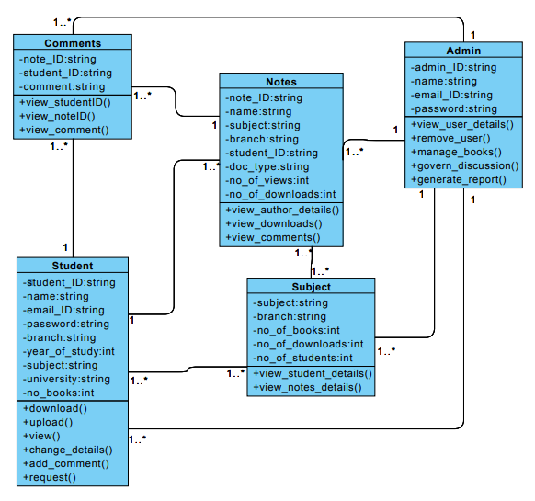

4.2 DATABASE

- ALBUM

Album is the table which stores the photos whichever the user have uploaded. It has album id (primary key) and photos.

- ALBUM DETAILS

The table of album details stores the details of all the album i.e. album id (primary key), author id, name of the album, starting of the date and ending of the date.

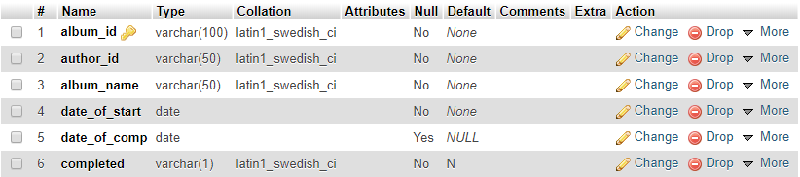

- DOWNLOADS

Download table in database stores the list of download that user have done. The attributes of download table is download id (primary key), note id, student id, number of downloads and date of downloads.

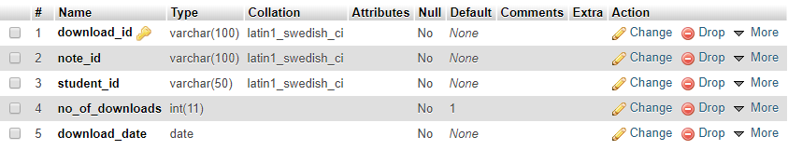

- NOTES

Notes table stores the list of the notes which are upload on the websites by many users. It has id of note (primary key), document name, type of the document, name of the notes, author id, subject to which notes belongs, date of uploads, number of views, remarks and registered will be Y when the user is registered and N when the user is not registered.
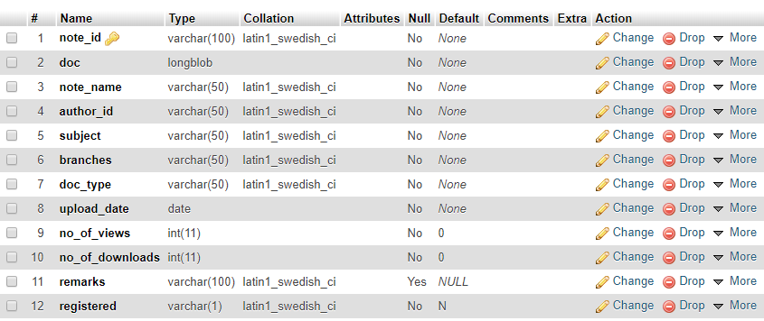

- STUDENT

Student table keeps records of the students which are registered into the websites. So whenever the user tries to login it checks in students table that whether the user is registered or not, if yes then it allows the user to be log in. The table has student id, username, email, phone number, university, branch, password and user photo, registered will be Y when the user is registered and N when the user is not registered.

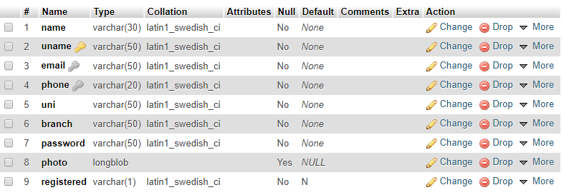

CHAPTER - 5

IMPLEMENTATION

5.1 USER MODULES

5.1.1 HOME PAGE

This is the main page of our websites. The initial page of the websites so whenever the user visit the sites, this page will open to attract the visitors.

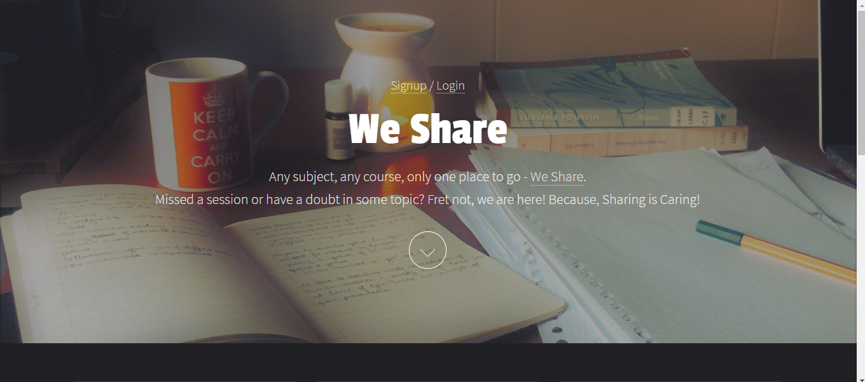

5.1.2 REGISTRATION PAGE

This is the registration page of the websites where the user enters his/her details on this page and then creates the user accounts.

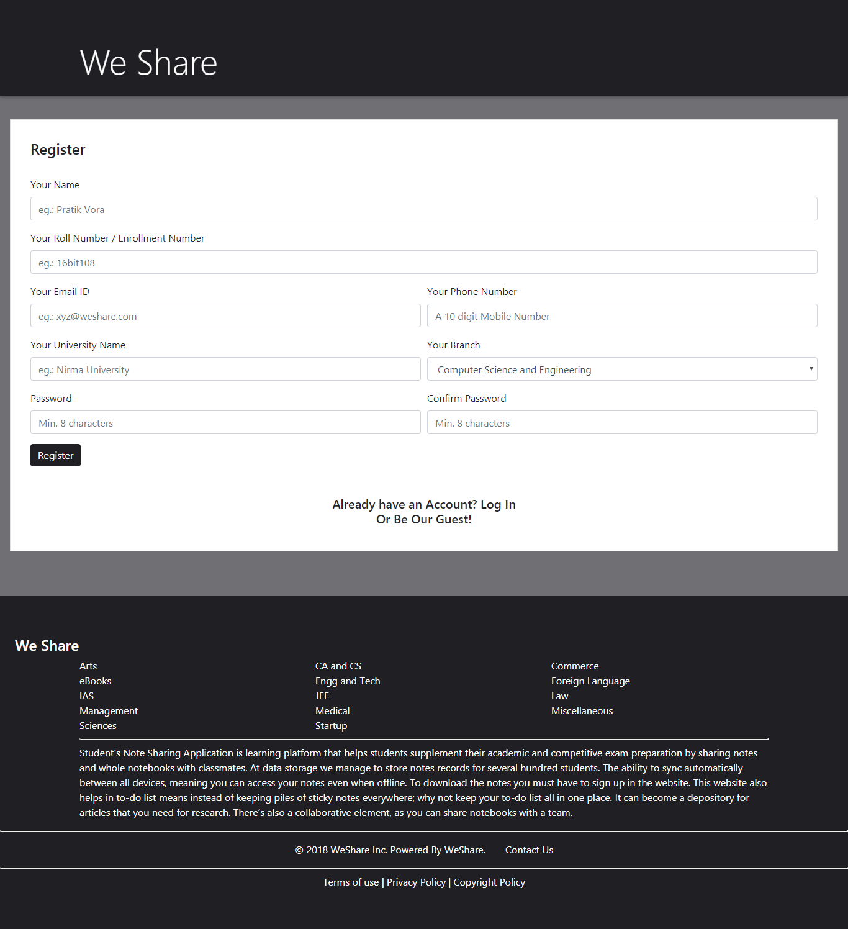
5.1.3 LOGIN PAGE

Login page is the page when the registered users enter their registration ID/ mobile number and password. If this information is correct then only the user will be log in into the websites.

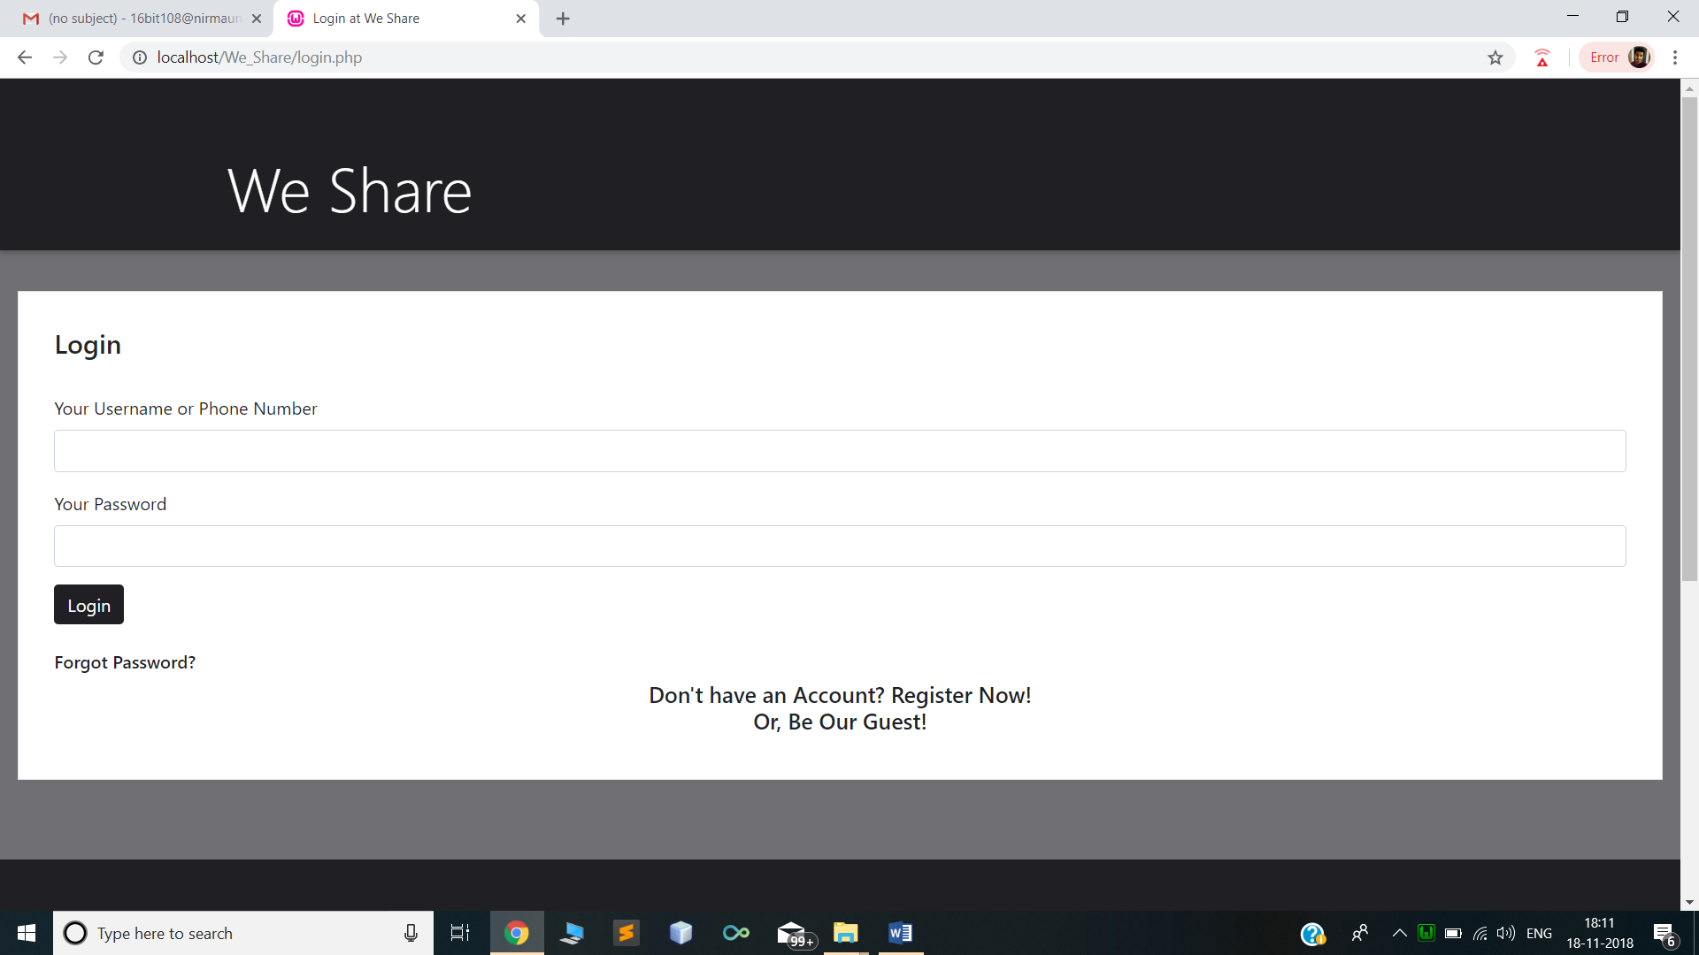

5.1.4 FORGET PASSWORD

Forget password page is the page whenever the user forgot their password, they can go to this page and enter their registration ID/mobile number. And their password is fetched from the database table of student details and mail to the user on their mail id entered by them while registration.
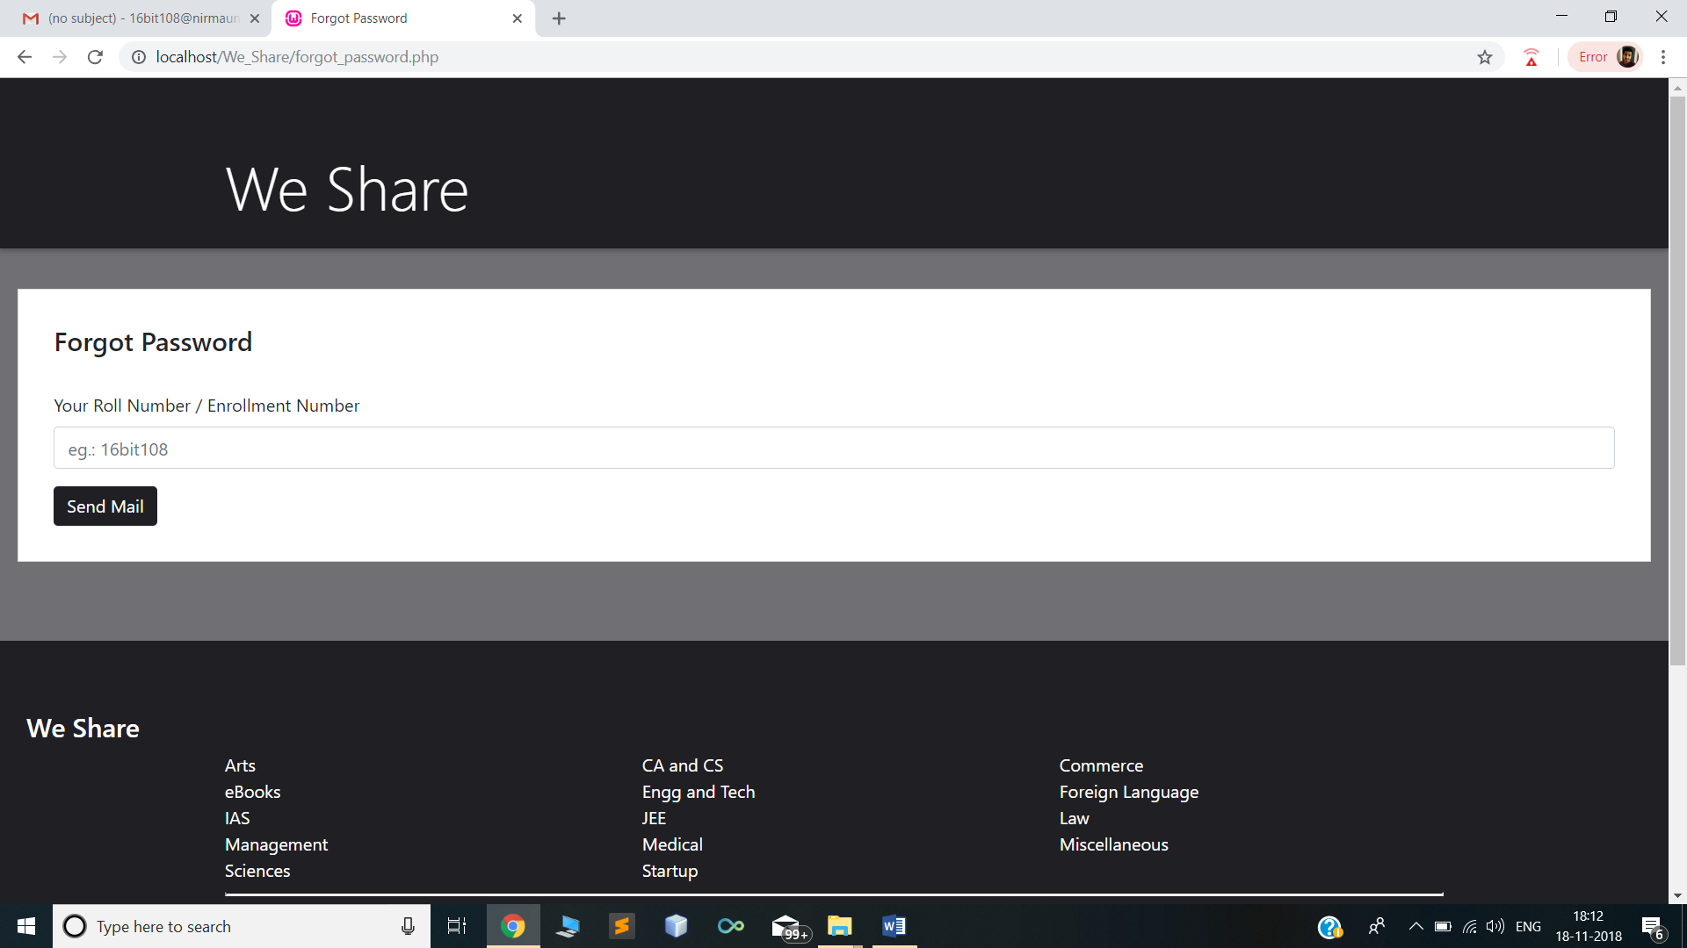

5.1.5 CHANGE DETAILS

This is the page where user can view/change their details whenever they want too.

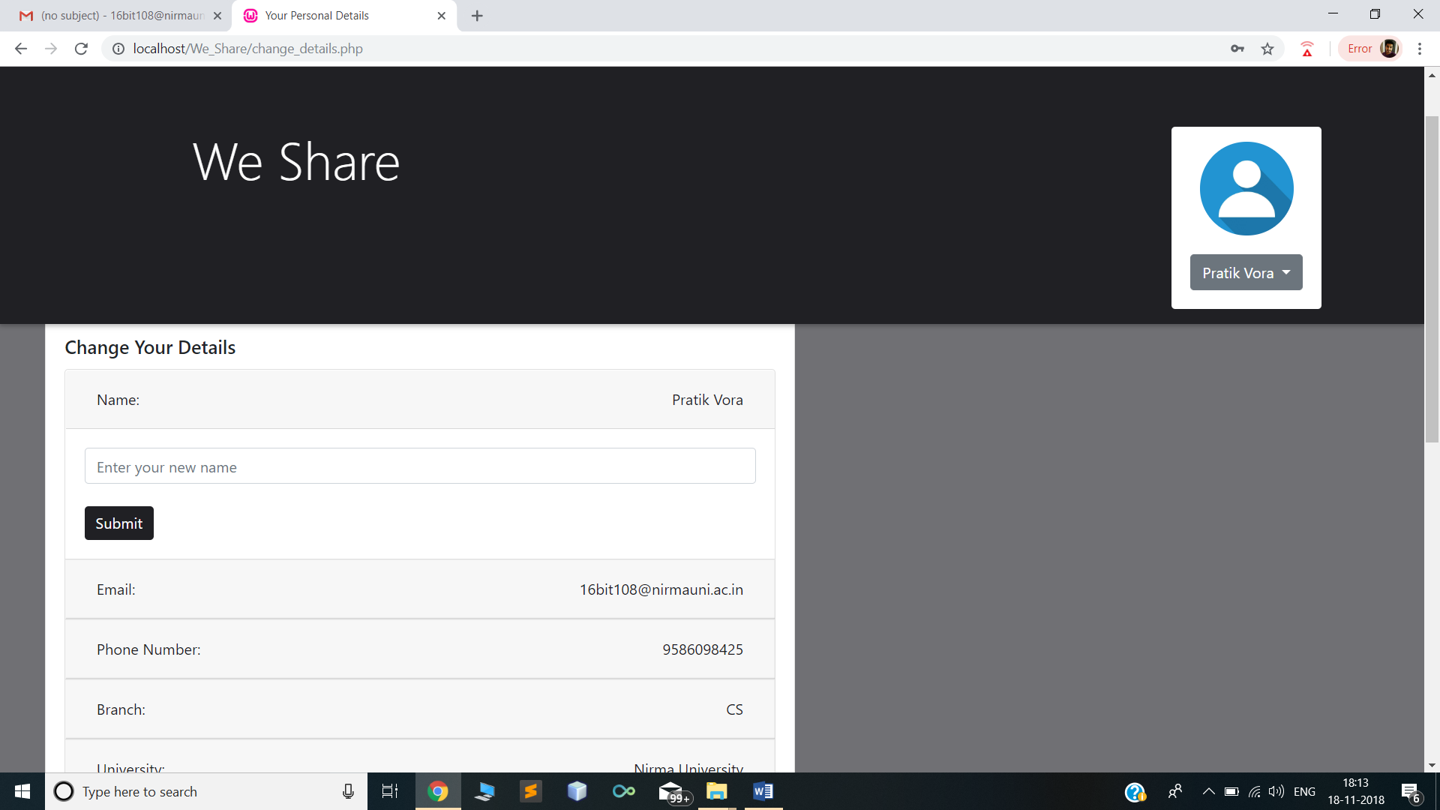

5.2 ADMIN MODULES

5.2.1 ADMIN

This is the admin page which is only handled and viewed by the websites administration. It is where the admin can create and add various functionality and manages the websites.

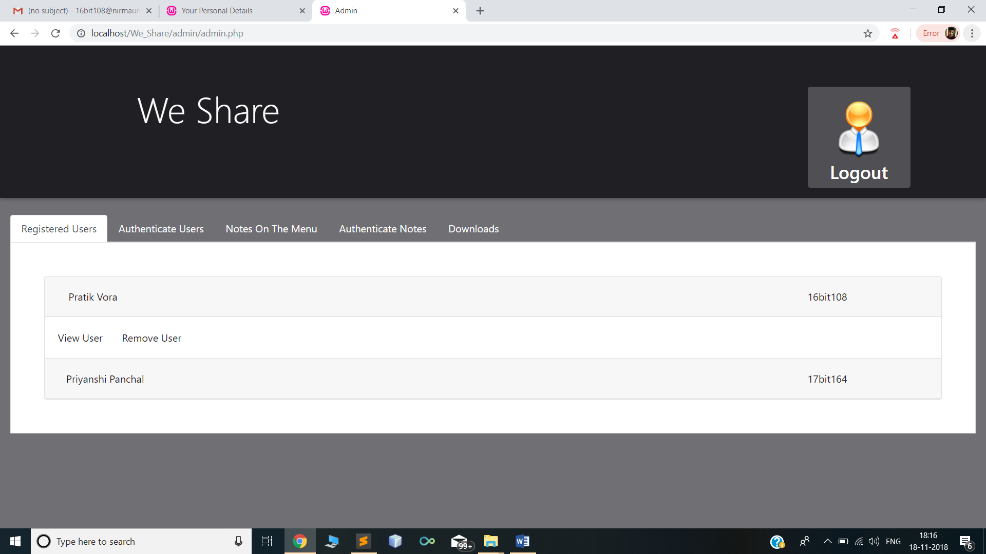

5.2.2 ACCEPT NOTES

User can only upload the notes after the permission of the admin, so if any user want to upload any notes it first come to admin, if the notes will be valuable in knowledge and helpful to others then only admin will allow that notes to be uploaded. And also the user should be registered user.
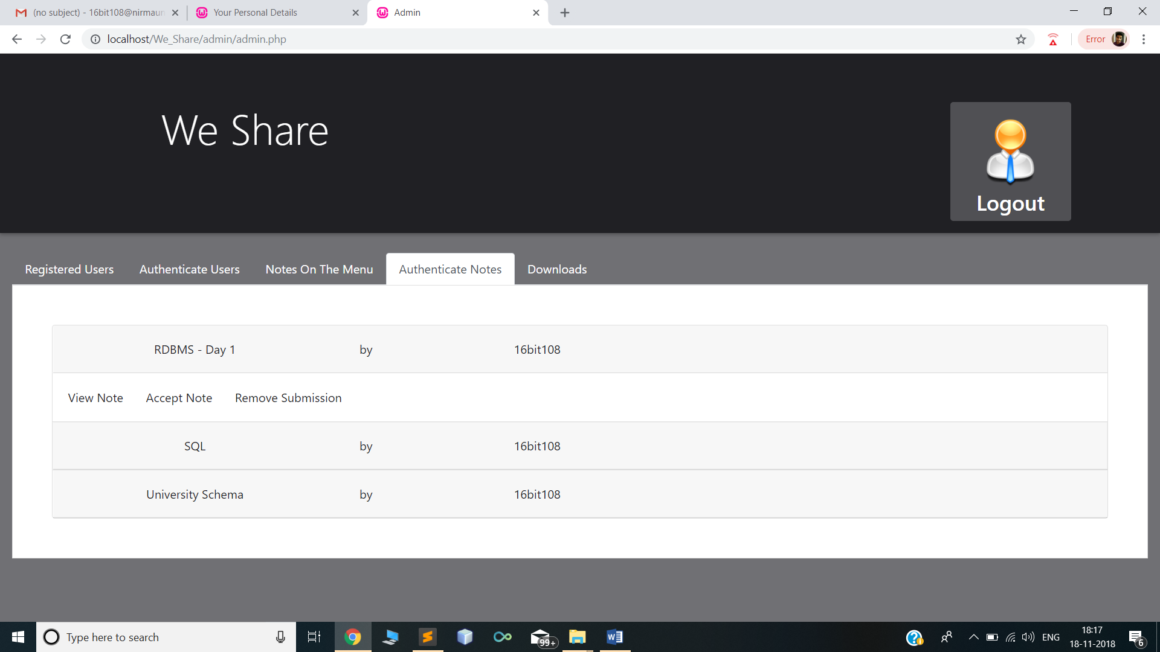

5.2.3 REMOVE NOTES

The notes which are uploaded by the user, can later be removed by the admin whenever he wants too.

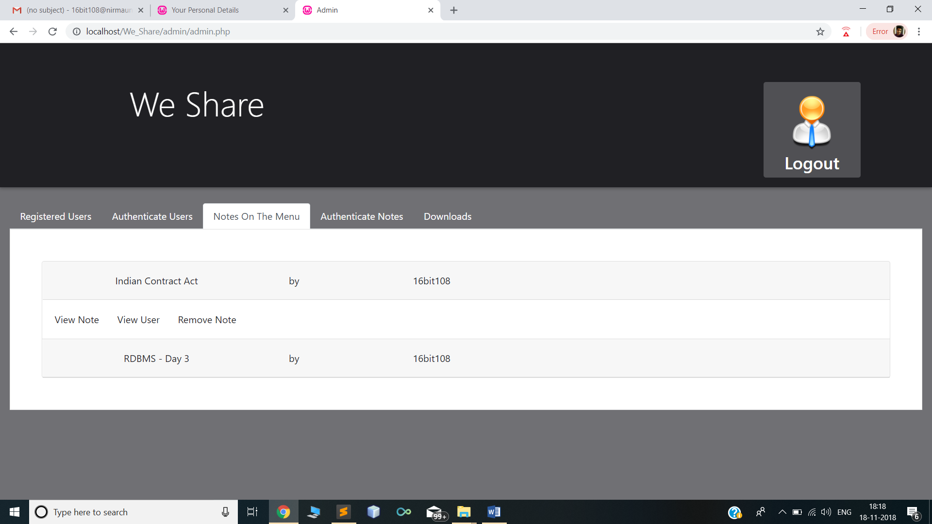

5.2.4 REMOVE USER

Admin has also an authority to remove the user from the websites.

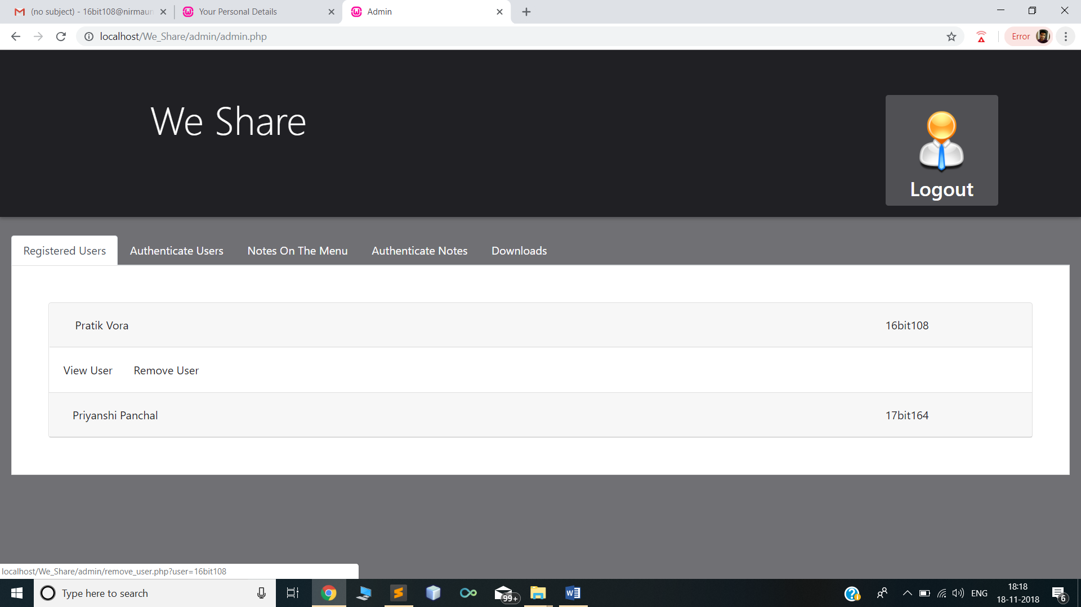

5.2.5 REMOVE REQUEST

User request the admin for giving the access to upload a particular notes. If the notes is valuable and helpful to other students then the admin will give access to it, if not he will remove the request of the user.

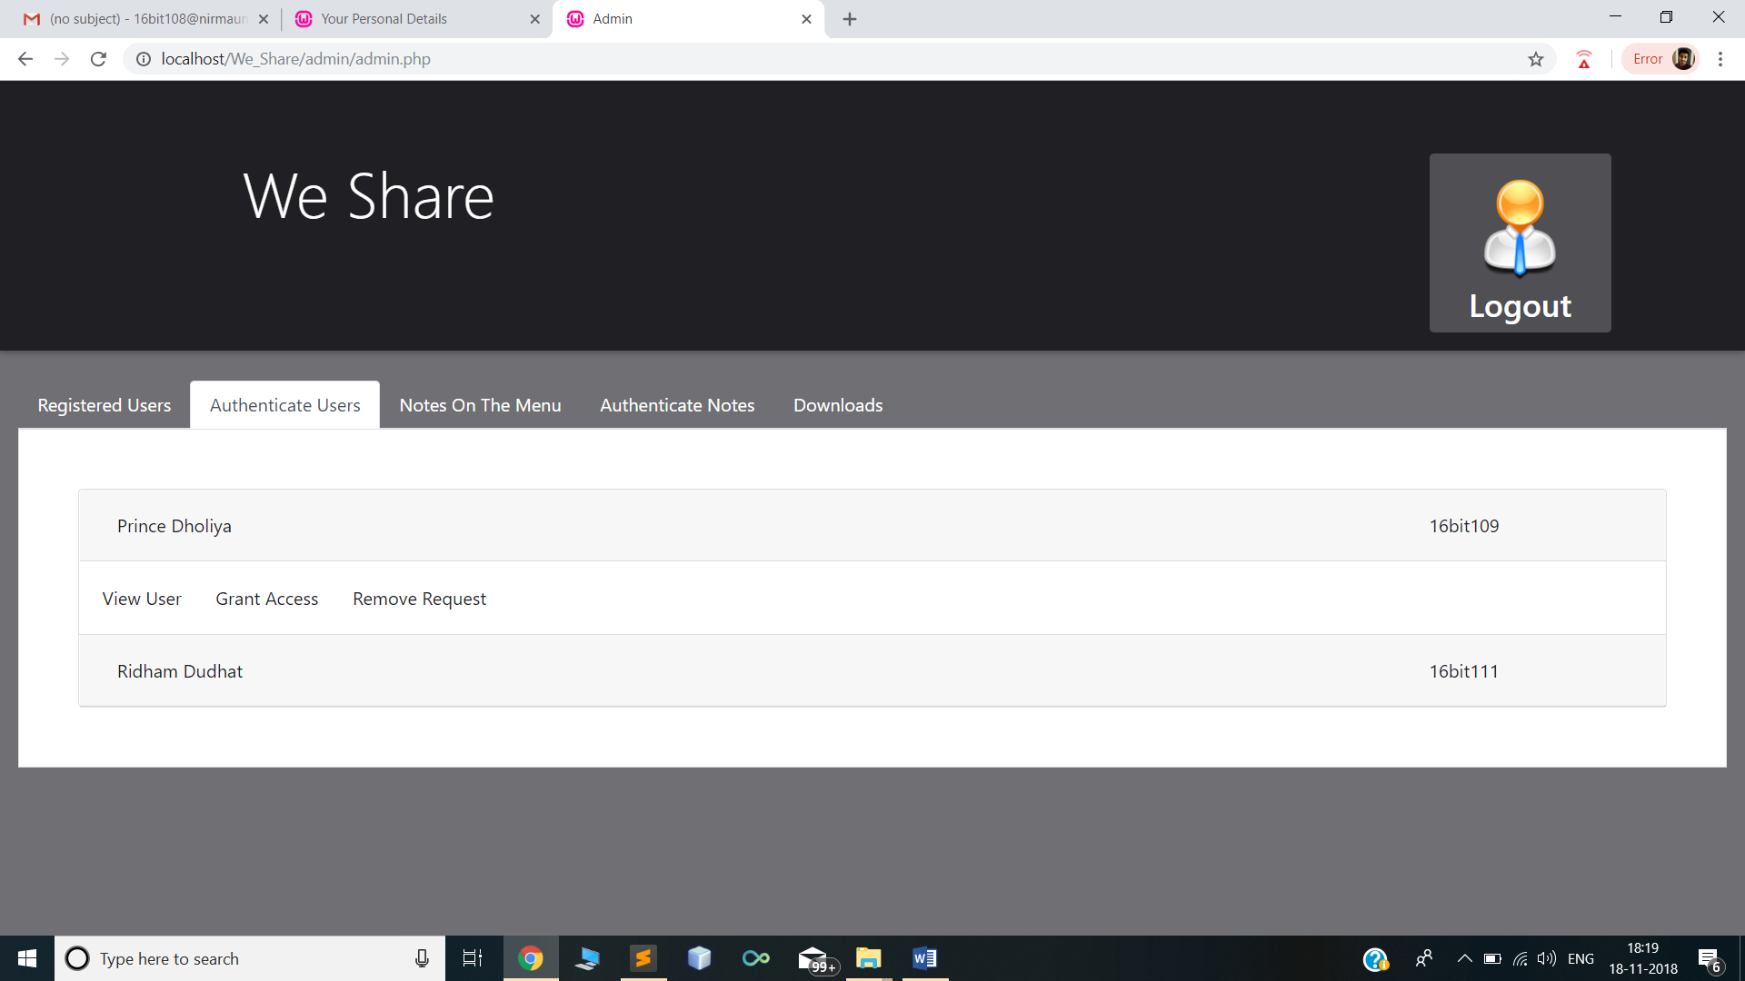

5.2.6 VIEW USER

Admin can also keep records of number of user are registered in the websites and the details about them. So later on admin can view the details of particular user.

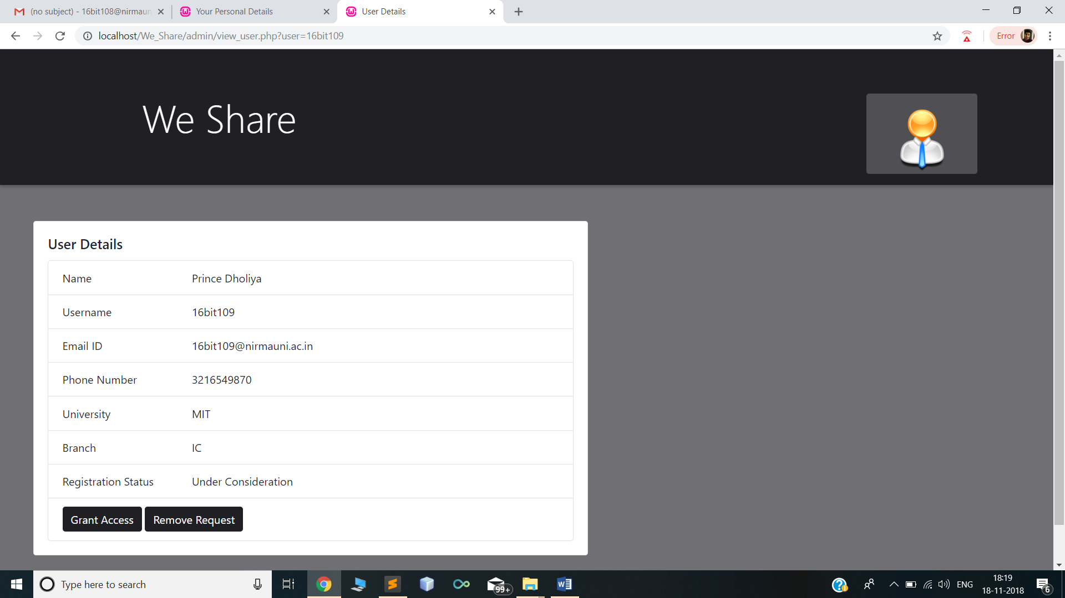

CHAPTER - 6

SUMMARY & CONCLUSION

6.1 SUMMARY

It is no wonder that today’s world is known as the world of Internet and web browsing has played a huge role in it. Also, it is crucial for every student to keep up with his curriculum and studies and a guide such as We Share can not only help them but also get them good scores.

A student can have the notes that he needs at his fingertips and this can help him in times when he might need to refer at the eleventh hour. Easy to view and light-weight web application is all we need. Also, it is based on the platform provided by Bootstrap. Hence, the view of the web application on both computers and mobile phones is similar making it more user friendly. It is a user app and the user can freely submit his notes and view any note that he/she wishes to.

6.2 CONCLUSION

I hereby conclude that we had made this application in such a way that user won’t faced any problem in getting the document. It is very efficient. User can easily search, view the notes, download the required notes and also upload the notes which can further be helpful for other student’s also.

REFERENCES

- Luke Welling, Laura Thomson, ‘PHP and MYSQL Web Development’, Dorling Kinderslen (India) Pvt. Ltd., 2001.
- Robin Nixon, ‘Learning PHP, MySQL, JavaScript, CSS & Html5: A Step-By-Step Guide to Creating Dynamic Websites’, O’ Reilly Media, Inc., 2009.

APPENDIX

- https://en.wikipedia.org/wiki/PHP
- https://en.wikibooks.org/wiki/PHP_Programming
- https://www.w3schools.com

