WEEK 3 TASK REPORT
Advanced Data Analysis and Visualization in Logistics
Exploratory data analysis, visualization and insight generation on a simulated Indian logistics dataset using Python
Prepared by: Pratik
Programme: MBA (Finance and Business Analytics), RTMNU
Tools: Python 3, pandas, NumPy, SciPy, Matplotlib, Seaborn
Date: 22 October 2026
Report at a glance
A hypothetical dataset of 2,500 shipments across 12 Indian cities and 4 transport modes was simulated, cleaned and analysed. Only 43.2% of shipments were on time. Delays were driven mainly by the monsoon quarter (Jul to Sep) and by Carrier D, while transport charges make up 86.4% of total cost. The report documents the dataset design, EDA, eight visualizations with justification, insights and recommendations.

1. Introduction and Objective
Logistics is a data-rich function. Every shipment generates information about distance, weight, transit time, delay and cost, and companies such as Delhivery, Blue Dart, Gati and the freight arms of Indian Railways and Tata-owned networks make routing, carrier and pricing decisions from this kind of data every day. This task builds the analytical skill needed to turn such raw shipment records into decisions.
The objective of this report is to deepen analytical skills by exploring, analysing and visualizing logistics data using Python. Specifically, the report:
- defines a hypothetical logistics dataset and its key variables (delivery times, shipment volumes, transportation costs);
- performs a thorough Exploratory Data Analysis (EDA) covering central tendencies, distributions and correlations;
- produces multiple visualizations of trends, distributions and relationships and justifies each chart choice;
- interprets the visualizations to draw conclusions about operational efficiency, cost drivers and bottlenecks; and
- documents the methodology, Python code and recommendations in a structured way.
Note on data
The dataset is simulated. Relationships such as the monsoon effect and the weaker performance of one carrier were deliberately built into the data-generating process so that the analysis has realistic patterns to detect. The findings therefore demonstrate the analytical method; they are not claims about any real company.

2. Hypothetical Logistics Dataset

2.1 Business scenario
A mid-sized third-party logistics (3PL) provider operates from eight hub cities (Mumbai, Delhi, Bengaluru, Chennai, Kolkata, Pune, Hyderabad, Ahmedabad) and delivers to twelve destinations, which also include Nagpur, Jaipur, Lucknow and Kochi. Shipments move by Road, Rail, Express Road or Air through four contracted carriers during calendar year 2025.

2.2 Structure and key variables
The dataset has 2,500 rows (one per shipment) and 22 columns. The table below lists the main variables.
Variable | Type | Description
shipment_id | Identifier | Unique shipment code (SHP100000 onwards)
ship_date | Date | Dispatch date, 1 Jan to 31 Dec 2025
origin / destination | Categorical | Hub city and delivery city
mode | Categorical | Road, Rail, Express Road, Air
carrier | Categorical | Carrier A, B, C, D
distance_km | Numeric | Route distance (log-normal, 80 to 2,800 km)
weight_kg / volume_m3 | Numeric | Shipment weight (right skewed) and volume
planned_days | Numeric | Promised transit time = distance / mode speed + handling days
actual_days / delay_days | Numeric | Realised transit time and the delay beyond plan
on_time | Binary | 1 if delay is 0.3 days or less (grace period), else 0
delay_reason | Categorical | Root cause recorded for delayed shipments
transport / fuel / handling / penalty | Numeric (Rs) | Four components of cost
total_cost, cost_per_km, cost_per_kg | Numeric (Rs) | Derived cost metrics
customer_rating | Numeric | Post-delivery rating on a 1 to 5 scale

2.3 How the data was simulated
A fixed random seed (42) makes the dataset reproducible. Distances and weights were drawn from log-normal distributions because both are positive and right skewed in real freight data. Planned transit time depends on distance and mode speed. The delay for each shipment was drawn from a gamma distribution whose mean increases for the monsoon months, the festive season (Oct and Nov), heavier loads, Rail and Road modes, and Carrier D. Costs were generated per mode with random noise, then a small share of missing values was injected in weight and customer rating to practise realistic data cleaning.

3. Methodology
The analysis followed a five-step workflow, implemented in a single reproducible Python script (logistics_analysis.py).
- Simulate: generate the dataset with NumPy and pandas and save it as logistics_dataset.csv.
- Clean: check missing values and duplicates; impute missing weights with the median of the shipment mode and missing ratings with the overall median.
- Describe: compute mean, median, mode, standard deviation, coefficient of variation and skewness; aggregate by mode, carrier, origin hub and month.
- Test: compute the correlation matrix, a one-way ANOVA across carriers and a Welch t-test for monsoon against non-monsoon delays.
- Visualize and interpret: build eight figures with Matplotlib and Seaborn, then translate patterns into insights and recommendations.

4. Exploratory Data Analysis

4.1 Data quality
The data had no duplicate shipment IDs. Missing values were found in weight_kg (25 rows, 1%) and customer_rating (75 rows, 3%). Both gaps are small, so imputation by median was preferred to dropping rows. The median is robust to the heavy right skew in weight and the left skew in ratings.

4.2 Central tendency and spread
Variable | Mean | Median | Std dev | Min | Max | Skew | CV %
Distance (km) | 847.18 | 744.00 | 453.33 | 85.0 | 2,800.0 | 1.21 | 54
Weight (kg) | 308.01 | 205.45 | 356.55 | 10.1 | 4,385.3 | 4.42 | 116
Planned days | 2.64 | 2.40 | 1.13 | 0.6 | 7.6 | 0.99 | 43
Actual days | 3.49 | 3.20 | 1.58 | 0.6 | 11.2 | 0.95 | 45
Delay (days) | 0.85 | 0.50 | 1.08 | 0.0 | 8.0 | 2.13 | 127
Total cost (Rs) | 10,207.53 | 6,338.00 | 13,312.81 | 916.0 | 2,42,036.0 | 6.10 | 130
Cost per km (Rs) | 11.96 | 8.23 | 11.40 | 3.0 | 190.1 | 4.52 | 95
Rating (1 to 5) | 4.44 | 4.60 | 0.65 | 1.0 | 5.0 | -1.76 | 15

Reading the table. Mean delivery time is 3.49 days against a median of 3.20 and a mode of about 3 days, so a typical shipment arrives in roughly three days but a long tail of slow shipments pulls the mean up. Total cost shows the strongest skew (6.1): the mean of Rs 10,208 is far above the median of Rs 6,338 because a few heavy, long-distance air shipments are very expensive. Using the interquartile-range rule, 256 shipments (10.2%) lie above the upper cost fence of Rs 20,281. Delay itself is highly variable (coefficient of variation 127%), which signals an unstable process. Customer rating is negatively skewed, with most customers rating 4.5 or above.

4.3 Performance by transport mode
Mode | Shipments | Avg days | Avg delay | On-time % | Avg cost (Rs) | Cost / km (Rs)
Road | 1,272 | 3.75 | 0.88 | 42.0 | 7,026 | 8.60
Express Road | 475 | 2.96 | 0.74 | 47.0 | 9,925 | 12.70
Rail | 501 | 4.26 | 1.03 | 36.5 | 4,939 | 6.09
Air | 252 | 1.60 | 0.57 | 55.2 | 37,272 | 39.21

Air is the fastest (1.6 days) but costs about 7.5 times as much as Rail per shipment. Rail is the cheapest but slowest and has the lowest on-time rate (36.5%). Express Road sits in the middle: it is about 1.3 days faster than Rail and costs roughly a quarter of Air.

4.4 Performance by carrier
Carrier | Shipments | Avg delay (days) | On-time % | Avg cost (Rs) | Avg rating
Carrier A | 860 | 0.68 | 50.0 | 10,502 | 4.54
Carrier B | 726 | 0.94 | 39.5 | 10,329 | 4.39
Carrier C | 554 | 0.79 | 46.4 | 9,317 | 4.44
Carrier D | 360 | 1.15 | 29.2 | 10,630 | 4.31

4.5 Correlations and statistical tests
Test / measure | Result | Interpretation
Correlation: distance and total cost | r = 0.42 | Moderate positive; cost rises with distance but mode matters too
Correlation: weight and total cost | r = 0.33 | Moderate positive; heavier loads cost more
Correlation: distance and actual days | r = 0.51 | Longer routes take longer, as expected
Correlation: delay and customer rating | r = -0.78 | Strong negative; delays directly hurt satisfaction
ANOVA: delay across 4 carriers | F = 19.09, p < 0.001 | Carrier delays differ significantly
Welch t-test: monsoon vs other months | t = 13.69, p < 0.001 | Mean delay 1.47 vs 0.65 days

5. Visualizations and Justification
Each chart below was chosen for the specific question it answers. For every figure the report states why that chart type was selected and what it shows.

5.1 Distribution of delivery time and delay
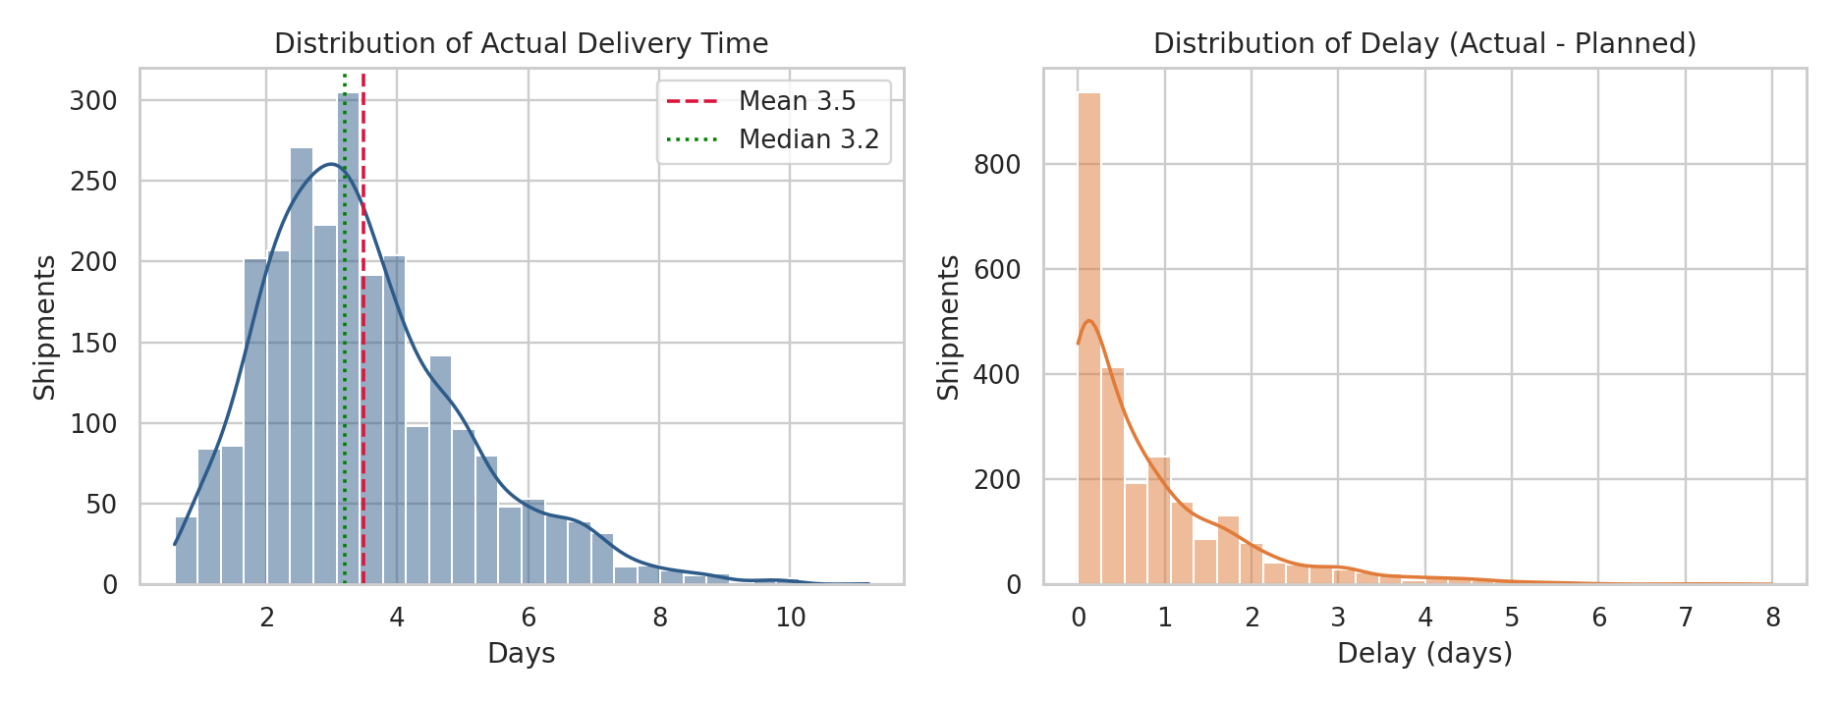
Figure 1: Histograms with KDE of actual delivery time and delay
Why a histogram with a density curve: the question is about the shape of a single numeric variable. A histogram shows where most shipments fall, and the overlaid KDE smooths sampling noise. The mean and median lines make skew visible at once.
Interpretation: delivery time is right skewed, with the mean (3.5 days) to the right of the median (3.2 days). The delay histogram has a large spike at zero and a long tail; a minority of shipments account for most of the lost days. Operations should therefore target the tail, not the average.

5.2 Delivery time and delay by transport mode
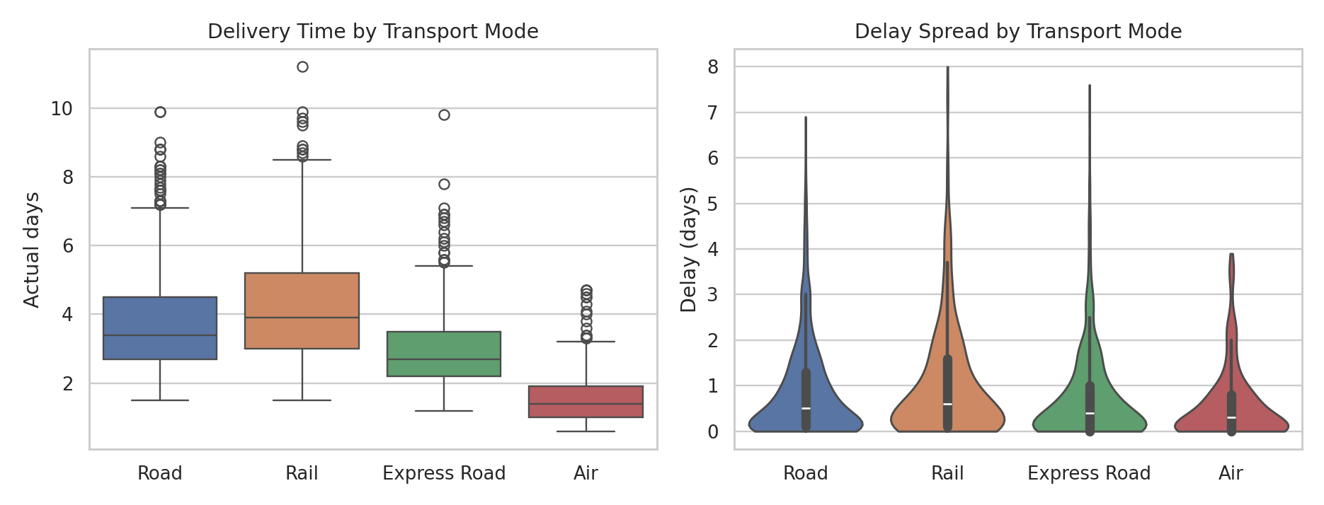
Figure 2: Box plot of delivery time and violin plot of delay by mode
Why box and violin plots: comparing a numeric variable across categories needs the median, spread and outliers per group. The box plot gives the quartiles and outliers; the violin plot adds the full density, which shows how delay is concentrated near zero for Air and spread widely for Rail.
Interpretation: Air is both fastest and most predictable. Rail has the highest median delivery time and a wide delay spread, so it is cheap but unreliable. Road and Express Road show many high outliers, which points to exposure to congestion and weather.

5.3 Monthly volume and on-time performance
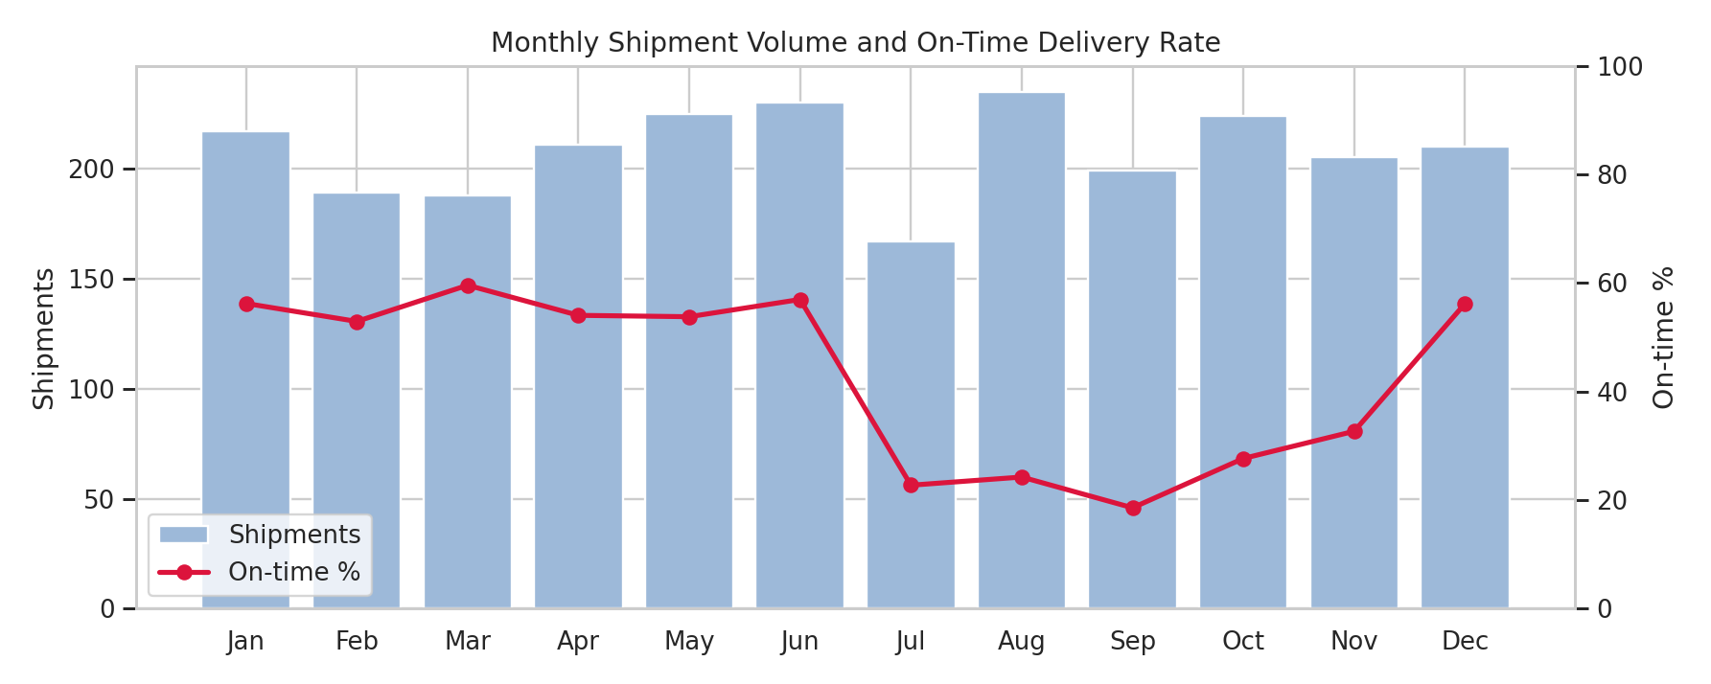
Figure 3: Monthly shipment volume (bars) and on-time rate (line)
Why a dual-axis bar and line chart: a time trend of two related metrics with different units (counts and percentages). Bars show volume while the line shows service level, so a reader can check whether performance falls when volume rises.
Interpretation: on-time performance is stable at about 53 to 60% from January to June, then collapses to 23%, 24% and 19% in July to September, the monsoon quarter, and recovers only partially in the festive months (28% in October, 33% in November) before returning to 56% in December. Volume does not rise in these months, so the drop is caused by conditions, not by overload.

5.4 Distance versus cost
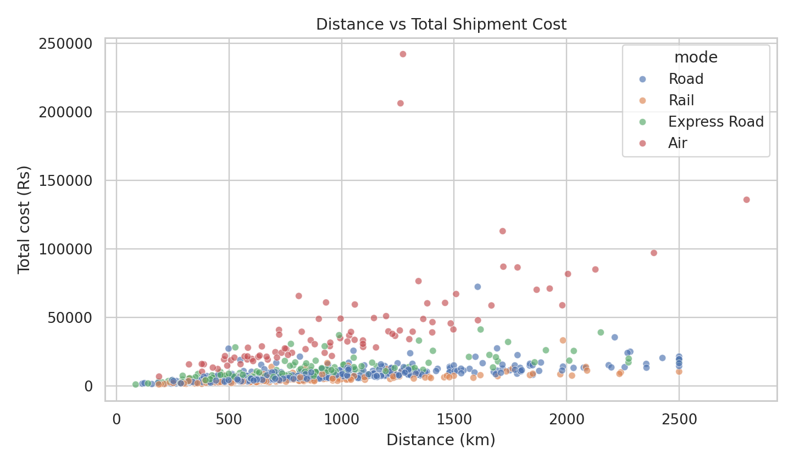
Figure 4: Scatter plot of distance against total cost, coloured by mode
Why a scatter plot with colour: the question is the relationship between two continuous variables, and the colour adds the third dimension (mode). A scatter plot shows both the trend and the clusters that a single correlation coefficient hides.
Interpretation: cost increases with distance, but each mode follows its own slope. Air forms a steep, separate band at the top, while Rail and Road stay near the bottom. This explains why the overall correlation is only moderate: mode choice changes the cost of a kilometre far more than distance itself.

5.5 Correlation matrix
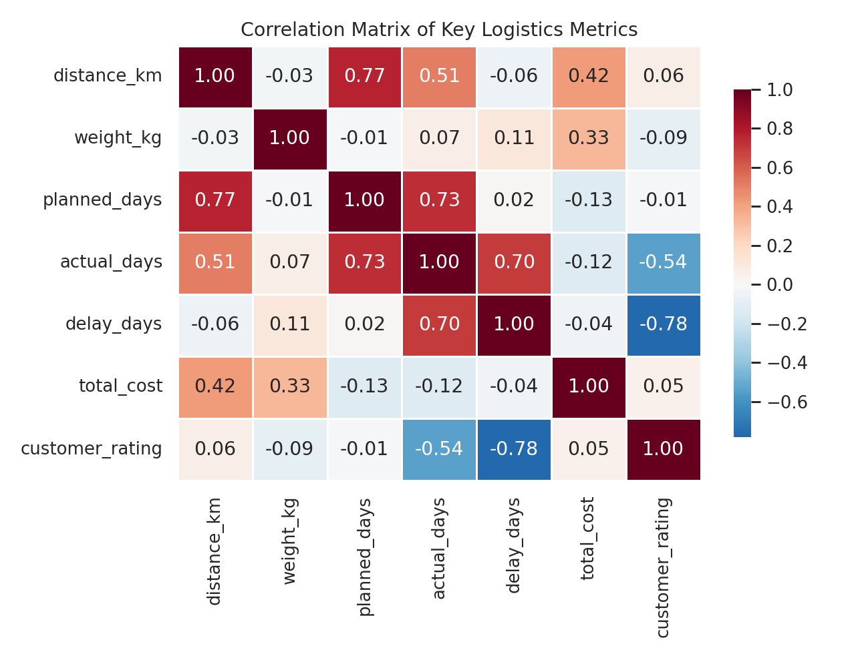
Figure 5: Correlation heatmap of key logistics metrics
Why a heatmap: with seven numeric variables there are 21 pairs, which is too many to read from a table. A diverging colour scale shows the strength and sign of every relationship at a glance.
Interpretation: the standout is the strong negative link between delay and customer rating (r = -0.78). Distance relates to actual days (0.51) and to cost (0.42). Planned days and distance are almost perfectly related by design, so planned days adds little independent information.

5.6 Carrier and hub performance
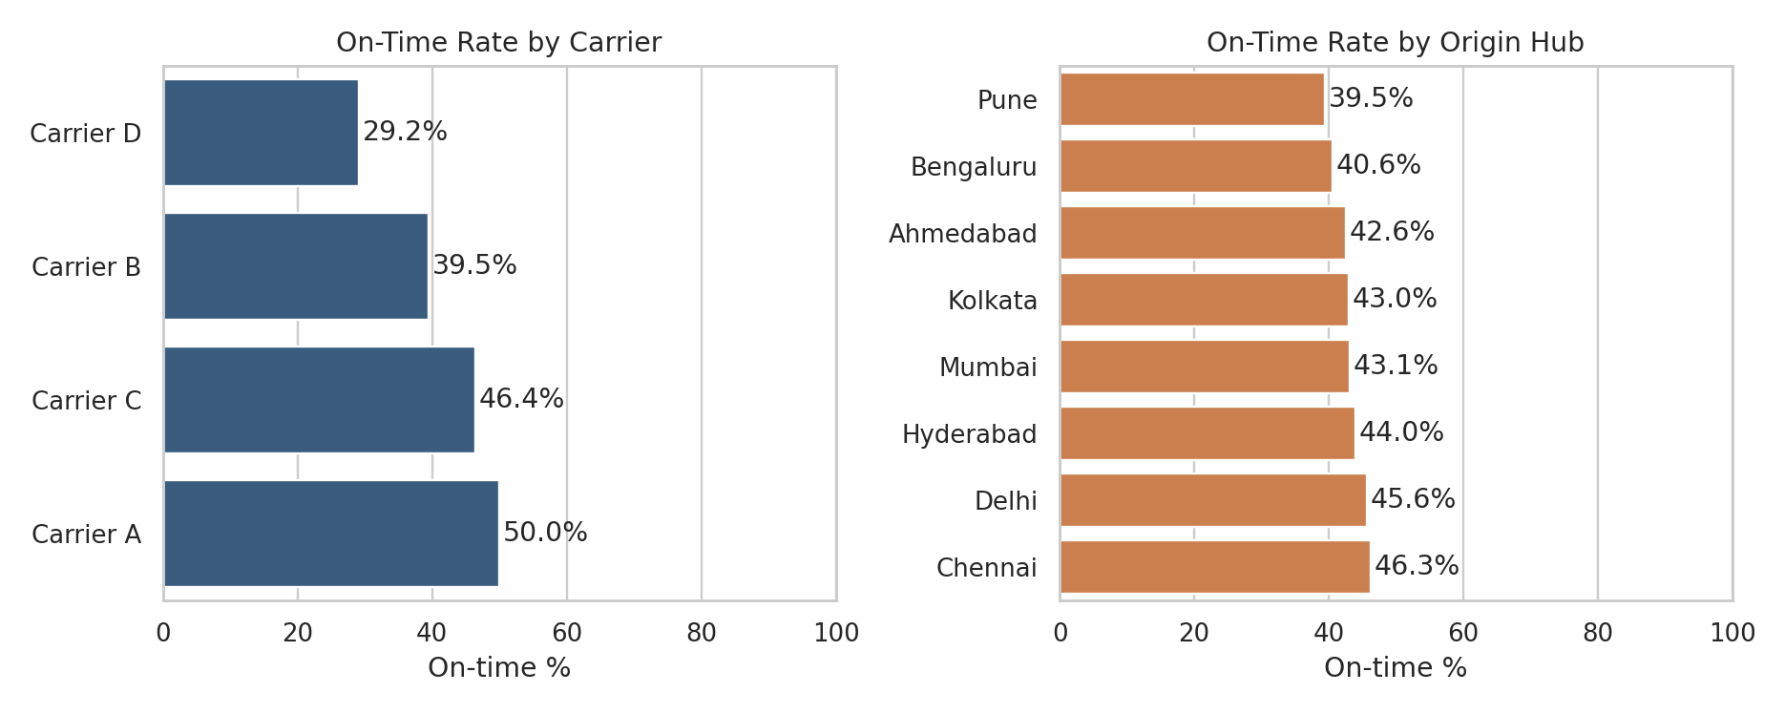
Figure 6: On-time rate by carrier and by origin hub
Why horizontal bar charts: ranking categories by a single metric is the job of a bar chart; horizontal bars keep the labels readable and sorted order makes the best and worst performers obvious. Both axes start at zero to avoid exaggerating differences.
Interpretation: Carrier A leads with 50.0% on-time, while Carrier D trails at 29.2%, and the ANOVA confirms the difference is statistically significant. Hub differences are much smaller (39.5% to 46.3%), so carrier selection matters more than origin city.

5.7 Cost structure and root causes of delay
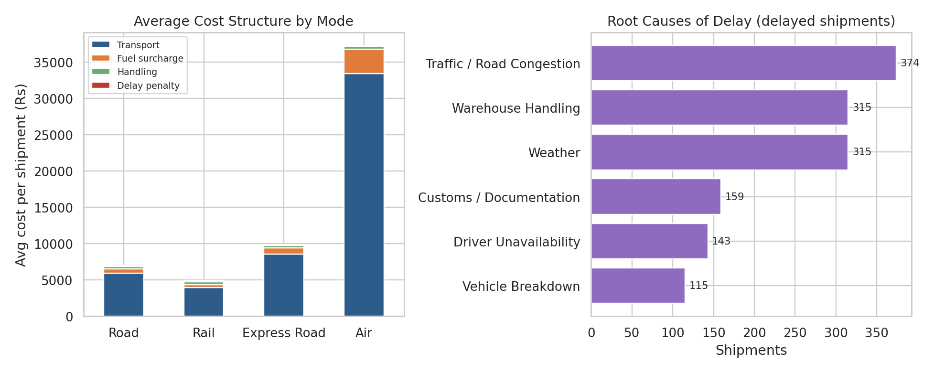
Figure 7: Stacked cost components by mode and ranked causes of delay
Why a stacked bar and a ranked bar: the stacked bar shows how a total is built from parts, per mode. The ranked bar is a Pareto-style view that identifies which causes deserve attention first.
Interpretation: transport charges are 86.4% of all spend, fuel surcharge 8.7%, handling 3.5% and direct delay penalties only 1.5%. Among delayed shipments, traffic or congestion (26.3%) is the top cause, followed by warehouse handling and weather (22.2% each). Warehouse handling is the largest cause that the company controls directly.

5.8 Hub and month heatmap
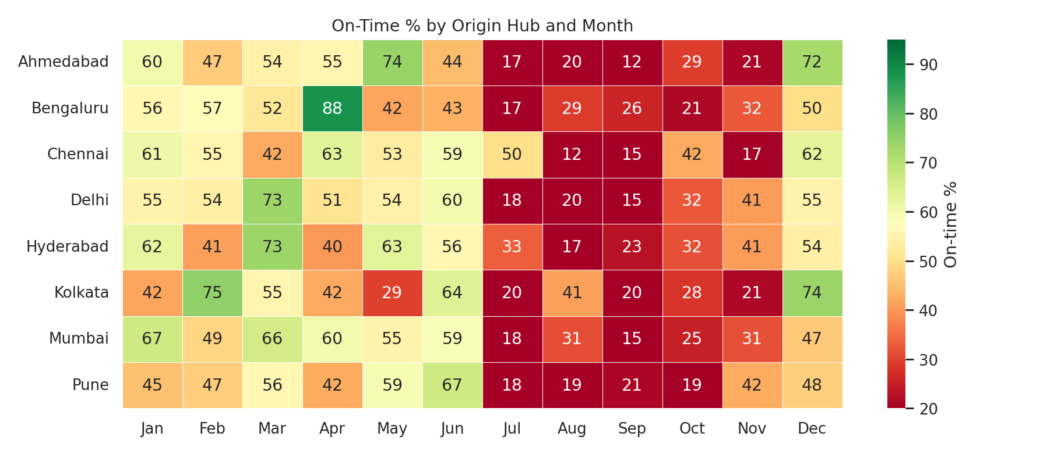
Figure 8: On-time percentage by origin hub and month
Why a two-way heatmap: it combines two categorical dimensions (hub and month) with one metric, which exposes local problem spots that the separate charts above average away.
Interpretation: the red band from July to October runs across every hub, confirming the problem is network-wide and seasonal. The weakest cell is Chennai in Aug (12% on-time) and the strongest is Bengaluru in Apr (88%). Some of the cell-level variation reflects small sample sizes, so single cells should be read as hints rather than conclusions.

6. How the Visualizations Help Interpret Logistics Performance Metrics
Logistics performance is judged on a small set of metrics. The table maps each metric to the visualization that explains it best and the decision it supports.
Metric | Best visualization | Question it answers | Decision supported
Transit time | Histogram, box plot | How long does delivery take and how variable is it? | Promise realistic delivery dates
On-time delivery % | Trend line, bar, heatmap | When, where and with whom do we fail? | Carrier review, seasonal planning
Delay (days) | Violin plot | How severe is the tail of late shipments? | Escalation and buffer stock rules
Cost per km / shipment | Scatter, stacked bar | What drives cost and what is mode-driven? | Mode mix and pricing
Delay root cause | Ranked bar (Pareto) | Which cause should be fixed first? | Process improvement priorities
Customer rating | Correlation heatmap | How much do delays hurt satisfaction? | Service level targets

Without visualization, these patterns are buried in 2,500 rows. For example, a summary table gives the average on-time rate of 43%, which hides that it is above 50% for six months and below 25% for three. Charts let a manager see the cause, the timing and the size of a problem together.

7. Analytical Insights

7.1 Operational efficiency
- Service level is weak overall. Only 43.2% of shipments arrive within the grace period, and delayed shipments are late by 1.43 days on average.
- Seasonality is the dominant factor. Monsoon-quarter shipments are delayed 1.47 days on average against 0.65 days in other months, a statistically significant gap (p < 0.001).
- Mode matters for reliability. Rail has the lowest on-time rate (36.5%) and the longest delivery time (4.3 days); Air is most reliable but expensive.
- Carrier quality differs. Carrier D carries 360 shipments at 29.2% on-time, about 21 percentage points below Carrier A.

7.2 Cost drivers
- Mode choice is the biggest cost lever. Air costs about Rs 39 per km against Rs 6 for Rail, so the share of Air in the mix drives the cost average.
- Transport charges dominate at 86.4% of total spend (Rs 255 lakh in total, about Rs 2.55 crore). Fuel surcharge adds 8.7%.
- Hidden cost of delay. Direct penalties are only 1.5% of spend, but delay and rating have a correlation of -0.78. The real cost of lateness is lost customer satisfaction, which this cost table does not capture.
- Costs are heavily skewed. About 10% of shipments are high-cost outliers; pricing and budgeting based on the average would be misleading.

7.3 Potential bottlenecks
- Road congestion is the single largest cause of delay (26.3% of delayed shipments).
- Warehouse handling (22.2%) is as large as weather and is fully within the company's control.
- Customs and documentation (11.2%) is concentrated in air shipments and is a process rather than a physical bottleneck.
- Peak season, Jul to Nov, is the network-wide bottleneck: no hub escapes the drop in on-time performance.

8. Recommendations
# | Recommendation | Evidence | Expected benefit
1 | Build monsoon buffers: add 1 to 1.5 days to promised delivery times and pre-position stock from June | Delay 1.47 vs 0.65 days; on-time under 25% in Jul to Sep | Fewer missed promises; better customer experience
2 | Reallocate volume away from Carrier D or put it on a performance improvement plan | 29.2% on-time; ANOVA p < 0.001 | Higher network on-time rate at similar cost
3 | Use Express Road instead of Rail for time-critical, mid-distance loads | Express: 3.0 days at Rs 9,925; Air: Rs 37,272 | Faster than Rail at about a quarter of the cost of Air
4 | Run a warehouse dwell-time audit and add cut-off time rules | Warehouse handling causes 22.2% of delays | Removes the largest controllable cause
5 | Add real-time route monitoring and dynamic rerouting on congested corridors | Congestion causes 26.3% of delays | Shorter tail of late shipments
6 | Track customer rating as a KPI beside on-time %, and report medians with averages | r = -0.78; cost skew 6.1 | Decisions based on service impact and robust statistics

9. Python Code Excerpts
The full script (logistics_analysis.py) and dataset (logistics_dataset.csv) accompany this report. Key excerpts follow.

9.1 Simulating the dataset
import numpy as np, pandas as pd
np.random.seed(42)
N = 2500
df["distance_km"] = np.random.lognormal(6.6, 0.55, N).clip(80, 2500)
df["weight_kg"] = np.random.lognormal(5.3, 0.9, N).clip(10, 8000)
speed = {"Road": 450, "Rail": 380, "Air": 1800, "Express Road": 650}
df["planned_days"] = df["distance_km"] / df["mode"].map(speed) + 1.0

# delay: gamma distribution whose mean rises in monsoon, festive months, bad carriers
delay_mean = 0.25 + 0.9*monsoon + 0.6*festive + 0.0003*df["weight_kg"] \
+ 1.5*carrier_risk + 2.0*mode_risk
df["delay_days"] = np.random.gamma(1.6, delay_mean/1.6) - 0.35
df["actual_days"] = df["planned_days"] + df["delay_days"].clip(0, 8)
df["on_time"] = (df["delay_days"] <= 0.3).astype(int)

9.2 Cleaning and descriptive statistics
print(df.isna().sum()) # weight_kg: 25, customer_rating: 75
df["weight_kg"] = df["weight_kg"].fillna(
df.groupby("mode")["weight_kg"].transform("median"))
df["customer_rating"] = df["customer_rating"].fillna(df["customer_rating"].median())

desc = df[num_cols].describe().T
desc["median"] = df[num_cols].median()
desc["skew"] = df[num_cols].skew()
desc["cv_%"] = desc["std"] / desc["mean"] * 100

by_mode = df.groupby("mode").agg(shipments=("shipment_id", "count"),
avg_days=("actual_days", "mean"),
on_time_pct=("on_time", lambda s: s.mean()*100),
avg_cost=("total_cost", "mean"))

9.3 Correlation and hypothesis tests
from scipy import stats
corr = df[corr_cols].corr()
F, p = stats.f_oneway(*[g["delay_days"] for _, g in df.groupby("carrier")])
monsoon = df[df.ship_date.dt.month.isin([7, 8, 9])]["delay_days"]
other = df[~df.ship_date.dt.month.isin([7, 8, 9])]["delay_days"]
t, p2 = stats.ttest_ind(monsoon, other, equal_var=False) # Welch t-test

9.4 Visualization code (examples)
import matplotlib.pyplot as plt, seaborn as sns
sns.set_theme(style="whitegrid")

# Fig 1: distribution with KDE and mean/median markers
sns.histplot(df["actual_days"], bins=30, kde=True)
plt.axvline(df["actual_days"].mean(), color="crimson", ls="--")

# Fig 2: delivery time by mode
sns.boxplot(data=df, x="mode", y="actual_days", order=mode_order)

# Fig 5: correlation heatmap
sns.heatmap(corr, annot=True, fmt=".2f", cmap="RdBu_r", center=0)

# Fig 8: hub x month on-time heatmap
pv = df.pivot_table(index="origin", columns="month_name",
values="on_time", aggfunc="mean") * 100
sns.heatmap(pv, annot=True, fmt=".0f", cmap="RdYlGn", vmin=20, vmax=95)

9.5 Pseudocode of the full pipeline
1. SET random seed; DEFINE cities, modes, carriers
2. FOR each of 2,500 shipments:
DRAW origin, destination, mode, carrier, date
DRAW distance and weight from log-normal distributions
COMPUTE planned_days from distance and mode speed
DRAW delay from gamma(mean depends on season, carrier, mode, weight)
COMPUTE costs, total_cost, cost_per_km, rating
3. INJECT a small share of missing values; SAVE CSV
4. CLEAN: impute missing weight by mode median, rating by overall median
5. DESCRIBE: mean, median, mode, std, skew, CV; group by mode/carrier/hub/month
6. TEST: correlation matrix, ANOVA (carrier), Welch t-test (monsoon)
7. PLOT: histograms, box/violin, trend, scatter, heatmaps, bars
8. EXPORT charts and results; INTERPRET and RECOMMEND

10. Conclusion
This task applied the full analytical cycle (data design, cleaning, EDA, visualization and interpretation) to a simulated logistics dataset of 2,500 shipments. The analysis shows that service performance is mainly a seasonal and carrier problem rather than a hub problem, that mode choice is the main cost lever, and that delays carry a large hidden cost through customer satisfaction. The charts made each of these findings visible in a way that summary tables could not.
Limitations. The data is synthetic, so effect sizes reflect the assumptions built into the simulation. Real data would also bring effects not modelled here, such as vehicle type, route-level congestion, fill rate and fuel price changes. Future work could apply the same pipeline to real shipment data, add a predictive model for delay risk (for example logistic regression or gradient boosting), and build a Power BI dashboard on top of the cleaned dataset.

