**Experiment No 2**

Q.1 Check the no is Even or Odd.

/*Program to check whether entered no is even or odd */

/*Declaration Section(header files,variable declaration if)*/

%{#include<stdio.h>

#include<stdlib.h>

%}

/*Rules section*/

%%

[+-]?[0-9]+ {

int i=atoi(yytext);

if(i%2==0){

printf("It is Even Number");

}

else{

printf("It is odd Number");}

}

.* {

printf("Invalid input");}

%%

int yywrap(){} //main section

int main(){

yylex();

return 0;

}

Output:

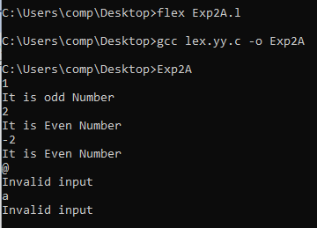

Q.2 Program to check wheather entered character is Vowel or Consonent

/*Program to check wheather entered character is Vowel or Consonent*/

%{

#include<stdio.h>

int vowel=0;

int conso=0;

%}

%%

"a"|"e"|"i"|"o"|"u"|"A"|"E"|"I"|"O"|"U" {printf("Entered character is Vowel");vowel++;}

[a-zA-Z] {printf("Enter character is consonent");conso++;}

.* {printf("Invalid Input");}

%%

int yywrap(){}

int main(){

printf("Enter the characters:");

yylex();

return 0;}

Output:

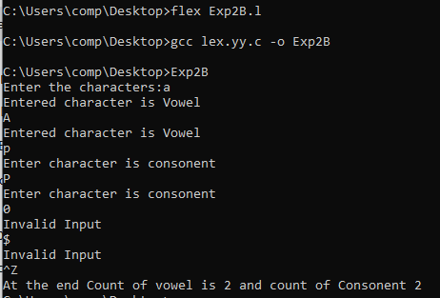

Q.3 Program for counting no of characters or numbers.

%{

#include<stdio.h>

int i=0;

%}

%%

[a-zA-Z0-9] {i++;}

"\n" {printf("Count: %d\n",i);i=0;}

. {}

%%

int yywrap(){}

int main(){

yylex();

return 0;

}

Output:

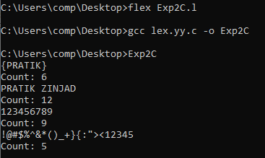

Q.4 To identify relational operators.

%{

#include <stdio.h>

#include <stdlib.h>

%}

%option noyywrap

%%

== { printf("Encountered IsEqual to operator.\n"); }

!= { printf("Encountered Not equal to operator"); }

> { printf("Encounter Greater than operator"); }

>= { printf("Encounter Greater than equal to operator"); }

\< { printf("Encounter less than operator"); }

\<= { printf("Encounter less than equal to operator"); }

. { printf("Invalid input"); }

%%

int main() {

printf("Enter input:\n");

yylex();

return 0;

}

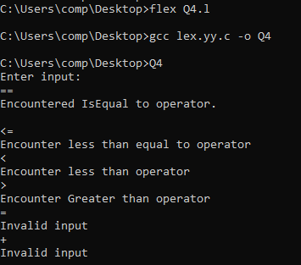

Q.5 To Copy the content from one file to another.

%{

#include <stdio.h>

#include <stdlib.h>

FILE *outFile;

%}

%option noyywrap

%%

. {fputc(yytext[0],outFile);}

%%

int main(int argc,char *argv[]) {

if(argc!=3){

printf("You should give lexfilename inputfile outputfile");

return 0;

}

FILE *inFile=fopen(argv[1],"r");

if(inFile==NULL){

printf("There is error while opening file");

return 0;

}

outFile=fopen(argv[2],"w");

if(outFile==NULL){

printf("There is error while opening file");

return 0;

}

yyin=inFile;

yylex();

printf("File copied successfully.");

return 0;

}



