##### PHARMACY MANAGEMENT SYSTEM



**Submitted to the**

**Department of Master of Computer Applications**

**in partial fulfilment of the requirements**

**for the MCAE07-NoSQL Databases Laboratory**

**by**

**PRATIM DUTTA**

**1MS18MCA24**

**Ramaiah Institute of Technology**

**(Autonomous Institute, Affiliated to VTU)**

**Bangalore-54**

**2019RAMAIAH INSTITUTE OF TECHNOLOGY**

**(Autonomous Institute, Affiliated to VTU)**

**Bangalore-54**

**DEPARTMENT OF MASTER OF COMPUTER APPLICATIONS**



# CERTIFICATE

This is to certify that the project entitled as “PHARMACY MANAGEMENT SYSTEM” being submitted by Pratim Dutta bearing USN No. respectively 1MS18MCA24 in partial fulfillment of the requirement for the award of the degree of 3rd Semester, for MCAE07, NoSQL Databases Laboratory, during the academic year 2019-2020.

The report submitted is genuine & no part of this report has been submitted anywhere for the award of any degree from any University.

Faculty In-charge Head of the Dept.

Name of Examiners Signature with Date

ABSTRACT

“**Pharmacy Management System**” will be developed in such a way the user will be able to use the system online. In this system, we can easily manage the pharmacy details, easy to find the total orders till the date, easy to search the order details and update the status of the order.

The main aim of the project is to develop such a system which will keep total information of daily transactions of the Pharmacy with proper data and security.

This project is carried out using PHP as a front end and NoSQL as back end. The main objective of this project is to provide solution for Pharmacy Customers to manage most there work using computerized process. This software application will help the Pharmacist to handle Customer and order information. The system also gives on idea about how the visitor details are maintained in a particular concern.

The Pharmacy Management System also includes some special features such as, the Pharmacist has a unique identify for each customer and order by searching the Order Id, Drug Id, Drug Name, Customer Name, Customer Mobile Number or Order Date.

INTRODUCTION

**Problem Definition:**

**Pharmacy Management System** aims at a front end HTML-PHP interface for users to perform basic CRUDS (Create, Read, Update, Delete and Search) operations on a dataset stored in MongoDB database using No-SQL.

**Requirement Analysis:**

Requirement Analysis is the first step in the system development life cycle. This requirement emphasizes on the identification of need. This is a user request to change, improve or enhance a manual or automated existing system. During the preparation of the initial information has to receive from customers and service adviser. The objective is to decide whether the request is valid and feasible.

**Software Requirement:**

* *Operating System : Windows XP, 7, 8 or 10 and all open source Operating systems.*
* *Back End : MongoDB Database.*
* *Application Server : XAMPP Control Panel v3.2.4*
* *Front End : HTML5, PHP.*
* *Browser : Chrome or Firefox or Internet Explorer*

**Hardware Requirement:**

* *Processor: Intel Core i3 Duo or Higher*
* *500 GB HDD.*
* *2GB RAM.*
* *Mouse General.*
* *Keyboard General*

FUNCTIONAL REQUIREMENTS

Functional requirements are product features or functions that developers must implement to enable users to accomplish their tasks. So, it’s important to make them clear both for the development team and the stakeholders. Generally, functional requirements describe system behaviour under specific conditions.

Here are the some feasible formats and documents of Functional Requirements:

* Software Requirements Specification(SRS) document
* Use cases
* User stories
* Work Breakdown Structure (WBS) (functional decomposition)
* Prototypes
* Models and Diagrams

The Functional Requirements as per **Pharmacy Management System** are:

1. PHP used for MongoDB and User-Interface connection
2. MongoDB connection for verifying operation status through the Master Form
3. User data Insertion through form.
4. Insurance data updating.
5. Deletion user data collection.
6. Searching user data

DESIGN MODEL

**1. Data Flow Diagram :**

Customer

Customer Details

User

Pharmacy Database

1. **Database Design :**

oentry

Customer

Customer Name (String)

Contact Number(Integer)

Prescription Showed(String)

Gender(String)

Order

Order Date(Date)

Order Id(String)

Drug Id(String)

Drug Name(String)

Date of Mfg(Date)

Date of Exp(Date)

Amount(Integer)

Quantity(Integer)

Total Amount(Integer)

Payment Type(String)

IMPLEMENTATION

**Code Snippets Of Functional Requirements**

**(a) Insertion Operation Connection:**

$bulk = new MongoDB\Driver\BulkWrite;

**(b) Localhost connection:**

$mng = new MongoDB\Driver\Manager('mongodb://localhost:27017');

**(c) Insertion of a document:**

$doc=["_id"=>new MongoDB\BSON\ObjectID,

'customer'=>['cname'=>$cname,'cnum'=>$cnum,'prescription'=>$prescription,'gender'=>$gender], 'order'=>['odate'=>$odate,'oid'=>$oid,'did'=>$did,'dname'=>$dname,'dom'=>$dom,'doe'=>$doe,'amount'=>$amount,'quantity'=>$quantity,'totalamount'=>$totalamount,'ptype'=>$ptyp]];

$bulkWrite->insert($doc);

**(d) Variable initialization from form to php block:**

$cname=$_POST['cname'];

$cnum=(int)$_POST['cnum'];

$prescription=$_POST['prescription'];

$gender=$_POST['gender'];

$odate=$_POST['odate'];

**(e)Updating an existing value with a condition:**

$bulk->update (['_id'=> new MongoDB\BSON\ObjectId($id)], ['customer'=>['cname'=>$cname,'cnum'=>$cnum,'prescription'=>$prescription,'gender'=>$gender],

'order'=>['odate'=>$odate,'oid'=>$oid,'did'=>$did,'dname'=>$dname,'dom'=>$dom,'doe'=>$doe,'amount'=>$amount,'quantity'=>$quantity,'totalamount'=>$totalamount,'ptype'=>$ptype]]);

**(f)Deleing a document in a collection:**

$bulk->delete(['_id'=>new MongoDB\BSON\ObjectId($id)]);

**(g)Executing a BulkWrite operation of a collection belonging to a database:**

$mng->executeBulkWrite('pharmacy.oentry',$bulkWrite);

USER INTERFACE/SCREENSHOTS

Master Login:

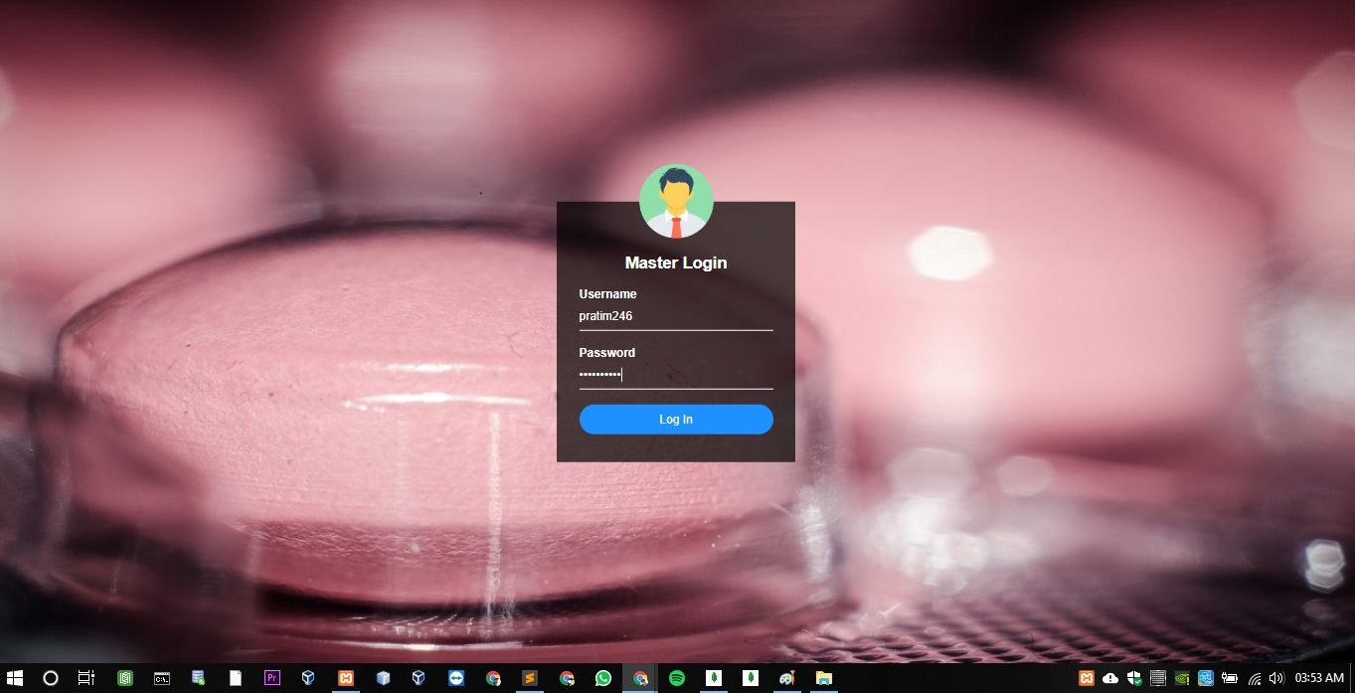

Fig.1 Pharmacy Interface for Master Login form

Homepage:



Fig.2 Pharmacy Interface for Homepage Form

New Order Entry:

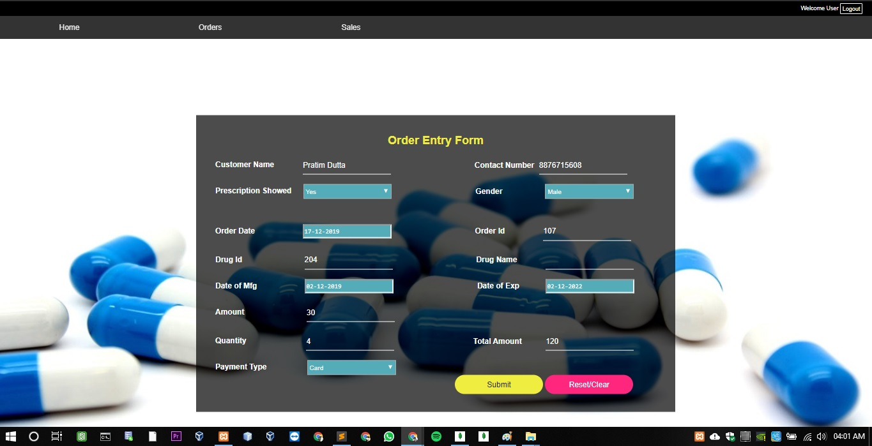

Fig.3 Pharmacy Interface for Order Entry form

Edit/Delete Records:

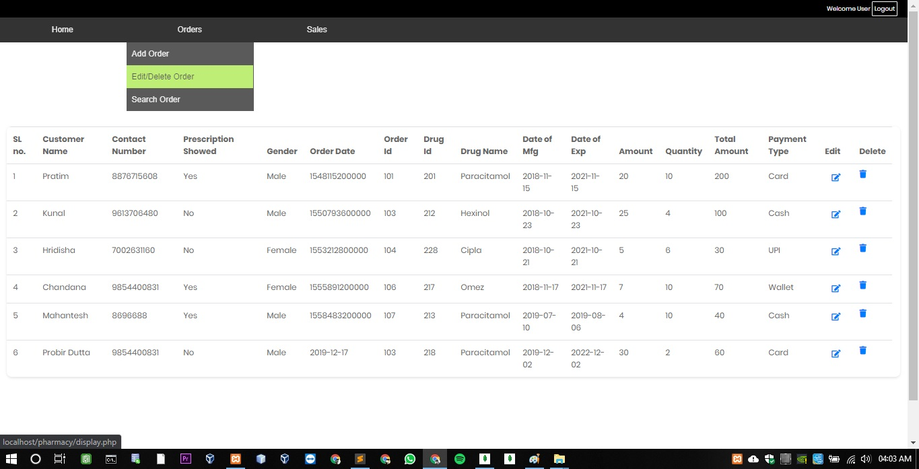

Fig.5 Pharmacy Interface for Managing Records form

Order Update:

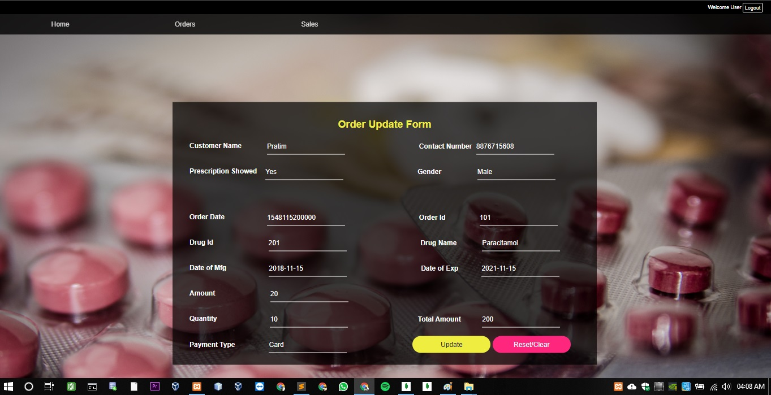

Fig.4 Pharmacy Interface for Order Update form

Search By Customer Name/Customer Number/Order Id/Order Date:

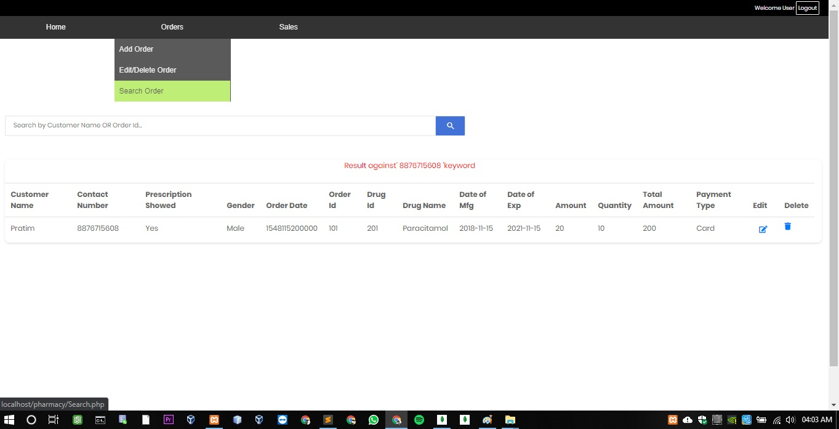

Fig.6 Pharmacy Interface for Search form

Sales Report:

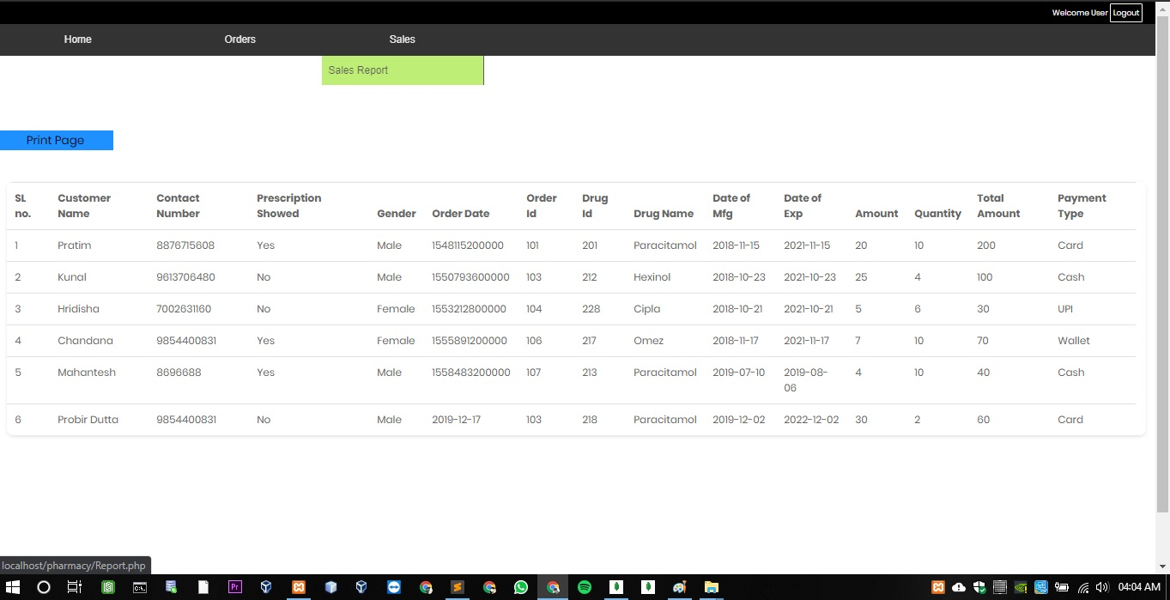

Fig.7 Pharmacy Interface for Sales Report form

Print Report:

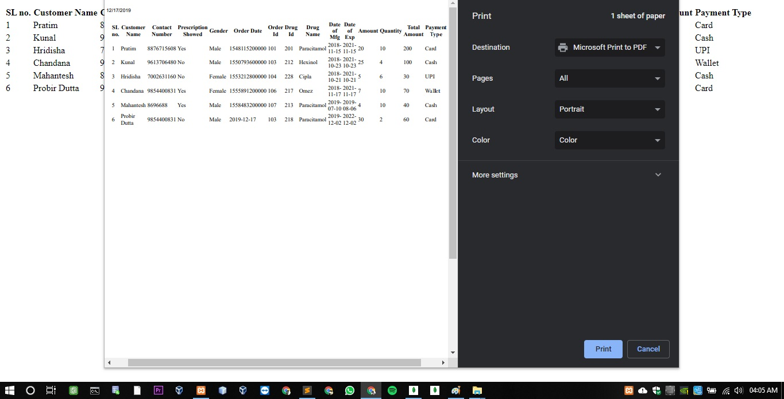

Fig.8 Pharmacy Interface for Print Page form

CONCLUSION

The **Pharmacy Management System** need to be computerized to reduce human errors and to increase the efficiency. The purpose **Pharmacy Management System** in this proposal will be computerized management system developed to maintain in all the daily transaction details.

The software **Pharmacy Management System** is designed and developed to satisfy all the mentioned organization needs as far as possible. The design of the package is done in such a manner so that the users can operate the system very easily. The menus are designed in a user friendly manner and reports are of general type.

This was effort to develop a simple **Pharmacy Management System** which may be useful in Pharmacy to insert, store, handle and retrieve information about the daily transactions.

The software package is a portable one and can be run on IBM compatible machines.

SCOPE FOR FURTHER ENHANCEMENTS

* More functionality can be added depending upon the user requirements and specifications.
* The project can be expanding as per the need of the company and if there will any more requirements that can be satisfy.
* Modification can be easily done according to requirements as and when necessary.