**EXPERIMENT-8**

**Distance Vector Routing protocol**

**Aim:** Configure a Network using Distance Vector Routing protocol.

* RIP

**Apparatus (Software):** packet tracer software

**Theory:** In computer communication theory relating to packet-switched networks, a distance-vector routing protocol is one of the two major classes of routing protocols, the other major class being the link-state protocol. Distance-vector routing protocols use the Bellman–Ford algorithm, Ford–Fulkerson algorithm, or DUAL FSM (in the case of Cisco Systems’s protocols) to calculate paths. A distance-vector routing protocol requires that a router informs its neighbors of topology changes periodically. Compared to link-state protocols, which require a router to inform all the nodes in a network of topology changes, distance-vector routing protocols have less computational complexity and [message overhead](http://en.wikipedia.org/w/index.php?title=Message_overhead&action=edit&redlink=1).

The Routing Information Protocol (RIP) is one of the oldest distance-vector routing protocols, which employs the hop count as a routing metric. RIP prevents routing loops by implementing a limit on the number of hops allowed in a path from the source to a destination. The maximum number of hops allowed for RIP is 15. This hop limit, however, also limits the size of networks that RIP can support. A hop count of 16 is considered an infinite distance, in other words the route is considered unreachable.

**Procedure:**

1. Develop a Topology shown in figure given below.

1. Configure all Routers

Implement RIP protocols in Router to configure Network

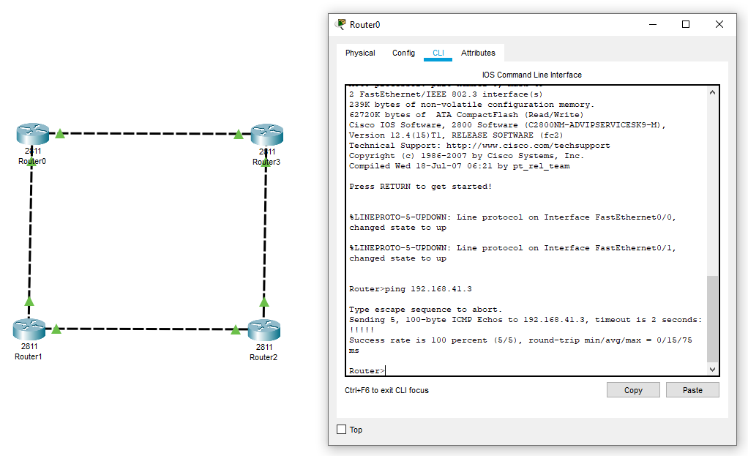



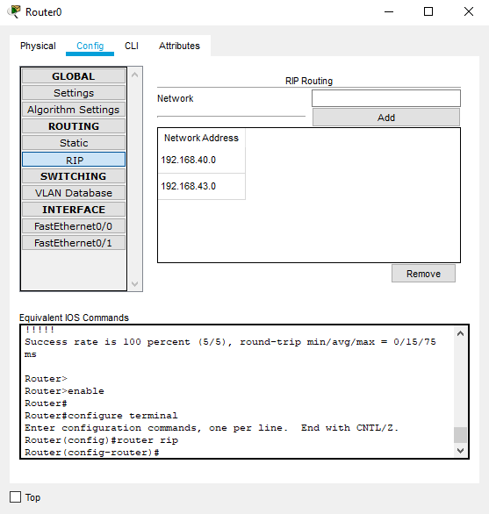

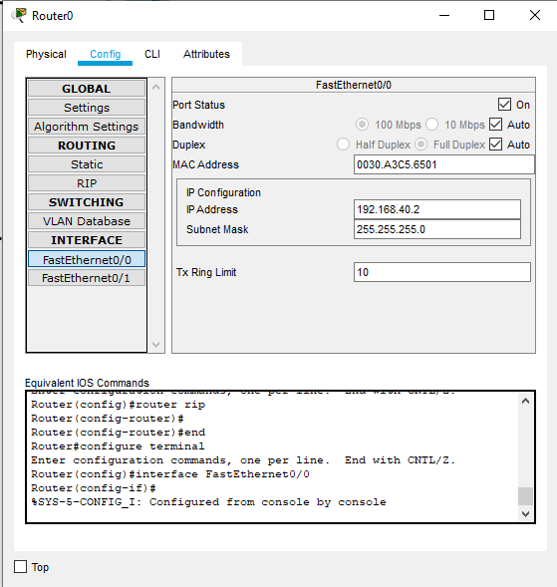

**EXPERIMENT-9**

**Link State Vector Routing protocol**

**Aim:** Configure Network using Link State Vector Routing protocol.

* OSPF

**Apparatus (Software):** Packet Tracer Software/GNS3

**Theory:** Open Shortest Path First (OSPF) is a link-state routing protocol for Internet Protocol (IP) networks. It uses a link state routing algorithm and falls into the group of interior routing protocols, operating within a single autonomous system (AS). It is defined as OSPF Version 2 in RFC 2328 (1998) for IPv4. The updates for IPv6 are specified as OSPF Version 3 in RFC 5340(2008).

OSPF is perhaps the most widely used interior gateway protocol (IGP) in large enterprise networks. IS-IS, another link-state dynamic routing protocol, is more common in large service provider networks. The most widely used exterior gateway protocol is the Border Gateway Protocol (BGP), the principal routing protocol between autonomous systems on the Internet.

**Procedure:**

* Develop a Topology shown in figure given below.
* Configure all the workstations
* Configure all switches
* Configure all Routers
* Implement OSPF protocols in Router to configure Network.

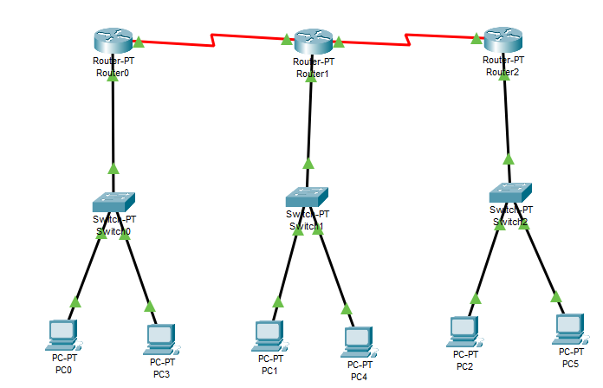

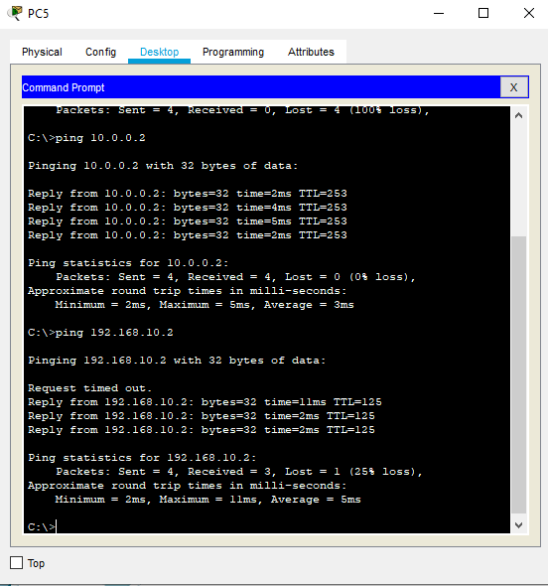

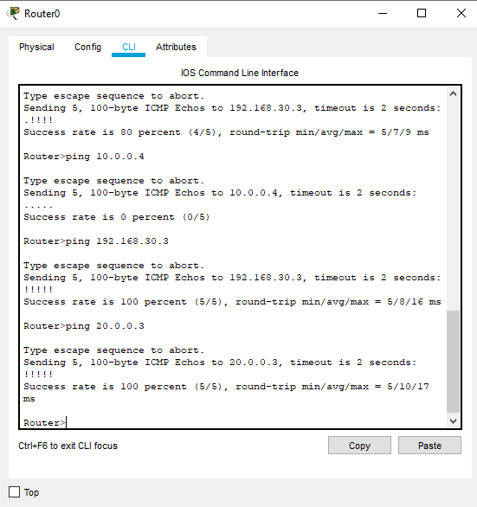

**EXPERIMENT-10**

**Border gateway protocol**

**Aim:** Configure Network using Border gateway protocol.

**Apparatus (Software):** Packet Tracer Software/GNS3

**Theory:** Border Gateway Protocol (BGP) is a standardized exterior gateway protocol designed to exchange routing and reachability information between autonomous systems (AS) on the Internet. The protocol is often classified as a path vector protocol, but is sometimes also classed as a distance vector routing protocol. The Border Gateway Protocol does not use Interior Gateway Protocol (IGP) metrics, but makes routing decisions based on paths, network policies and/or rule-sets configured by a network administrator. The Border Gateway Protocol plays a key role in the overall operation of the Internet and is involved in making core routing decisions.

**Procedure:**

* Develop a Topology shown in figure given below.
* Configure all the workstations
* Configure all switches
* Configure all Routers
* Implement BGP protocols in Router to configure Network.

