FETCHING THE DATA FROM SQLITE DB AND DISPLAYING

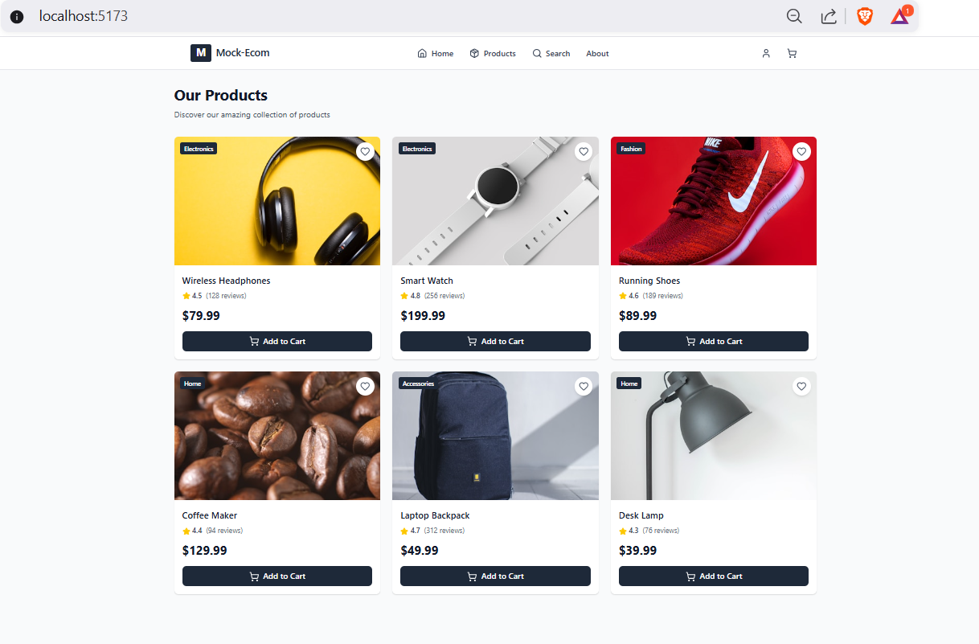

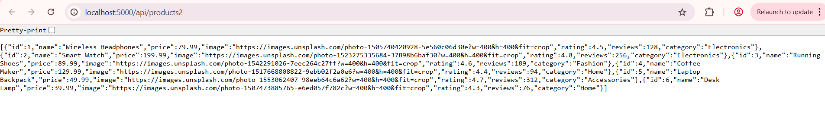

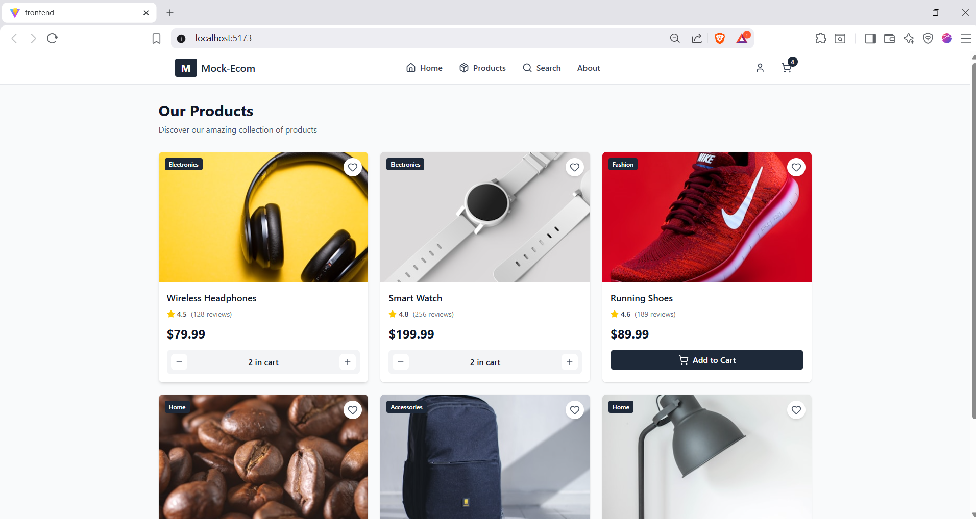

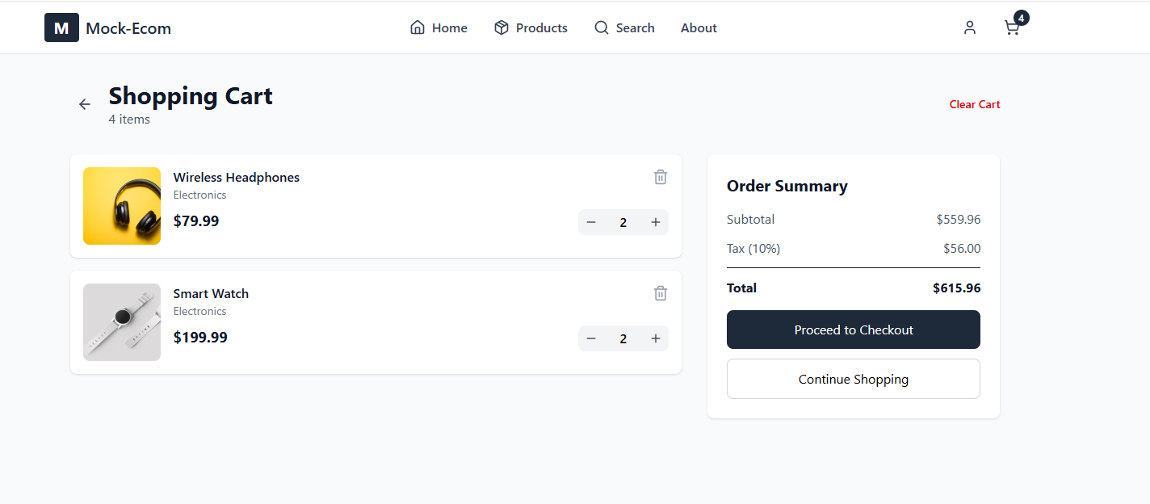  
IN CART IT DISPLAY THE ORDERS IF WE ADD , REMOVE , OR UPDATE  
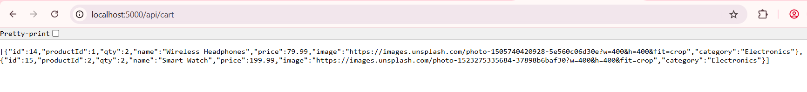

ORDER CONFIRMATION AFTER CHECKING OUT   
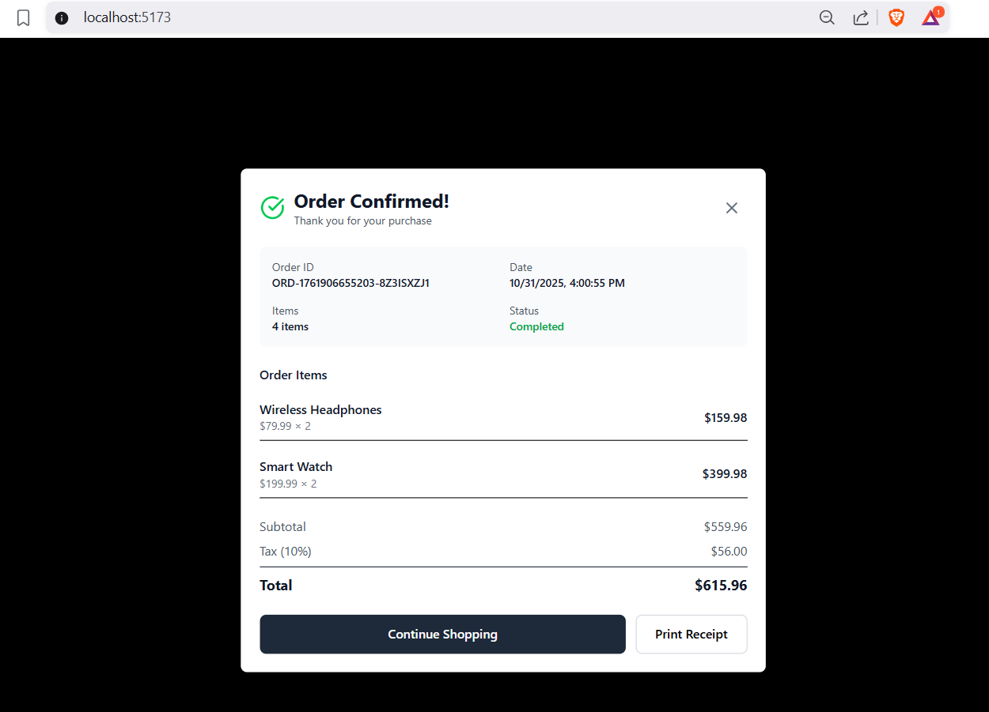  
  
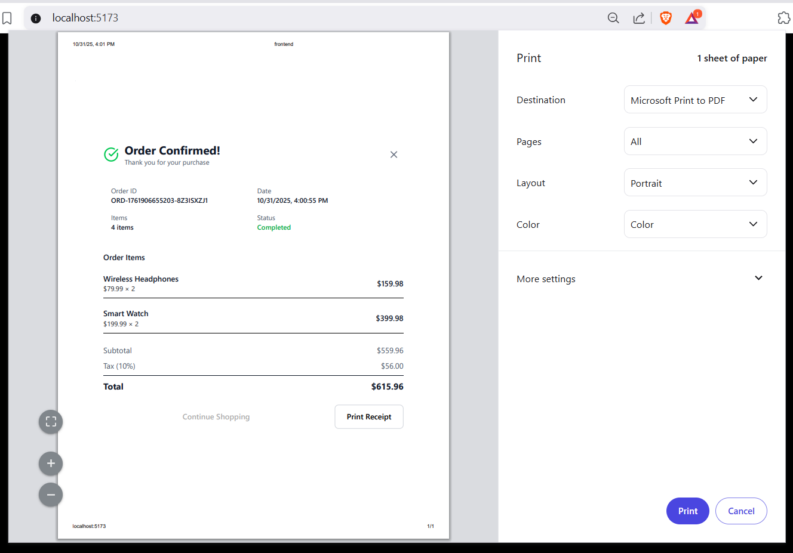  
  
UNIQUE ORDER ID FOR EACH ORDER  
