IaC:

AWS native: Cloud Formation Template

Azure Native: ARM Template

Cloud independent: Terraform

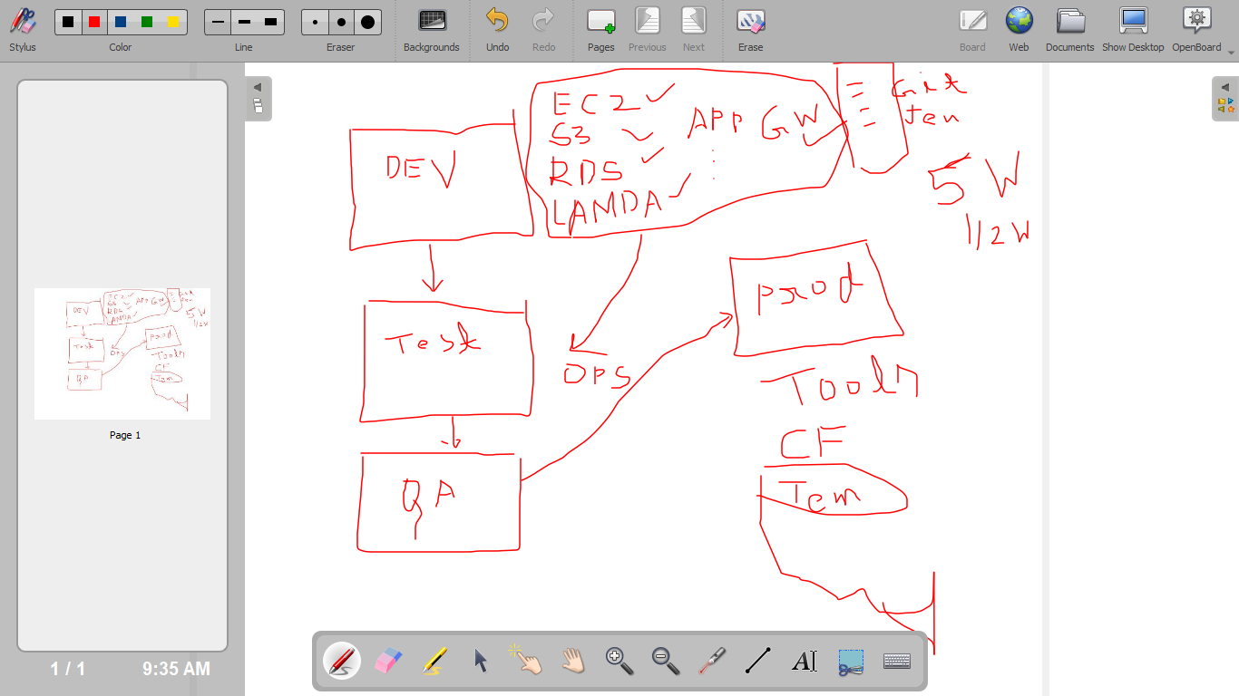

Terraform

1. Terraform init
2. Terraform plan
3. Terraform apply
4. Terraform destroy

State file should be saved in a location that is n no of replica

Terraform script

Create s3

Create ec2

Deployed-🡪 s3 is already available so we are going to provision ec2

(Statefile)

Install terraform on top of ec2 ubuntu

wget https://releases.hashicorp.com/terraform/0.14.9/terraform_0.14.9_linux_amd64.zip

#install unzip

apt install unzip

unzip terraform_0.14.9_linux_amd64.zip

mv terraform /usr/local/bin/

+++++++++++++++++++++++++++++++++++++++++++++++++++

Need to authenticate with AWS account using terraform so that we can create the required services

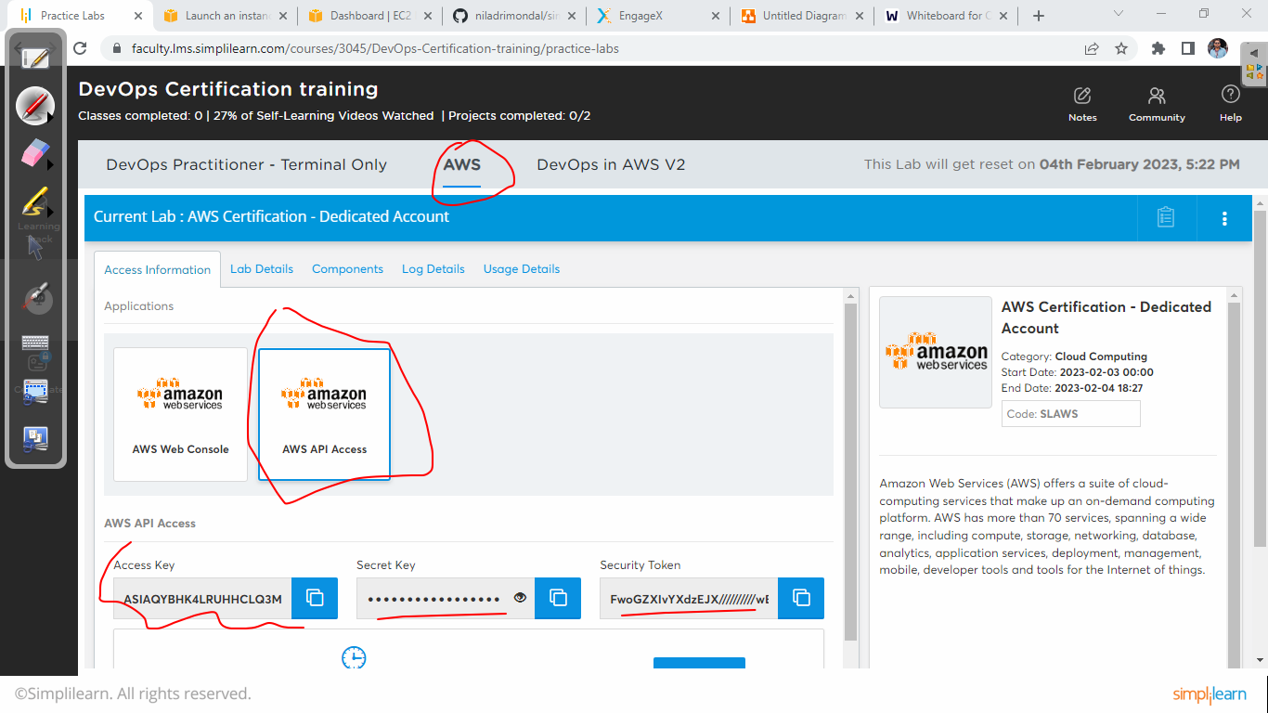

Create the creds.tf and provide the different value

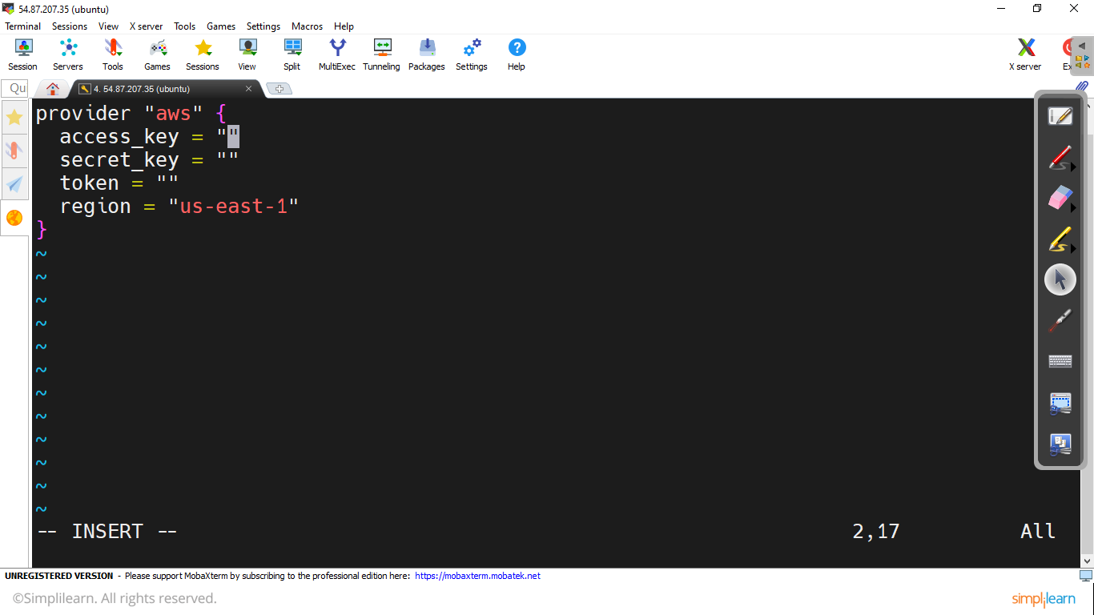

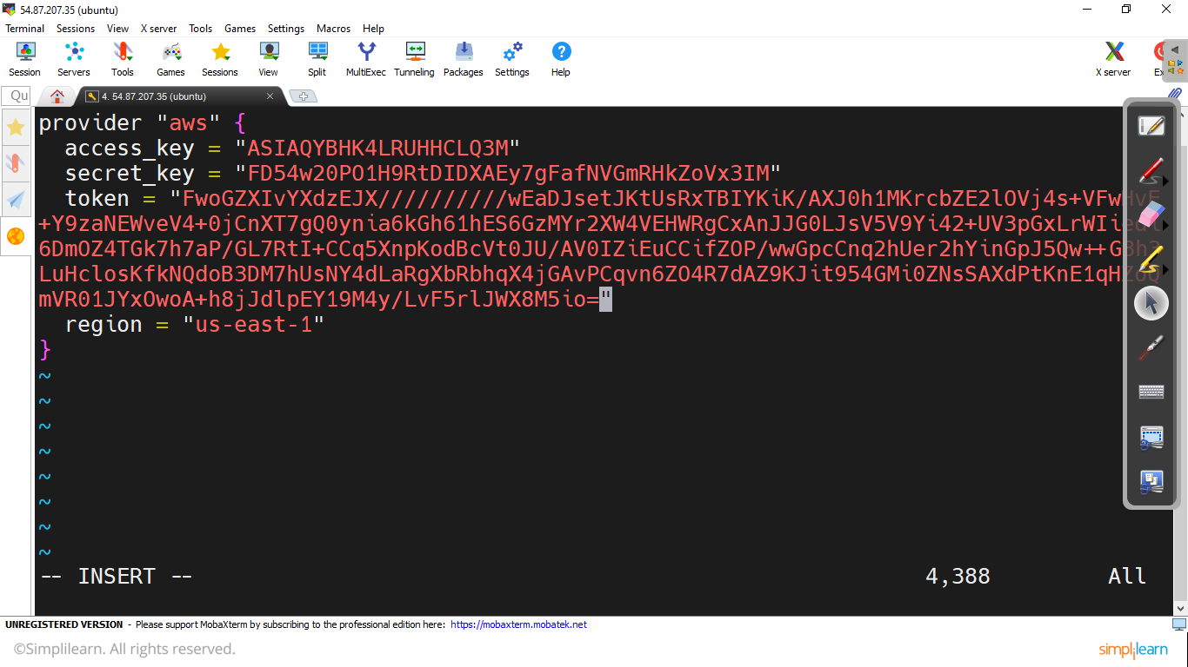

Create a s3 bucket using main.tf

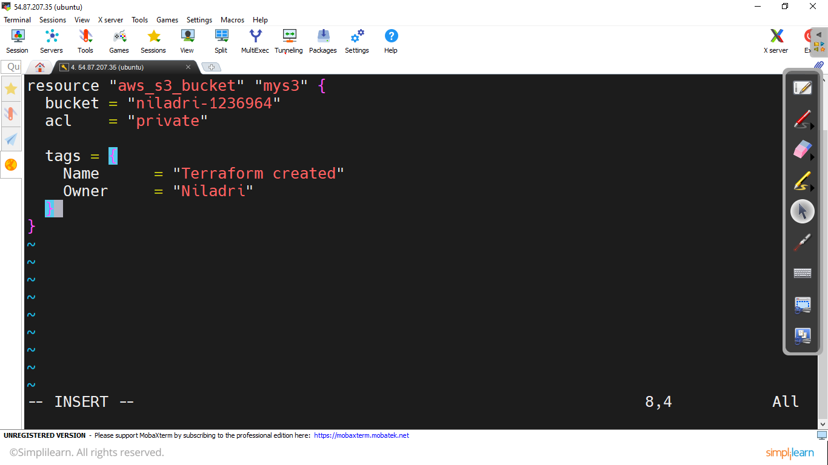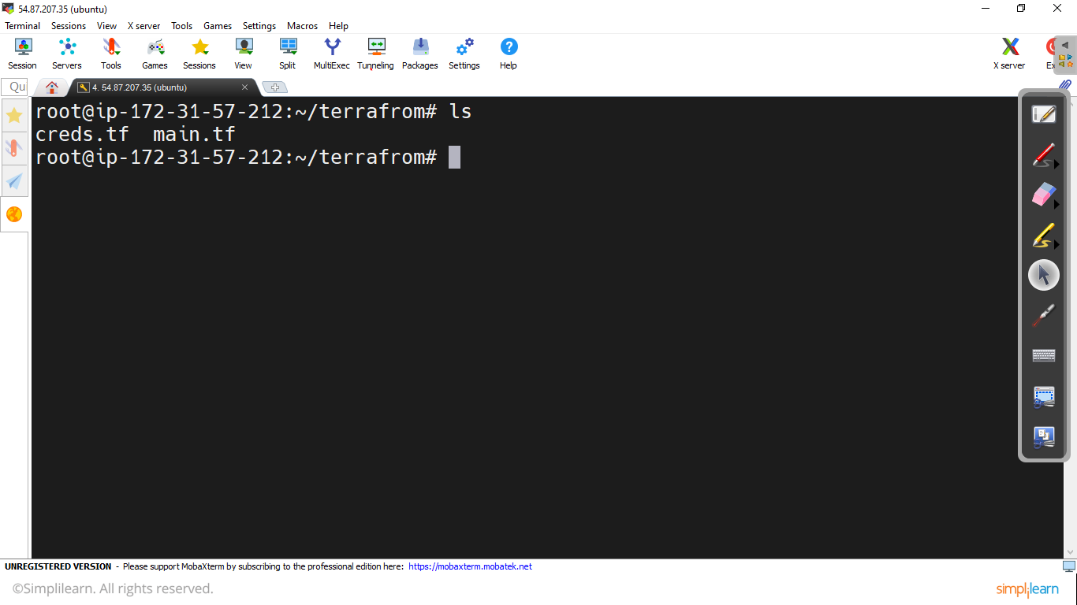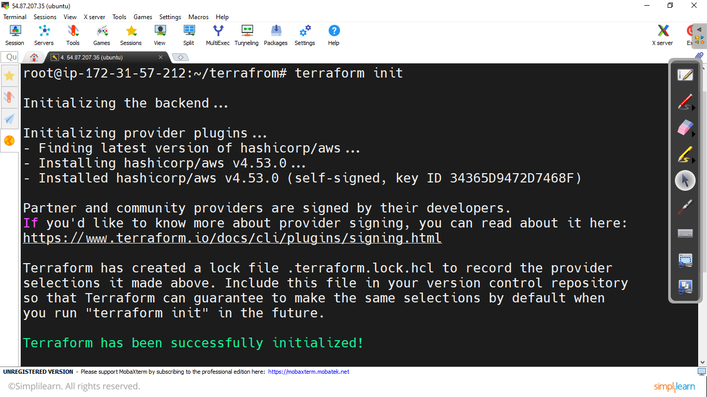

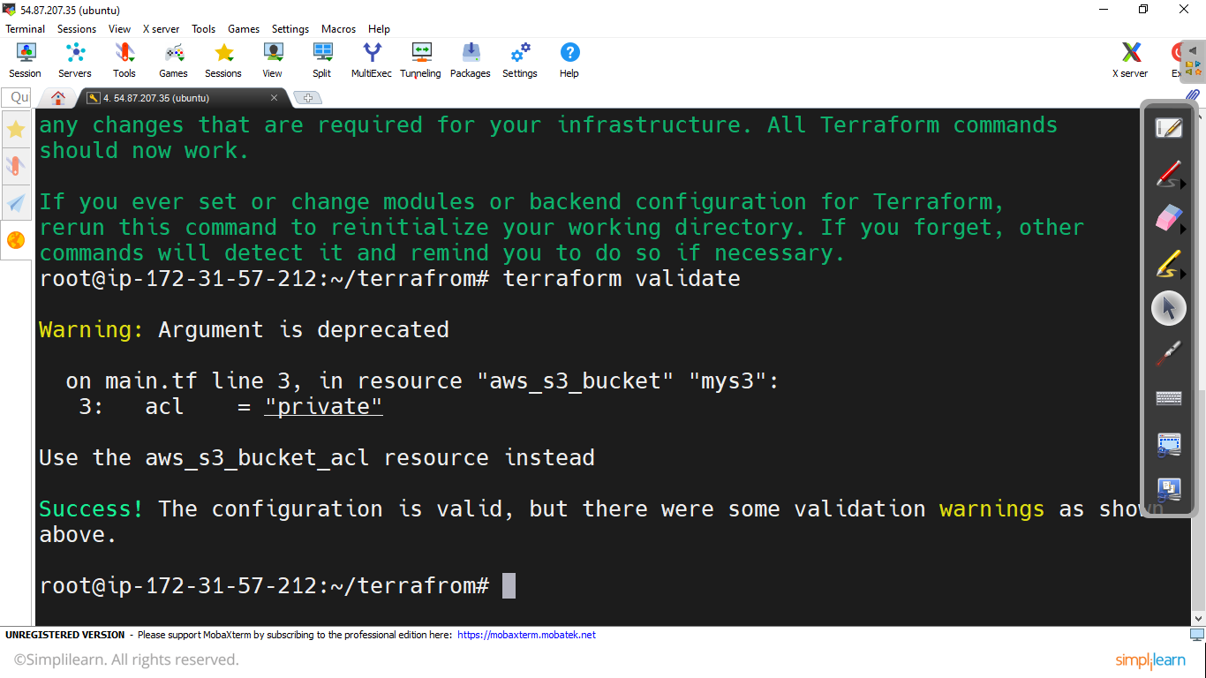

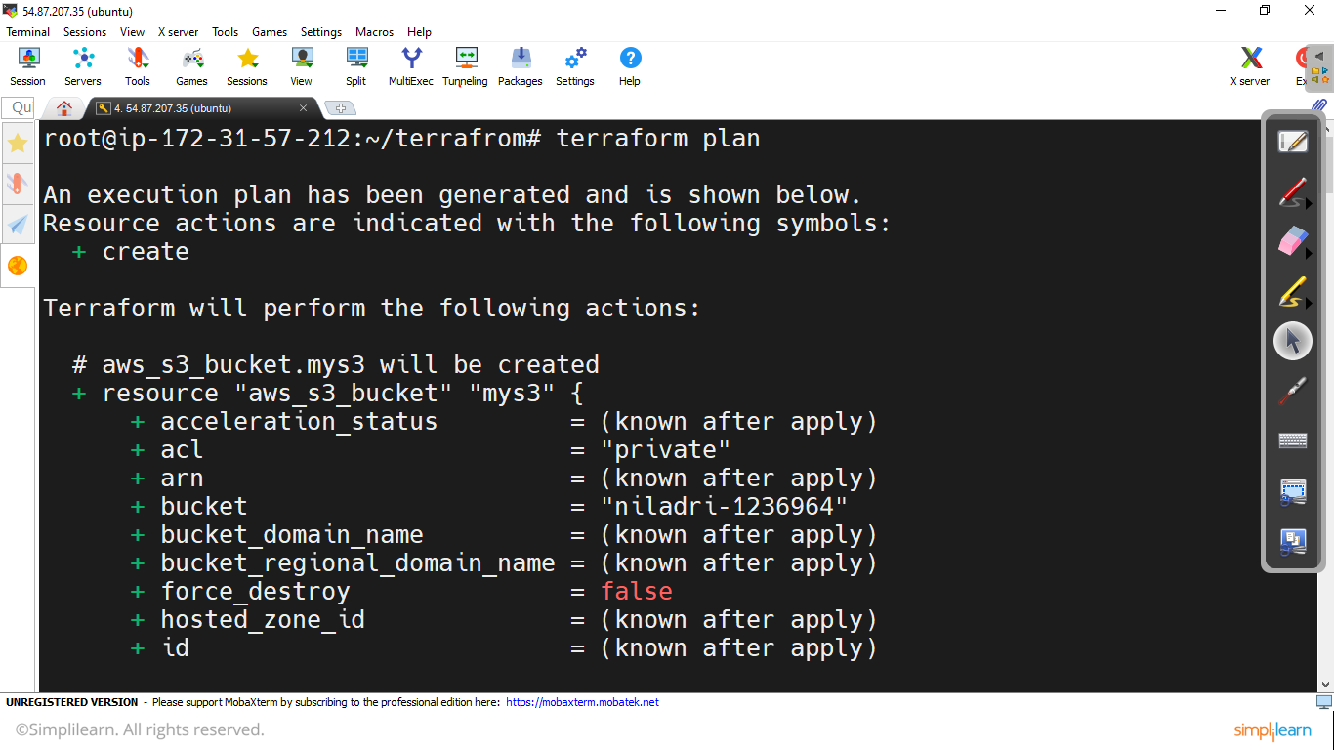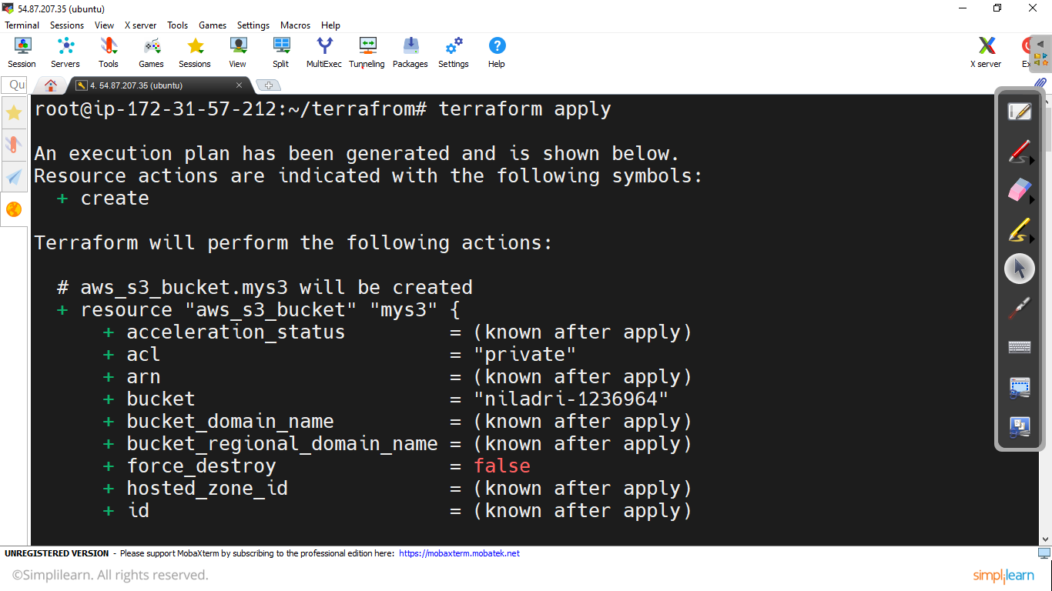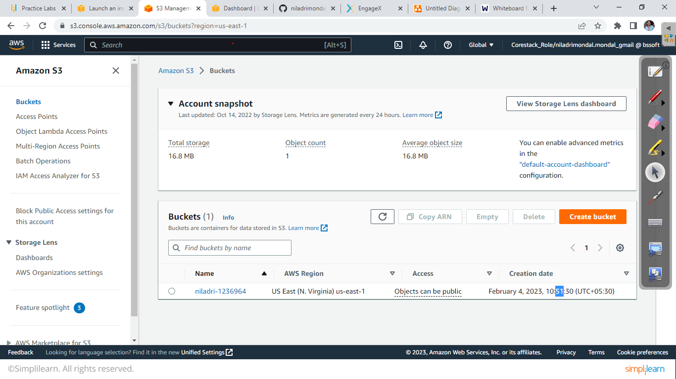

Adding Aws instance creation script in the main.tf

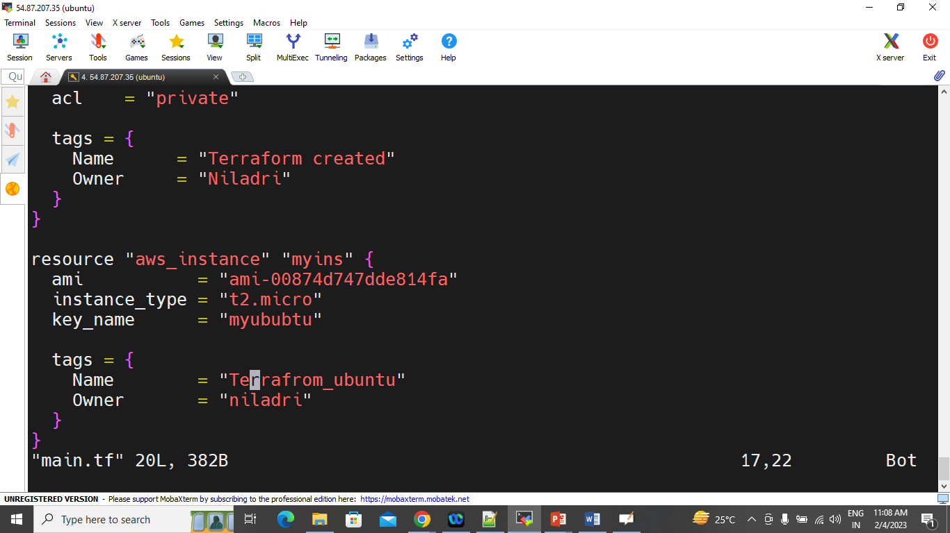

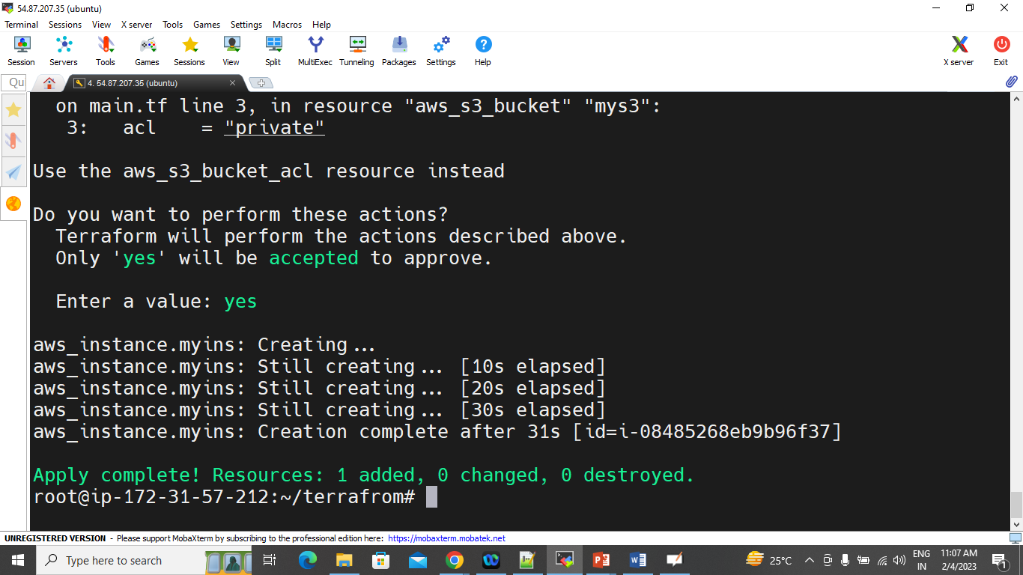

<https://developer.hashicorp.com/terraform/tutorials/aws-get-started>

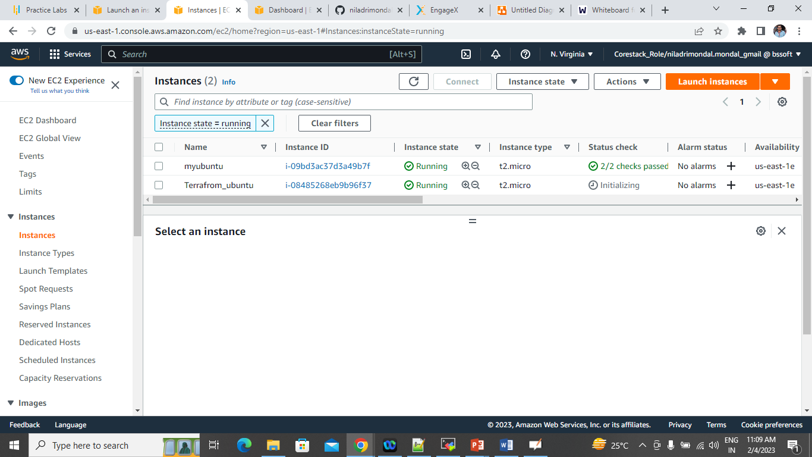

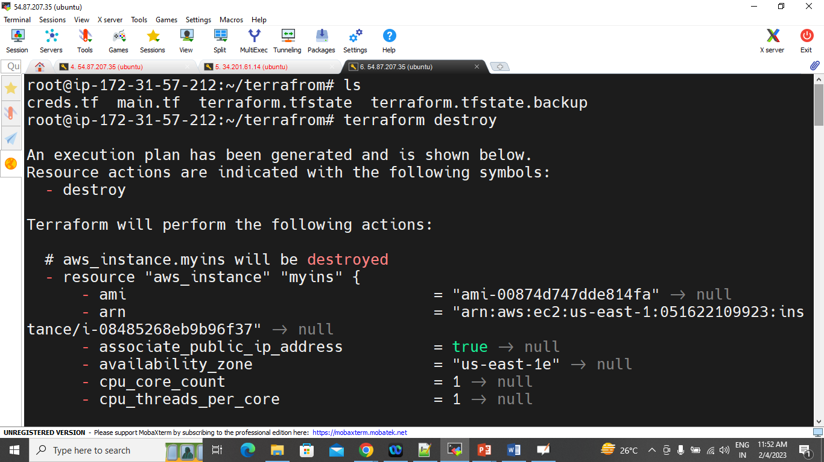

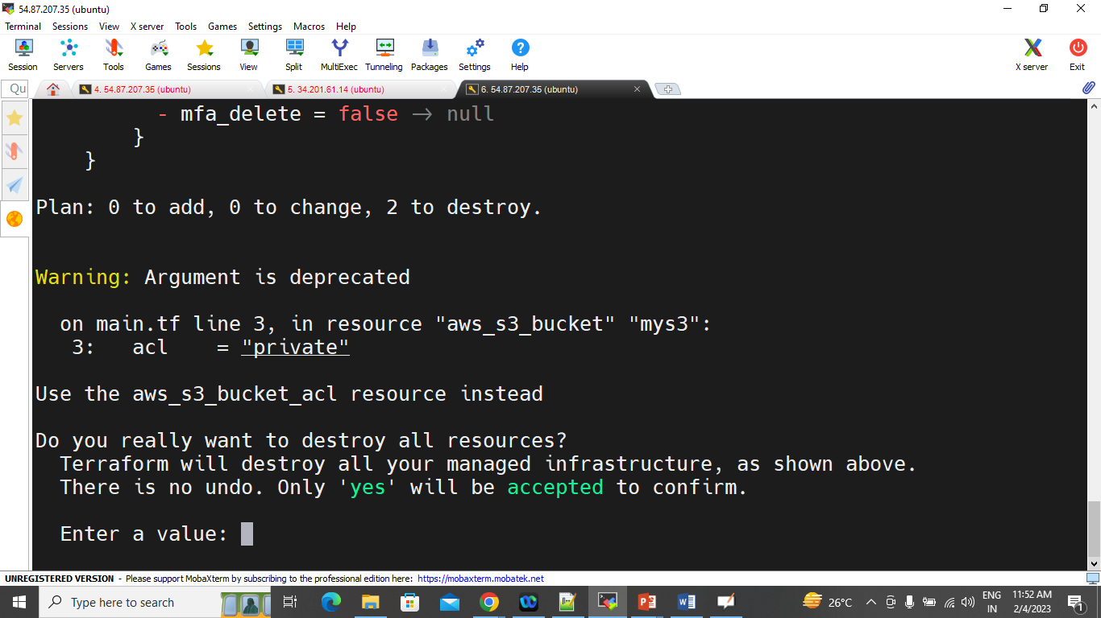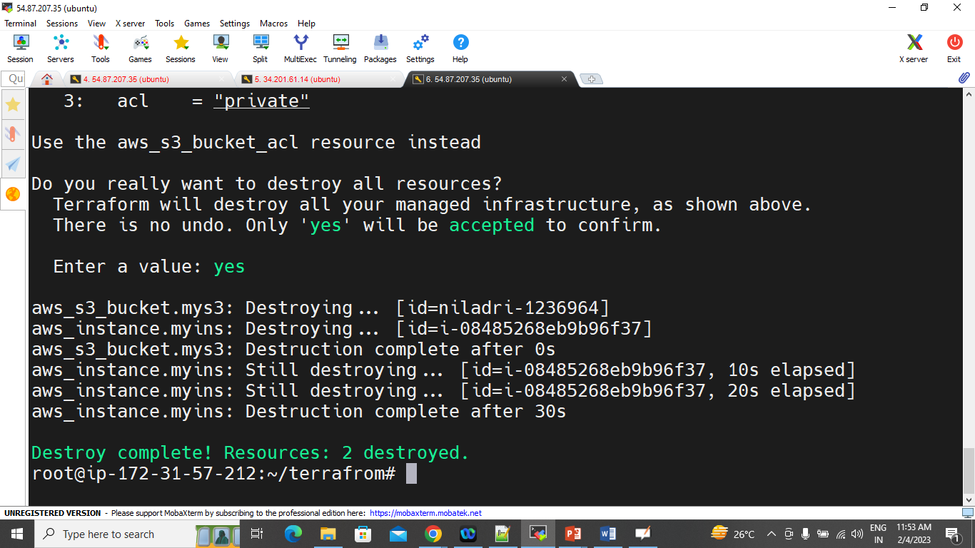

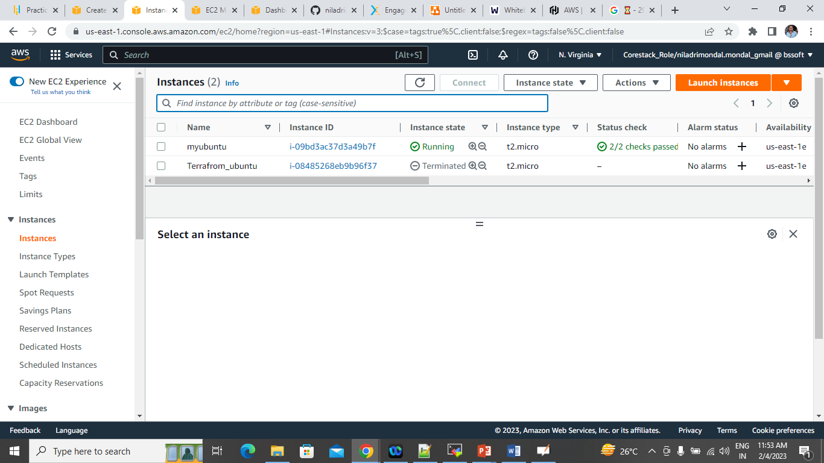

Docker:

