SMART INDIA HACKATHON 2026

SOLUTION RESEARCH & FEASIBILITY REPORT
Research, innovation validation and deployable design
Problem Statement ID: 26245
Problem Statement: AI-Based Real-Time Monitoring of Training Centres for Attendance and Infrastructure Compliance
Organization: Ministry of Skill Development and Entrepreneurship (MSDE)
Category / Theme: Software / Smart Education

Proposed Solution: PRAMAAN: Presence & Resource Assurance and Monitoring with AI at the Edge Network
Prepared By: Team name and members: to be added by the team
Institution: To be added by the team
Date: 3 October 2026
Version: 1.0 (research draft)
Status note: this report contains no measured accuracy results. All targets are hypotheses; cost and bandwidth figures are planning assumptions. Sources marked "re-verify" in Section 29 must be checked before submission.

Table of Contents

1. Executive Summary 4
1.1 The problem 4
1.2 Existing ecosystem and the gap 4
1.3 Proposed solution and core innovation 4
1.4 Honest assessment 4
1.5 Scope and limits of the research behind this report 4
2. Problem Statement Analysis 5
2.1 Core problem 5
2.2 Why the problem exists (root causes) 5
2.3 Who is affected 5
2.4 Consequences if unsolved 5
2.5 Why it matters 5
2.6 Current workflow 6
3. Stakeholder Analysis 7
4. Real-World Ecosystem Research 8
4.1 Government systems and scheme rules 8
4.2 State and institutional AI-attendance deployments 8
4.3 Technology and standards 8
4.4 Privacy and regulation 8
4.5 What we could not verify 9
5. Existing Solution Landscape 10
5.1 Gap questions answered 11
6. Gap Analysis 13
6.1 Technical gaps 13
6.2 Operational gaps 13
6.3 User / UX gaps 14
6.4 Scalability gaps 14
6.5 Cost and adoption gaps 15
6.6 Prioritisation 15
7. Brainstorming Multiple Solution Directions 16
8. Solution Evaluation Matrix 21
8.1 Reasoning 22
9. Existing Solution vs Our Differentiation 23
10. Novelty & Innovation Validation 24
11. Final Proposed Solution 25
11.1 Solution name 25
11.2 One-line pitch 25
11.3 Problem 25
11.4 Existing situation 25
11.5 Identified gap 25
11.6 Proposed solution 25
11.7 Core innovation 25
11.8 Key features 25
12. Complete Technical Architecture 26
12.1 Layer-by-layer explanation 27
12.2 Reconciliation logic 28
12.3 Infrastructure compliance logic 28
13. Technology Stack 30
14. Data Feasibility 31
14.1 Verdict on data feasibility 33
15. AI/ML Validation 34
15.1 Errors, bias, edge cases 34
16. Security & Privacy Analysis 35
16.1 Regulatory considerations (to be confirmed by legal counsel) 35
16.2 What is and is not identified (privacy-design note) 35
17. Real-World Deployment Model 37
18. SIH MVP 38
18.1 MUST HAVE (demonstrable at SIH) 38
18.2 SHOULD HAVE 38
18.3 FUTURE 38
18.4 MVP workflow 38
19. Prototype Implementation Plan 40
20. SIH Demo Strategy 41
21. Performance Metrics 42
22. Real-World Cost Analysis 43
23. Risks & Failure Modes 44
24. Judge Attack Mode 45
25. Competitive Positioning 48
25.1 Defensible differentiators 48
26. Implementation & Adoption Model 49
27. Final Solution Summary 50
28. Final Evaluation 51
29. References 52
30. Appendices 54
Appendix A. Data-flow summary 54
Appendix B. Edge record example 54
Appendix C. Database concept 54
Appendix D. Next research tasks 54
Appendix E. Prototype assumptions 55
Appendix F. Glossary 55
Appendix G. Quality-control audit 55

1. Executive Summary
One-paragraph summary
Government skilling schemes pay training centres on attendance and infrastructure milestones, but verification between periodic inspections relies on self-reported data and photos. The Comptroller and Auditor General (CAG) audit of PMKVY found weak monitoring, reused evidence photos and low compliance with Aadhaar-based attendance [1]. PRAMAAN is an edge-first video-analytics system that reuses the CCTV cameras many schemes already mandate [12][13], counts people and sanctioned equipment on-site, reconciles those counts with attendance claims and the sanctioned inventory, and sends only tiny signed metadata (plus blurred evidence on exceptions) to a monitoring dashboard.

1.1 The problem
Attendance records can drift from physical presence, and approved infrastructure can be missing or idle between inspections. Periodic visits are resource-intensive and capture only a snapshot. Existing cameras are mostly passive recorders; where footage review is prescribed it is sampled [13].

1.2 Existing ecosystem and the gap
India already has identity-based attendance (Aadhaar-enabled biometric attendance, now moving to face authentication [5]), geo-tagging, remote self-assessment by Training Centre staff [14], CCTV mandates [12][13] and several state-level AI attendance apps [15][17]. What is missing is an independent, continuous, privacy-preserving physical-presence and infrastructure signal that does not depend on the centre's own submissions and can be cross-checked against the claimed numbers.

1.3 Proposed solution and core innovation
- Claim-vs-observation reconciliation: aggregate person counts per zone and batch-session are compared with claimed attendance using robust statistics, with explicit NO-DATA / PENDING states so a camera outage is never mistaken for a violation.
- Sanctioned Layout Profile: a zone-based digital description of the approved equipment, captured at an inspection visit, against which the system checks item presence and evidence of use.
- Evidence integrity: feed-health and tamper checks, signed minute-level records, and duplicate-evidence detection aimed at the reused-photo problem documented by CAG [1].
- Edge-first, low-bandwidth, no face identification: about a quarter of a kilobyte per camera-minute leaves the centre; raw video and face data do not.

1.4 Honest assessment
The detection technologies (person and object detection) are mature commodities; PRAMAAN's differentiation is in integration, workflow, privacy design and evidence integrity, not a new algorithm. It is strongest at flagging gross discrepancies (ghost batches, large over-claims, absent major equipment) and weakest at proving that a machine is truly functional. We rate it technically feasible as a student MVP and deployable only with real-world calibration, hardware at centres, and Government approvals. Overall self-assessment: strong and credible, not guaranteed to win (Section 28).

1.5 Scope and limits of the research behind this report
Research was conducted through web searches of government, NSDC, CAG-summary, legal-commentary and vendor-licence sources (Section 29). Not done in this session: patent-database searches, IEEE/ACM database searches (literature references in Section 29 are cited from well-known papers and flagged for re-verification), access to NSDC/MSDE internal systems, and any experiments. No accuracy figures in this report are measured results; all targets are labelled as hypotheses to be validated.

2. Problem Statement Analysis

Official problem statement (SIH PS 26245, MSDE)
AI-Based Real-Time Monitoring of Training Centres for Attendance and Infrastructure Compliance. Category: Software. Theme: Smart Education. Dataset: not provided in advance; sample/dummy training-centre footage will be supplied for evaluation.

2.1 Core problem
Two recurring integrity risks in government-funded skilling: (a) attendance records that do not reflect actual physical presence, and (b) approved infrastructure (equipment, seating, workshop facilities) that is not consistently available or maintained between inspection cycles. The required system must analyse camera feeds, reconcile with centre records and the sanctioned inventory, flag discrepancies on a dashboard, work on weak bandwidth and camera quality, and preserve privacy.

2.2 Why the problem exists (root causes)
- Financial incentive: payments are outcome-linked and tranche-based on attendance milestones (for example, in Skill India Centres a tranche is tied to a batch reaching 70% AEBAS attendance) [5][6], so inflating attendance pays.
- Sparse inspection capacity: a dispersed network is inspected periodically; CAG noted unreliable supporting documents and, in 84% of on-spot inspection cases, no geotagging [1]. Inspectors were also reported to have visited centres in different states on the same day [4] (secondary source).
- Identity systems verify a person-event, not a room: biometric or face-authentication checks confirm that an enrolled person authenticated on a device, not that the batch was physically in class for the session.
- Passive cameras: CCTV is mandated in some schemes, but review is by sampling and no technical specification is prescribed in at least one SOP [13].
- Weak evidence trail: CAG found the same photos used as evidence for different trainings [1]; secondary reporting describes centres that existed only on paper and fake attendance [2][3].

2.3 Who is affected
Genuine trainees (poor-quality training, lost credentials value), honest Training Partners (unfair competition), MSDE/NSDC and state missions (unreliable data, fund leakage), employers (certified but unskilled workers), and the public (inefficient expenditure). Stakeholders are detailed in Section 3.

2.4 Consequences if unsolved
- Public funds paid for training that did not happen or ran without sanctioned infrastructure.
- Credibility loss of scheme data reported to the Ministry; CAG-style audit findings recur.
- Low-quality skilling and weak placement outcomes. CAG reported about 41% placement among certified candidates under the short-term and special-project components [1].
- Disruption when large-scale blacklisting happens after the fact (reported as 178 Training Partners/Centres in secondary coverage [2]).

2.5 Why it matters
Skill India is a flagship programme, and its digital layer (Skill India Digital Hub, positioned as digital public infrastructure [9][11]) already reduces some risks. Continuous physical assurance closes the remaining gap and shifts monitoring from periodic and reactive to continuous and risk-targeted, letting scarce inspectors focus on centres that actually need a visit.

2.6 Current workflow
Figure 1 documents the workflow as understood from public sources [5][6][12][13][14]. Internal NSDC/MSDE processes may differ and should be validated with the monitoring units.
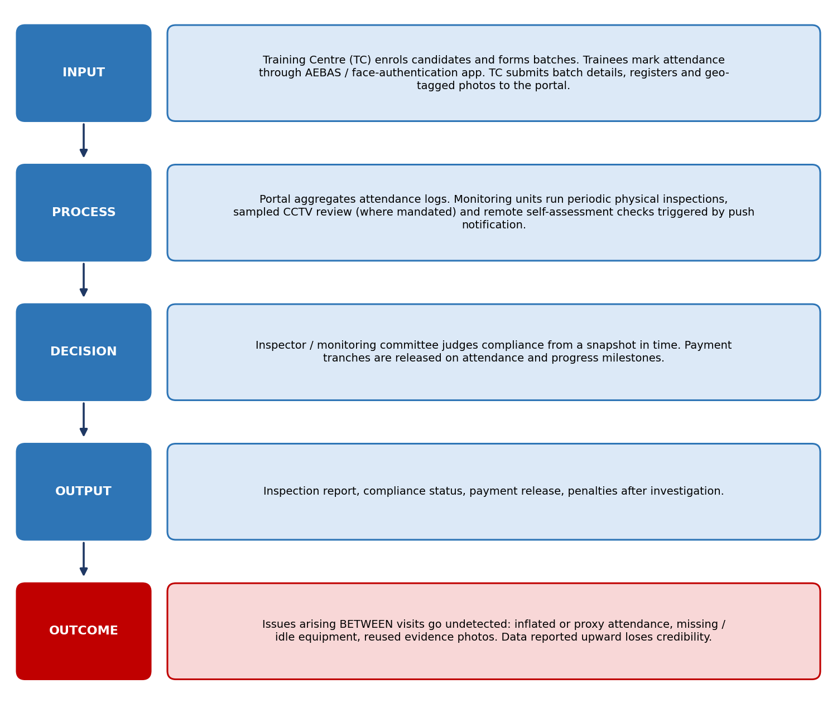
Figure 1: Current monitoring workflow and its blind spot

3. Stakeholder Analysis
Stakeholder behaviour matters as much as technology: the system succeeds only if monitoring units trust the flags and honest centres accept the monitoring. Roles below are inferred from public documents and must be validated in discovery interviews.
Table 1: Stakeholder analysis summary
Stakeholder | Role | Current workflow | Pain point | Requirement | Expected benefit from PRAMAAN
Trainees (primary) | Attend training, earn certification | Mark AEBAS/face-auth attendance; attend sessions | Genuine trainees suffer when equipment is missing; privacy concern about surveillance | Fair attendance credit; no face tracking | Better-equipped centres; privacy-preserving counting
Trainers (primary) | Deliver training | Own attendance; teaching with available kit | Blamed for centre shortfalls; unclear data of room use | Accurate session record | Objective record of session occupancy
Training Centre / Partner (primary) | Deliver, claim payment | Submit batches, registers, photos; host inspections | Cost of compliance; fear of false flags | Predictable rules; right to respond | Fair, evidence-backed record; fewer surprise findings
MSDE / NSDC monitoring units (primary) | Monitor compliance, release tranches | Periodic inspection, sampled review, virtual verification [14] | Cannot cover all centres; evidence reuse | Prioritised, explainable flags | Risk-targeted inspections; credible data
State Skill Missions (secondary) | Run state schemes, field oversight | Local inspections and approvals | Capacity limits; inconsistent tooling | Common dashboard; state views | Shared assurance layer
Auditors / CAG / Internal Monitoring Committees | Independent assurance | Sample audits post-hoc [1][12] | Unreliable source documents | Tamper-evident records | Auditable evidence trail
Technology providers (NIC, NSDC tech, camera/NVR vendors) | Platforms, integration | Run portal, SIDH, AEBAS apps [5][11] | Heterogeneous cameras, integration effort | Open interfaces (ONVIF [29], REST) | Clear API contract
Data providers (UIDAI/MeitY via SIDH; attendance logs) | Authentication and attendance data | AEBAS / face authentication [5][11] | Aggregate logs needed without exposing identities | Aggregate-count export | Minimal-data integration
Employers & public (indirect) | Beneficiaries of quality skilling | Rely on certificates | Certified-but-unskilled workers | Credible credentials | Higher trust in certification

4. Real-World Ecosystem Research
This section summarises what was found and, equally important, what could not be verified. Source types: official and scheme documents, CAG summaries, state-government pages, legal commentary, and vendor licence pages. Secondary sources (news analysis sites) are labelled as such.

4.1 Government systems and scheme rules
- AEBAS / face authentication: training centres must have a functional Aadhaar-enabled biometric attendance system; candidates cannot mark attendance without an Aadhaar number; minimum 50% biometric attendance is a candidate-eligibility criterion for assessment; tranche payments depend on attendance milestones [5][6][7]. The Ministry has stated that face authentication has recently replaced biometric devices, via apps on candidate and trainer devices [5].
- Skill India Digital Hub (SIDH): a Digital Public Infrastructure for skilling with Aadhaar-based eKYC, AI/face authentication, a geotagged Skill India Map, and multi-ministry integration [9][10][11].
- CCTV mandates in sister schemes: PM-VIKAS requires CCTV in all classrooms and laboratories [12]; the DDU-GKY SOP prescribes CCTV coverage of instruction, assessment and attendance areas, sampled review chosen by system-generated random numbers, and no technical specification [13].
- NSDC virtual verification: since June 2023, third-party agencies push notifications to Training Centre SPOCs who must complete a self-assessment with photos during training hours [14]. This is remote but still centre-supplied evidence.

4.2 State and institutional AI-attendance deployments
- Karnataka: face-recognition attendance for government and aided schools via a teacher phone app; the government states images are encrypted and converted into non-reversible codes, while civil-society groups contest the privacy and necessity [15][16].
- Assam, Shiksha Setu: AI-based face-recognition attendance with offline mode for students and teachers [17].
- Osmania University: CCTV-camera face-recognition attendance for staff, extending to students [18].
These are identity-based and individual-level. None of the sources found describes aggregate presence reconciliation against claimed batch attendance or sanctioned-equipment verification for skilling centres. Absence of evidence in a limited search is not proof of absence; it must be confirmed with the NSDC technical team.

4.3 Technology and standards
- Detection and tracking: COCO [27] and CrowdHuman [26] are standard datasets for person detection in everyday and crowded scenes; RT-DETR [23] and YOLOX [24] are real-time detectors; ByteTrack [25] is a lightweight multi-object tracker; MCNN-style crowd counting [28] suits dense crowds.
- Licensing trap: Ultralytics states that use of its YOLO code, models and trained or fine-tuned models requires either releasing the whole project under AGPL-3.0 or buying an Enterprise licence [22]. For a Government deployment, prefer permissively licensed detectors (verify each model and weight licence) or budget for a licence.
- Camera interoperability: ONVIF is the established standard for IP-camera interoperability [29]; PRAMAAN should read RTSP/ONVIF streams so existing cameras can be reused.

4.4 Privacy and regulation
- The Digital Personal Data Protection Rules, 2025 were notified in November 2025; Rules 1, 2 and 17-21 took effect immediately and the substantive fiduciary obligations (Rules 3, 5-16, 22, 23) take effect 18 months after publication, i.e. around May 2027 [19][20].
- The Rules require verifiable parental consent before processing a child's data [21]; trainees under 18, if any, would need handling. Government exemptions exist but are contested, so the design should not rely on them [19].

4.5 What we could not verify
Whether NSDC or MSDE is already piloting video analytics internally; the exact current inventory-verification procedure for Training Centres; commercial video-analytics products suited to this use case (only the product category is considered here); relevant patents; and peer-reviewed accuracy of classroom person counting under Indian CCTV conditions. These are listed as next research tasks in Appendix D.

5. Existing Solution Landscape
Only solutions evidenced in the sources of Section 29 are listed. Entries marked (category) describe a class of products, not a specific audited product.
Table 2: Existing solution comparison
Existing solution | Organization | Country | Technology | Problem solved | Strengths | Weaknesses | Users | Cost / accessibility | Relevant gap
AEBAS / face-authentication attendance [5][6][7] | MSDE / NSDC (UIDAI services via SIDH) | India | Aadhaar biometric, now face authentication through apps on candidate and trainer devices | Identity-bound attendance; basis for tranche release | Mandated, linked to payments, identity-verified | Verifies a person-event on a device, not a batch physically in a room; CAG found only 13% of batches compliant with the Aadhaar-attendance requirement [1] | Trainees, trainers, TCs | Low marginal cost; needs Aadhaar and devices | No independent cross-check of physical presence
Skill India Digital Hub [9][10][11] | MSDE / NSDC / MeitY | India | DPI platform: eKYC, face authentication, geotagged Skill India Map, verifiable credentials | Discoverability, identity, credentials, ecosystem integration | National scale, multilingual, interoperable | Platform for learners and ecosystem; not an in-room monitoring tool | Citizens, TPs, assessment bodies | Public, free to users | Continuous physical assurance
PMKVY TC virtual verification / self-assessment app [14] | NSDC (app managed by a third-party vendor per notice) | India | Push-notified remote check with photos from TC SPOC | Remote spot verification during training hours | Random timing; low cost; no travel | Evidence is centre-captured; manual review; sample only; photo reuse risk [1] | NSDC monitoring, TC SPOCs | Low | Automated, tamper-evident, continuous evidence
CCTV mandates (PM-VIKAS; DDU-GKY SOP) [12][13] | Ministry of Minority Affairs; Ministry of Rural Development | India | CCTV in classrooms and labs; sampled footage review; local storage | Passive evidence of training activity | Infrastructure often already installed | Manual, sampled review; no technical spec in SOP [13]; no analytics | Monitoring committees, PIAs | Camera cost borne by centres | Turning footage into automated compliance signals
Geotagged inspection and attendance [1][3] | MSDE / NSDC | India | Geo-tagging in inspection and attendance apps | Place-binding of evidence | Simple, cheap | 84% of on-spot inspection cases lacked geotagging per CAG [1]; location is not presence | Inspectors, TCs | Low | Presence and equipment evidence
Face-recognition school attendance (Karnataka) [15][16] | Government of Karnataka | India | Teacher phone app, face recognition, encrypted non-reversible codes | School attendance accuracy, welfare targeting | Fast (class in seconds, per officials) | Privacy and necessity contested by civil society [15]; identity-level; not about infrastructure | Teachers, students, department | State-funded | Privacy-preserving alternative for compliance checks
Shiksha Setu (Assam) [17] | Samagra Shiksha Assam | India | AI face-recognition app, offline mode | Student and teacher attendance, irregular-attendee flags | Offline-capable; single information source | Individual identification; school context | Teachers, department | State-funded | Aggregate presence checks; infrastructure
CCTV face-recognition attendance, Osmania University [18] | Osmania University | India | Face-recognition on selected cameras | Staff and student attendance | Hands-free | Identity-based; limited camera set; privacy exposure | University staff and students | Institutional | Scale, privacy, equipment checks
Commercial VMS / people-counting analytics (category) | Various CCTV and analytics vendors | Global | Detection, counting and zone analytics inside video-management platforms | Occupancy and footfall analytics | Mature, tested | Not tied to scheme records or sanctioned inventory; licensing and cloud-streaming cost; not evaluated individually here | Retail, facilities, security | Varies, often subscription | Scheme-specific reconciliation and evidence workflow
Academic classroom attendance systems (category) [28] | Universities and research groups | India / global | Face detection and recognition, crowd counting | Automatic classroom attendance | Demonstrate feasibility | Mostly lab-grade, identity-based, no tamper resistance or deployment model | Researchers | Low (prototype) | Deployable, tamper-aware, bandwidth-aware system

5.1 Gap questions answered

What has already been solved?
Identity-bound attendance (AEBAS and face authentication), geographic discoverability of centres, digital credentials, and CCTV installation mandates in several schemes.

What remains unsolved?
Independent confirmation that the claimed batch was physically present in the room during the session, and continuous confirmation that sanctioned infrastructure exists and is in use.

What is inefficient?
Periodic visits and sampled footage review: high effort per centre, low temporal coverage.

What is expensive?
Field inspections across a dispersed network; streaming or storing raw video centrally; individual-level face-recognition infrastructure.

What is inaccessible?
Raw CCTV evidence sits at the centre; monitoring units cannot see it between visits. Rural centres may have low bandwidth.

What still requires manual work?
Reviewing sampled footage, judging self-assessment photos, reconciling attendance with observed reality.

What has scalability problems?
Manual review and per-visit inspection; central video streaming.

What has reliability problems?
Reused or edited evidence photos [1][4]; inspections without geotagging [1]; non-compliance with attendance requirements [1].

What has security/privacy limitations?
Face-based systems raise contested privacy questions [15]; self-captured evidence is easy to curate.

What has adoption problems?
Centres bear compliance costs and may see monitoring as surveillance; heterogeneous cameras complicate rollout.
Reality check on "AI innovation"
Using AI, IoT or an app is not itself innovative here. The comparison above shows that identity-based AI attendance already exists. PRAMAAN is only justified where it adds what those systems lack: independent presence reconciliation, sanctioned-layout checking, evidence integrity and a privacy-preserving, low-bandwidth architecture.

6. Gap Analysis
Framework applied to every gap: CURRENT SYSTEM → LIMITATION → ROOT CAUSE → CONSEQUENCE → OPPORTUNITY. Severity: Critical (core to the problem statement and must be targeted), Important, Minor. Severity ratings are the team's judgement based on the cited sources.

6.1 Technical gaps
Table 3: Technical gaps
ID | Current system and limitation | Root cause | Consequence | Opportunity | Severity
T1 | Attendance systems confirm identity events; no independent signal of how many people are physically in the room | Systems designed for identity, not occupancy | Over-claimed attendance can pass undetected | Aggregate person counting reconciled with claims | Critical
T2 | Attendance from personal devices cannot by itself prove the holder is in class (risk, not a documented finding) | Device-based authentication | Possible proxy or remote marking | Cross-check with room occupancy | Important
T3 | Evidence photos can be reused or edited [1][4]; no automated duplicate or tamper checks | Manual evidence handling | Fake training evidence accepted | Perceptual-hash duplicate detection, signed records, feed-health checks | Critical
T4 | CCTV footage is stored but not analysed; no technical spec in at least one SOP [13] | Cameras installed for recording only | Idle asset; poor quality in some centres | Edge analytics on existing cameras with quality gating | Important
T5 | Sanctioned inventory is not machine-linked to what cameras see | Inventory on paper or forms | Missing equipment detected only at visits | Sanctioned Layout Profile and zone-based item checks | Critical

6.2 Operational gaps
Table 4: Operational gaps
ID | Current system and limitation | Root cause | Consequence | Opportunity | Severity
O1 | Inspections are periodic and capacity-limited [1][12] | Few inspectors, many centres | Issues between visits unseen | Risk-based, continuous screening to target visits | Critical
O2 | Findings arrive after payment milestones may have been met [5][6] | Detection lag | Funds released on unverified claims | Near-real-time flags before milestone release | Important
O3 | Follow-up is fragmented across emails and reports | No unified case workflow | Slow closure, weak audit trail | Case manager with evidence pack and audit log | Important
O4 | Shuttered or paper-only centres reported [2][3] | No continuous activity signal | Whole-centre leakage | Zero-occupancy detection across scheduled sessions | Critical
O5 | Inconsistent inspection records; geotagging missing in 84% of on-spot cases [1] | Process compliance weak | Unreliable audit trail | Inspector app with enforced geo-time capture | Important

6.3 User / UX gaps
Table 5: User and UX gaps
ID | Current system and limitation | Root cause | Consequence | Opportunity | Severity
U1 | Reviewers face hours of raw footage | Footage-first review model | Reviews skipped or sampled thinly [13] | Exception-first dashboard | Important
U2 | Honest centres cannot continuously demonstrate compliance | Evidence only at inspections | Unfair penalties or suspicion | Transparent TC view and right to respond | Important
U3 | Trainee privacy concerns with face recognition [15] | Identity-level collection | Resistance, legal exposure | Aggregate-only default; no face identification | Important
U4 | Centre staff may have limited digital literacy and bandwidth | Rural and semi-urban conditions | Setup failures | Plug-and-play edge kit, local-language guided setup | Minor
U5 | Officers need plain-language reasons for a flag | Opaque scores | Distrust of AI output | Explainable flags with evidence and rule shown | Important

6.4 Scalability gaps
Table 6: Scalability gaps
ID | Current system and limitation | Root cause | Consequence | Opportunity | Severity
S1 | Streaming all video centrally is infeasible on rural links | Bandwidth and cost | Centres excluded or video downsampled | Edge inference; transmit kilobytes | Critical
S2 | Manual review does not scale with centre count | Human-bound process | Coverage shrinks as network grows | Automated screening and prioritisation | Critical
S3 | Camera heterogeneity (resolution, angle, lighting) | No standard specification | Variable accuracy | Baseline calibration and quality gating at install | Important
S4 | Different trades have different equipment | Job-role diversity | Detector must be retrained per role | Modular class packs and few-shot fine-tuning | Important
S5 | Central raw-video storage raises cost and legal burden | Centralised design | Compliance and breach exposure | Raw video stays at the centre; only metadata travels | Important

6.5 Cost and adoption gaps
Table 7: Cost and adoption gaps
ID | Current system and limitation | Root cause | Consequence | Opportunity | Severity
C1 | Per-centre hardware cost for analytics | Edge compute needed | Adoption barrier for small centres | Reuse cameras; low-cost edge device; phased rollout | Important
C2 | Training Partners may view monitoring as surveillance | Trust deficit | Resistance, workarounds | Privacy-by-design, transparent rules, TC feedback loop | Important
C3 | AGPL licence obligations for popular YOLO code and weights [22] | Licence terms | Legal risk for Government deployment | Use permissive-licence models or buy licence | Important
C4 | Integration effort with Skill India portal and attendance logs | Closed or evolving APIs | Pilot delays | Aggregate-count interface; minimal data contract | Important
C5 | Monitoring staff need training to act on flags | New workflow | Flags ignored | Simple RAG workflow and SOP | Minor

6.6 Prioritisation
Critical gaps targeted by PRAMAAN: T1, T3, T5, O1, O4, S1, S2. Important gaps addressed secondarily: T2, T4, O2, O3, U1, U3, U5, S3, S5, C2, C4. Items such as C1 (hardware cost) and S4 (trade diversity) are constraints the design must live with rather than gaps it removes.

7. Brainstorming Multiple Solution Directions
Nine genuinely different directions were generated, spanning video analytics, mobile-assisted verification, forensics, log analytics, IoT and process tooling. C3 and C8 were included deliberately as options we expect to reject. Costs are indicative orders of magnitude, not quotes.

C1. Edge presence-count reconciliation
Attribute | Description
Problem solved | Attendance claims not matching physical presence (T1, O4)
Technical approach | Per-zone person counting on-site; robust session statistic compared with claimed count; RAG status
Required data | Claimed count per batch-session; timetable; camera streams
Required infrastructure | Existing camera, small edge device, central API
Technologies | Person detector (permissive licence), OpenCV, FastAPI, PostgreSQL
Stakeholders | Monitoring units, TCs
Feasibility | High: person detection is mature
Estimated complexity | Medium
Approximate cost (indicative) | Edge kit per centre; see Section 22
Scalability | High: only metadata travels
Differentiation | Independent of centre-submitted evidence; aggregate and privacy-friendly
Risks | Occlusion and blind spots; staged-presence gaming
SIH prototype potential | Excellent: visible live counting and flags

C2. Sanctioned-layout infrastructure twin
Attribute | Description
Problem solved | Equipment missing or idle between inspections (T5)
Technical approach | Inspector records zones and item counts at baseline; edge checks item presence per zone with persistence rules; usage evidence proxies
Required data | Sanctioned inventory per centre; baseline reference scenes; custom item classes
Required infrastructure | Same as C1 plus annotation tool
Technologies | Detector fine-tuned for item classes, zone masks, simple state classifiers
Stakeholders | Inspectors, TCs, monitoring units
Feasibility | Medium: needs per-trade training data
Estimated complexity | Medium-high
Approximate cost (indicative) | Annotation effort per trade
Scalability | Medium: class packs per job role
Differentiation | Ties vision to the sanctioned inventory; reports UNCERTAIN honestly
Risks | Cannot prove functionality; occlusion; domain data scarcity
SIH prototype potential | Good: remove an item in the demo and watch the flag

C3. CCTV face-recognition identity attendance
Attribute | Description
Problem solved | Proxy attendance
Technical approach | Face embeddings matched against enrolled gallery
Required data | Enrolled face gallery (biometric)
Required infrastructure | Cameras, GPU or cloud, secure biometric store
Technologies | Face detection and recognition models
Stakeholders | TCs, trainees
Feasibility | Technically easy
Estimated complexity | Medium
Approximate cost (indicative) | High (biometric governance)
Scalability | Medium
Differentiation | Low: duplicates AEBAS/face-auth [5]
Risks | Privacy and legal exposure [15], DPDP; contradicts PS privacy directive
SIH prototype potential | Easy to demo but off-brief

C4. Mobile random-challenge verification
Attribute | Description
Problem solved | Remote spot verification that is hard to curate
Technical approach | Monitoring unit pushes challenge; TC captures guided 360-degree clip; on-device AI counts and checks items
Required data | Sanctioned inventory; challenge records
Required infrastructure | Smartphone, backend
Technologies | On-device detector, PWA/Android, geo-time stamps
Stakeholders | NSDC monitoring, TC SPOCs
Feasibility | High
Estimated complexity | Medium
Approximate cost (indicative) | Low
Scalability | High: no fixed hardware
Differentiation | Extends the existing virtual-verification idea [14] with automatic checks
Risks | Still centre-captured; sample only; staging possible
SIH prototype potential | Good as a fallback mode

C5. Evidence-integrity and tamper forensics
Attribute | Description
Problem solved | Reused or edited evidence; camera blocked, moved or looped (T3)
Technical approach | Feed-health metrics; perceptual-hash duplicate search across centres; signed hash-chained records
Required data | Frames or hashes; device logs
Required infrastructure | Edge agent, central hash index
Technologies | OpenCV, perceptual hashing, signing libraries
Stakeholders | Auditors, monitoring units
Feasibility | High
Estimated complexity | Low-medium
Approximate cost (indicative) | Low
Scalability | High
Differentiation | Directly targets documented reused-photo finding [1]
Risks | A determined insider controlling the edge device
SIH prototype potential | Good: cover the camera, watch the alert

C6. Non-video attendance-log anomaly analytics
Attribute | Description
Problem solved | Suspicious attendance patterns
Technical approach | Statistical and ML anomaly scoring on log timing, device sharing, batch patterns
Required data | Attendance logs (access needed)
Required infrastructure | Analytics service
Technologies | Python, scikit-learn
Stakeholders | Monitoring units
Feasibility | High if data accessible
Estimated complexity | Low-medium
Approximate cost (indicative) | Low
Scalability | High
Differentiation | Useful complement; not video
Risks | Data access; not what the PS asks; explainability
SIH prototype potential | Weak visual demo

C7. IoT power telemetry for machinery
Attribute | Description
Problem solved | True equipment operability
Technical approach | Smart plugs or clamp sensors report power draw during practicals
Required data | Sensor streams
Required infrastructure | Sensors per machine, gateway, connectivity
Technologies | MQTT, microcontroller, time-series DB
Stakeholders | TCs, monitoring units
Feasibility | Medium
Estimated complexity | High (hardware)
Approximate cost (indicative) | Per-machine sensor cost
Scalability | Low-medium
Differentiation | Strongest operability evidence
Risks | Hardware cost, tampering, rollout; out of PS software scope
SIH prototype potential | Possible with a bench demo

C8. Vision-language-model footage auditor
Attribute | Description
Problem solved | General narrative audit of sessions
Technical approach | Periodic frames summarised by a VLM; rules over text
Required data | Frames
Required infrastructure | GPU or cloud API, bandwidth
Technologies | Multimodal LLM
Stakeholders | Monitoring units
Feasibility | Medium
Estimated complexity | Medium
Approximate cost (indicative) | Per-call inference cost
Scalability | Low
Differentiation | Flexible but unproven for counting
Risks | Counting unreliable; privacy exposure; cost; hard to validate
SIH prototype potential | Impressive but fragile

C9. Inspector copilot app
Attribute | Description
Problem solved | Inconsistent and slow physical inspection
Technical approach | Guided capture, auto-check against inventory, enforced geo-time stamps
Required data | Inventory; inspection forms
Required infrastructure | Smartphone app, backend
Technologies | PWA, on-device detector
Stakeholders | Inspectors
Feasibility | High
Estimated complexity | Low-medium
Approximate cost (indicative) | Low
Scalability | Medium
Differentiation | Improves existing process
Risks | Still periodic; depends on inspector diligence
SIH prototype potential | Good

8. Solution Evaluation Matrix
Scores (1-10) are the team's reasoned judgement, not measurements. Colour bands: green 8-10, yellow 6-7, orange 4-5, red 1-3. Totals are a screening aid; they do not replace reasoning.
Key: C1 edge presence-count reconciliation; C2 sanctioned-layout infrastructure twin; C3 CCTV face-recognition attendance; C4 mobile random-challenge verification; C5 evidence-integrity and tamper forensics; C6 attendance-log anomaly analytics; C7 IoT power telemetry; C8 vision-language-model auditor; C9 inspector copilot app.
Table 8: Concept evaluation matrix (judgement-based)
Criterion | C1 | C2 | C3 | C4 | C5 | C6 | C7 | C8 | C9
Problem relevance | 9 | 9 | 6 | 8 | 8 | 7 | 7 | 5 | 7
Innovation | 6 | 7 | 3 | 5 | 7 | 4 | 7 | 6 | 5
Novelty | 5 | 6 | 2 | 4 | 6 | 3 | 6 | 4 | 4
Technical feasibility | 8 | 6 | 8 | 7 | 7 | 8 | 5 | 5 | 7
Data availability | 6 | 5 | 5 | 6 | 7 | 6 | 4 | 6 | 6
Deployment feasibility | 7 | 6 | 5 | 6 | 7 | 8 | 4 | 5 | 8
Scalability | 8 | 7 | 6 | 7 | 8 | 9 | 5 | 4 | 6
Cost effectiveness | 7 | 6 | 5 | 8 | 8 | 9 | 4 | 3 | 7
Security | 7 | 7 | 4 | 6 | 8 | 7 | 6 | 4 | 7
Privacy | 8 | 8 | 2 | 7 | 8 | 8 | 9 | 5 | 8
Adoption potential | 7 | 6 | 3 | 6 | 6 | 8 | 4 | 5 | 8
Prototype feasibility | 9 | 7 | 9 | 7 | 7 | 9 | 5 | 6 | 7
Demo potential | 9 | 8 | 8 | 7 | 7 | 5 | 6 | 7 | 6
Long-term sustainability | 8 | 7 | 4 | 7 | 8 | 8 | 6 | 4 | 7
TOTAL (max 140) | 104 | 95 | 70 | 91 | 102 | 99 | 78 | 69 | 93

8.1 Reasoning
- C1 (104), C5 (102), C2 (95) are shortlisted: they directly address critical gaps T1, T3, T5, O1, O4, S1 and S2, fit the problem statement's software scope, and can be demonstrated.
- C6 (99) scores well on feasibility and cost but is not video analytics, has low demo value and low novelty. It is absorbed as a lightweight risk-scoring layer on the central dashboard rather than a standalone direction.
- C9 (93) and C4 (91) are useful operating modes: C4 becomes the fallback for centres without a usable camera; C9 shares components with the inspector app.
- C3 (70) is rejected: it duplicates identity attendance already deployed [5], conflicts with the privacy-preserving direction of the problem statement, and carries contested legal and public-trust risk [15].
- C7 (78) is the best operability evidence but is hardware-heavy; kept as a future extension. C8 (69) is rejected for unreliable counting and cost.
Selected for deeper analysis and integration: C1 + C2 + C5, with C6-lite risk scoring and C4 fallback.

9. Existing Solution vs Our Differentiation
This section answers the classic judge question: "This already exists. What is new in your solution?"
Table 9: Differentiation analysis of shortlisted concepts
Question | C1 Reconciliation | C2 Layout twin | C5 Evidence integrity
What already exists? | Person-counting inside commercial VMS products; face-recognition attendance [15][17][18]; sampled CCTV review [13]. | Manual inspection inventory checks; CCTV recording [12][13]; generic object detection. | Self-captured photos and geotags [14][1]; no automated duplicate or tamper checks found in the sources reviewed.
What exactly are we changing? | Count is reconciled against the centre's own claimed batch attendance, per session, with NO-DATA and PENDING states. | Detection is anchored to a Sanctioned Layout Profile created at an inspection and checked with persistence rules. | Records are signed and hash-chained at the edge; duplicates are searched across centres; feed health is scored.
Why does the difference matter? | Turns a passive camera into a cross-check on the payment-relevant number. | Turns paper inventory into a testable, location-aware checklist. | Makes evidence trustworthy, which is the root of the documented CAG finding [1].
What measurable benefit? | Detection rate of gross over-claims; time from event to flag (to be measured). | Item-presence precision and recall per class; days-to-detect (to be measured). | Duplicate-evidence detection rate; tamper-event detection rate (to be measured).
Why have existing systems not solved it? | Identity systems were built for identity; analytics vendors do not hold scheme data. (Inference, not verified.) | Inventory-to-vision mapping needs per-trade effort that generic products do not offer. (Inference.) | Evidence handling has been manual; no sign of a deployed forensic layer in the sources found.
Could this be a feature of an existing system? | Yes. It could be a module in the Skill India portal or an NVR vendor product. | Yes, as a module. | Yes, as a module.
If yes, why does our approach still have value? | Nobody has built the scheme-specific reconciliation; we deliver the logic, thresholds and evaluation, which are portable. | The profile schema and detection packs are reusable by any host system. | Edge signing and duplicate search can be embedded in host platforms.

Short answer for judges
Identity-based AI attendance exists. What we add is (1) an independent occupancy cross-check on the payment-relevant attendance number, (2) a sanctioned-inventory-aware infrastructure check, (3) tamper-evident evidence, delivered (4) at kilobyte bandwidth with no face identification. Any single piece could be added to an existing platform; the value is the integrated, scheme-specific logic, thresholds and evaluation protocol.

10. Novelty & Innovation Validation
Classification: combination of existing technologies with meaningful differentiation in integration, workflow, privacy design and evidence integrity. Not a new algorithm. We make no patent-novelty or "first in the world" claim; no patent search was performed.
Table 10: Innovation validation by dimension
Dimension | Assessment | Evidence / reasoning | Claim we may make
Technology | Not novel | Detection, tracking and counting are standard [23][24][25][26][27] | None
Workflow | Differentiated | Claim-versus-observation reconciliation with NO-DATA and PENDING states; flags as leads not penalties | "Designed for scheme verification workflow"
Integration | Differentiated | Joins attendance counts, timetable, sanctioned inventory and video-derived counts | "Integrates four data sources"
Deployment | Differentiated | Reuses mandated cameras [12][13]; edge-first | "Reuses existing cameras"
Cost | Plausibly differentiated | Avoids central video streaming; hardware still needed; to be measured | "Designed to avoid video backhaul"
Accessibility | Differentiated | Store-and-forward for weak connectivity; fallback mobile mode | "Works with intermittent links (to be tested)"
Security | Differentiated if validated | Signed hash-chained records, feed-health and duplicate checks target documented evidence reuse [1] | "Tamper-evident design"; not tamper-proof
Data processing | Differentiated | Aggregate-only by default; redaction without a face detector | "No face identification in compliance path"
Architecture | Standard good practice | Edge plus central, store-and-forward | None
User experience | Differentiated | Exception-first dashboard with explainable flags | "Explainable flags"
Operational model | Differentiated | Risk-based inspection targeting | "Targets inspections by evidence"
Decision support | Differentiated | RAG with persistence rules and calibrated thresholds (pending pilot) | "Decision support", not automated decisions

11. Final Proposed Solution

11.1 Solution name
PRAMAAN (Hindi: proof or evidence): Presence & Resource Assurance and Monitoring with AI at the Edge Network. The name is a proposal; no trademark search has been done.

11.2 One-line pitch
PRAMAAN turns a training centre's existing camera into a privacy-preserving, tamper-evident witness that checks claimed attendance and sanctioned equipment against what is physically there, and sends only kilobytes to the monitoring dashboard.

11.3 Problem
Attendance and infrastructure claims between inspections are unverified, and evidence can be reused or curated.

11.4 Existing situation
Identity-based attendance, periodic inspection, sampled CCTV review and remote self-assessment [5][12][13][14].

11.5 Identified gap
No continuous, independent, privacy-preserving physical-presence and infrastructure signal (T1, T3, T5, O1, O4, S1, S2).

11.6 Proposed solution
An edge agent at each centre analyses existing camera streams, produces signed minute-level counts, item status and feed-health signals, and uploads them when connectivity allows. A central engine reconciles them with attendance claims, timetable and sanctioned inventory, and presents explainable RAG flags with redacted evidence in a case-management dashboard.

11.7 Core innovation
- Reconciliation with explicit uncertainty states, so absence of data is never treated as violation.
- Sanctioned Layout Profile linking inventory to zones and cameras.
- Evidence integrity: signing, feed-health, duplicate-evidence search.
- Privacy and bandwidth by design: aggregate-first, edge-first.

11.8 Key features
Table 11: Feature-to-problem mapping
Feature | Real problem it solves | Gap
Per-zone person counting with session statistic | Claims versus presence | T1
Ghost-batch and empty-centre detection | Paper centres, fake batches | O4
Sanctioned Layout Profile and item checks | Missing or excess equipment, overcrowding | T5
Usage-evidence proxies (person at station, screen on) | Idle equipment, limited by what cameras can see | T5
Feed-health and tamper alerts | Blocked, moved, frozen or offline cameras | T3
Signed, hash-chained records and duplicate-evidence search | Reused or edited evidence | T3
Store-and-forward edge queue | Weak connectivity | S1
Redacted evidence keyframes | Privacy; reviewable proof | U3
Case manager with audit log and TC response | Fragmented follow-up; fairness | O3, U2
Risk score across centres (C6-lite) | Prioritising inspections | O1, S2
Fallback mobile challenge mode (C4) | Centres without usable cameras | C1, S3

12. Complete Technical Architecture
The architecture follows the flow USER/FIELD INPUT → DATA COLLECTION → DATA VALIDATION → PROCESSING → AI/RULE ENGINE → STORAGE → DECISION ENGINE → ALERT → DASHBOARD/API → END USER, split across three tiers so that raw video never leaves the centre.
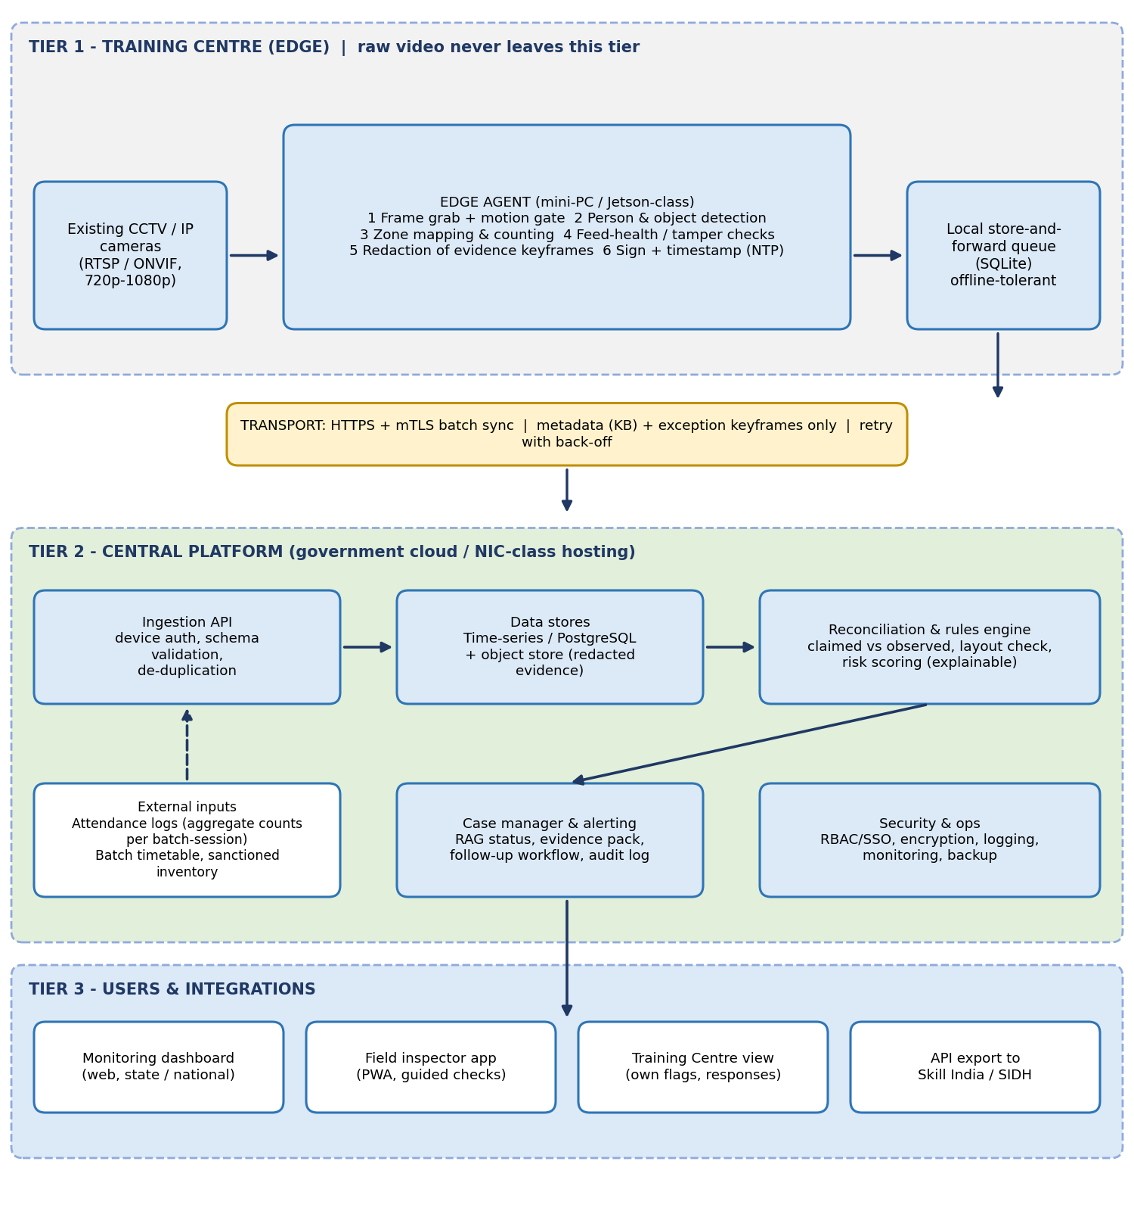
Figure 2: PRAMAAN system architecture
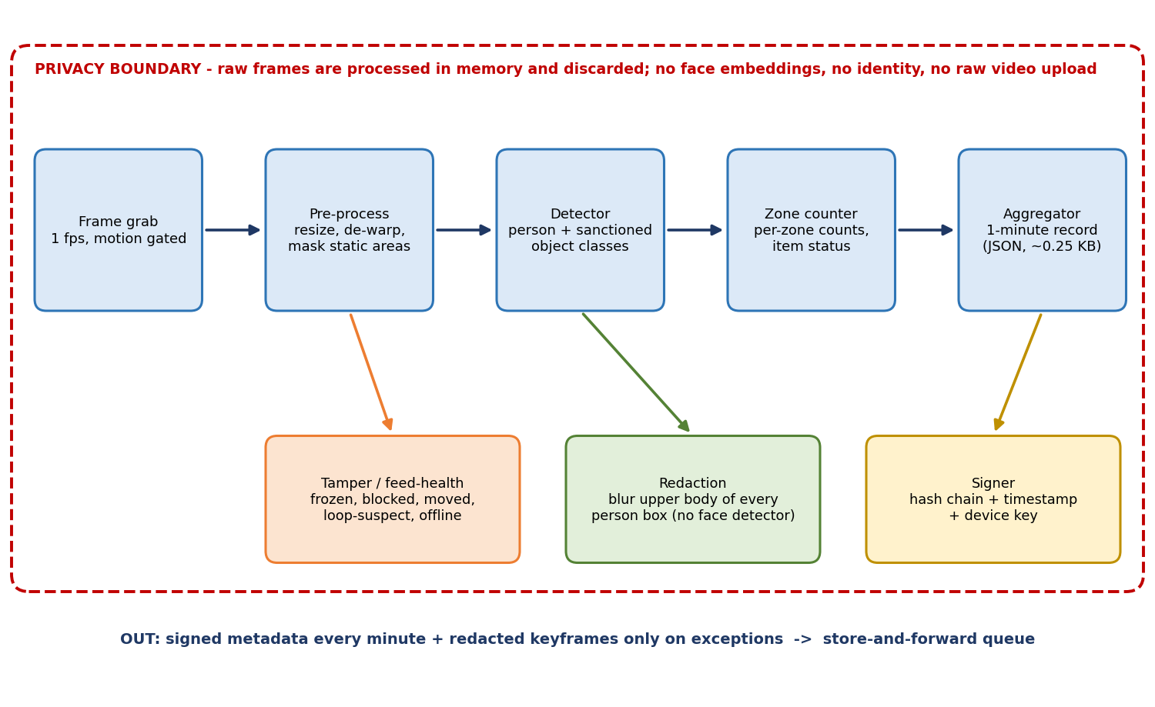
Figure 3: Edge pipeline and privacy boundary

12.1 Layer-by-layer explanation
Table 12: Architecture layers and rationale
Layer | Function | Key design decisions | Why
Cameras | Provide RTSP/ONVIF streams [29] | Reuse existing cameras; no new camera purchase by default | Cost and adoption (C1)
Edge agent: frame grab and motion gate | Pull frames at about 1 fps; skip static scenes | Low frame rate; configurable by session schedule | CPU budget on small devices
Pre-processing | Resize, optional de-warp, mask irrelevant areas (windows, corridors) | Per-camera zone masks set at baseline visit | Avoid counting people outside the room
Detector | Persons and sanctioned item classes | Permissively licensed model; exported to ONNX and run via OpenVINO or TensorRT | Licence and speed [22][23][24]
Zone counter | Counts per zone; item status per zone | Counts only; track IDs, if used, live in memory for the session | Privacy; no persistent identity
Tamper and feed health | Detect frozen, blocked, moved, dark, offline feed | Compare against baseline reference scene; frame-hash repetition test | Evidence integrity (T3)
Redaction and signing | Blur upper body of every person box before any keyframe is stored; sign records | Hash chain with device key and NTP time | Privacy and tamper evidence
Store-and-forward queue | Hold records during outages | Local queue with retry and back-off | Connectivity (S1)
Ingestion and validation | Authenticate device, validate schema, de-duplicate, plausibility checks | mTLS; reject impossible rates of change | Security and data quality
Storage | Time-series records; object store for redacted evidence | Retention periods configurable by policy | Data minimisation [20]
Reconciliation and rules engine | Claimed-versus-observed, layout checks, risk scores | Rule-based with calibrated thresholds; explainable | Trust and auditability
Case manager and alerts | RAG status, evidence pack, workflow, audit log | Flags are leads, not penalties; TC can respond | Fairness
Dashboard, apps, API | Maps, filters, drill-down, export | Exception-first views; read-only API for portal integration | Usability (U1, U5)

12.2 Reconciliation logic
Figure 4 shows the decision logic. Thresholds (0.80 and 0.50) are initial hypotheses chosen to leave room for occlusion and to avoid flagging small differences; they must be calibrated on pilot data. The strongest and most defensible signals are gross: near-zero occupancy against a large claim, and sustained large shortfalls. Fine-grained differences are not claimed to be reliable.
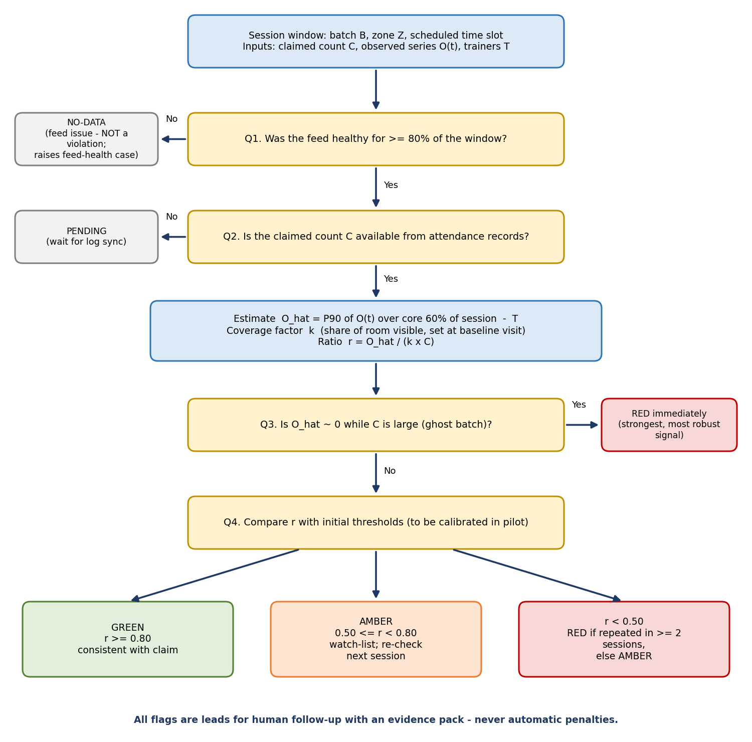
Figure 4: Claim-versus-observation decision logic

12.3 Infrastructure compliance logic
- Sanctioned Layout Profile (SLP): at an inspection (or a guided self-capture with geo-time stamp), zones are drawn on a reference frame and the sanctioned item counts per zone are recorded.
- Presence status per item class and zone: PRESENT, ABSENT or UNCERTAIN. ABSENT is raised only when the item is not seen across several unoccluded windows on at least two days (persistence rule). Occlusion and camera outage yield UNCERTAIN, never ABSENT.
- Capacity check: peak occupancy against sanctioned seating or workstation count.
- Apparent operability: reported only as evidence of use (a person at the station during a practical session; a computer screen that is on). The wording on the dashboard is "no evidence of use in N practical sessions", not "non-functional". Real operability requires power telemetry (concept C7, future).

13. Technology Stack
Table 13: Technology stack and rationale
Area | Choice | Why selected (and alternatives considered)
Frontend | React with TypeScript; map library for centre locations; charting library; installable PWA for field inspectors | Component reuse, offline-capable PWA for low connectivity; native apps unnecessary for MVP
Backend | Python with FastAPI | Same language as the ML code; async ingestion; automatic OpenAPI documentation for integration
Database | PostgreSQL with a time-series extension; S3-compatible object storage for evidence | Relational integrity for centres, batches and cases; time-series queries for counts. Check the licence of any local S3-compatible server used in development
AI/ML | PyTorch for training; ONNX export; OpenVINO or TensorRT at the edge; permissively licensed detector (for example RT-DETR [23] or YOLOX [24]; verify weights licence); OpenCV | Avoids AGPL obligations of Ultralytics YOLO [22]; portable runtimes for heterogeneous edge hardware. ByteTrack [25] optional for short-term continuity
Perceptual hashing | Standard perceptual-hash library | Duplicate-evidence detection needs no ML training
APIs | REST/JSON with OpenAPI; RTSP/ONVIF for cameras [29]; webhooks to external portals | Interoperability with existing cameras and national platforms
Authentication | OIDC single sign-on and role-based access for people; per-device X.509 certificates over mTLS for edge devices | Separate human and machine identity; revocable device credentials
Cloud / infrastructure | Containers; Kubernetes in production; hosting on an approved government cloud (to be decided) | Reproducible deployment; hosting must meet Government requirements
Hardware (edge) | Candidates: x86 mini-PC (OpenVINO), Jetson-class module (TensorRT), single-board computer with an AI accelerator. Choice by benchmark | Unknown until benchmarked; avoid committing to one vendor
Networking | TLS 1.3, mTLS, batch uploads, optional cellular fallback, NTP time sync | Security and low-bandwidth operation
Monitoring | Metrics and dashboards for device heartbeat, queue depth, model version; centralised logs | Operate thousands of devices
Security | Encrypted storage and transport, secrets management, signed software and model updates, audit logs, penetration test before pilot | Section 16

Bandwidth arithmetic (design estimate, to be measured)
Routine upload: one signed record per camera-minute of about 250 bytes gives about 15 KB per hour and about 150 KB over a 10-hour day, plus a few redacted keyframes on exceptions. For comparison, continuous 1080p streaming at a typical 2-4 Mbps is about 9-18 GB over 10 hours (2 Mbps x 36,000 s = 9 GB). The 250-byte record size and the stream bitrates are planning assumptions, not measurements.

14. Data Feasibility
Rule applied: never assume Government or private data is automatically available. Items marked "Not verified" need confirmation from MSDE/NSDC.
Table 14: Data inventory and feasibility
Dataset | Source | Access | Format | Scale | Update frequency | Privacy | Licensing | Prototype availability
Centre camera footage | Training-centre CCTV; SIH organisers have said sample/dummy footage will be provided | Prototype: provided or team-staged. Production: on-site RTSP with scheme condition and TC consent. Not verified | RTSP, H.264/H.265 | 2-8 cameras per centre (assumption) | Continuous | Contains faces: processed at the edge only | Footage terms from SIH to be confirmed; own staged footage is ours | Yes, sample promised; staged clips as backup
Claimed attendance (aggregate count per batch-session) | AEBAS / face-authentication logs held by the Skill India platform [5] | Requires an NSDC/MSDE export or API. Not verified | CSV / JSON | Per batch per session | Daily | Aggregate count only: low; identities not required | Government data; sharing agreement needed | Simulated with realistic noise
Batch timetable and sanctioned job role | Training-centre registration and batch data on the portal [8] | Same as above. Not verified | JSON | Per batch | On creation / change | Low | Government data | Simulated
Sanctioned inventory per centre | Affiliation / accreditation records and inspection forms | Likely exists on paper or forms; digitisation needed. Not verified | Structured form (to be defined) | Tens of items per centre | On inspection | Low | Government / TC data | Hand-authored for demo centres
Trainer attendance count | Same logs as trainees | Same as above | CSV / JSON | Per session | Daily | Aggregate: low | Government data | Simulated
Public pre-training data | COCO [27]; CrowdHuman [26] | Download | Images with boxes | Large public sets | Static | Public images; contains people | Check each licence before use; verify for any commercial or Government deployment | Yes
Domain-specific item images | Team-collected photos of lab and workshop items; open image sets with matching classes (to be verified) | Team collects with consent; open sets after licence check | Images with boxes | Planning assumption: a few hundred per class, to be revised after pilot | Per new trade | Remove people or obtain consent | Own data: ours | To be created
Baseline reference scenes | Inspector or guided self-capture at install | Needs an inspection step | Images with zone polygons | Per camera | On camera change | Low (blur applied) | Government / TC | Created for demo

14.1 Verdict on data feasibility
Video and public pre-training data are obtainable for the prototype. The two items we cannot assume are production access to attendance logs and digitised sanctioned inventories. Design response: the interface needs only an aggregate claimed count per batch-session and a small structured inventory, which minimises both the integration burden and personal-data exposure. Production route: an MSDE/NSDC data-sharing arrangement and API, aligned with the DPDP Rules [19][20]. If access is refused: the system can still run in a "presence-only" mode (empty-centre, overcrowding, equipment presence, feed health) without attendance reconciliation, with reduced value.

15. AI/ML Validation
AI is used only where simpler logic is inadequate. Using AI for the reconciliation itself would reduce explainability without benefit.
Table 15: AI necessity and validation plan
Component | AI needed? | Reasoning | Model / method | Evaluation
Person counting | Yes | Varied scenes, occlusion, lighting; classical methods are inadequate | Real-time detector, fine-tuned on staged classroom views; dense-crowd counter only if needed [28] | Per-session count error (MAE, relative error); detection precision and recall
Item detection | Yes | Learned appearance needed for chairs, benches, machines | Same detector with trade-specific class pack | Per-class precision, recall, mAP; item-presence decision precision and recall
Usage-evidence proxies | Partly | Screen-on and person-at-station are simple classifiers or geometry rules | Brightness/colour rules; small classifier | Per-proxy accuracy on labelled clips
Reconciliation and thresholds | No | Explainability and calibration matter more | Rule engine, robust statistics (P90 over core window) | Flag precision and recall versus staged ground truth
Duplicate evidence | No | Exact and near-duplicate search is a hashing problem | Perceptual hashing with index | Duplicate detection rate and false match rate
Feed health and tamper | No | Classical image statistics suffice | Blur, brightness, frame-difference, scene-drift against reference | Tamper-event detection rate on staged tests
Cross-centre risk score | Optional | Adds ranking value later | Simple weighted rules first; learned model only with pilot labels | Lift in inspection hit rate (pilot)

15.1 Errors, bias, edge cases
- False positives (centre wrongly flagged): cost is wasted follow-up and loss of trust. Mitigation: AMBER carries no penalty; RED needs persistence; TC can respond.
- False negatives (missed leakage): cost is undetected leakage. Mitigation: favour recall on gross discrepancies; use a high percentile of the occupancy series to reduce occlusion under-counting.
- Bias and fairness: test across lighting, camera angles, clothing, heights, seated and standing postures, and assistive devices such as wheelchairs, so the system does not under-count some trainees.
- Edge cases: mannequins (tailoring), posters and screens showing people, reflections, visitors, trainees working outside the camera view, multiple rooms, dense seating. People who never move over a whole session can be tagged "static" and reviewed.
- Retraining: collect hard cases from reviewed flags under policy, retrain periodically, run a candidate model in shadow mode before release, version every model and record the version in each signed record.
- Deployment: signed model packages pushed over the air with staged rollout and rollback.

16. Security & Privacy Analysis
Table 16: Threat model and mitigations
Threat | Scenario | Mitigation | Residual risk
Authentication | Stolen or cloned edge credentials; shared user accounts | Per-device certificates with revocation; single sign-on; multi-factor for admins | Compromised device before revocation
Authorization | TC user views another centre; insider edits thresholds | Role-based access scoped by centre and state; two-person approval and audit log for configuration | Collusion between privileged users
Data leakage | Exposure of evidence keyframes | Blur at the edge; encryption at rest and in transit; short-lived signed links; retention limits | Blur imperfect for unusual poses
API attacks | Injection, replay, flooding | Schema validation, timestamps and nonces, rate limits, web application firewall | Sophisticated DDoS
Data tampering | Edited counts, replayed old data, looped video | Hash-chained signed records; server-side plausibility; random on-demand evidence requests; feed-health checks | Attacker with full control of the edge device
Model / adversarial input | Printed photos or mannequins to inflate counts; adversarial patches | Multi-frame consistency; "static person" tagging; periodic human spot checks | Novel physical attacks
Insider (centre staff) | Staging people for the camera | Continuous rather than snapshot monitoring; timetable correlation; identity attendance from the existing system remains; future random challenge | A staged crowd matching the claimed count is hard to detect
Infrastructure | Compromise of the edge box or cloud | Minimal services; signed updates; tamper-evident enclosure; hardened cloud; independent security audit before pilot | Physical access attacks
Privacy | Re-identification from keyframes; function creep | No face embeddings; aggregate-first; purpose limitation; access logging; data-protection impact assessment | Public perception of surveillance
Availability | Power cuts, network loss, cloud outage | Local queue; UPS recommended; heartbeat monitoring; cloud redundancy | Long outages produce NO-DATA, not evidence

16.1 Regulatory considerations (to be confirmed by legal counsel)
- The DPDP Rules, 2025 were notified in November 2025; the main fiduciary obligations apply 18 months later [19][20]. Video from which individuals can be identified is personal data, so the design uses data minimisation, purpose limitation, retention limits and breach-response processes.
- If trainees under 18 attend, verifiable parental consent is required under the Rules [21]; the approach for such batches must be agreed with MSDE.
- Government exemptions exist but are contested [19]; the design does not depend on them.
- Other applicable standards (for example CERT-In requirements and Government hosting guidelines) were not researched in this session and should be checked.

16.2 What is and is not identified (privacy-design note)
Table 17: Privacy design: what is and is not identified
Item | Identified? | Treatment
Individual faces | No | Not recognised; no embeddings stored. Evidence keyframes blur the upper body of every detected person
Individual identity | No | The video pipeline never links a person to a name; identity stays inside the existing attendance system
Number of persons per zone per minute | Yes (aggregate) | Stored as a count
Equipment items per zone | Yes | Stored as counts and status
Raw video | Not uploaded | Stays on the centre's recorder under existing rules; frames processed by the edge agent are discarded after inference
Redacted keyframes | Stored on exception | Retention to be set by policy
Dispute resolution | Controlled | An authorised reviewer may request the original footage held at the centre, with an audit log; this is a policy decision for MSDE

Trade-off: aggregate counting cannot say which trainee was absent. That resolution is deliberately left to human follow-up using the existing attendance system.

17. Real-World Deployment Model
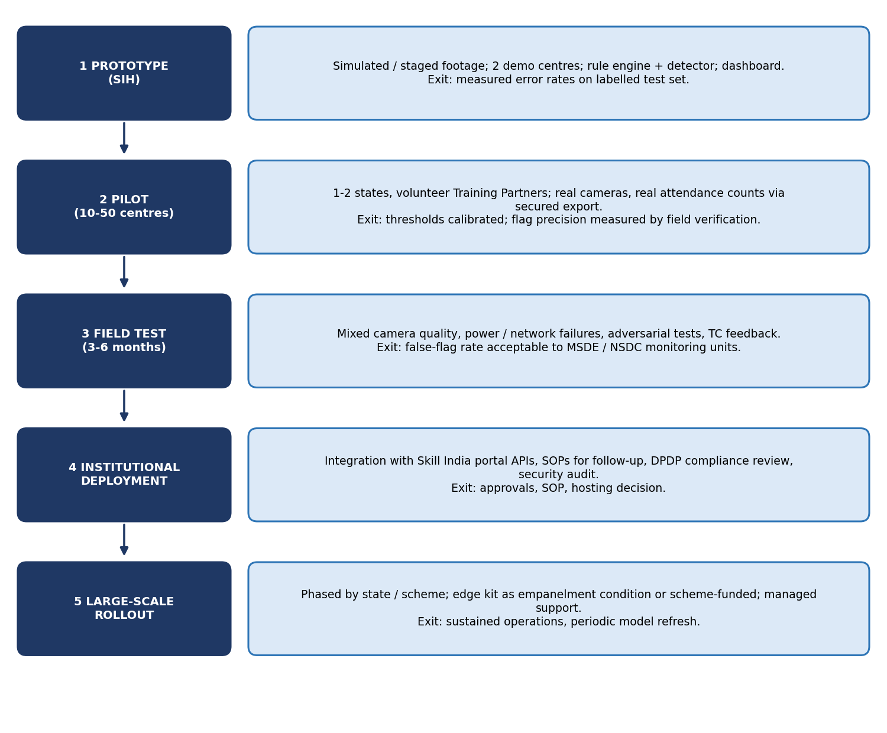
Figure 5: Deployment pathway from prototype to large-scale rollout
Table 18: Deployment questions
Question | Answer
Who deploys it? | MSDE/NSDC monitoring unit as owner, with a systems integrator; Training Partners install the edge kit on site with guided setup.
Who maintains it? | A managed-service team for the central platform; edge devices supported through remote monitoring and signed updates.
Who pays? | Options: empanelment condition borne by Training Partners (there is precedent that a functional attendance system is a prerequisite [7]); scheme-funded in the pilot; or shared. A decision for MSDE.
What hardware is needed? | Existing cameras plus one edge device per centre (type chosen by benchmark); recommended UPS and optional cellular fallback.
What software is needed? | Edge agent, central platform, dashboard, inspector PWA.
What integrations are required? | Aggregate attendance counts, batch timetable, sanctioned inventory, and optional export to Skill India services.
What approvals may be needed? | MSDE sanction, data-sharing agreement, hosting approval, security audit, DPDP review, and a policy on evidence retention.
What training is required? | Short training for monitoring staff on RAG flags and case workflow; guided installation for centre staff.
How do users adopt it? | Start with volunteer centres and make benefits visible: fewer surprise inspections for consistently green centres. Publish the rules.
What happens without internet? | The edge queue holds records and uploads later. Missing time is shown as NO-DATA and never counted as violation; prolonged outages trigger a feed-health case.
What if data is missing? | Reconciliation shows PENDING until the attendance count arrives.
What if the AI is wrong? | Flags are leads for human follow-up with an evidence pack; no automatic penalties; the TC can respond; errors feed model improvement.
What happens under heavy load? | Inference is at the edge. As a hypothetical scale check, 40,000 cameras each sending one record per minute is about 670 records per second, which is modest for a standard database. Real scale tests are needed.

18. SIH MVP

18.1 MUST HAVE (demonstrable at SIH)
- Edge pipeline on staged or provided footage: person counting per zone with live overlay.
- Two demo centres: a computer lab and a tailoring/apparel workshop, each with a Sanctioned Layout Profile.
- Reconciliation of simulated claimed attendance against observed counts with GREEN / AMBER / RED, NO-DATA and PENDING states.
- Item presence check against the sanctioned inventory with UNCERTAIN handling.
- Dashboard: centre list and map, flags, drill-down with redacted evidence, timeline of claimed versus observed.
- Low-bandwidth mode: store-and-forward demonstration (disconnect, queue, reconnect, sync) and a measured data-volume counter.
- Feed-health alert (cover the camera) and duplicate-evidence detection.
- Privacy design note and accuracy assessment (false positives and false negatives) on the demonstration dataset.

18.2 SHOULD HAVE
- Usage-evidence proxies (person at station, screen on).
- Inspector PWA for baseline capture; fallback mobile challenge mode.
- Cross-centre risk ranking (simple weighted rules).
- Case workflow with TC response.

18.3 FUTURE
- Power telemetry for true operability (C7); random in-class identity challenge to counter staged crowds; integration with Skill India APIs; multi-scheme templates; auto-calibration of thresholds; managed device fleet and over-the-air updates at scale.

18.4 MVP workflow
Table 19: MVP workflow
Step | What happens
INPUT | Staged or provided footage plus simulated attendance counts and timetable
PROCESS | Edge agent detects, counts per zone, checks feed health, redacts, signs
DECISION | Rule engine compares claimed against observed and layout against sanctioned
OUTPUT | RAG flags with explanation and redacted evidence on the dashboard
ACTION | Reviewer opens case, requests inspection or closes with note; TC can respond

19. Prototype Implementation Plan
Planned for a student team of four to six members. Durations are planning estimates and depend on when sample footage arrives.
Table 20: Phased implementation plan
Phase | Tasks | Technologies | Deliverables | Dependencies | Risks
1 Research (week 1) | Read scheme documents; interview a mentor or industry contact if possible; define scenarios and metrics | Documents, this report | Requirements, scenario list, evaluation protocol | Access to people | Wrong assumptions about real workflow
2 Data (weeks 1-3) | Obtain provided footage; record staged clips with consent; annotate; build simulated attendance and inventory; create ground truth | Annotation tool, OpenCV | Labelled test set; simulated records | Participants, lab access | Too little variation; privacy of participants
3 Backend (weeks 2-4) | Ingestion API, schema, database, reconciliation engine, case manager | FastAPI, PostgreSQL | Working API and engine with tests | Schema from phase 1 | Scope creep
4 AI/ML (weeks 2-5) | Select and fine-tune detector; zone counting; item classes; feed-health; hashing; export to ONNX and benchmark on candidate edge hardware | PyTorch, ONNX, OpenVINO | Models; benchmark table; error analysis | Labelled data | Poor accuracy on item classes; licence issues
5 Frontend (weeks 3-5) | Dashboard, map, drill-down, evidence viewer, inspector PWA | React, TypeScript | Usable UI | API contract | Over-design
6 Integration (weeks 5-6) | Edge agent to API with store-and-forward; end-to-end flow; signing | Python, containers | End-to-end demo pipeline | Phases 3-5 | Timing and clock issues
7 Testing (weeks 6-7) | Accuracy tests; tamper tests; offline tests; security checks; privacy review | Test scripts | Accuracy report; test log | Ground truth | Metrics disappoint; must be reported honestly
8 Deployment (week 7) | Package containers; deploy a demo instance; document | Docker | Deployed demo; install guide | Stable build | Demo-day network failure
9 Demo (week 8) | Script, rehearse, prepare fallback recordings and Q&A | Slides, recorded fallback | Demo script; backup video | Phase 8 | Live failure

20. SIH Demo Strategy
Target 3-5 minutes. The core technology must visibly work; prototype simulations are labelled as such, with production integration explained.
Table 21: Demo script
Time | Show | Real or simulated?
0:00-0:30 | Problem: CAG finding on reused photos and weak monitoring [1]; blind spot between inspections (Figure 1) | Real data cited
0:30-1:15 | Centre A computer lab. Show Sanctioned Layout Profile; live footage with counts. Simulated attendance claims 25; the room shows 9. Flag turns RED with explanation | Real footage (staged); simulated attendance feed
1:15-2:00 | Centre B workshop. Three sanctioned machines removed during the clip. Item status: ABSENT after persistence; one item UNCERTAIN due to occlusion | Real footage (staged)
2:00-2:30 | Evidence pack: blurred keyframe, counts timeline, rule that fired; TC response | Real
2:30-3:15 | Disconnect network: edge queue grows; reconnect and sync; show bytes sent versus streaming equivalent | Real
3:15-3:45 | Cover the camera: feed-health alert; replay an old photo: duplicate detected | Real
3:45-4:30 | Accuracy slide: confusion matrices on our labelled test set; limits stated openly | Measured on demo data only
4:30-5:00 | Deployment path and what we need from MSDE (data access, pilot centres) | Plan

21. Performance Metrics
No results have been measured. Targets below are hypotheses for the team to test; the "validated" column stays empty until experiments are run.
Table 22: Metrics: baseline, target and validation status
Metric | Current baseline | Target (hypothesis) | Experimentally validated result
Batches compliant with Aadhaar-based attendance requirement | About 13% of short-term and special-project batches since 2018, per CAG [1] | Not a PRAMAAN metric; context only | n/a
On-spot inspections with geotagging | 16% (84% lacked it) per CAG [1] | Not a PRAMAAN metric; context only | n/a
Per-session person-count relative error on standard classroom views | No baseline available | At most 10% | To be measured
Gross over-claim detection recall (claim at least 2x observed) | No baseline available | At least 90% at precision of at least 80% | To be measured
Item-presence precision and recall for sanctioned classes | No baseline available | At least 85% recall at high precision after persistence rule | To be measured
False-flag rate on genuine sessions (RED) | No baseline available | Below 5% of sessions | To be measured
Latency from event to dashboard (online) | Days to weeks (inspection cycle) | Under 5 minutes | To be measured
Data uploaded per camera per day (routine) | Streaming equivalent about 9-18 GB (assumed bitrate) | At most 0.5 MB | To be measured
Edge throughput | n/a | At least 0.5 frames per second per camera on chosen hardware | To be benchmarked
Tamper-event detection (blocked, moved, frozen) | Not systematically detected | At least 90% on staged tests | To be measured

22. Real-World Cost Analysis
Read this first
All figures are order-of-magnitude assumptions in Indian rupees, built from stated assumptions, without vendor quotes. They show where cost sits, not what it will be. Obtain quotes before any budget decision.

Table 23: Indicative cost ranges (assumption-based)
Item | Prototype | Pilot (about 50 centres) | Production (per 1,000 centres) | Assumptions
Edge hardware | Rs 0-25,000 (existing laptops; optional mini-PC) | Rs 10-20 lakh | Rs 2-4 crore | Rs 20,000-40,000 per centre, one device each; cameras reused
Cloud and storage | Free tier / student credits | Rs 2-5 lakh per year | Rs 10-30 lakh per year | Small metadata volume; evidence objects on exceptions
Software development | Team effort (unpaid) | Rs 20-40 lakh | Rs 1-2 crore per year (maintenance team) | Small engineering team
APIs and data | None | Data-sharing arrangement (negotiated) | Same | Cost may be zero or internal
Annotation and model refresh | Team effort | Rs 3-8 lakh | Rs 10-25 lakh per year | Per-trade class packs
Maintenance and support | None | Rs 2-4 lakh | Rs 20-60 lakh per year | About 10-15% of hardware per year plus support
Security and audit | Self-review | Rs 3-8 lakh | Rs 5-15 lakh per year | External penetration test
Training and onboarding | Minimal | Rs 2-4 lakh | Rs 10-20 lakh | Training sessions and material
Monitoring and operations | Basic | Included above | Included above | Dashboards and on-call

Cost-effectiveness cannot be asserted without leakage data. The honest framing is: the cost is small relative to scheme outlays only if flagged cases lead to recoveries or deterrence; that must be measured in the pilot.

23. Risks & Failure Modes
Table 24: Risk register
Risk | Probability | Impact | Mitigation | Residual risk
Technical: accuracy lower than targets on poor cameras | High | High | Quality gating at install; conservative thresholds; AMBER carries no penalty | Medium
Technical: cannot judge equipment functionality | High | Medium | Honest "evidence of use" wording; power telemetry as future extension | Medium
Data: attendance logs or inventories not accessible | Medium | High | Aggregate-count interface; presence-only mode | Medium
Data: insufficient domain training images | High | Medium | Few trades at first; active collection; synthetic augmentation | Medium
Security: edge device compromised or video staged | Medium | High | Signing, feed-health, plausibility checks, random inspections | Medium
Privacy: public backlash or legal challenge | Medium | High | No face identification, blur, minimal data, published rules, legal review | Low
Operational: reviewers ignore or over-trust flags | Medium | Medium | Training; SOP; RAG semantics; audit of closed cases | Low
Financial: hardware cost deters Training Partners | Medium | Medium | Scheme-funded pilot; phased empanelment condition; low-cost devices | Medium
Adoption: Training Partners resist monitoring | High | Medium | Transparency; TC response right; benefits for green centres | Medium
Regulatory: DPDP and Government hosting requirements | Medium | High | Early legal review; data minimisation; approved hosting | Low
Scalability: heterogeneous cameras and many trades | High | Medium | ONVIF reuse; modular class packs; benchmark-based hardware | Medium
Licensing: AGPL contamination from the detector [22] | Medium | Medium | Permissive-licence models; legal check of weights | Low

24. Judge Attack Mode
Twenty-three difficult questions, each with a strong answer, evidence needed, the weakness that remains and how to improve it. Answers are written to be honest: where the answer is weak, it says so.
Table 25: Judge question bank
# | Judge question | Strong answer | Evidence needed | Weakness remaining | How we improve it
1 | Doesn't this already exist? | Identity-based AI attendance exists [15][17][18], and CCTV is mandated in sister schemes [12][13]. We do not claim to replace them. We add an independent occupancy cross-check, a sanctioned-inventory check and tamper-evident evidence. We found no source describing that combination for skilling centres, though our search was limited. | A short survey with NSDC and a vendor scan; written confirmation of no internal equivalent. | We could not rule out internal pilots. | Ask the NSDC technical team directly; position as a module that can plug into the portal.
2 | AEBAS and face authentication already verify attendance. Why add cameras? | They verify an identity event on a device, not that the batch was in the room. CAG found low compliance and unreliable evidence [1]. Counts give an independent signal on the number that triggers payment. | Pilot data showing cases where logs and counts diverge. | Without pilot data we only argue by design. | Run a pilot comparison with real logs.
3 | Where will your data come from? | Footage: sample/dummy footage from organisers plus staged clips. Production: existing CCTV. Claims, timetable and inventory: aggregate exports needing MSDE/NSDC agreement. Public datasets [26][27] for pre-training. | Data-sharing arrangement; sample footage. | Production access to attendance logs is not verified. | Presence-only fallback mode; early engagement with NSDC.
4 | Why do you need AI? | Detecting people and equipment across varied scenes needs learned detectors. We deliberately do not use AI for reconciliation, hashing or feed-health, where rules are clearer and explainable. | Ablation showing classical methods fail. | We have not run the ablation yet. | Run a classical baseline during testing.
5 | What happens when the AI fails? | Flags are leads for human follow-up, never automatic penalties. AMBER carries no penalty. RED needs persistence. Uncertain observations are reported as UNCERTAIN or NO-DATA. | Case-closure statistics from the pilot. | Reviewers may over-trust output. | Training; audit of closed cases; confidence shown on every flag.
6 | How accurate is it? | Not yet known. We will report measured count error and flag precision and recall on our labelled test set, with limitations. Targets are hypotheses [Section 21]. | Labelled test set; results. | Staged data may be easier than real centres. | Pilot on real footage; report separately.
7 | What if there is no internet? | Inference and storage are on-site. Records queue and sync later; missing time is NO-DATA, not violation. Long outages raise a feed-health case. | Offline test log. | Delayed detection during outages. | Cellular fallback; UPS advice.
8 | Who pays for deployment? | Options: empanelment condition on Training Partners (functional attendance infrastructure is already a prerequisite [7]), scheme-funded pilot, or shared. Costs are indicative only [Section 22]. | Vendor quotes; MSDE decision. | Small centres may struggle with hardware cost. | Phased rollout; low-cost device options.
9 | Who maintains the system? | A managed-service team for the central platform; remote monitoring and signed updates for edge devices. | Operations plan; service-level targets. | Field hardware failures in remote areas. | Spare-device pool; remote diagnostics.
10 | How can the Government integrate it? | Through a minimal interface: aggregate claimed counts, timetable, sanctioned inventory in; read-only API and exports out. SIDH is positioned as digital public infrastructure with interoperability [9][11]. | API specification agreed with NSDC. | Integration timelines are outside our control. | Publish an open API contract.
11 | Why can't an existing system add this feature? | It can. We say so openly (Section 9). Our contribution is the scheme-specific logic, thresholds, privacy design and evaluation protocol, which are portable. | Interest from a host platform. | Value could be absorbed without us. | Offer open specifications and reference implementation.
12 | What is your genuine innovation? | Integration and workflow: claim-versus-observation with uncertainty states, sanctioned-layout checking, evidence integrity, aggregate-first privacy, kilobyte bandwidth. Not a new algorithm; we make no first-in-the-world claim. | Comparison against existing tools in a pilot. | Innovation is incremental. | Strengthen with measured results and a published evaluation protocol.
13 | How does it scale? | Inference at the edge; central load is small. As a hypothetical check, 40,000 cameras at one record per minute is about 670 records per second. Per-trade class packs scale the detector. | Load test. | Annotation effort grows with trades. | Few-shot fine-tuning; reuse across trades.
14 | What happens during a cyberattack? | Mutual TLS, signed records, plausibility checks, audit logs, hardened hosting, independent security test before pilot. Edge devices keep running offline. | Penetration-test report. | A fully compromised edge device can lie. | Random on-demand evidence; physical inspections targeted by risk.
15 | How is privacy protected? | No face recognition; no embeddings; raw video not uploaded; upper-body blur on stored keyframes; aggregate counts; retention limits; DPDP review [19][20][21]. | Data-protection impact assessment. | Public perception; minors need parental consent [21]. | Publish the privacy note; agree minor-handling with MSDE.
16 | How will you validate the solution without real data? | Staged footage with ground truth, public datasets, controlled tamper tests, and clear statements that results are on demonstration data only. | Test protocol; ground-truth labels. | Domain gap to real centres. | Pilot with real centres.
17 | What if users do not adopt it? | Adoption is a real risk. We design for transparency, a response right for centres, and visible benefits for green centres. | Pilot feedback. | Trust deficit may remain. | Co-design with Training Partners.
18 | How do you support rural, low-resource centres? | Edge-first, store-and-forward, low frame rate, reused cameras, mobile fallback mode for centres without a usable camera. | Field tests on poor links and cameras. | Very poor cameras reduce accuracy. | Quality gating; recommend camera placement at baseline.
19 | What happens after the hackathon? | Seek a pilot with a state mission or NSDC, calibrate thresholds on real data, complete security and privacy reviews, harden the edge agent. | A pilot sponsor. | Team continuity. | Open documentation; mentor support.
20 | Can you realistically build this? | The MVP uses mature components (detector, rules, API, dashboard). The riskiest parts are domain item detection and data volume; scope is limited to two demo centres. | Working end-to-end build by phase 6 (Section 19). | Item detection accuracy. | Cut item classes to those that work; be transparent.
21 | How can a camera know a machine is working? | It cannot, with certainty. We report evidence of use (person at the station during practicals, screens on) and phrase flags accordingly. Power telemetry is a future extension. | Per-proxy accuracy results. | Operability remains weak evidence. | Add power sensors in a pilot subset.
22 | What if trainees are outside the camera view or in several rooms? | The coverage factor k is set at the baseline visit per zone, and zones must cover the sanctioned training areas. Uncovered areas are listed as blind spots, and flags are computed per zone. | Baseline visit records. | Poor coverage lowers sensitivity. | Recommend extra cameras where gaps are large.
23 | Can a centre game the system by staging people? | Yes, partly. A crowd of the right size could pass the count check. Defences: continuous monitoring, timetable correlation, existing identity attendance, risk-based inspections. A random in-class identity challenge is a future feature. | Red-team test in pilot. | Staged crowds are hard to detect by counting. | Add random identity challenge; correlate with attendance timing patterns.

25. Competitive Positioning
Columns compare capability classes found in the sources, not individually tested products. Cells state what is supported by the sources; "Unknown" means no evidence was found.
Table 26: Competitive capability comparison
Capability | AEBAS / face-auth [5] | CCTV mandate + sampled review [12][13] | Self-assessment photos [14] | State face-recognition apps [15][17] | PRAMAAN (proposed)
Verifies identity of individual attendees | Yes | No | No | Yes | No (by design)
Independent physical-presence signal | No | Partly (manual) | No (centre-captured) | Partly (identity capture in class) | Yes (aggregate)
Continuous coverage | Daily events | Recorded, sampled review | Sampled | Daily | Yes (session-level)
Checks sanctioned equipment | No | Manual, if reviewed | Manual photos | No | Yes (presence; limited operability)
Tamper or duplicate-evidence detection | Unknown | No | No (reuse documented [1]) | Unknown | Yes (designed)
Works with low bandwidth | Unknown | Local storage | Photo upload | Offline mode reported (Assam [17]) | Yes (kilobytes, store-and-forward)
Privacy posture | Biometric / face data | Raw video held locally | Photos | Contested [15] | Aggregate, no face identification
Already deployed at scale | Yes | Mandated in some schemes | Yes (NSDC) | Yes (states) | No (prototype)

25.1 Defensible differentiators
- Independent cross-check: the only signal not supplied by the centre.
- Sanctioned-layout awareness with honest UNCERTAIN and "evidence of use" states.
- Tamper-evident evidence aimed at a documented failure [1].
- Privacy-by-design: no face identification in the compliance path.
- Kilobyte bandwidth through edge-first design (to be measured).
We do not claim superiority in identity verification, deployment maturity, or true equipment operability.

26. Implementation & Adoption Model
Table 27: Implementation and adoption model
Element | Assessment
Beneficiary | Scheme monitoring units and the public (credible spending); honest Training Partners; trainees (better-equipped centres).
Adopter | MSDE / NSDC and state skill missions.
Operator | A managed-service team under the monitoring unit; centre staff run only local setup.
Funding / payer | To be decided by MSDE: Training Partner condition, scheme funding, or shared (Section 17).
Maintenance | Managed service for platform; remote support and signed updates for edge devices.
Partnerships | NSDC technology team; camera/NVR vendors; a state skill mission for the pilot; an independent security auditor.
Integration | Aggregate attendance counts, timetable, inventory in; API and export out; read-only link to Skill India services.
Deployment pathway | Prototype, pilot, field test, institutional deployment, phased rollout (Figure 5).

Best fit: B2G / public-sector institutional deployment, designed as a module of public digital infrastructure (open interfaces, open specifications). B2C and B2B models do not fit: the buyers and beneficiaries are Government programme owners. An open-source reference implementation could widen adoption but would require a decision on hosting and ownership.

27. Final Solution Summary
Table 28: Final summary
Item | Summary
Solution name | PRAMAAN
One-line pitch | Turns a centre's existing camera into a privacy-preserving, tamper-evident witness for attendance and infrastructure compliance, uploading kilobytes.
Problem | Unverified attendance and infrastructure between inspections; evidence can be reused or curated.
Existing systems | Identity attendance, periodic inspection, sampled CCTV review, remote self-assessment, state face-recognition apps.
Critical gap | No independent, continuous, privacy-preserving presence and infrastructure signal (T1, T3, T5, O1, O4, S1, S2).
Proposed solution | Edge analytics plus central reconciliation and case management.
Core innovation | Claim-versus-observation with uncertainty states; Sanctioned Layout Profile; evidence integrity; aggregate-first privacy.
Technology | Permissive-licence detector, OpenCV, ONNX/OpenVINO, FastAPI, PostgreSQL, React, mTLS.
Data | Footage (provided / staged), aggregate attendance counts, timetable, sanctioned inventory, public pre-training sets. Production access not verified.
MVP | Two demo centres; live counting; RAG reconciliation; layout check; dashboard; store-and-forward; tamper and duplicate detection.
Deployment | Pilot with volunteer centres; calibrate thresholds; security and privacy review; phased rollout.
Security | Signed records, mTLS, feed-health, plausibility checks, audit logs; residual risk from a compromised edge device.
Impact | Risk-based inspections; credible scheme data; deterrence of over-claiming (to be measured).
Cost | Prototype low; pilot in lakhs; production in crores per thousand centres (indicative).
Risks | Accuracy on poor cameras; operability evidence is weak; data access; adoption.
Scalability | Edge inference; small uploads; annotation effort per trade is the bottleneck.
Competitive differentiation | Independent cross-check; layout awareness; tamper evidence; privacy; low bandwidth.

28. Final Evaluation
Table 29: Final evaluation (judgement-based)
Criterion | Score /10 | Explanation
Problem relevance | 9 | Directly maps to the problem statement and to documented audit findings [1]
Innovation | 6 | Integration and workflow differentiation; no new algorithm
Novelty | 5 | Components are standard; no patent search; no first-in-the-world claim
Technical feasibility | 8 | Mature components for the MVP; item detection is the main risk
Real-world deployability | 6 | Needs edge hardware, data access, approvals and calibration
Scalability | 8 | Edge inference and tiny uploads; annotation effort grows with trades
Cost effectiveness | 7 | Reuses cameras; hardware cost real; benefit unquantified until pilot
Data feasibility | 6 | Prototype data fine; production attendance and inventory access unverified
Security | 7 | Good design; compromised edge device remains a residual risk
Privacy | 8 | No face identification and aggregate-first; minors and policy details open
Impact | 8 | Potentially large if flags lead to action; depends on adoption
Prototype feasibility | 8 | Two-centre demo is realistic for a student team
Demo potential | 8 | Visible counting, flags, offline and tamper demos
Sustainability | 7 | Needs funded maintenance and model refresh
Average | 7.2 | Unweighted mean of the scores above; a screening aid only

Evidence-based overall assessment: PRAMAAN addresses a real, documented problem [1], reuses assets Government already mandates [12][13], and offers a defensible differentiation in integration, privacy and evidence integrity. It is a credible student MVP. Its main weaknesses are modest technical novelty, weak evidence of true equipment operability, unverified production data access, and dependence on calibration with real footage. Winning depends on execution quality, honest accuracy results and how well the team handles questioning; nothing here predicts an outcome.

29. References
Status column: "Retrieved" means the source was found and read in this research session; "Cited from literature; re-verify" means the reference is a well-known publication cited from knowledge and should be checked before submission. Secondary sources (news analysis sites) are marked and should be replaced with primary documents (the CAG report itself) where possible.
Table 30: Reference list
# | Reference | URL | Status
[1] | PRS Legislative Research. CAG Report Summary: Skill Development under Pradhan Mantri Kaushal Vikas Yojana (CAG report submitted 18 Dec 2025; summary dated 2 Jan 2026). | https://prsindia.org/policy/report-summaries/skill-development-under-pm-kaushal-vikas-yojana | Retrieved
[2] | Drishti IAS. Pradhan Mantri Kaushal Vikas Yojana (PMKVY), news analysis (secondary source). | https://www.drishtiias.com/current-affairs-news-analysis-editorials/news-analysis/08-11-2025/print/manual | Retrieved (secondary)
[3] | Vision IAS. CAG on gaps in PMKVY, summarising The Indian Express, 20 Dec 2025 (secondary source). | https://visionias.in/current-affairs/upsc-daily-news-summary/article/2025-12-20/the-indian-express/schemes-in-news/cag-on-gaps-in-pradhan-mantri-kaushal-vikas-yojana-scheme | Retrieved (secondary)
[4] | Clarity IAS. PMKVY CAG Audit Findings (secondary source). | https://clarityupsc.com/news/article/pmkvy-cag-audit-findings-skill-development-shortcomings-placement-funds-3162 | Retrieved (secondary)
[5] | OpenGov Asia. India Expands Skill Development Network Under Skill India Mission. | https://opengovasia.com/india-expands-skill-development-network-under-skill-india-mission/ | Retrieved
[6] | NSDC. Skill India Centres FAQ: AEBAS, attendance and payment tranches. | https://stag-api.nsdcindia.org/taxonomy/term/263 | Retrieved (NSDC content via staging host)
[7] | NSDC. Pre-requisites for Skill India Centres to become a Training Provider. | https://stag-api.nsdcindia.org/node/6599 | Retrieved (NSDC content via staging host)
[8] | NSDC. Skill India Centres FAQ (portal and batch compliance). | https://innovation.nsdcindia.org/faq | Retrieved
[9] | Vikaspedia. Skill India Digital Hub. | https://en.vikaspedia.in/social-welfare/skill-development/skill-india-digital-hub | Retrieved
[10] | NSDC. Skill India Digital Hub (SIDH) overview. | https://stag-api.nsdcindia.org/taxonomy/term/261 | Retrieved (NSDC content via staging host)
[11] | NeGD / MSDE. Digitally Skilling India: The SIDH Implementation Journey (Oct 2025). | https://negd.gov.in/wp-content/uploads/2025/10/Amit-Bhatnagar-Digitally-Skilling-India-Solution-The-SIDH-Implementation-Journey.pdf | Retrieved
[12] | Ministry of Minority Affairs. PM-VIKAS Monitoring and Evaluation Guidelines. | https://pmvikas.minorityaffairs.gov.in/uploads/documents/c100356c-e192-4e24-9b31-a8cb8c2ef652.pdf | Retrieved
[13] | DDU-GKY. Standard form of SOP, SF 5.2B: CCTV specifications, location, recording, review and storage. | https://ddugkysop.in/pluginfile.php/31556/mod_page/content/7/SF%205.2B%20CCTV%20-%20Specifications%2C%20location%20and%20recording%2C%20review%20and%20storage.pdf | Retrieved
[14] | NSDC. Important notice on virtual verification through PMKVY TC Self-Assessment application, 14 June 2023. | https://udaan.nsdcindia.org/photos/shares/products/YfjqCCLzkImi3W4310LMrImWMKaFe9WTsdBa4Ldk.pdf | Retrieved
[15] | Privacy International. Classrooms to be fitted with AI face-recognition to track student attendance in India (citing The Independent). | https://www.privacyinternational.org/examples/5707/classrooms-be-fitted-ai-face-recognition-track-student-attendance-india | Retrieved
[16] | Deccan Herald. AI-based facial recognition tech for govt school attendance in Karnataka. | https://www.deccanherald.com/amp/story/india%2Fkarnataka%2Fai-based-facial-recognition-tech-for-govt-school-attendance-3462631 | Retrieved
[17] | Digital India. Shiksha Setu Axom (Samagra Shiksha Assam). | https://www.digitalindia.gov.in/?p=8485 | Retrieved
[18] | OpenGov Asia. India: University Implements AI/ML for Efficient Tracking (Osmania University), 2 June 2023. | https://archive.opengovasia.com/2023/06/02/india-university-implements-ai-ml-for-efficient-tracking/ | Retrieved
[19] | Hogan Lovells. India's Digital Personal Data Protection Act 2023 brought into force (DPDP Rules 2025). | https://www.hoganlovells.com/en/publications/indias-digital-personal-data-protection-act-2023-brought-into-force- | Retrieved
[20] | Storyboard18. Govt notifies final DPDP Rules; staggered rollout, 14 Nov 2025. | https://www.storyboard18.com/digital/breaking-govt-notifies-final-dpdp-rules-sets-staggered-rollout-with-key-obligations-for-data-fiduciaries-84201.htm | Retrieved
[21] | Moneylife. Govt Notifies Digital Personal Data Protection Rules, 2025, 14 Nov 2025. | https://moneylife.in/article/govt-notifies-digital-personal-data-protection-rules-2025/78843.html | Retrieved
[22] | Ultralytics. Licensing: AGPL-3.0 and Enterprise licence. | https://www.ultralytics.com/request-license | Retrieved
[23] | Zhao Y. et al. DETRs Beat YOLOs on Real-time Object Detection (RT-DETR). CVPR 2024. arXiv:2304.08069. | https://arxiv.org/abs/2304.08069 | Cited from literature; re-verify
[24] | Ge Z. et al. YOLOX: Exceeding YOLO Series in 2021. arXiv:2107.08430. | https://arxiv.org/abs/2107.08430 | Cited from literature; re-verify
[25] | Zhang Y. et al. ByteTrack: Multi-Object Tracking by Associating Every Detection Box. ECCV 2022. arXiv:2110.06864. | https://arxiv.org/abs/2110.06864 | Cited from literature; re-verify
[26] | Shao S. et al. CrowdHuman: A Benchmark for Detecting Human in a Crowd. arXiv:1805.00123, 2018. | https://arxiv.org/abs/1805.00123 | Cited from literature; re-verify
[27] | Lin T.-Y. et al. Microsoft COCO: Common Objects in Context. ECCV 2014. arXiv:1405.0312. | https://arxiv.org/abs/1405.0312 | Cited from literature; re-verify
[28] | Zhang Y. et al. Single-Image Crowd Counting via Multi-Column Convolutional Neural Network. CVPR 2016. | (see CVPR 2016 proceedings) | Cited from literature; re-verify
[29] | ONVIF. Open standard for IP-based physical security products. | https://www.onvif.org | Cited from general knowledge; re-verify

30. Appendices

Appendix A. Data-flow summary
Table 31: Data flows
Flow | From | To | Data | Frequency / size (design estimate)
F1 | Camera | Edge agent | RTSP frames | About 1 fps used
F2 | Edge agent | Local queue | Signed minute record | About 250 bytes per camera-minute
F3 | Edge agent | Local queue | Redacted keyframe on exception | Tens of KB, few per day
F4 | Local queue | Ingestion API | Batched records over mTLS | On connectivity
F5 | Attendance export | Platform | Aggregate claimed count per batch-session | Daily
F6 | Platform | Dashboard / API | Flags, timelines, evidence links | On demand

Appendix B. Edge record example
{ "device_id": "TC123-EDGE-01", "camera": "lab-front", "zone": "Z1",
"ts": "2026-10-05T10:31:00+05:30", "persons": 9,
"items": {"chair": 20, "monitor": 17}, "feed_ok": true,
"model": "det-v0.3", "prev_hash": "...", "sig": "..." }
Illustrative only; field names are not final.

Appendix C. Database concept
Table 32: Database concept
Table | Key fields
centre | centre_id, name, state, geo location, scheme, status
camera / zone | camera_id, centre_id, zone_id, polygon, coverage factor k
sanctioned_layout | centre_id, zone_id, item_class, sanctioned_count, critical flag
batch / session | batch_id, centre_id, trade, schedule, claimed_count, trainer_count
observation | device_id, zone_id, ts, persons, item counts, feed_ok, model_version, hash, signature
flag / case | flag_id, session_id, type, status (GREEN/AMBER/RED/NO-DATA/PENDING), rule fired, evidence link, owner, notes, TC response
audit_log | actor, action, object, timestamp

Appendix D. Next research tasks
- Confirm with NSDC whether video analytics pilots exist and how attendance and inventory data can be shared.
- Search patent databases (Indian Patent Office, WIPO, Espacenet) for classroom and workshop monitoring claims.
- Search IEEE Xplore, ACM and Springer for classroom person-counting accuracy under low-resolution CCTV, and re-verify the literature references.
- Study CERT-In and Government hosting requirements; obtain legal advice on DPDP applicability and minors.
- Benchmark candidate edge hardware; obtain vendor quotes.
- Obtain the CAG report itself to replace secondary sources.

Appendix E. Prototype assumptions
- Sample footage resembles real centres only partly; results will be reported as demonstration-data results.
- Attendance counts, timetable and inventory are simulated.
- Thresholds are hypotheses to be calibrated.
- Cost and bandwidth figures are planning assumptions.

Appendix F. Glossary
Table 33: Glossary
Term | Meaning
AEBAS | Aadhaar-enabled Biometric Attendance System
CAG | Comptroller and Auditor General of India
DPDP | Digital Personal Data Protection (Act 2023, Rules 2025)
MSDE / NSDC | Ministry of Skill Development and Entrepreneurship / National Skill Development Corporation
PMKVY | Pradhan Mantri Kaushal Vikas Yojana
RAG | Red / Amber / Green status
SIDH | Skill India Digital Hub
SLP | Sanctioned Layout Profile (zone-based description of approved equipment)
TC / TP | Training Centre / Training Partner
ONVIF / RTSP | Camera interoperability standard / streaming protocol

Appendix G. Quality-control audit
Table 34: Pre-publication quality audit
Area | Result | Note
Research: existing solutions investigated | Partial | Government, state and category-level sources; no product-by-product vendor study
Research: claims verified, no fabricated references | Pass with caveat | Retrieved sources marked; literature citations flagged for re-verification
Innovation meaningful | Partial | Differentiation is integration-level, honestly stated
Students can build the MVP | Pass | Mature components; limited scope
Required data exists and is accessible | Partial | Prototype yes; production access unverified
Deployable by an organisation | Partial | Needs hardware, data access and approvals
Security addressed | Pass | Residual edge-compromise risk stated
Cost realistic | Partial | Indicative ranges only
Scales | Pass | Edge-first; annotation is the bottleneck
Core innovation demonstrable and defensible | Pass | Demo plan and judge Q&A prepared

