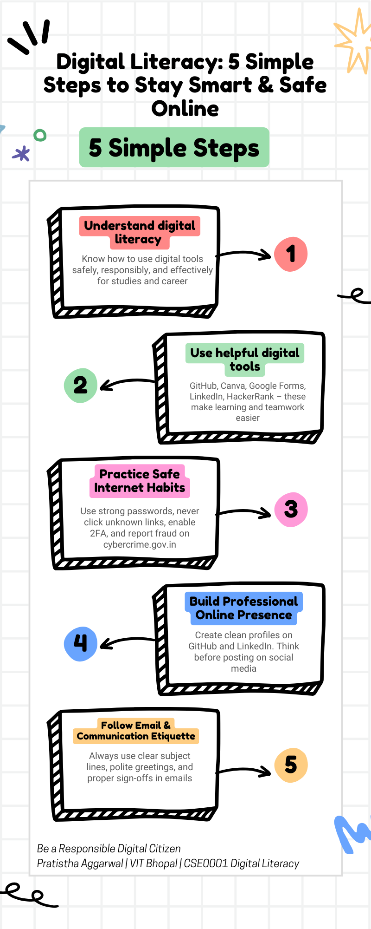

REPORT : TASK 1

For task 1, I created a Digital Literacy Awareness Infographic using CANVA. I selected the “5 simple steps” template because it looked clean and easy for first year students to understand at a glance. I changed the title to “Digital Literacy: 5 Simple Steps to Stay Smart & Safe Online” and filled each box with important information. The five boxes cover what digital literacy actually means, useful tools like GitHub and LinkedIn, safe internet practices, building a professional online presence, and proper email etiquette. I also added relevant icons to make it more attractive.
The most interesting part for me was seeing how the arrows connected all the steps and made everything flow nicely. However, it was a bit difficult to shorten the sentences so they would fit properly inside the boxes without looking crowded. I had to edit the text many times and it took me almost 30 minutes to finish.
This task really helped me learn how to present information in a visual way. I believe this infographic can actually help my batchmates understand why digital literacy is important. I am quite happy with the final colors I chose

