- HACKERRANK

- BADGE

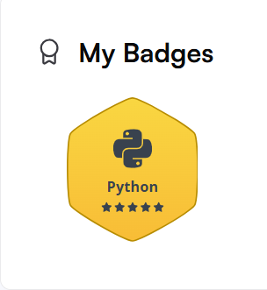

- PYTHON(basic)

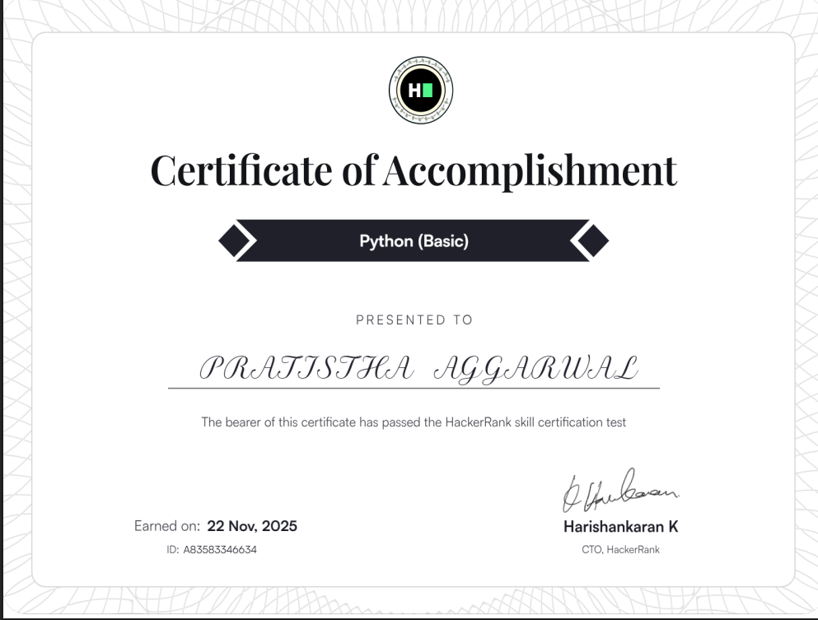

- PROBLEM SOLVING(basic)

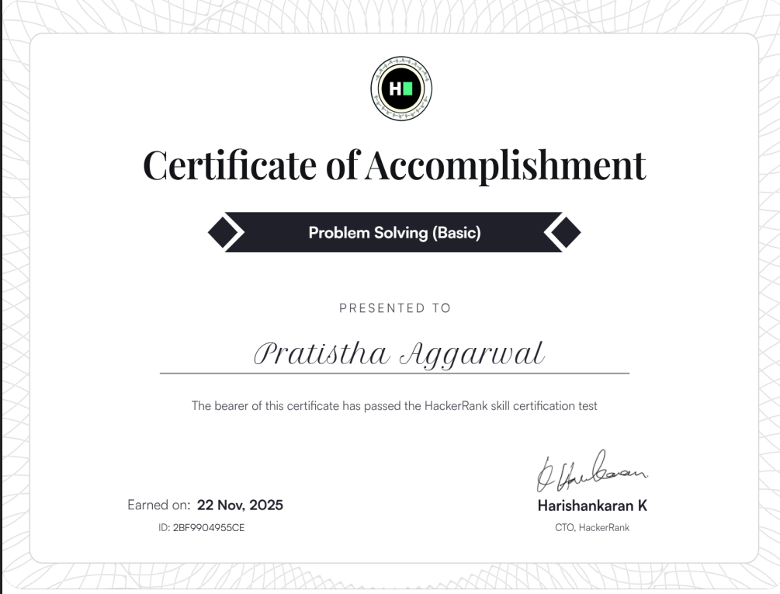

- PROBLEM SOLVING(intermediate)

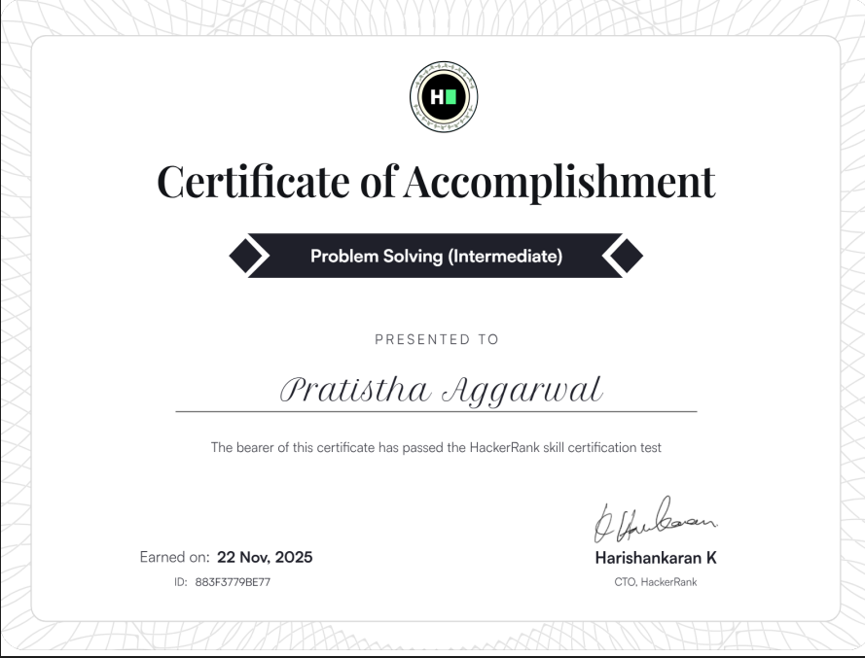

- GOOGLE WORKSPACE
https://docs.google.com/forms/d/e/1FAIpQLScRGeB_Ehx1_b2VivCQiaV3QnmhzS4wvjk4R1AO1ljOzx7Tfg/viewform?usp=publish-editor

- GOOGLE FORM

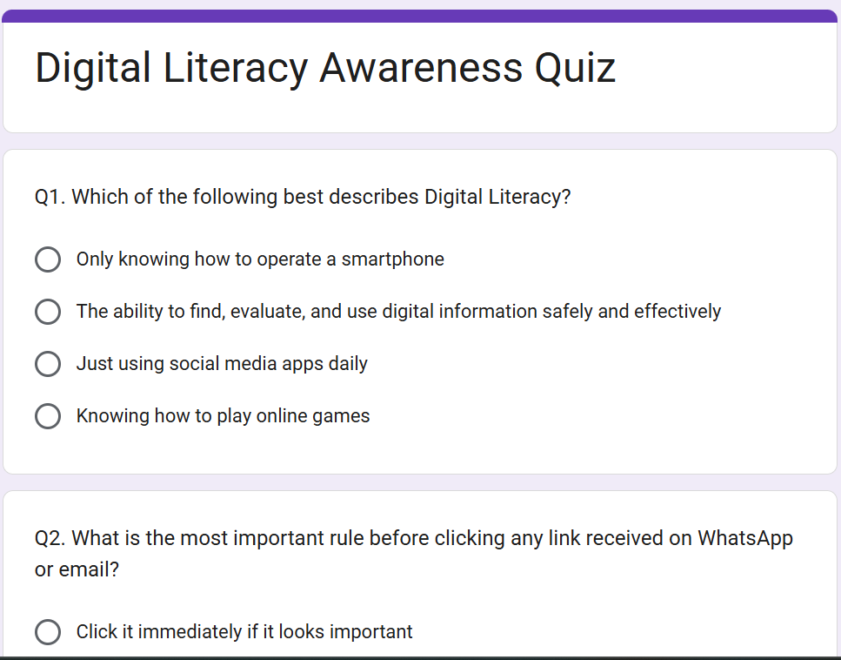
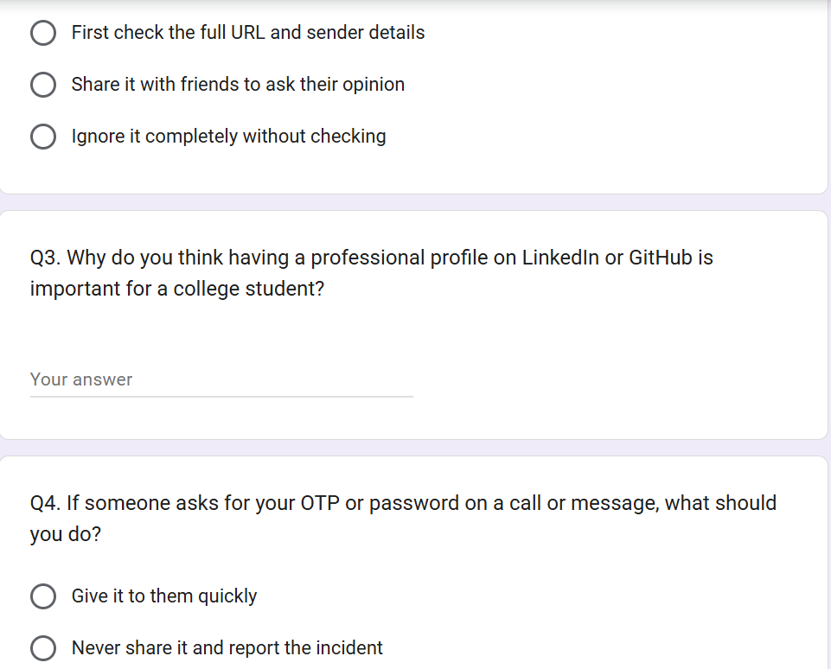
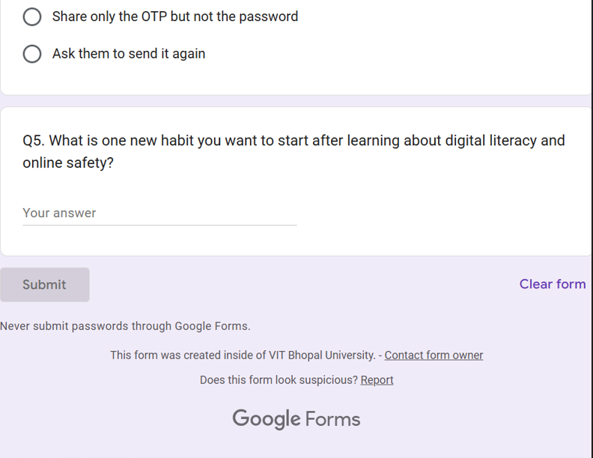

- RESPONSE SHEET

