

CSE0001 – Digital Literacy
PROJECT FILE

Name: Pratistha Aggarwal
Registration No: 25BAI10076

INTRODUCTION
As a first-year B.Tech CSE (AI & ML) student at VIT Bhopal University, I was selected as a Student Digital Ambassador. My role is to help my batchmates navigate the digital world safely and responsibly. For this CSE0001 Digital Literacy project, I had to build a complete Digital Literacy Portfolio containing five tasks – one for each module of the course.
The project helped me learn how to create a professional online presence, communicate properly through email, practise coding on different platforms, and most importantly, stay safe from cybercrimes. All my work is organised in a public GitHub repository. Through this assignment, I not only completed the required tasks but also gained practical knowledge that I can use throughout my college life and future career. This project has truly prepared me to guide my peers in becoming responsible digital citizens.

- TASK 1

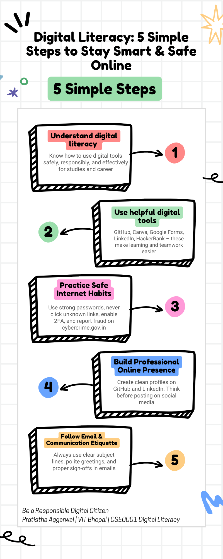

For task 1, I created a Digital Literacy Awareness Infographic using CANVA. I selected the “5 simple steps” template because it looked clean and easy for first year students to understand at a glance. I changed the title to “Digital Literacy: 5 Simple Steps to Stay Smart & Safe Online” and filled each box with important information. The five boxes cover what digital literacy actually means, useful tools like GitHub and LinkedIn, safe internet practices, building a professional online presence, and proper email etiquette. I also added relevant icons to make it more attractive.
The most interesting part for me was seeing how the arrows connected all the steps and made everything flow nicely. However, it was a bit difficult to shorten the sentences so they would fit properly inside the boxes without looking crowded. I had to edit the text many times and it took me almost 30 minutes to finish.
This task really helped me learn how to present information in a visual way. I believe this infographic can actually help my batchmates understand why digital literacy is important. I am quite happy with the final colors I chose

- TASK 2

- GitHub profile
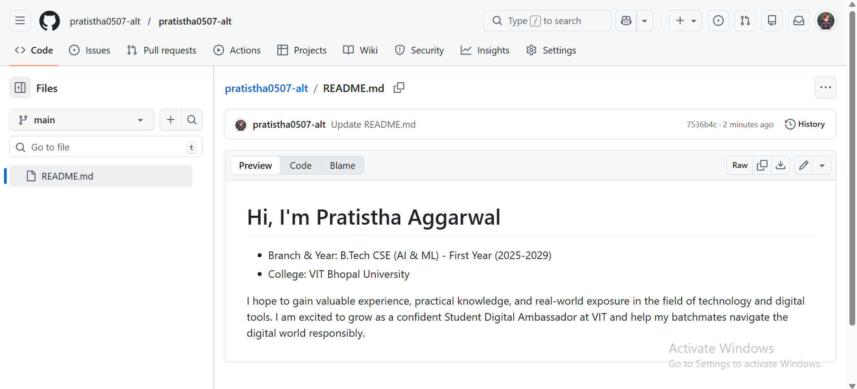
- LinkedIn profile

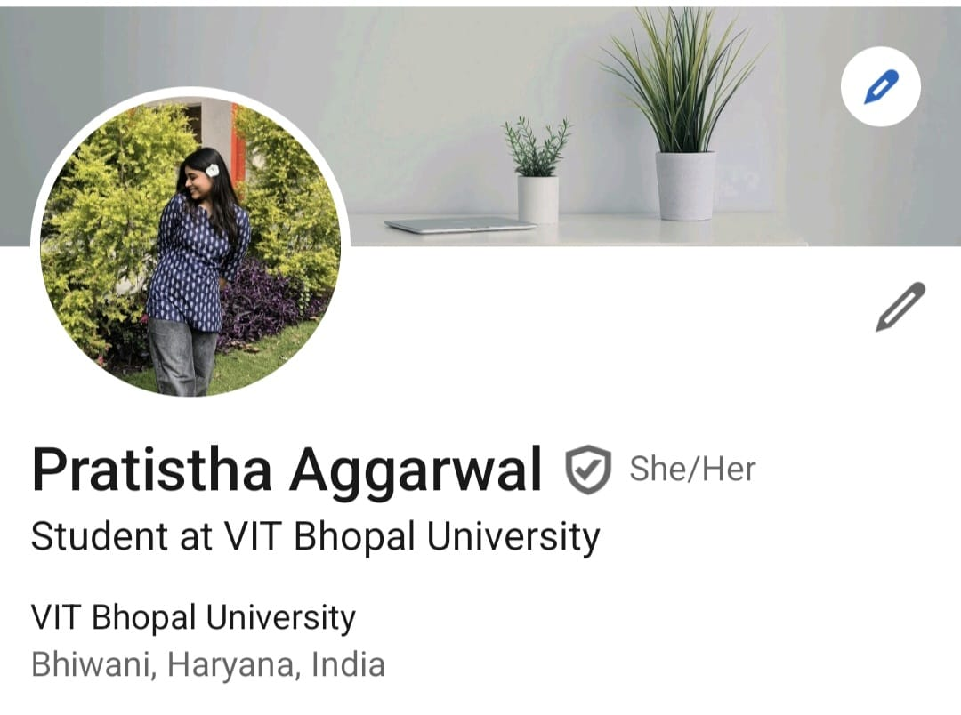

- Kaggle profile
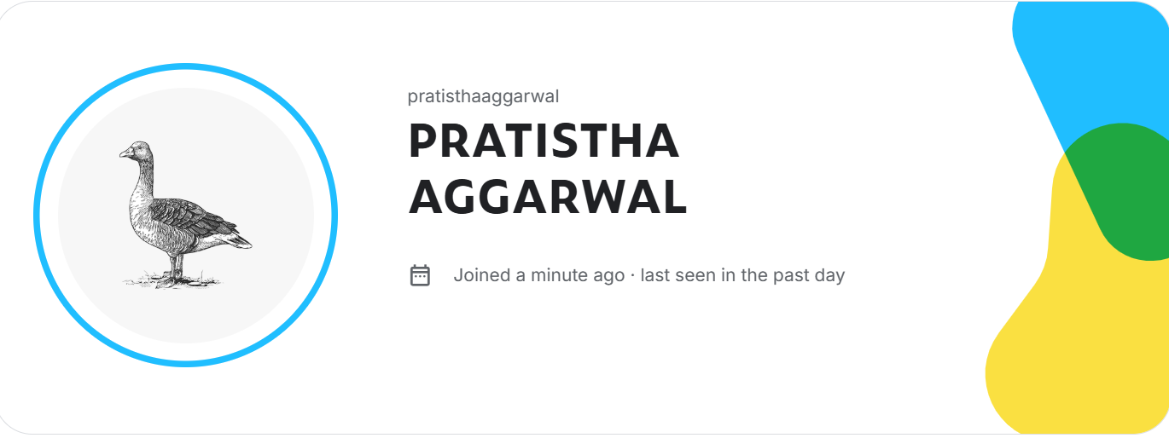
I built my student digital portfolio by creating profiles on three platforms: GitHub, LinkedIn, and Kaggle. I chose these platforms because they are widely used by students, professors, and companies.
On GitHub, I created a special profile README with my name, branch, year, and what I hope to learn. On LinkedIn, I filled in my Education section with details of BTech CSE (AI & ML) at VIT Bhopal University. On Kaggle, I made a basic profile which is useful for data science and machine learning practice. I took screenshots of all three profiles and uploaded them in the task 2 folder.
I plan to use GitHub to upload all my college projects and assignments over the next four years. I will use LinkedIn to connect with seniors, alumni, and companies for internships. I will use Kaggle to practice coding and participate in competitions. This task made me realize that having a professional online presence is important right from the first year. I am excited to update these profiles regularly.

- TASK 3
- HACKERRANK

- BADGE

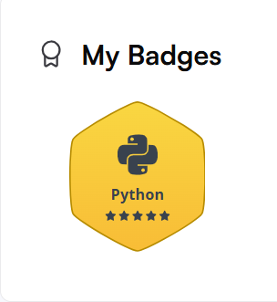

- PYTHON(basic)

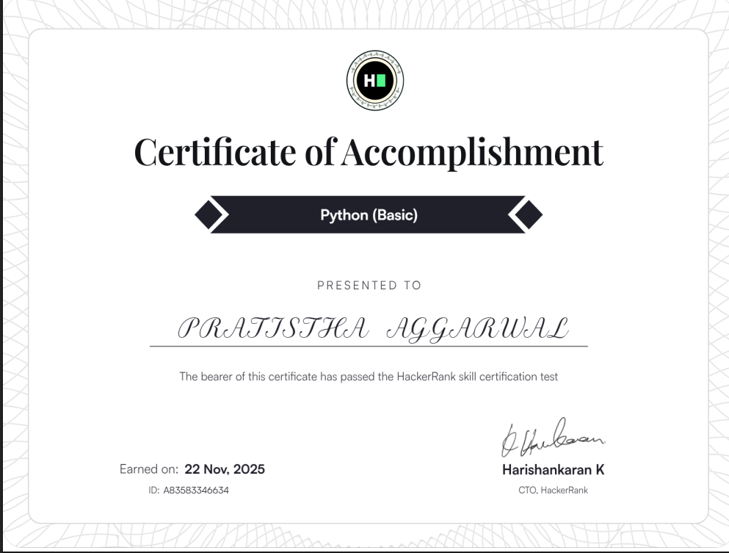
- PROBLEM SOLVING(basic)

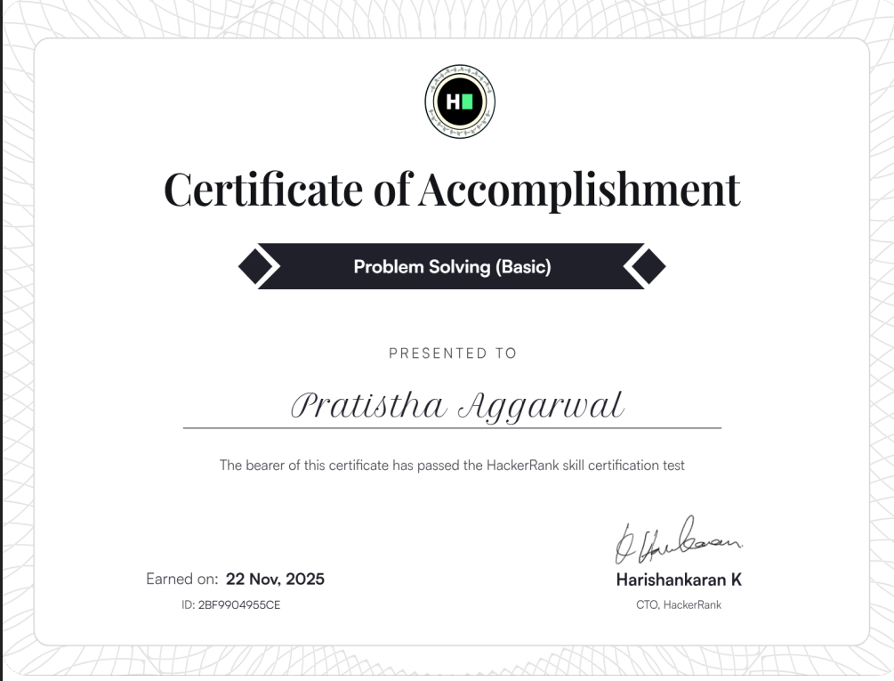

- PROBLEM SOLVING(intermediate)

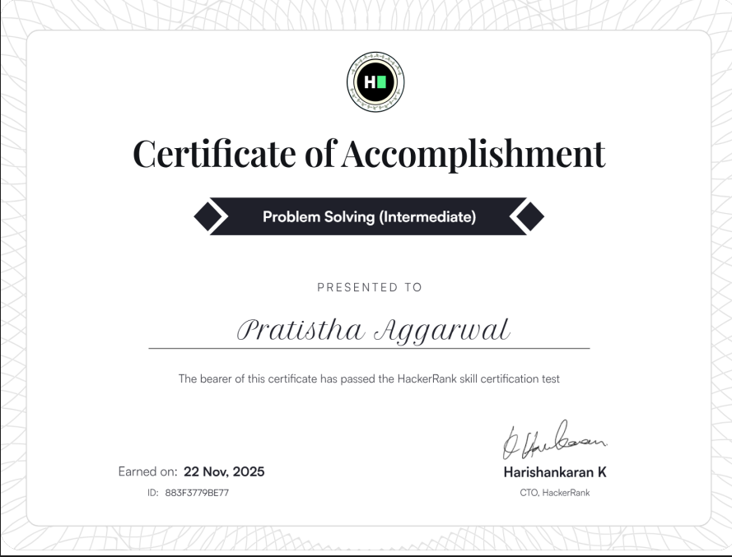

- GOOGLE WORKSPACE
https://docs.google.com/forms/d/e/1FAIpQLScRGeB_Ehx1_b2VivCQiaV3QnmhzS4wvjk4R1AO1ljOzx7Tfg/viewform?usp=publish-editor

- GOOGLE FORM

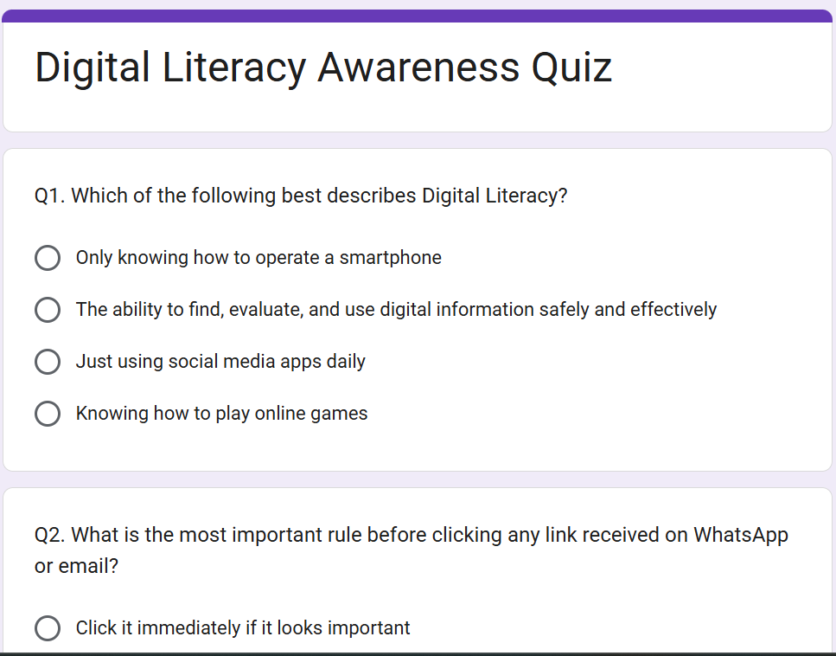
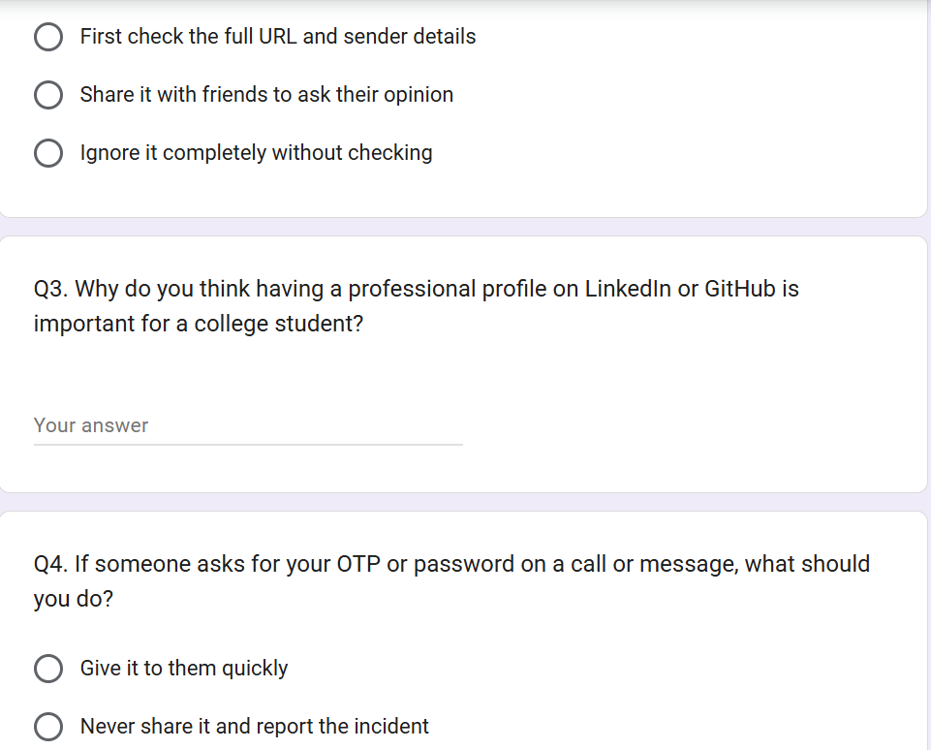
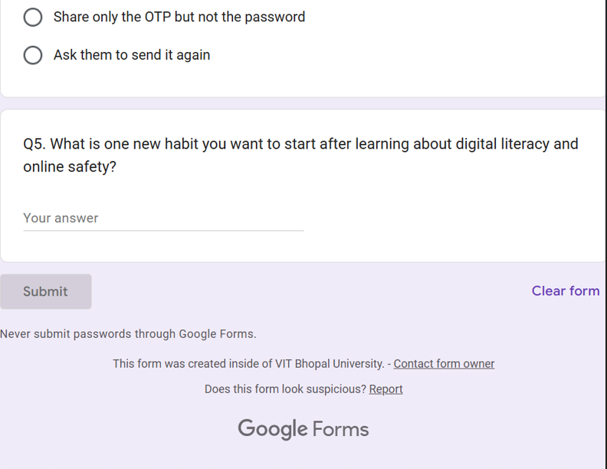

- RESPONSE SHEET
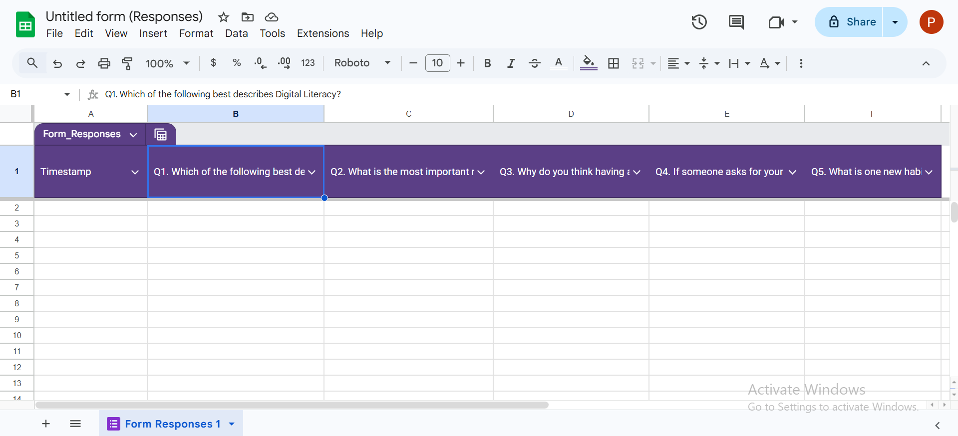
I completed both parts as required. In Part A, I created an account on HackerRank and solved the beginner-level challenge “Solve Me First” in Python. I submitted the code and got all test cases passed successfully. In Part B. I created a Google form titled “Digital Literacy Awareness Quiz” with exactly 5 questions. The questions included multiple choice and short answer types about digital literacy, safe internet practices, professional profiles, and online safety habits.
I found it interesting to create my own quiz. The difficult part was making the questions clear and unique so that they are useful for my batchmates. I took screenshots of the form and the responses sheet and uploaded them in the task-3-platforms folder.
These platforms will help me a lot in my academic journey. HackerRank will help me practice . Google Forms will be useful for creating surveys and quizzes for group projects and collecting feedback from classmates. I plan to use both tools throughout the next four years at VIT.

- TASK 4
One situation where poor digital communication caused a real problem was when a first-year student sent a casual WhatsApp message to a professor saying “Sir notes please” without any greeting or proper context. The professor felt it was disrespectful and ignored the message completely. As a result, the student missed important study material and had to struggle before the exam.
If the student had used a polite and professional tone, such as starting with “Respected Sir” and writing a full sentence like “Good morning Sir, could you please share the notes for the last lecture?”, the professor would have responded positively and helped the student. This shows how small mistakes in tone and structure can create misunderstandings and affect academic relationships.

- TASK 5
While researching this topic, what surprised me the most was how easily phishing attacks can happen even through official-looking college Gmail. I never thought that a mail claiming to be a “govt certified internship” could be completely fake. When I personally faced a similar incident and lost ₹2000, I realised how convincing these scams have become. Even after my college sent a warning about fake internships, I still had to go through the stress of trying to recover the money and repeated calls.
Because of this experience and research, I have decided to change one important habit. From now onwards, I will never make any payment or click any link for internships, offers or fee payments without first verifying it with my college placement cell or seniors. I will also start using 2FA (two factor authentication) on all my important accounts. This task has made me much more careful and responsible while using the internet

CONCLUSION
This Digital Literacy project has been a very valuable learning experience for me. From creating an infographic in Canva to building my professional profiles, practising on HackerRank, writing professional emails, and understanding phishing attacks, I have gained many practical skills.
The most important thing I learnt is that being digitally literate is not just about using technology but using it safely and responsibly. My personal experience with the fake internship phishing scam made me realise how important these skills are in real life. I am now more confident and plan to keep updating my GitHub and LinkedIn profiles regularly. This project will remain part of my permanent digital portfolio.

REFERENCES

- Canva https://www.canva.com
- Hacker Rank https://www.hackerrank.com
- Google Forms https://forms.google.com
- GitHub https://github.com
- LinkedIn https://www.linkedin.com
- Kaggle https://www.kaggle.com
- National Cyber Crime Portal https://cybercrime.gov.in

