SOFTWARE REQUIREMENT SPECIFICATION (SRS)
AI Resume & Portfolio Builder

1. Introduction
1.1 Purpose
The purpose of this Software Requirement Specification (SRS) document is to describe the requirements of the AI Resume & Portfolio Builder system.
This system is designed to help students generate professional resumes easily using artificial intelligence.
1.2 Scope
The AI Resume & Portfolio Builder is a web-based application that allows users to enter their personal details, skills, projects, and career goals.
The system processes the information and generates a structured resume automatically.
2. Overall Description
2.1 Product Perspective
The system follows a client-server architecture.
The frontend provides the user interface, while the backend processes data and generates resume content using AI logic.
2.2 Product Functions
- Accept user input
- Process skills and project details
- Generate resume automatically
- Display resume to the user
2.3 User Characteristics
- Students
- Fresh graduates
- Users with basic computer knowledge
3. Functional Requirements
- The system shall allow the user to enter personal information
- The system shall allow the user to enter skills
- The system shall allow the user to enter project details
- The system shall generate a resume automatically
4. Non-Functional Requirements
- The system should be easy to use
- The system should respond quickly
- The system should be reliable
5. System Requirements
5.1 Hardware Requirements
- Laptop or Desktop
- Minimum 4 GB RAM
5.2 Software Requirements
- Windows Operating System
- Python
- Node.js
- Visual Studio Code
- Web Browser
6. Future Scope
- Adding PDF resume download
- Adding portfolio website generation
- Adding login and user profiles
7. Conclusion
The AI Resume & Portfolio Builder provides an effective solution for students to create resumes using artificial intelligence and modern web technologies.

USE CASE
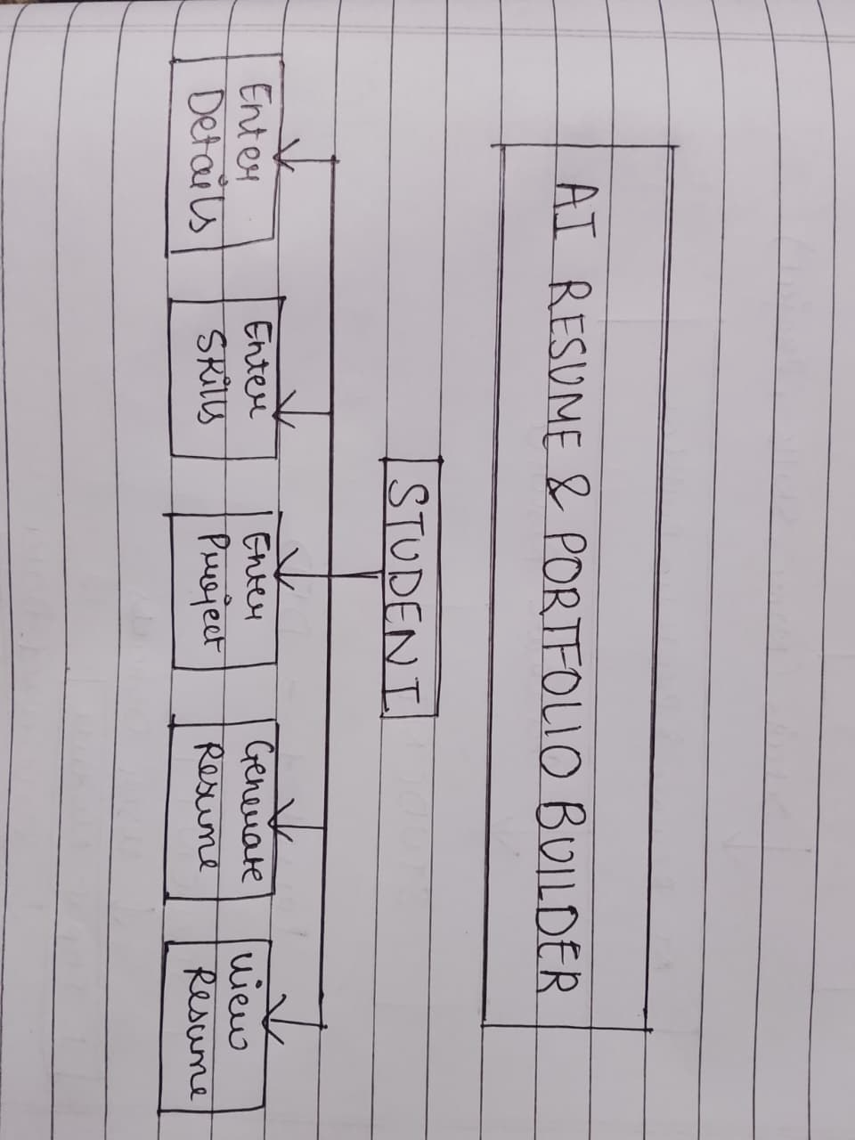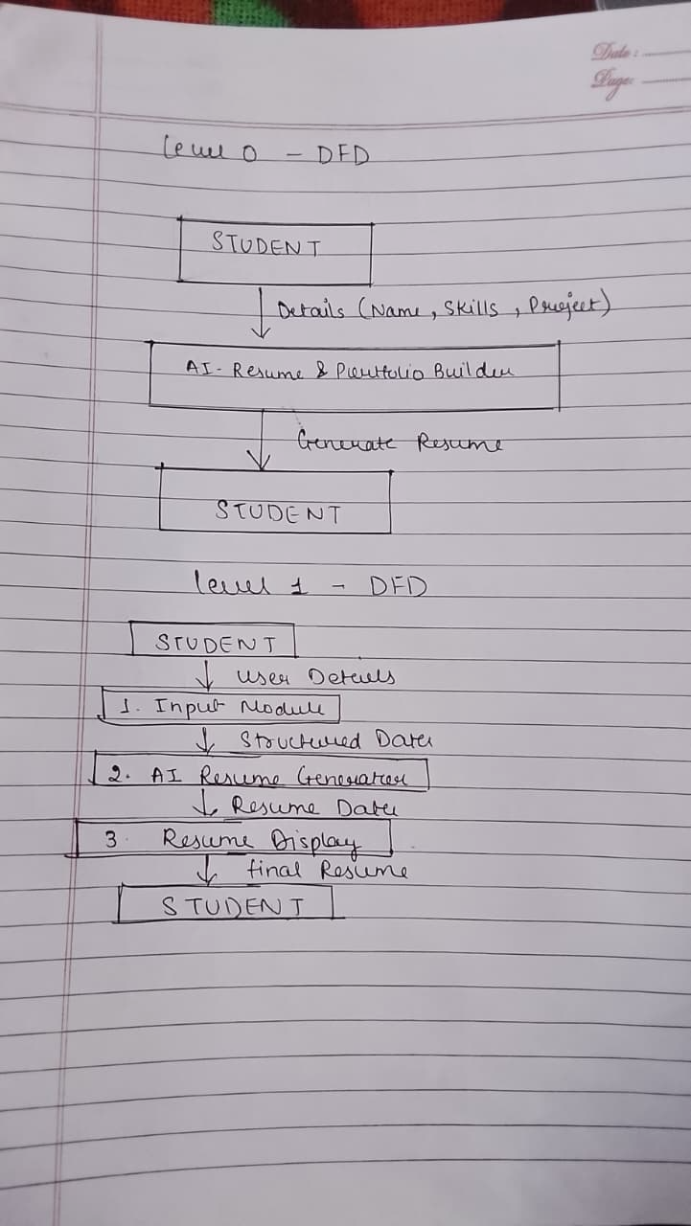
DFD

SYSTEM ARCHITECTURE DIAGRAM

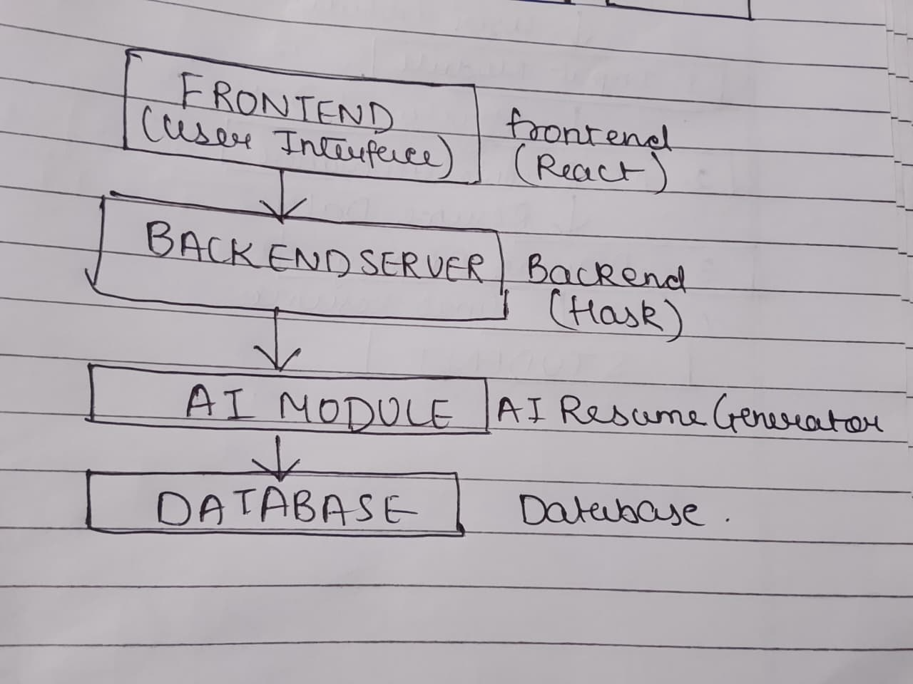

The system architecture diagram shows the overall structure of the AI Resume & Portfolio Builder. The frontend is responsible for user interaction, the backend processes requests, the AI module generates resume content, and the database stores user information.

