MapEase: A Guided Location Discovery and Nearby Places Finder
1. Introduction
OpenStreetMap (OSM) is an open-source mapping platform that provides geographic information about roads, buildings, locations and points of interest. It allows users to search for places and explore their geographic surroundings.
The objective of this project is to examine the existing OpenStreetMap website and develop a focused web application that improves a selected location-discovery workflow.
The proposed application, MapEase, is designed for students, newcomers and people visiting unfamiliar areas. It allows users to enter a location, select a category such as libraries, hospitals or restaurants, and view relevant search results in a simple interface.
The application is developed using HTML5, Tailwind CSS and JavaScript. It uses the Fetch API to retrieve geographic search data and processes the returned JSON to display readable results.
2. Benchmark Analysis
2.1 Target Users
The target users of MapEase are:
- Students looking for useful facilities around their college or hostel.
- Newcomers who are unfamiliar with a city or neighbourhood.
- Visitors who want to locate hospitals, libraries, restaurants and other facilities.
- Users who prefer a simple search interface with clear feedback.
These users may benefit from a guided workflow that combines location input, category selection and result presentation in one place.
2.2 Existing Website Features
The OpenStreetMap website provides several features relevant to this project:
- Interactive map: Users can explore geographic areas using map controls.
- Place search: Users can search for locations and geographic features.
- Location selection: Users can select places and inspect their positions on the map.
- Geographic exploration: Users can zoom in and out to understand an area's surroundings.
- Open geographic data: OpenStreetMap provides geographic data contributed by its community.
2.3 Existing Workflow
The selected workflow is location discovery.
The workflow examined for this project consists of the following steps:
- Open the OpenStreetMap website.
- Enter a location or place in the search interface.
- Review the available search results.
- Select a relevant result.
- Explore the selected location on the map.
This workflow is used as the benchmark for designing the MapEase application.
2.4 Observations and Evidence
Observation 1: Location search workflow
I examined the OpenStreetMap search interface to understand how a user enters a location and accesses the available search results. This helped me identify the steps involved in searching for a place.
Evidence:
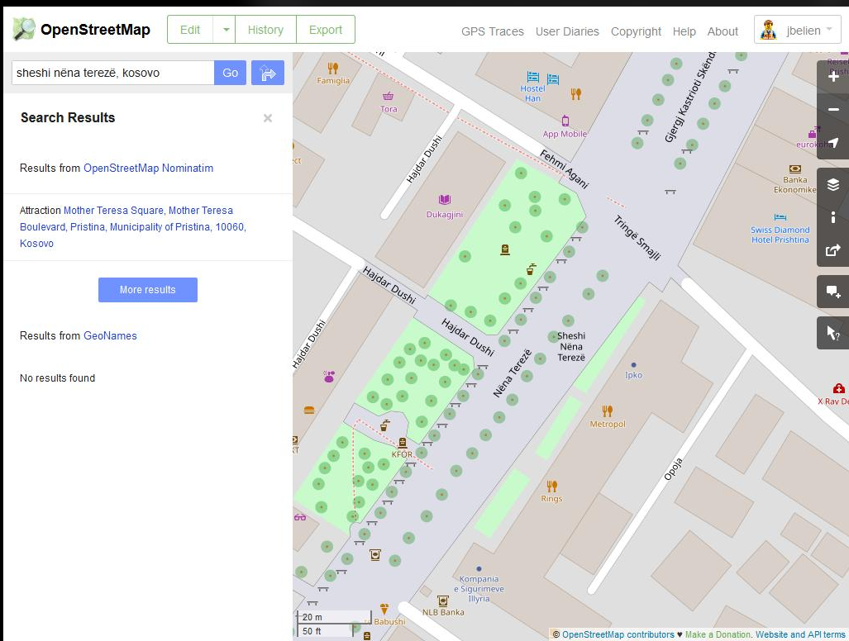
Observation 2: Viewing search results
I examined how a selected search result is presented and how the user can explore its geographic position on the map. This helped me understand the relationship between search results and map exploration.
Evidence:
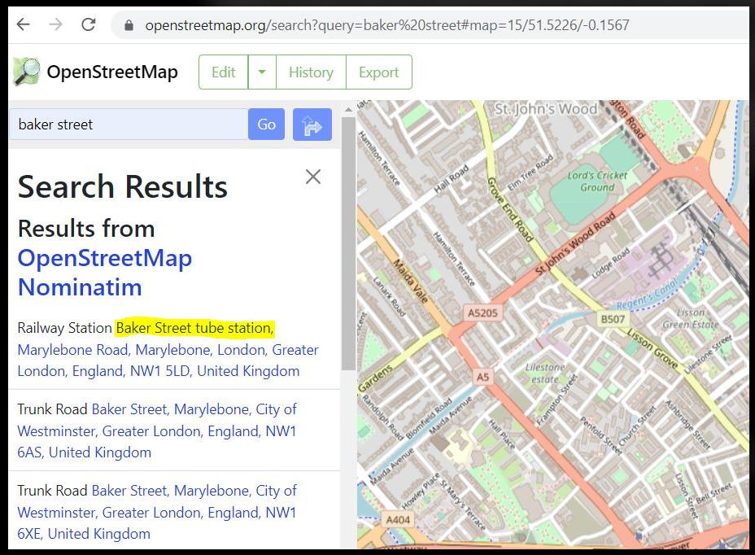
Opportunity for improvement: Based on the workflow examined, I propose a focused interface that combines location input, category selection, search feedback and readable result cards. This provides a clear alternative workflow for users who want to search for a particular category of place.
Note: These observations describe the workflow examined. Any claim about usability difficulties or missing functionality must be supported by actual testing. The screenshots should be captured from the real OpenStreetMap website.
3. Problem Definition
Students and newcomers may need to find specific facilities in unfamiliar areas. Searching for different categories of places may require users to enter different queries and inspect multiple results.
This project investigates whether a guided location-discovery interface can make this workflow easier to follow by combining location input, category selection, clear results and meaningful feedback.
Problem Statement
How can a responsive web application simplify location discovery for students and newcomers by providing location input, category-based search, readable results and clear feedback through a single interface?
Impact of the Problem
A guided location-discovery interface may help users:
- Find relevant categories of places more conveniently.
- Understand search results more easily.
- Recognise invalid inputs and unsuccessful searches.
- Access the selected location on OpenStreetMap.
These potential benefits will be evaluated through functional testing.
4. Innovative Solution: MapEase
MapEase is a responsive location-discovery web application that uses geographic search data to help users find places in unfamiliar areas.
Instead of reproducing the complete OpenStreetMap platform, MapEase focuses on one selected workflow: searching for places using a location and category.
4.1 Main Features
1. Location Input
Users can enter a city, neighbourhood or other location in a search field.
2. Category Selection
Users can select categories such as libraries, hospitals, restaurants, cafes, pharmacies and schools.
3. Form Validation
The application checks required input and provides feedback when the location field is empty or too short.
4. API Integration
The Fetch API sends a search request to the OpenStreetMap Nominatim service.
5. JSON Data Processing
JavaScript processes the JSON response and extracts the available place information.
6. Search Result Cards
Results are displayed as individual cards containing available place names and address information.
7. OpenStreetMap Links
Users can open a selected result in OpenStreetMap to examine its geographic position.
8. Loading and Error Messages
The application displays feedback while a search is running and provides a message when a request fails.
9. Empty-State Handling
A suitable message is displayed when the search returns no matching results.
10. Responsive Design
The interface adapts to different screen sizes using Tailwind CSS.
4.2 How the Proposed Solution Differs from the Benchmark
The original OpenStreetMap website provides a general-purpose map and search experience. MapEase is a focused application designed around category-based location discovery.
MapEase brings the location field, category dropdown, search action and structured results together in one guided interface. It also explicitly communicates loading, empty and error states.
The objective is not to claim that OpenStreetMap lacks these capabilities. Instead, MapEase demonstrates an alternative interface designed for the selected user group and workflow.
4.3 Feature-to-Technology Mapping
Feature | Technology Used
Structured page layout | HTML5
Responsive interface | Tailwind CSS
Form validation | HTML5 and JavaScript
Button and input events | JavaScript
Search requests | Fetch API
Data exchange | JSON
Dynamic result cards | JavaScript DOM manipulation
Error and loading feedback | JavaScript
Open location on map | OpenStreetMap URL
Source code management | Git and GitHub
4.4 Expected Benefits
The expected benefits of MapEase are:
- A simple and guided place-search workflow.
- Clear presentation of available search results.
- Better feedback for invalid input and unsuccessful searches.
- Responsive access from desktop and mobile devices.
- Practical implementation of HTML5, Tailwind CSS, JavaScript, Fetch API and JSON.
These benefits are expected outcomes rather than proven results. They will be assessed by testing the completed application.
5. Conclusion
MapEase is a focused web development project designed to improve a selected location-discovery workflow. The project examines the existing OpenStreetMap experience and proposes an alternative interface for searching places by location and category.
The implementation combines HTML5, Tailwind CSS and JavaScript with API integration, JSON processing, form validation and error handling.
The completed application will be evaluated through functional tests and screenshots. The results will help determine whether the proposed interface provides a clear and useful alternative for students and newcomers searching for facilities in unfamiliar areas.
PART III: DOCUMENTATION, GITHUB QUALITY AND DEPLOYMENT
Project Title: MapEase – A Guided Location Discovery and Nearby Places Finder
1. Project Documentation
1.1 Introduction
MapEase is a responsive web application developed to help students, newcomers and visitors discover useful places in unfamiliar areas. The application allows users to enter a location, select a category and view relevant search results.
The application uses HTML5 for page structure, Tailwind CSS for responsive styling and JavaScript for user interactions and dynamic content. The Fetch API retrieves geographic search information from the OpenStreetMap Nominatim service, and JSON data is processed to display place names and addresses.
The main objective of MapEase is to provide a guided and user-friendly alternative for category-based location discovery.
1.2 Objectives
- To simplify location discovery using a single search interface.
- To provide category-based searches for libraries, hospitals, restaurants, cafes, pharmacies and schools.
- To validate user input and display meaningful feedback.
- To retrieve and process geographic information using an external API.
- To display search results in readable cards.
- To provide links for viewing selected places on OpenStreetMap.
- To maintain the source code using Git and GitHub and deploy the application online.
1.3 Technologies Used
Technology | Purpose
HTML5 | Creates the semantic structure of the application.
Tailwind CSS | Provides responsive layouts, styling and reusable utility classes.
JavaScript | Handles user events, validation and dynamic result rendering.
Fetch API | Sends asynchronous requests to the search service.
JSON | Transfers geographic search information between the API and application.
OpenStreetMap Nominatim | Provides geographic search results.
Git | Tracks source code changes and versions.
GitHub | Hosts the project repository.
GitHub Pages | Can be used to deploy the static web application.
2. Source Code and Implementation Explanation
2.1 HTML5 Structure
The application uses semantic HTML elements such as header, nav, main, section, article and footer. These elements organize the navigation, introductory section, search form, results, instructions and footer.
The search form contains a location input, category dropdown and search button. The results section displays dynamically generated place cards.
2.2 Tailwind CSS and Responsive Design
Tailwind CSS is included using its CDN. Utility classes control spacing, colors, typography, borders and responsive layouts.
Examples used in the application include:
- grid-cols-1: Displays one column on smaller screens.
- sm:grid-cols-2: Displays two columns on small screens and above.
- lg:grid-cols-3: Displays three columns on large screens.
- max-w-6xl mx-auto: Centers the main content and limits its width.
Custom CSS is used for visual effects, loading skeletons, hover transitions and mobile adjustments.
2.3 JavaScript Events
The application implements several meaningful JavaScript events:
- Submit event: Handles the search form submission without reloading the page.
- Click event: Allows users to select category chips and clear the results.
- Change event: Synchronizes the selected category dropdown with the category chips.
- Input event: Checks the location field and updates its validation message.
These events make the interface interactive and responsive to user actions.
2.4 Form Validation
The location field is required and accepts a minimum of two characters and a maximum of 100 characters.
JavaScript trims unnecessary whitespace and checks the input before sending a search request. If the location is invalid, the application displays a validation message and prevents the request from proceeding.
2.5 Fetch API and JSON Data Handling
When the user submits the form, JavaScript constructs a search request for the selected category and entered location.
The request is sent to the OpenStreetMap Nominatim search endpoint using the Fetch API. The response is checked for HTTP errors and converted into JSON using response.json().
The application checks whether the returned data is an array. It then extracts the available place name, display address, latitude and longitude.
2.6 Dynamic Result Cards
JavaScript creates HTML elements dynamically for every returned place. Each result card contains:
- A category icon.
- The place name.
- A category label.
- The available address.
- A link to view the location on OpenStreetMap.
The implementation uses DOM methods such as document.createElement(), textContent, append() and appendChild() to create the result cards.
2.7 Loading, Error and Empty States
The application provides three important feedback mechanisms:
- Loading state: Displays animated skeleton cards and changes the search button text to “Searching...”.
- Error state: Displays an error message if the request fails or the service cannot be reached.
- Empty state: Displays a message when the API returns no matching places.
The finally block restores the search button after the request completes, whether the operation succeeds or fails.
2.8 OpenStreetMap Integration
Each result includes a link constructed using the returned latitude and longitude. Selecting the link opens OpenStreetMap at the corresponding geographic position in a new browser tab.
This allows users to continue exploring the selected place on the benchmark platform.
3. Implementation and Feature-to-Technology Mapping
Feature | Implementation
Page structure | HTML5 semantic elements
Responsive interface | Tailwind CSS and custom CSS
Location input | HTML form and input validation
Category selection | HTML select element and JavaScript events
Search functionality | JavaScript form submission
Geographic data retrieval | Fetch API
Data processing | JSON parsing
Dynamic result display | JavaScript DOM manipulation
Loading feedback | CSS animation and JavaScript
Error handling | try, catch and finally
Empty results | Conditional JavaScript logic
Map navigation | OpenStreetMap URL
Source code versioning | Git and GitHub
- GitHub Repository and Version Control
https://github.com/pratixa-jayani/MapEase
5. Deployment
5.1 Deployment Using GitHub Pages
https://pratixa-jayani.github.io/MapEase/
5.2 Deployment Verification
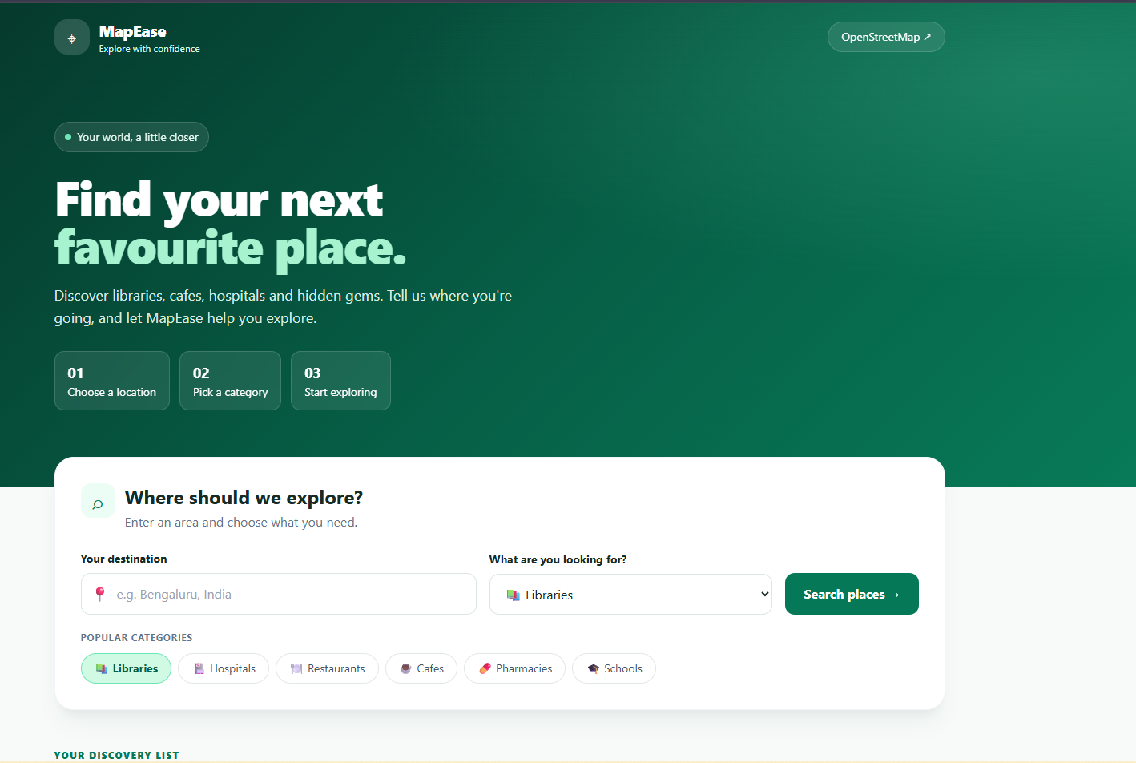
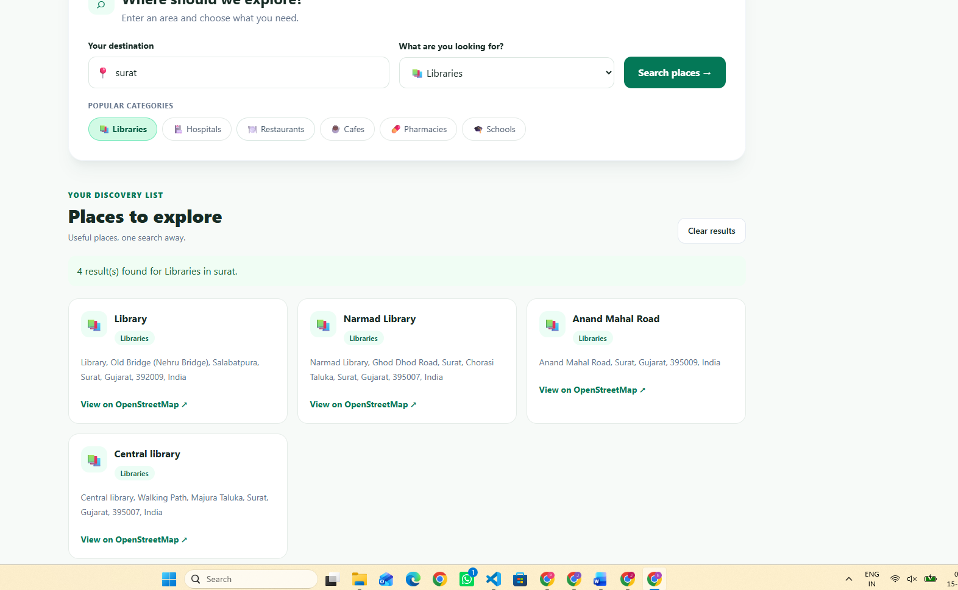
6. Testing Evidence
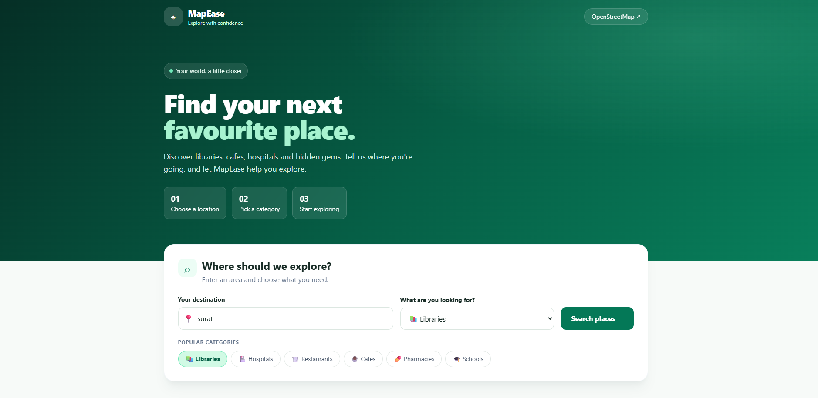
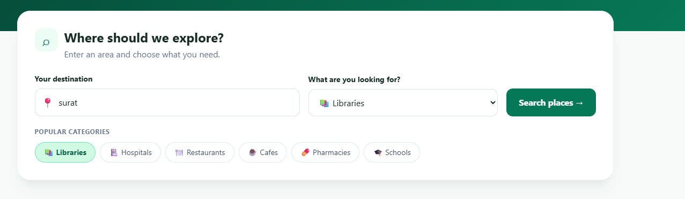
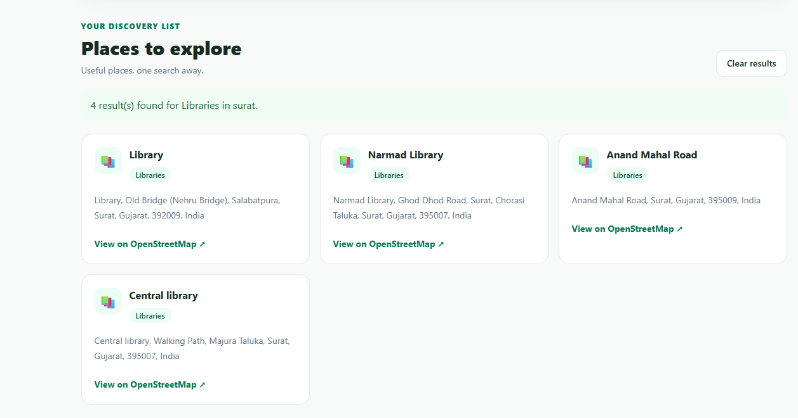
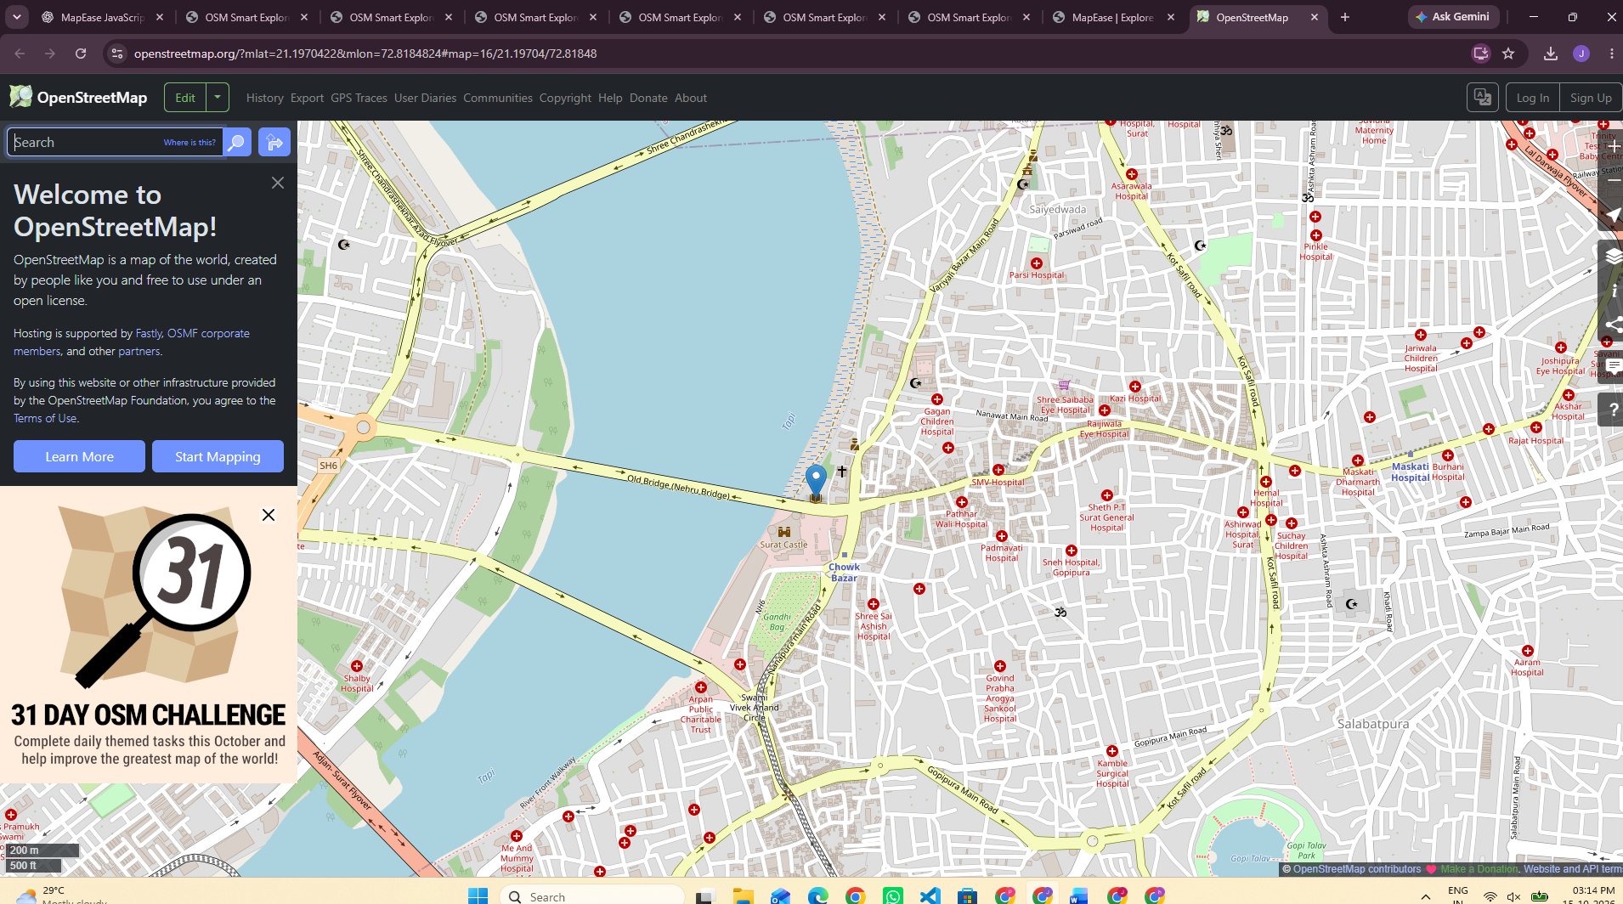
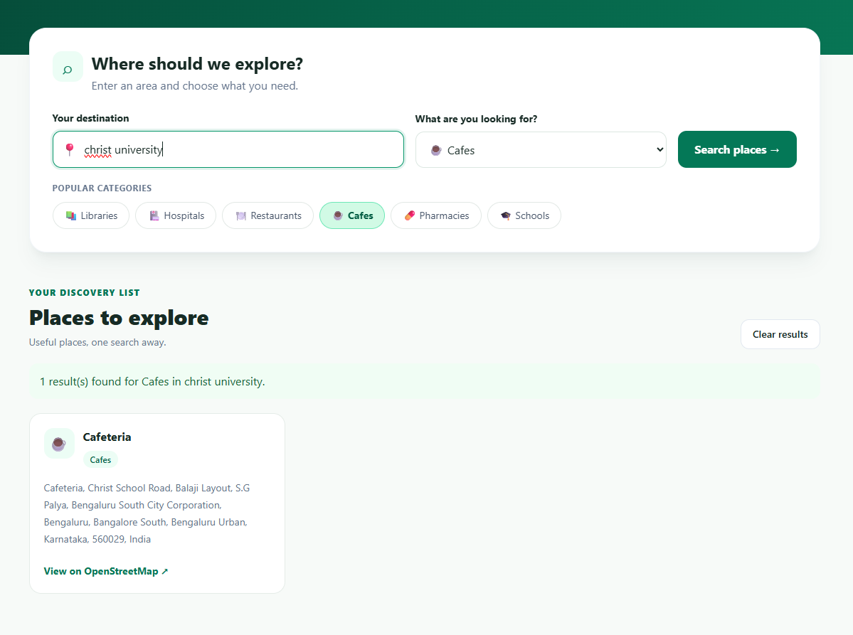
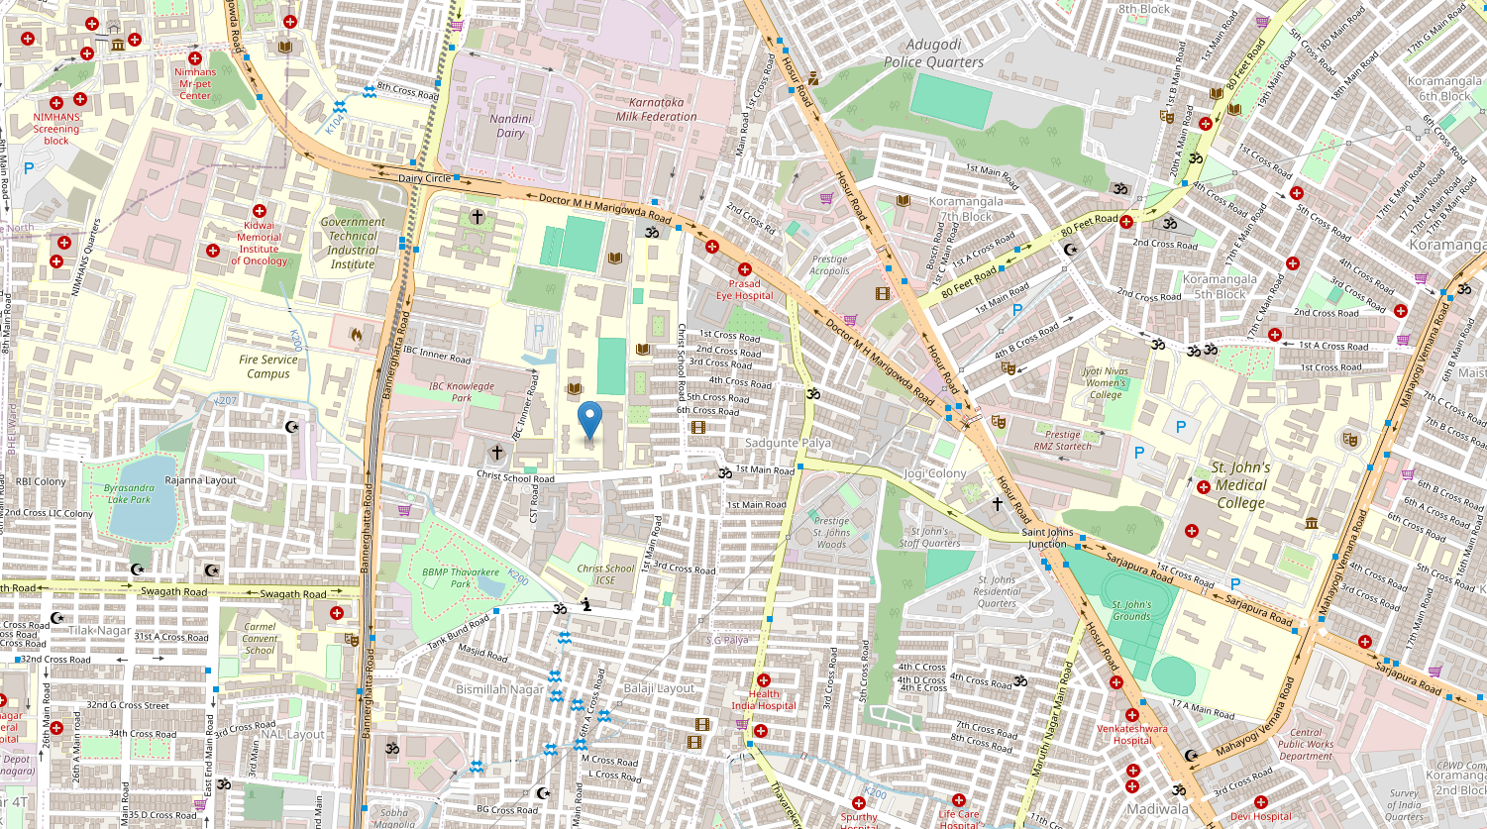
7. Limitations
The current MapEase implementation has the following limitations:
- Search accuracy depends on the geographic data returned by the Nominatim service.
- Search results may be incomplete if the requested place information is unavailable in OpenStreetMap.
- The application does not currently provide a dedicated interactive map embedded within the interface.
- It does not calculate routes, travel times or distances between places.
- It does not currently include user accounts, saved places or personalized recommendations.
- The application depends on internet access and the availability of the external search service.
- The search implementation uses a general text query for the selected category and location, so the returned results should be checked for relevance.
- The application does not independently verify the accuracy or current operating status of listed places.
8. Future Enhancements
- Integrate an interactive map using Leaflet and OpenStreetMap tiles.
- Add distance-based filtering and sorting.
- Provide autocomplete suggestions for locations.
- Add more categories and category-specific search queries.
- Implement location-based discovery using browser geolocation with user permission.
- Add saved places and search history.
- Improve accessibility through keyboard navigation and additional screen-reader support.
- Add automated testing for form validation, API responses and error states.
9. AI Usage Declaration
Artificial intelligence tools were used as assistance during project documentation, code explanation and preparation of implementation guidance. The project source code, application behaviour, testing results and final submission should be reviewed and verified by the student.
The student is responsible for understanding the implementation, validating the application, acknowledging AI assistance according to university requirements and ensuring that all submitted screenshots and results represent actual work.
10. Conclusion
MapEase demonstrates the development of a focused, responsive location-discovery application using HTML5, Tailwind CSS, JavaScript, the Fetch API and JSON data handling.
The application combines location input, category selection, validation, API integration, dynamic result cards and links to OpenStreetMap in a single interface. GitHub provides source code management, while GitHub Pages offers a suitable deployment option for the static application.
Functional testing, genuine screenshots, repository evidence and deployment verification will demonstrate whether the application meets the project requirements and provides a useful alternative workflow for students, newcomers and visitors.

