## Node Js Server

Install the Node Js Files, which are in the Install NodeJs Folder.  
After the Installation you have to edit the System environment variables. 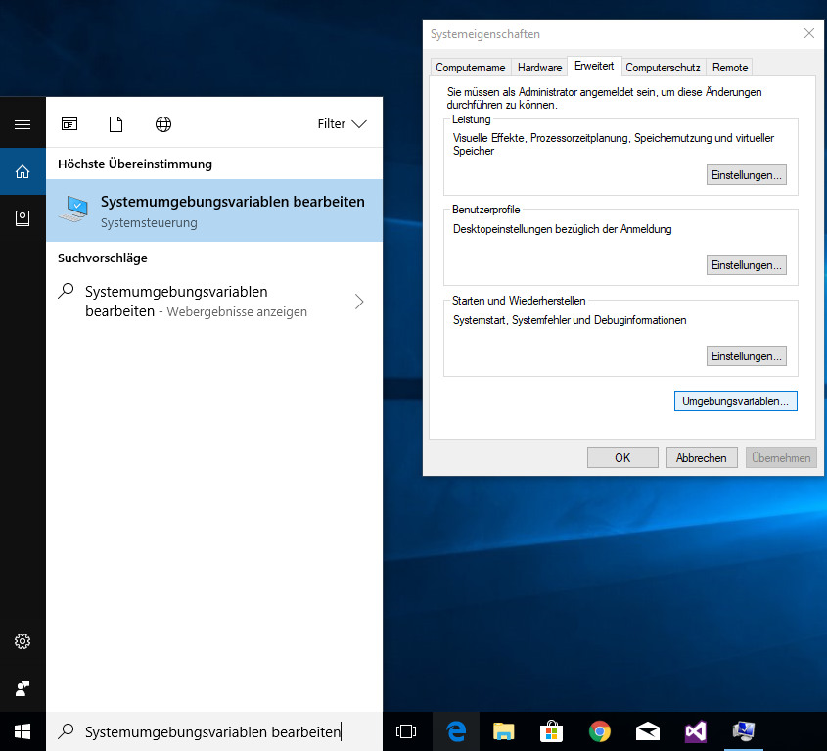

After that you must select the Path variable and edit it. (Benutzervariblen für Admin 🡪 auf Path klicken 🡪 Bearbeiten…)  
Than you must add a new Variable, therefor you click New. The Path is the located Nodejs Folder which was generated after the installation of the Nodejs files. (e.g. C:\Program Files\nodejs)

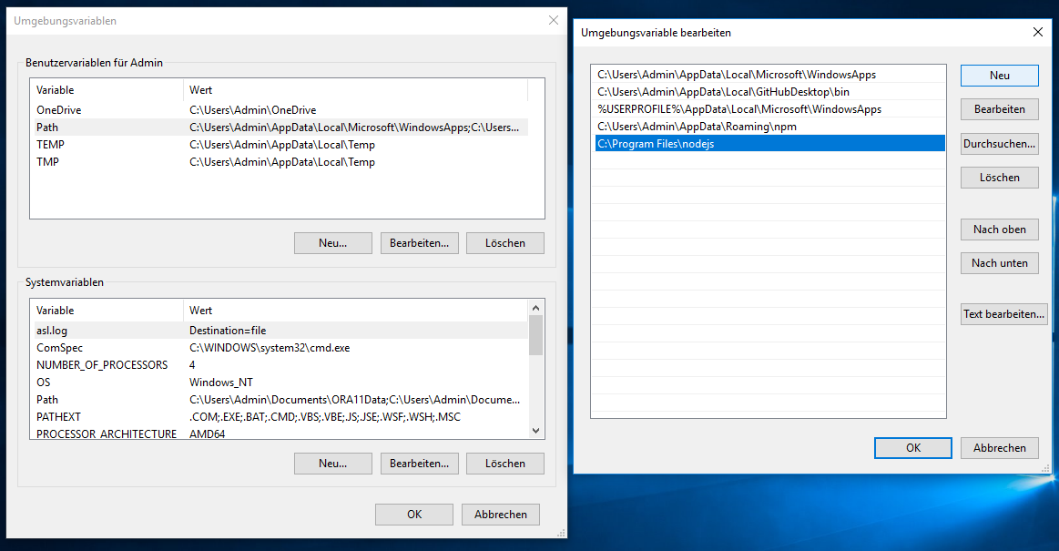

After that you should open a CMD (Eingabeaufforderung) and type PATH to see the current PATH.

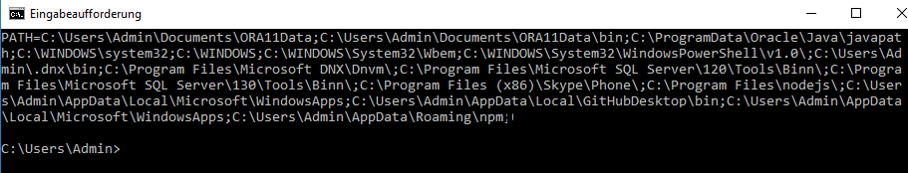

Than you must tap set PATH=%PAT%; than the Path of the nodejs (C:\Program Files\nodejs)

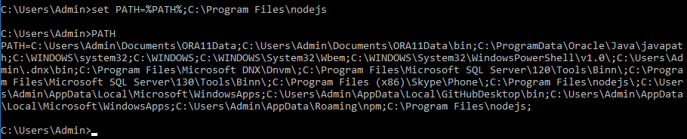

Now you can open the PongWebServer Solution.

