

**Mobile Innovations for Global Challenges**

**CS6432016.**

**Prof.** **Christelle Scharff**

**Fall 2016**

**Part 3: What is GitHub? When was it created? Why? By who? What similar platforms exist? Why would you use such a platform?**

* GitHub wraps a software version control system called “Git” which provides a web based interface to access control and several collaboration tools for basic management of every project.
* GitHub site was launched in April 2008 by Tom Preston-Werner, PJ Hyett and Chris Wanstrath the fundamental intension to build GitHub is to allow developers to host their projects online for free, where developers can store, trade, exchange, and talk about code.
* Some other popular platforms like GitHub that exists in the market are SourceForge, Bitbucket, and CodePlex.
* I would you use such a platform not only because GitHub is far more than a place to store project but it is a meeting hub that supports communities to collaborate. People also use it as a virtual place that allows information sharing and supports discussions.

**Part 4: Go through the Git tutorial here:** [**https://try.github.io**](https://try.github.io)**. While doing the tutorial, save your work the *LastnameFirstnameGitTutorial-mm-dd-yyyy.docx* file.**

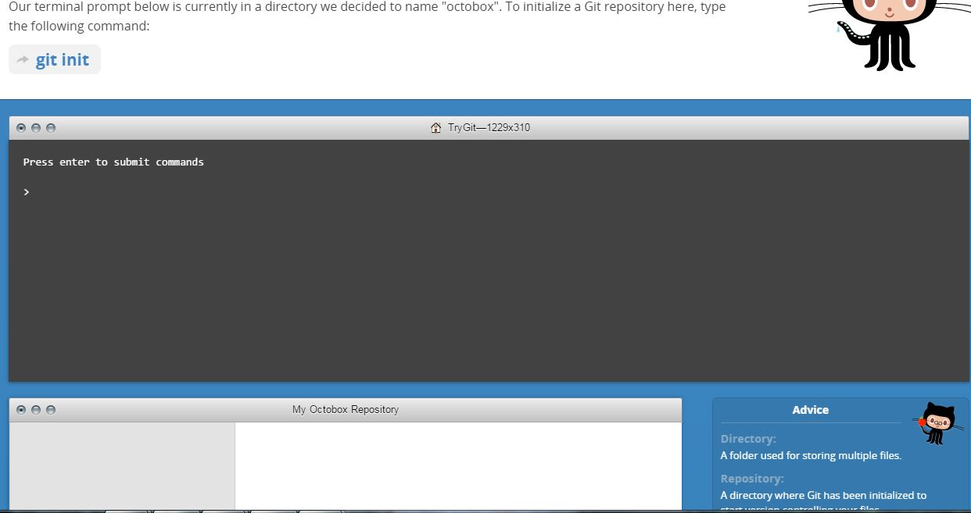

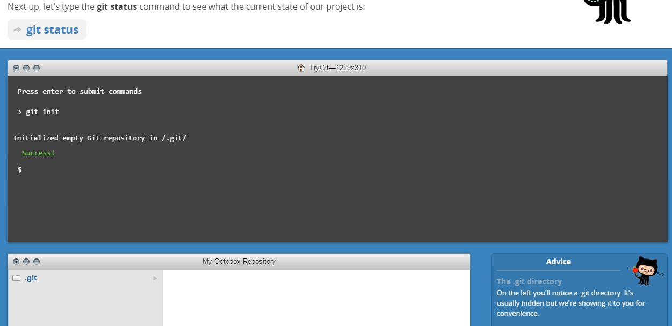

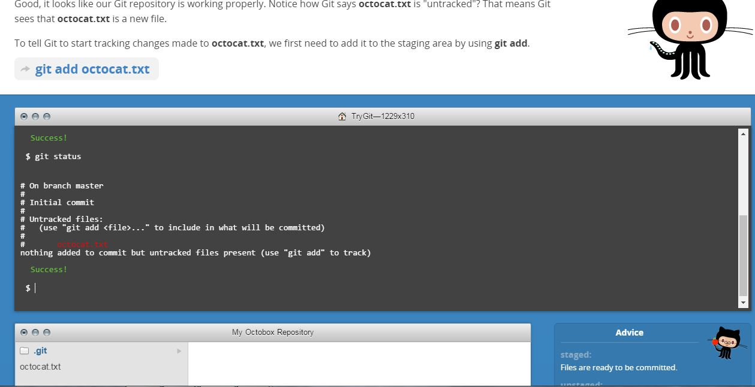

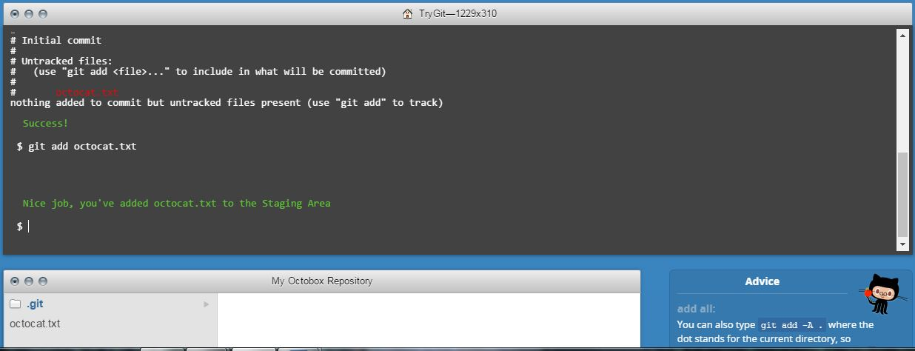

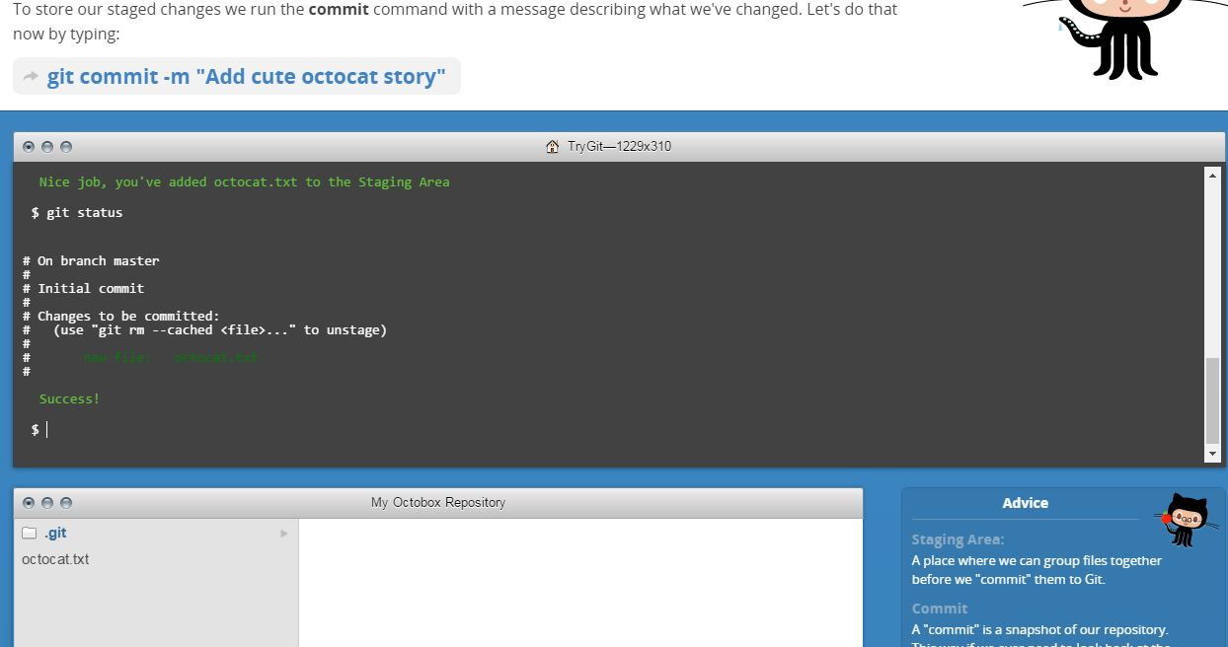

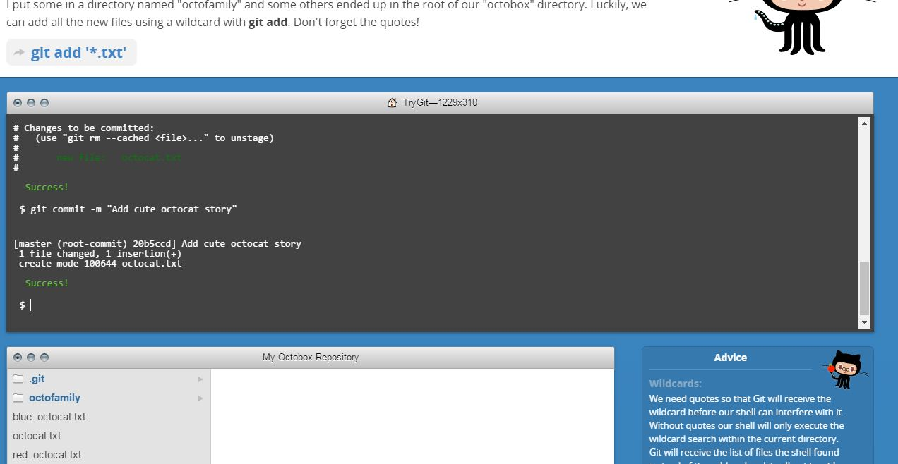

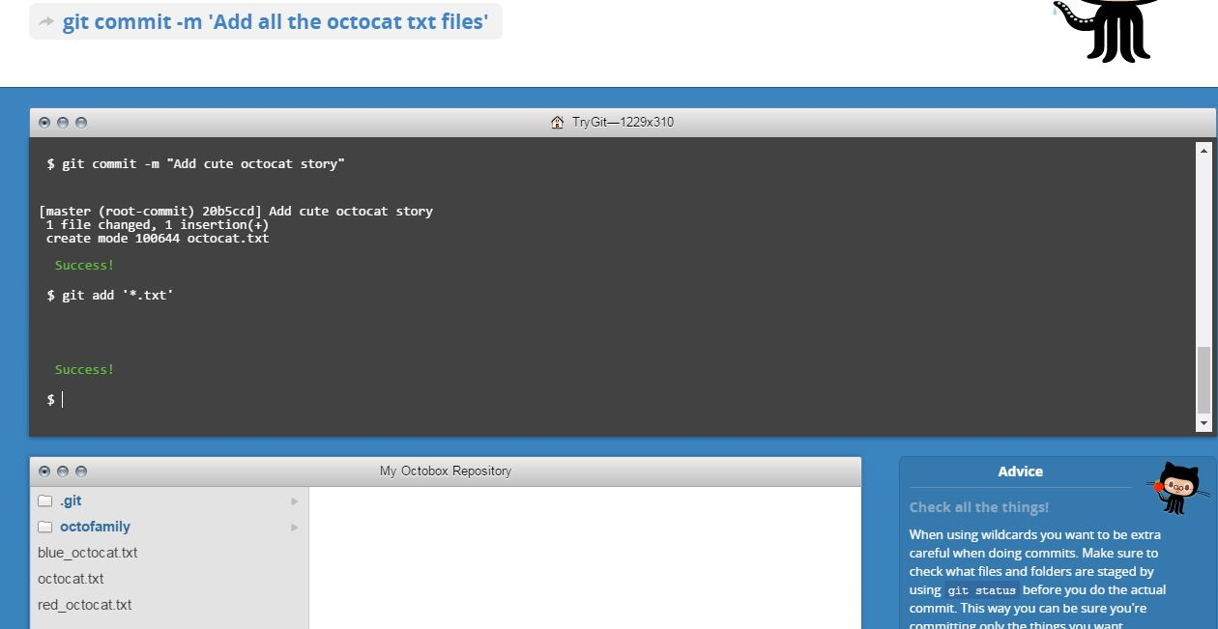

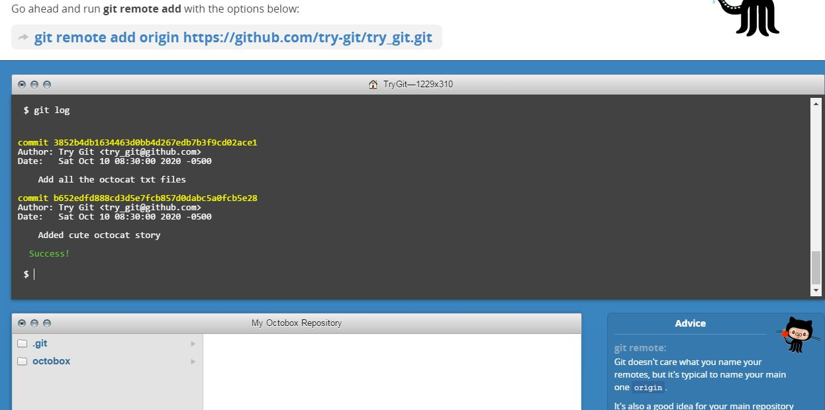

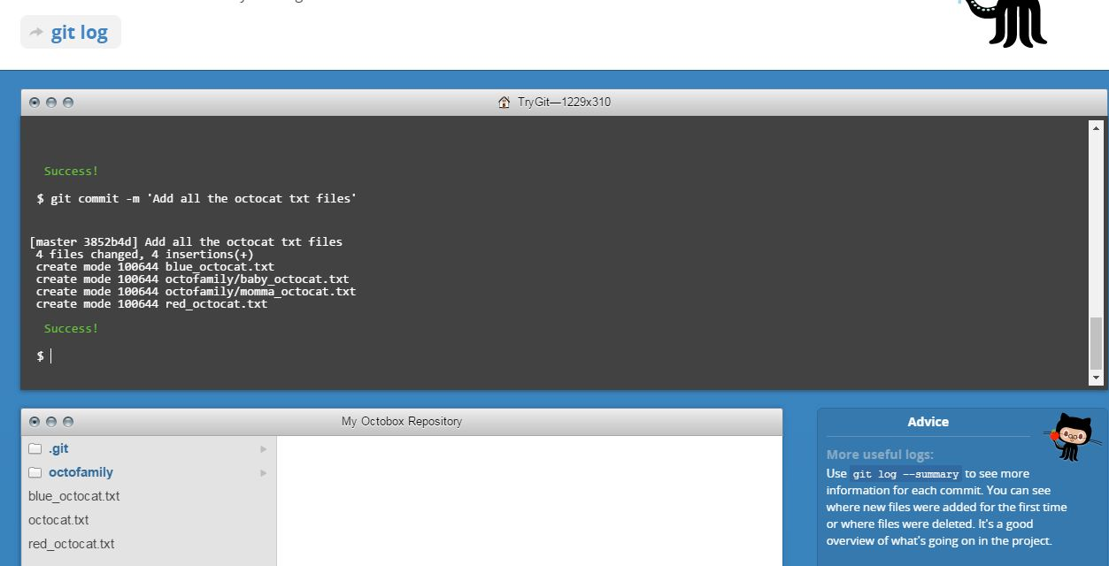

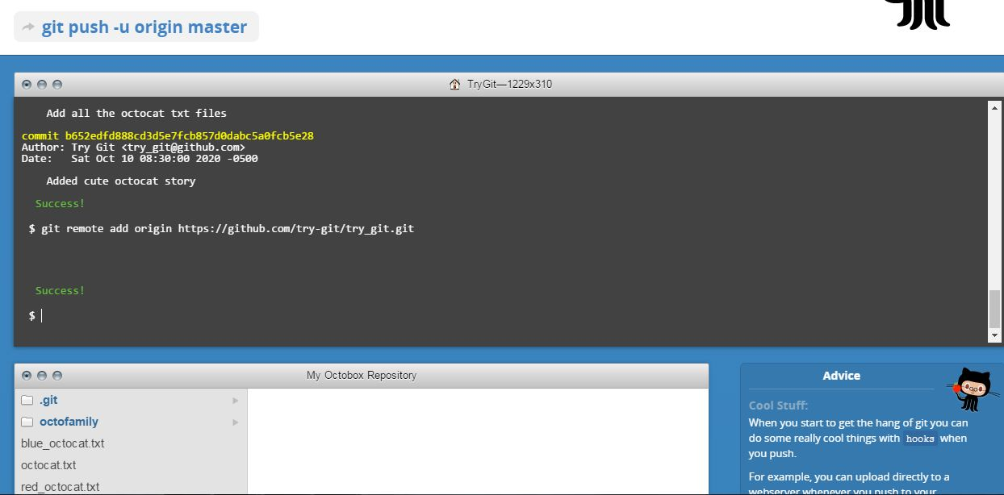

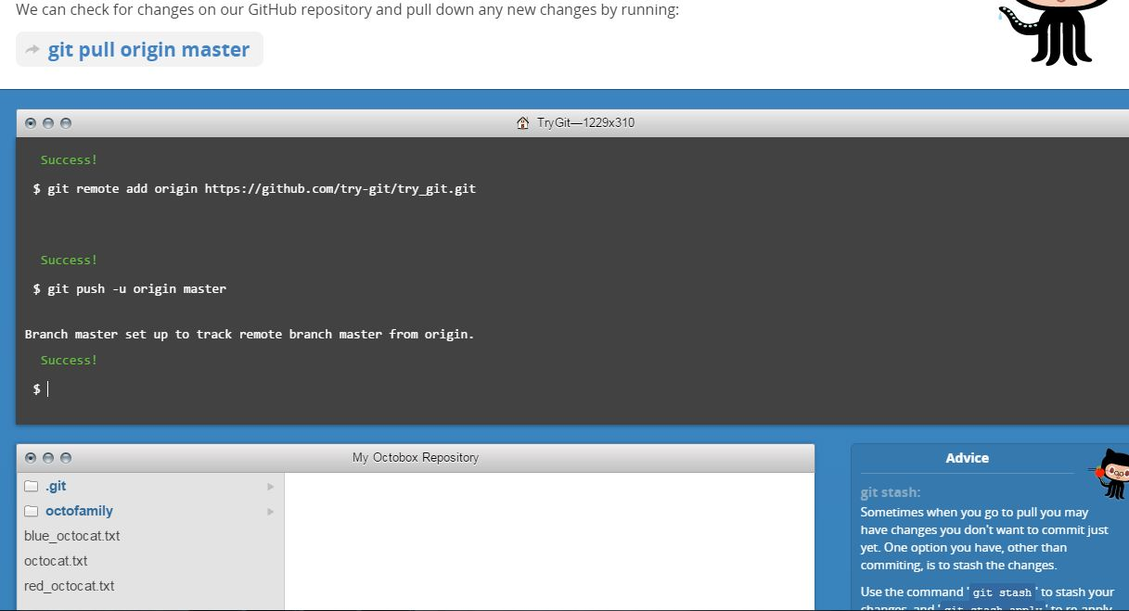

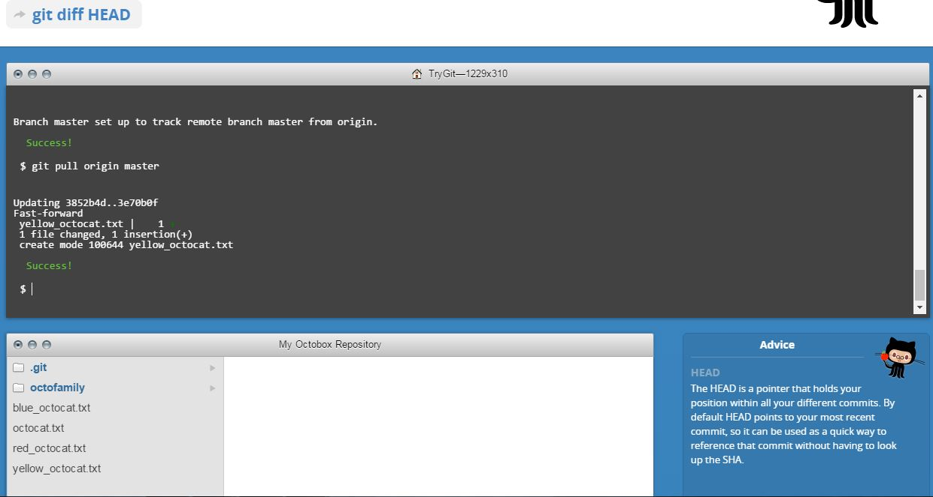

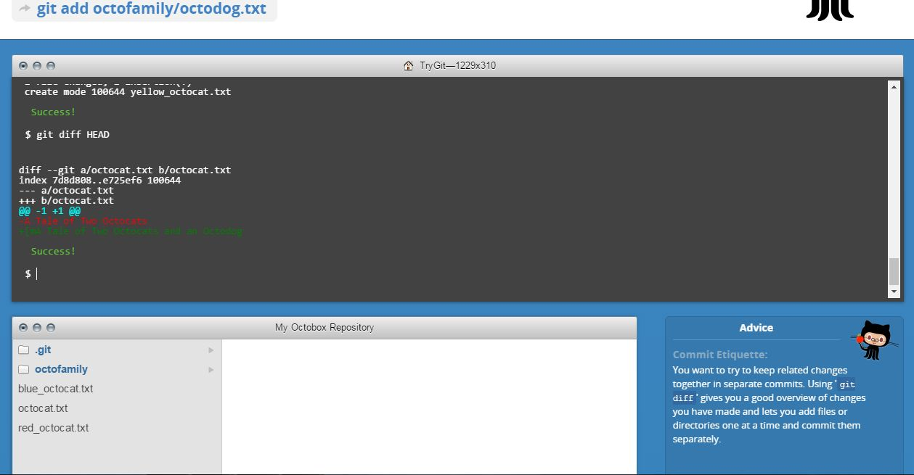

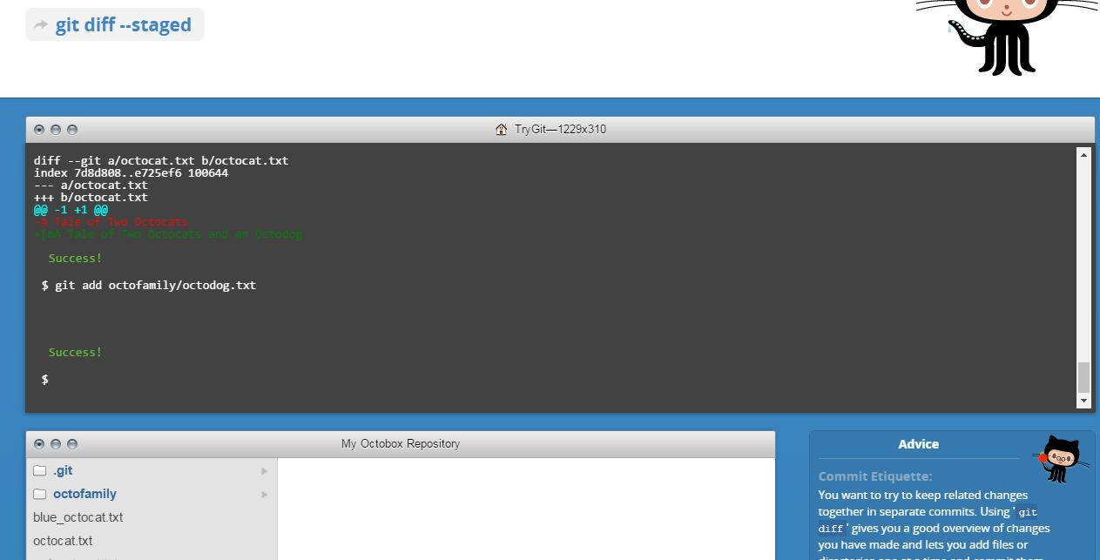

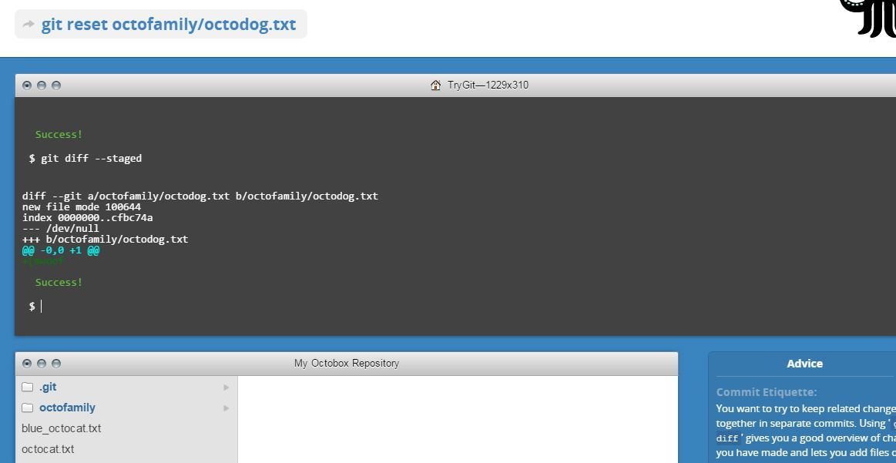

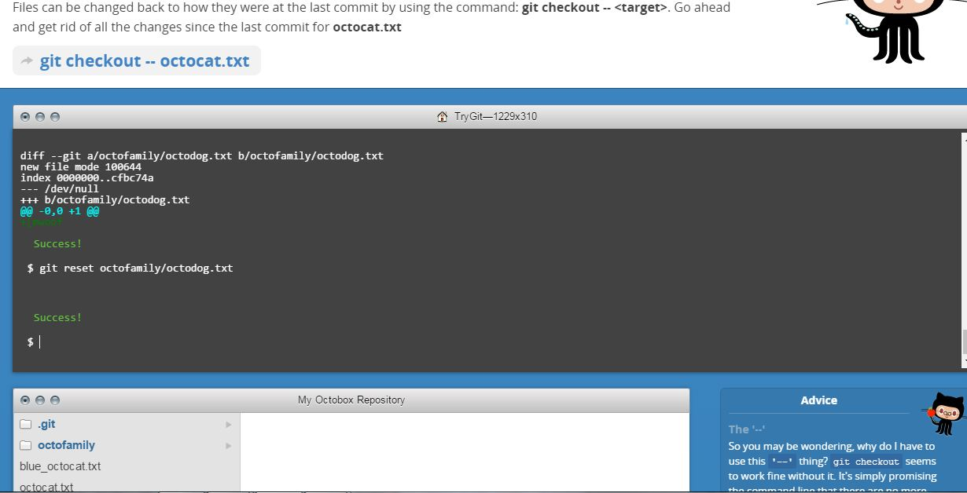

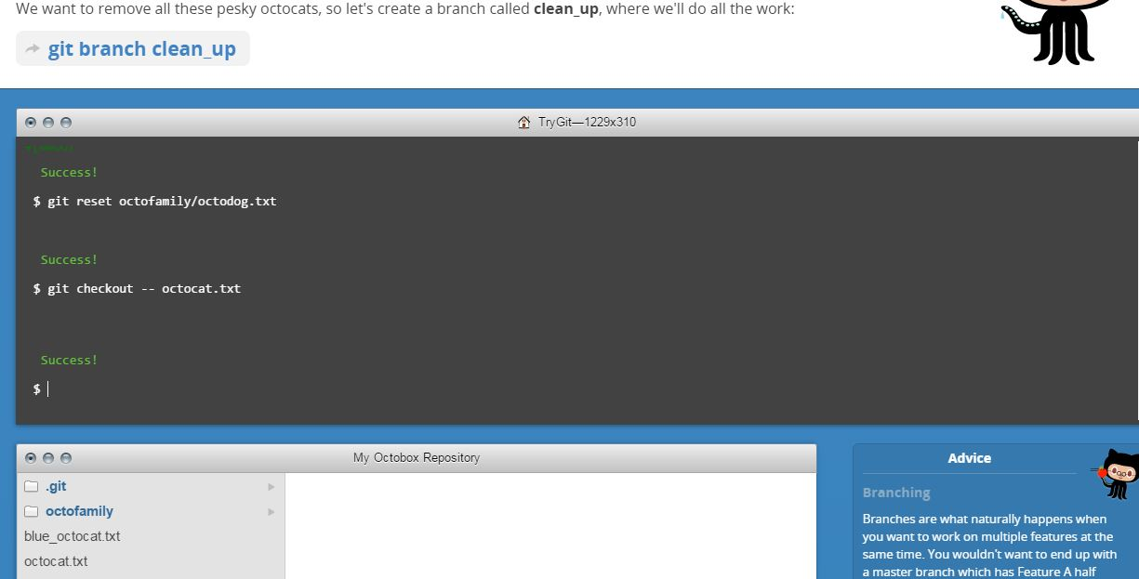

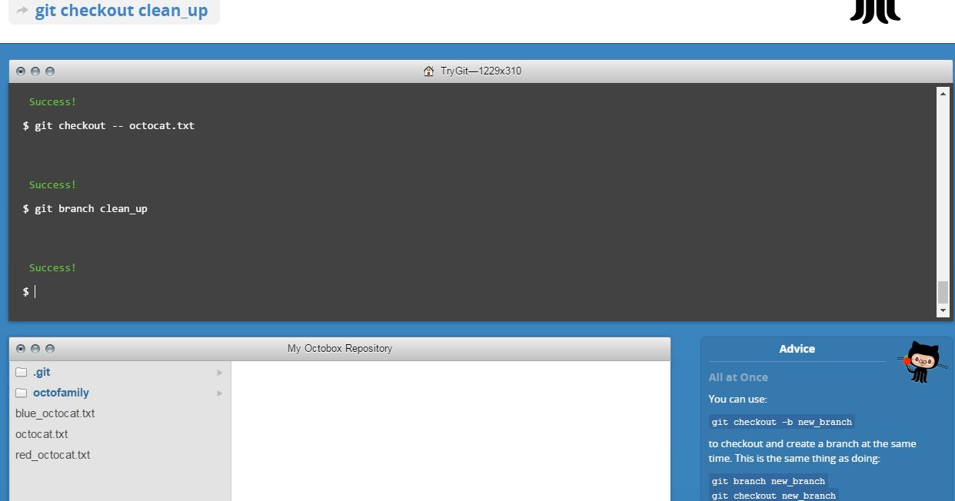

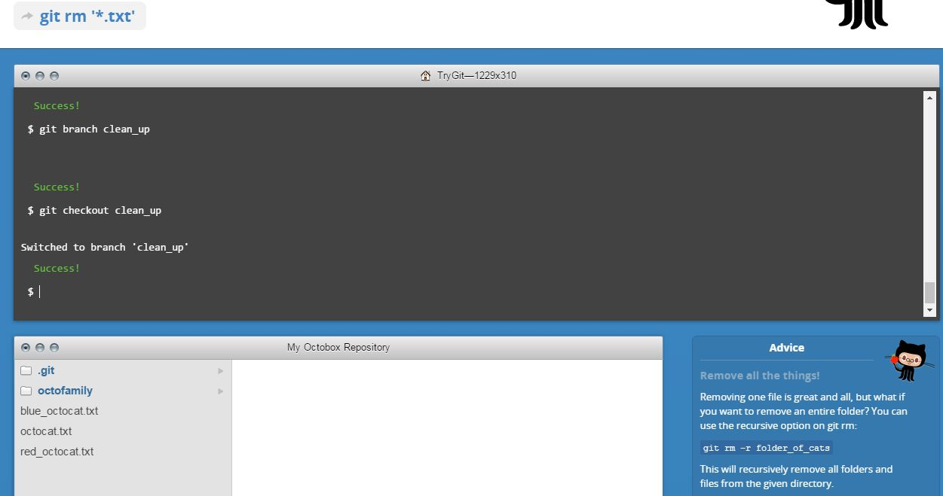

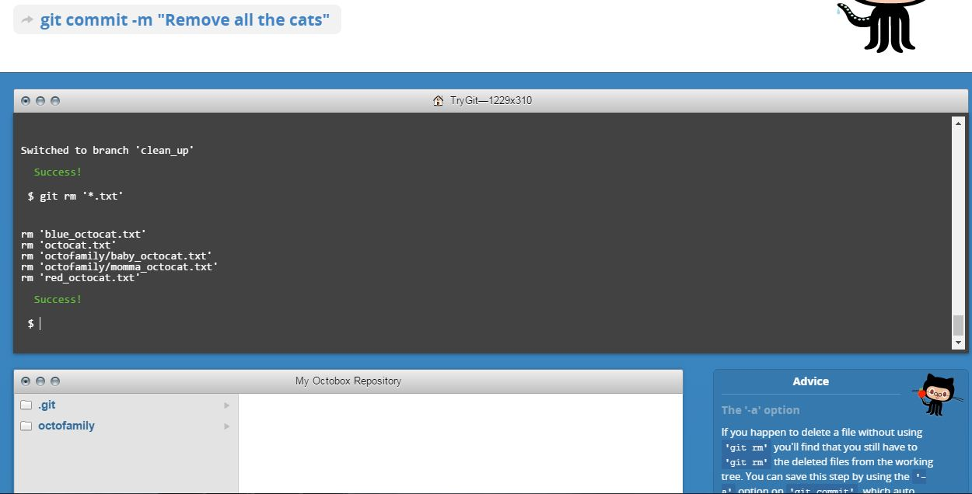

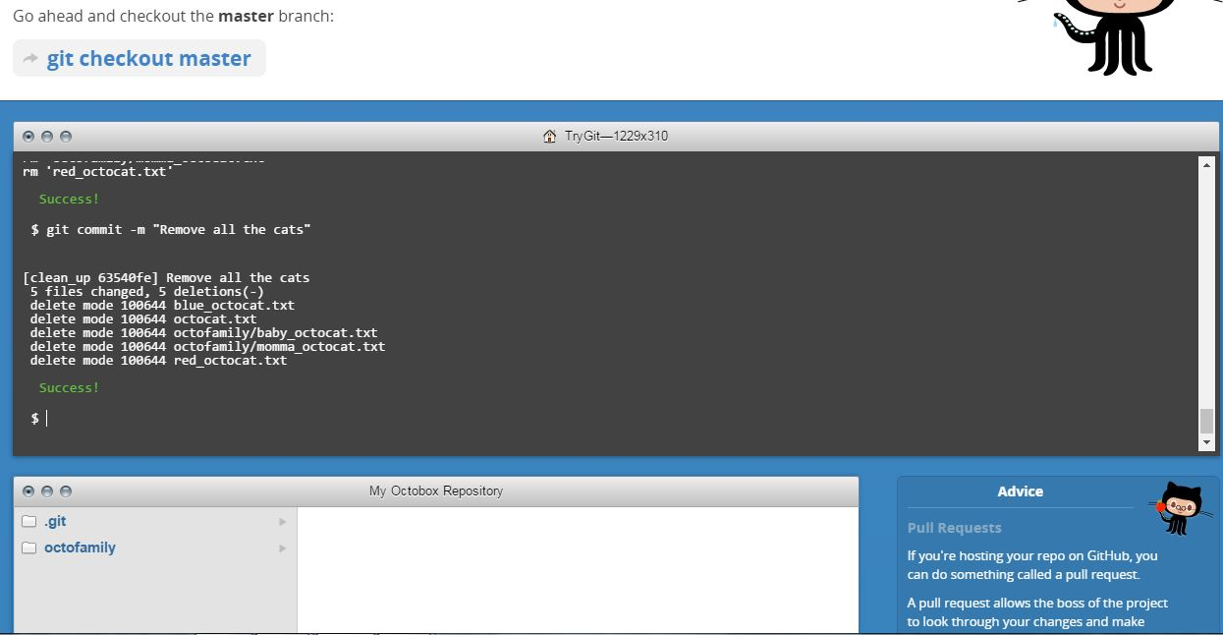

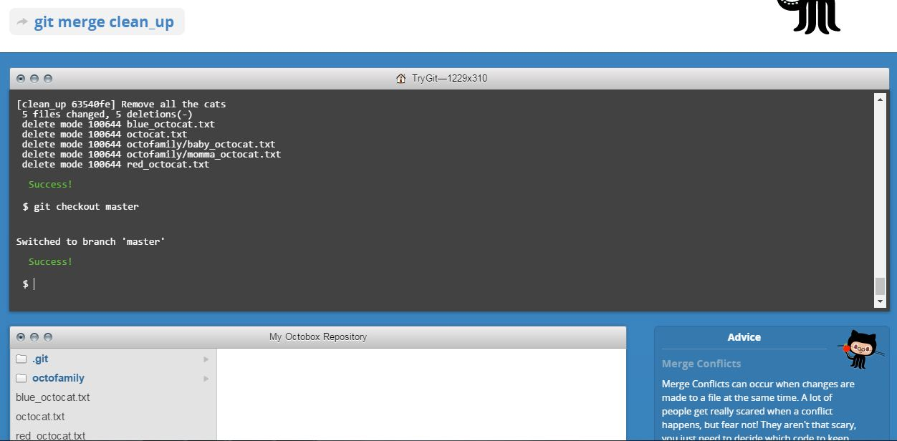

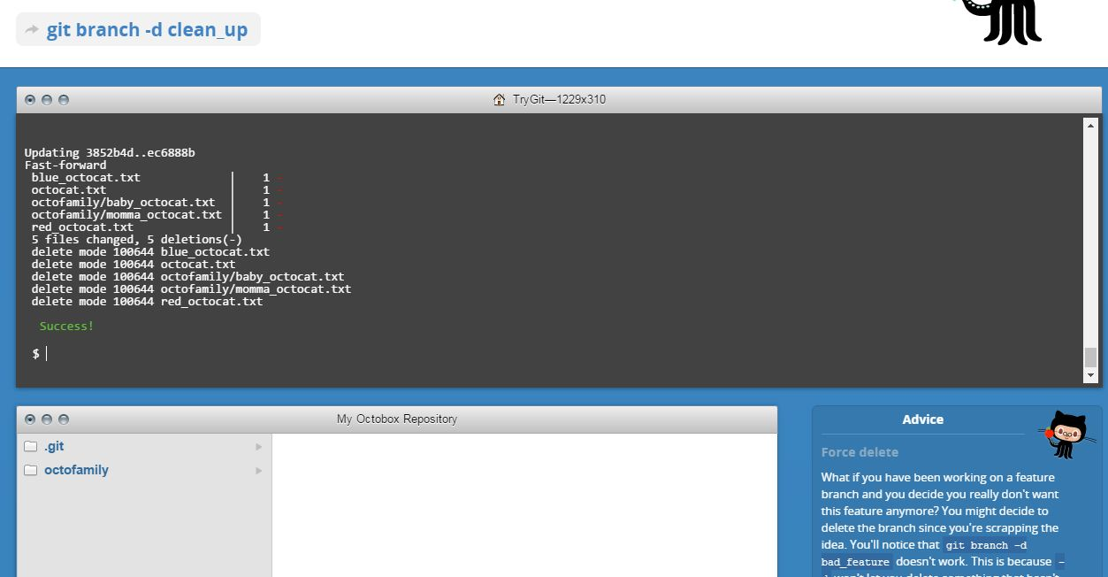

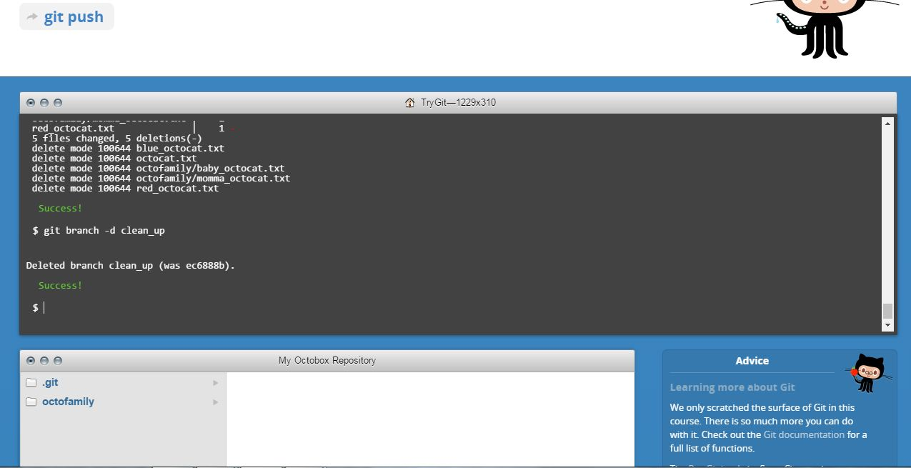

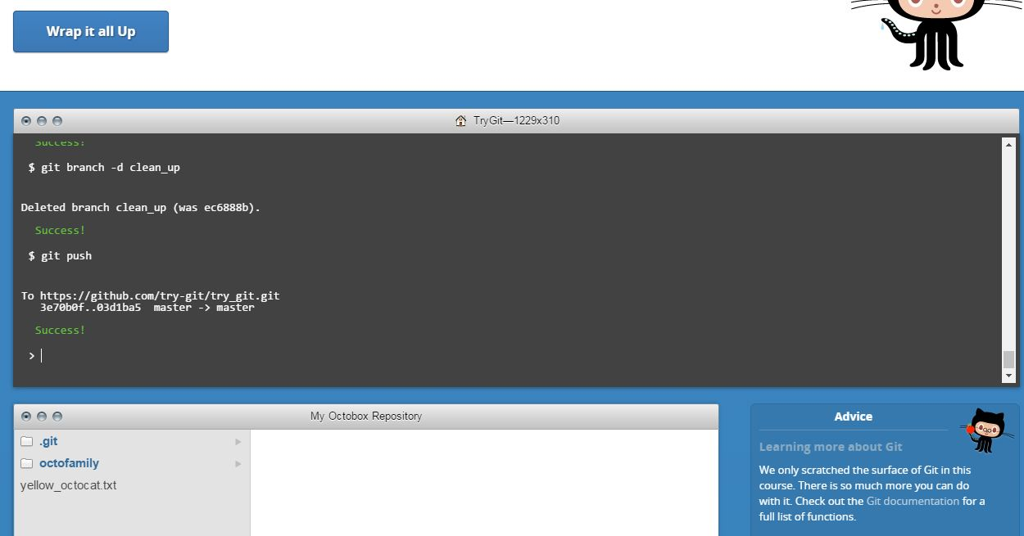

**Part 5 : Define the following terms in the context of Git**

* **Repository:** A directory space where your projects can live. A repository can contain code files, text files, image files and various other files.
* **Commit**: This is a powerful command that Git provides to users, commit command works as a checkpoint for a project from where user can reevaluate or restore to any pervious state.
* **Push**: Push command makes your local computer work visible online on GitHub.
* **Branch**: Branch command is the one that allows users to work with multiple collaborations. Each contributor can create his/her own branch and make changes to a project
* **Fork:** It is used to make a copy of the repository and make changes on your local machine or on in a GitHub account without affecting original work.
* **Merge:** When contributor is done working on a branch, they merge their changes back to master branch, which is visible to all collaborators.
* **Clone:** Clone command allow us to make a local copy of the most up-to-date version of our repository to work on our local machine.
* **Pull:** Pull is a high-level command that executes both ‘Fetch’ and ‘Merge’ commands by default.
* **Pull request:** Pull request ask other repository maintainers to pull your changes into theirs.

**Part 6:**

**Commands to Push the Word file in YOUR GitHub account in a repository called CS6432016**

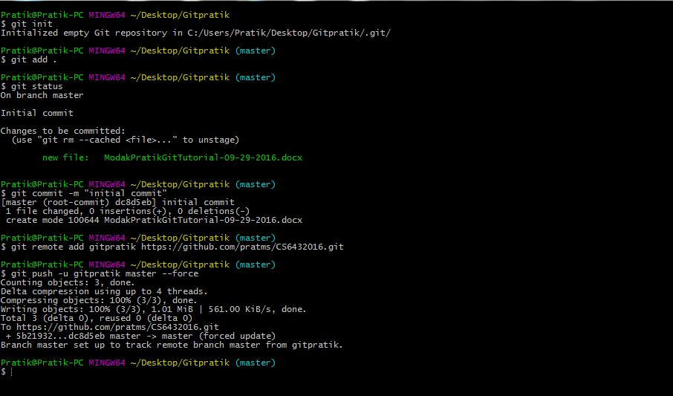

**Part 7:**

* Retrieve the README.md file from <https://github.com/paceuniversity/courses>.
* Fork README.md from the repository.
* Clone Repository on your local machine and make required changes.
* Push file back to GitHub repository.
* Send Pull request to repository maintainer <https://github.com/paceuniversity/courses>.