# **USE CASE 4: CICD Pipeline to deploy Springboot application (UI/Backend)**

1. **Create an ec2 instance in aws**:

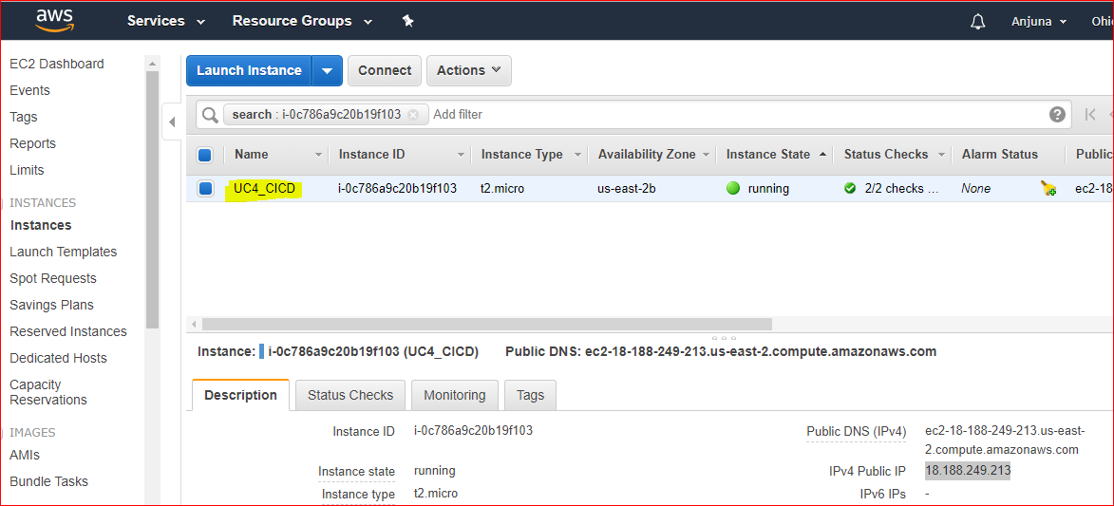

1. **CICD Toolset Installation**:

Please refer the below attached document for tool installation guide:



1. **Use case to deploy a sample Springboot microservices application (UI/Backend)**
   1. **Create freestyle job to configure, build and deploy frontend angular application**

Create freestyle job in Jenkins:

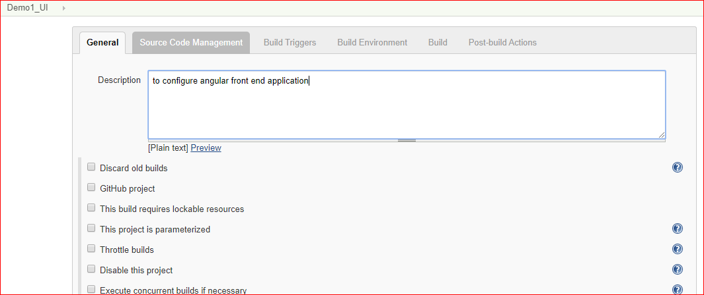

Select Git in SCM and provide the git URL:

<https://github.com/Anjuna661/Kalyanam-UI>

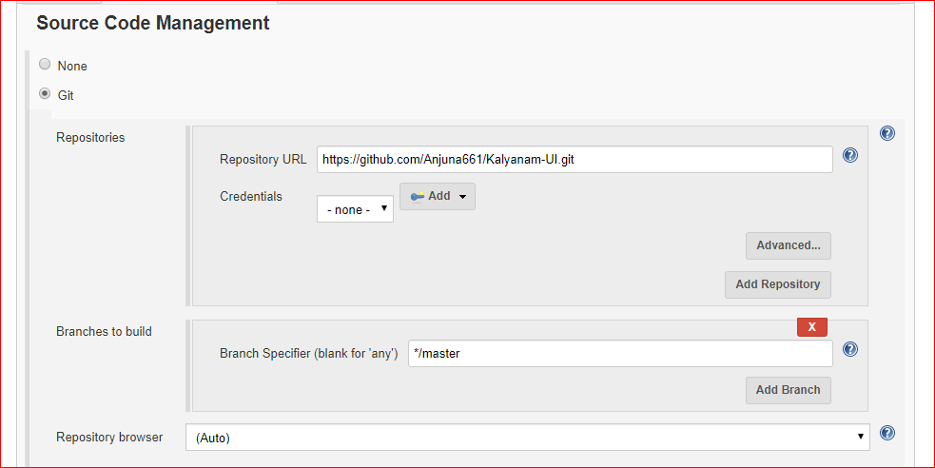

Provide the below commands in Build:

**npm install**

**ng build --base-href=/matrimony/**

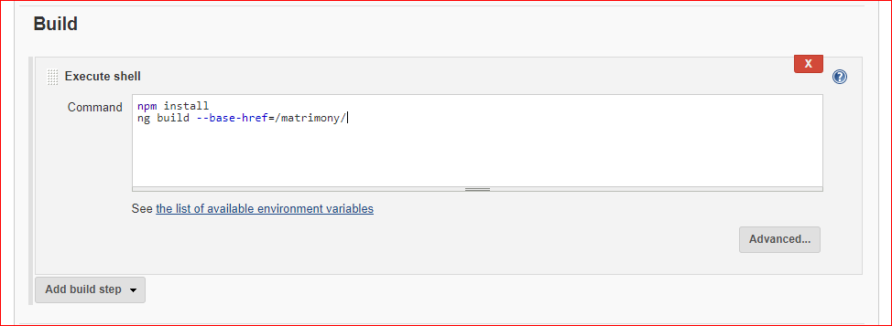

Now save the project and click on “**Build Now**”, check in the console output, the application is successfully build.

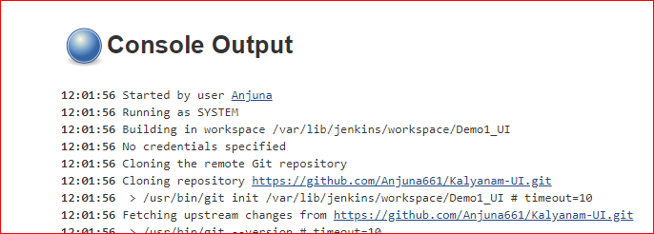

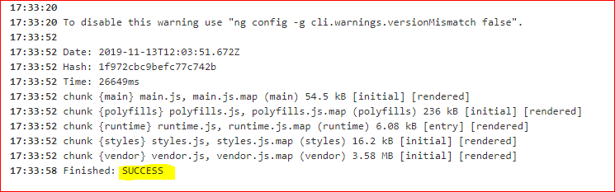

Now, to deploy the war to Tomcat server, follow below steps:

**cd /opt**

Go to workspace: **cd /var/lib/jenkins/workspace/**

**cd Demo1_UI**

**cd dist/**

**cd matrimony/**

**cd ..**

**cp -r matrimony/ /opt/apache-tomcat-9.0.27/webapps/**

**cd /opt/apache-tomcat-9.0.27/webapps/**

**chmod -R 777 matrimony/**

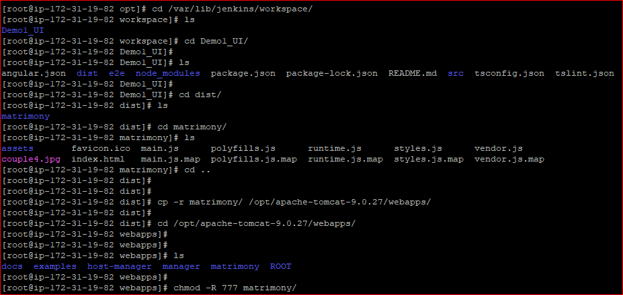

**Now we can see that our application is deployed in Tomcat server:**

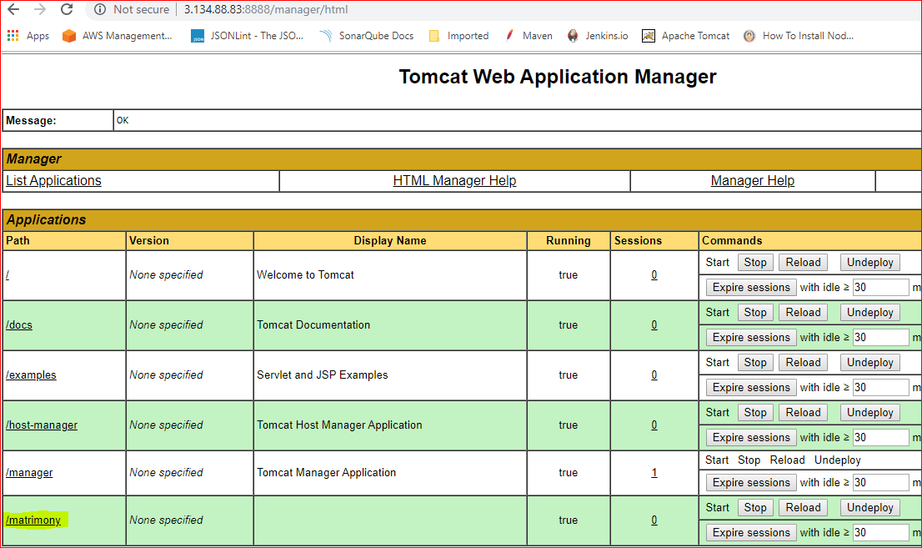

Click on **/matrimony**, we can see the below page:

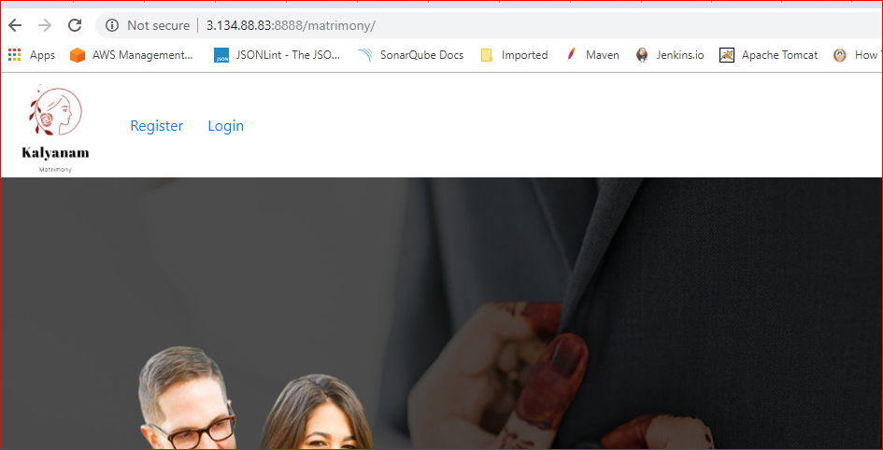

* 1. **Create maven project to configure and deploy backend java application**

Create maven project:

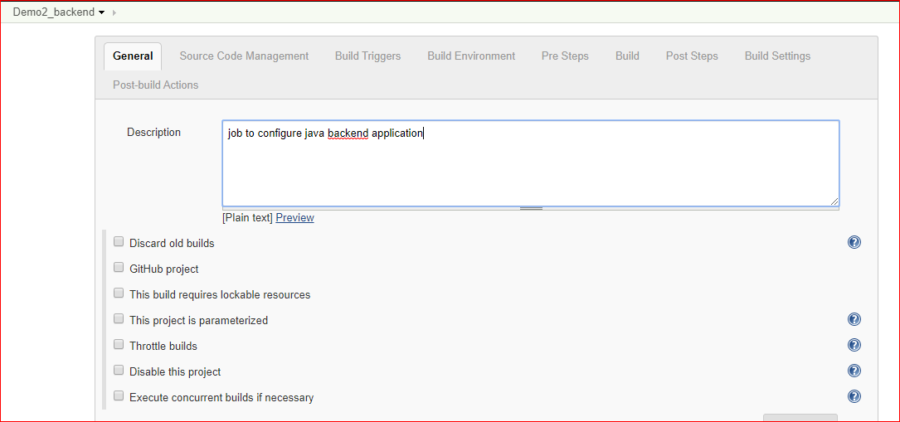

Provide the git URL:

<https://github.com/Anjuna661/kalyanam>

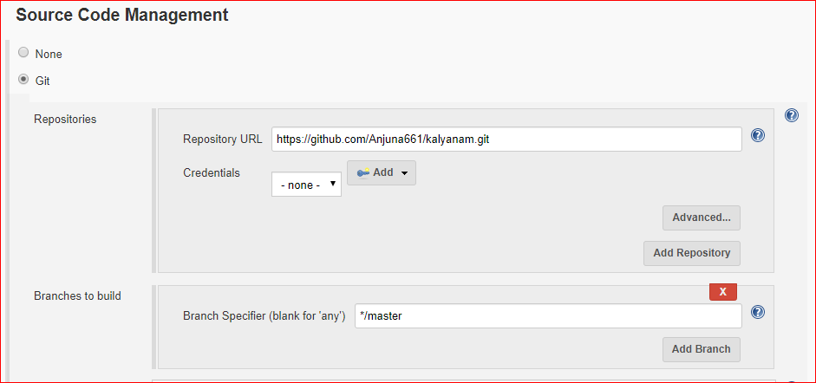

Provide below commands in Build:

**clean deploy**

[**Note**: if build is failed due to test case failure, then we can skip test phase by providing below goals along with clean deploy]

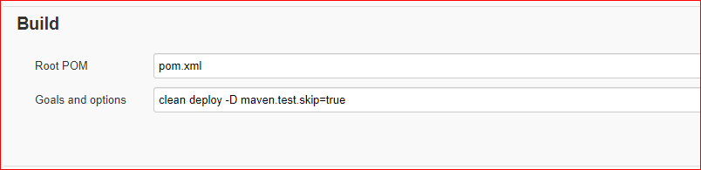

Post Steps: **mvn sonar:sonar**

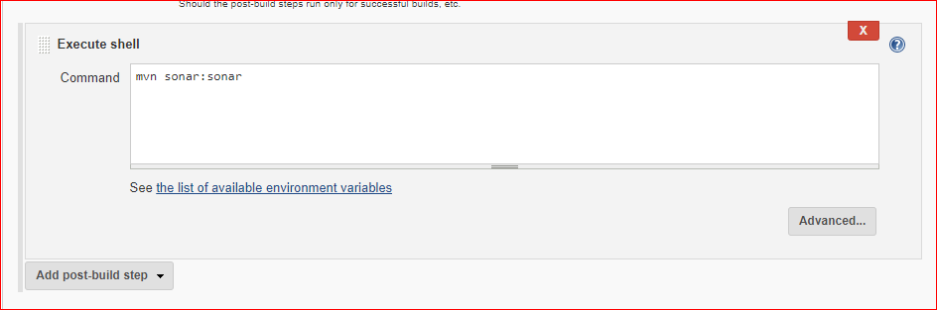

Now click on “**Build Now**”, our app is successfully deployed:

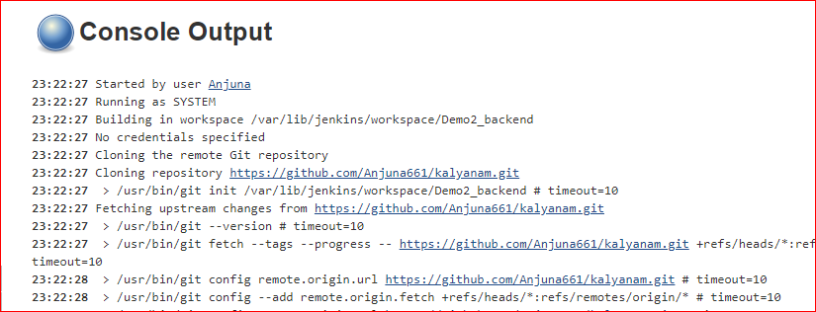

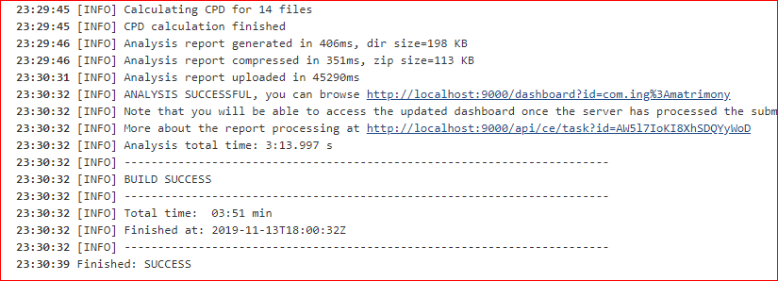

Change the application.properties as per our DB details or create DB details as per application.props

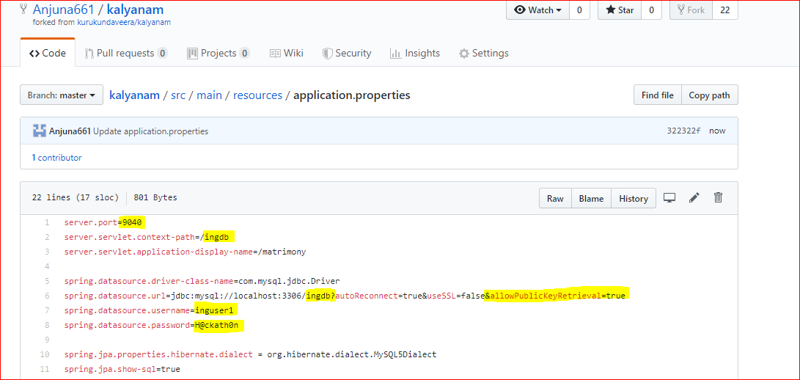

Metrics are published in Sonarqube dashboard shown below:

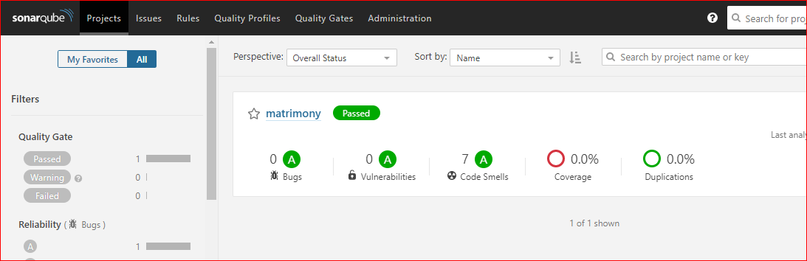

Artifacts are pushed to Nexus as shown below:

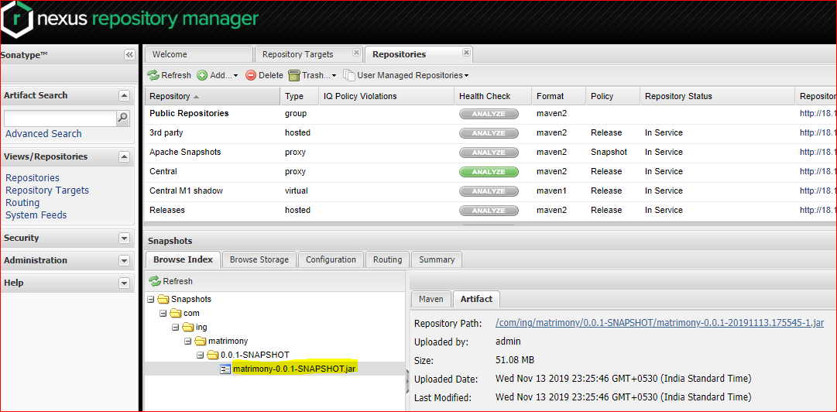

Sprint application procedure (To make backend application UP):

**cd apache-tomcat-9.0.27**

**cd /var/lib/jenkins/workspace/**

**cd Demo2_backend**

**cd target/**

**cd ..**

**cd src/main/resources/**

**cp -r application.properties /opt**

**cd /opt**

**cd target/**

**java -jar matrimony-0.0.1-SNAPSHOT.jar spring.config.location=file:/opt/application.properties**

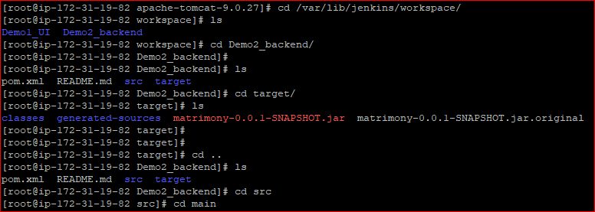

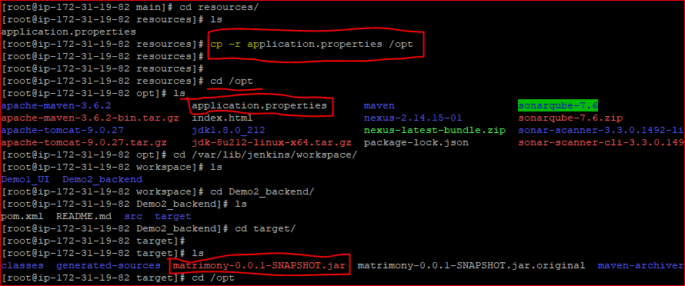



**To see backend application on swagger, use below url, we will bw able to see the swagger page:**

<http://18.188.249.213:9040/ingdb/swagger-ui.html#/>

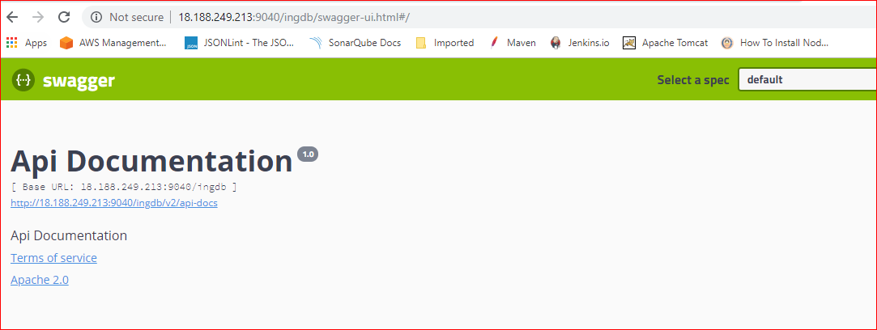

**Connecting to MySQL Workbench:**

