**PART 1**

*data <- getAllData()*

*all_plots(data, save_location)*

This will generate a PDF file in the save location provided by the user

**PART 2**

*data <- getAllData()*

*modplot(getModularity(data))*

This will create a modularity plot

**PART 3.B**

*data <- getAllData()*

*plotCpComparison(buildDataForCPChangeAnalysis(data))*

This will create a Fitness Vs Core Size Graph for first and last 14 months of data. Left side of the image represents first 14 months of data and right side of the image contains last 14 months of data.

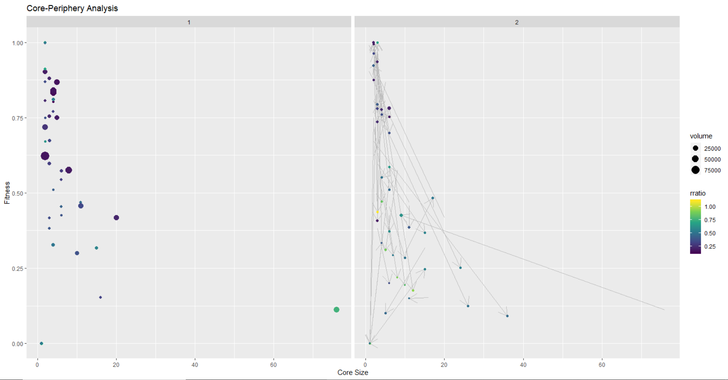

**PART 3.A**

*data <- getAllData()*

*getchi(data)*

This will generate percentages for 13 forums between core, periphery and X-periphery members.

I got the following output



**PART 4**

For the 4th part of the assignment, I divided the entire timeline into 5 chunks. 14 months before the design change, 14 months after the design change, two more 14 month periods and last 11 months of data. This allowed me to clearly visualize waxing or waning of relationships in time.

I wanted to observe the relationship between “phototaker” and “DavidHueben” who were core members in the diabetes forum before the design change. 2 years after the design change, their involvement with other members started to reduce. This can be verified when we see the 4th image in the gephi snapshot. I had labelled node size and node labels proportional to the degree of the node. From this we can prove that indeed their interaction has reduced.

Other members in the forum took their position of core members in the later half of 2012. This removal of phototaker and DavidHueben from the core might have been the outcome of some larger event taking place. As we see from the biweekly traffic plot, the forum traffic had been continuously decreasing after the design change. Sustainability of conversations between its periphery and core members would’ve been the major problem faced by phototaker and DavidHueben.

Looking at the conversations before the design change, I came to know that both phototaker and DavidHueben were retired professionals. Phototaker was a school teacher and David worked with IBM for 30 years. Having time on their hands and seeing lack of support for people with diabetic issues glued them to the forum. The following excerpt from a conversation between phototaker and David sums up the reason behind their active participation.

*Now I really enjoy passing "forward" what others have taught me. I have a desire to want to help new people not feel so anxious after learning they have diabetes, and learn how to make their lives easier or healthier, once they’ve found this out. I found I didn’t learn enough in my diabetes classes or with a dietician, but others who have been through this, have enlightened me with research they’ve done or ideas to help me. Thanks to everyone who has helped me learn about what works for me better and all the new "friends" who support me with comments and suggestions!*

After the design change there were some concerns with the user experience. This can be seen by the following excerpt:

*David, when I would log on yesterday, I could see the "What’s Happening Now", Discussions, etc. BUT when I would answer someone, and then want to go back to the discussions again, there would be an AD covering over the whole LEFT SIDE where the BLUE IS! check to see if it’s happening today.*

Overall in the 14 month period after the design change, they continued to serve diabetic patients. But the next 14 month of data showed some troubling findings. David was going through second retinal reattachment surgery and therefore was not very active on the forum. David was more like a big brother to phototaker and many other prominent members in the group. Without his presence, the group started to fall apart. xring and amanda2581 left the forum in June 2011 and Sept 2012 respectively. During this time, I saw the emergence of new core members such as flutetooter and auriga1.

During July 2012 and Sept 2013, David became legally blind and the conversations started to wane. It was correlated to the fact that the traffic on diabetes forum was also falling. Auriga1 and flutetooter were doing a great job of catering to questions in whatever that was left on the forum. David left the forum in Dec 2012 and subsequently phototaker left the forum in June 2013. They were true and honest people who helped more than a few thousand people over the course of 4 years. Cheers to their hard work!