**Assignment 4**

**Roll: 31164 Submitted On: 22-05-2021**

**TITLE**: Connectivity of Raspberry Pi /Beagle board circuit with InfraRed(IR) sensor.

**PROBLEM STATEMENT /DEFINITION:** Understanding the connectivity of Raspberry-Pi /Beagle board circuit with IR sensor. Write an application to detect obstacle and notify user using LEDs

**Learning Objectives:** Understanding the connectivity of Raspberry Pi /Beagle board circuit with IR sensor.

**Learning Outcomes:** The students will be able to :-

1. To interface IR sensor to Raspberry pi.
2. Detect the obstacle with IR sensor.
3. Can perform actuation.

**Theory:**

**Introduction:**

The Raspberry Pi is open hardware, with the exception of the primary chip on the Raspberry Pi, the Broadcom SoC (System on a Chip), which runs many of the main components of the board–CPU, graphics, memory, the USB controller, etc. One powerful feature of the Raspberry Pi is the row of GPIO (general purpose input/output) pins along the top edge of the board.

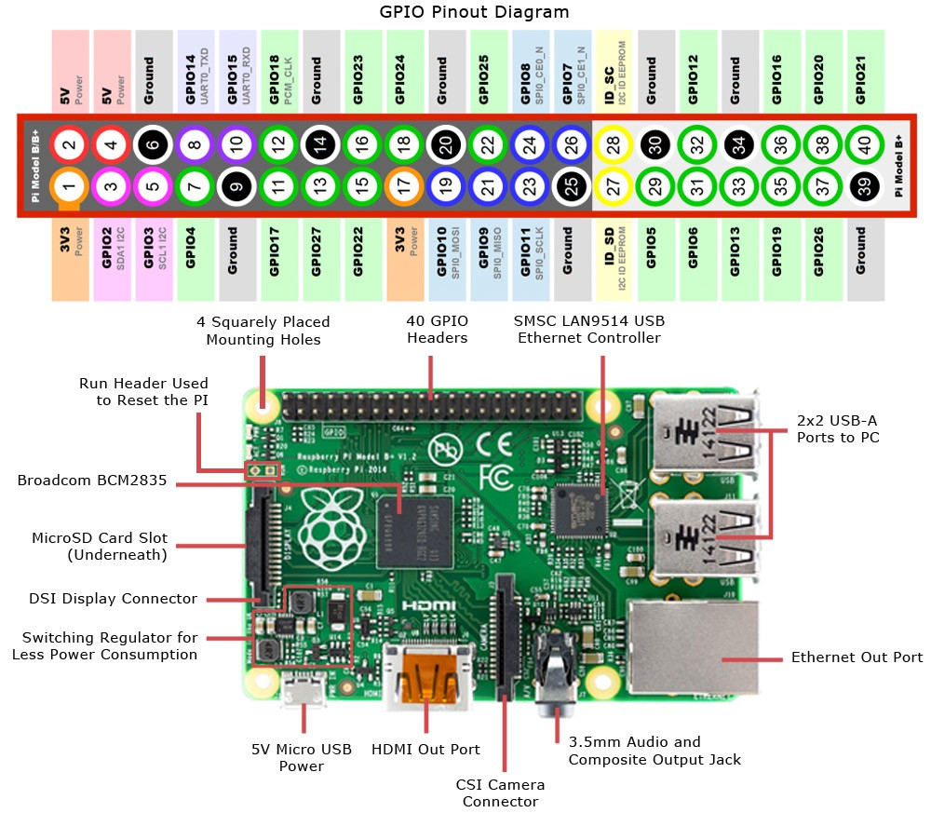

**InfraRed (IR) Sensor :**

IR (Infrared) Sensor works by emitting infrared signal/radiation and receiving of the signal when the signal bounces back from any obstacle. In other words, the IR Sensor works by continuously sending signal (in a direction) and continuously receive signal, if comes back by bouncing on any obstacle in the way.

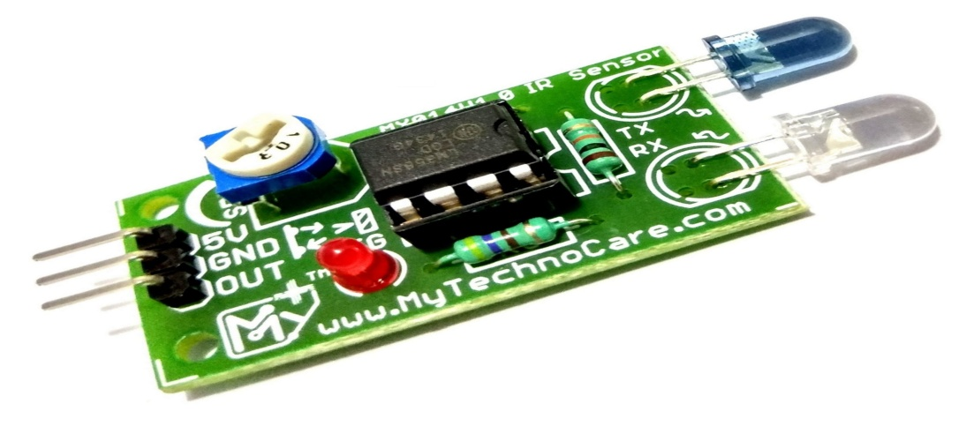

**Connecting IR Sensor :**

1. Connect GPIO 17 from the Raspberry Pi to Breadboard.
2. Connect OUT pin of the sensor with the Breadboard This will send input received from sensor to GPIO 17, which will be processed further.
3. Connect GND (any pin from board will work) with negative line on left side of the breadboard .
4. Connect GND of the IR Sensor to Breadboard .
5. Connect GND from Step 3 to Breadboard .
6. Connect VCC of the IR Sensor to Breadboard .
7. Connect 3v3 (Pin #1) to positive line on left side of the breadboard .
8. Connect 3v3 (connected in Step 7) to the Breadboard.

**Connecting LED**

Objective is to turn on the LED when obstacle is detected.

1. Connect GPIO 4 from the board to the Breadboard .
2. Connect positive point of the LED (longer pin of the LED) to the Breadboard.
3. Connect negative point of the LED (smaller pin of the LED) to the Breadboard.
4. Use resistor (330 Ω) to connect negative to the negative point of the LED.

**Python code to detect obstacle**

from gpiozero import LED

from signal import pause

import RPi.GPIO as GPIO

import time GPIO.setmode(GPIO.BCM)

LED_PIN = 27

IR_PIN = 17

indicator = LED(LED_PIN)

GPIO.setup(IR_PIN, GPIO.IN)

count = 1

while True:

got_something = GPIO.input(IR_PIN)

if got_something:

indicator.on() print("{:>3} Got something".format(count))

else:

indicator.off()

print("{:>3} Nothing detected".format(count))

count += 1

time.sleep(0.2)

**CONCLUSION:** We were able to understand how to connect Raspberry-Pi with camera and perform operations on it.