**Assignment B2**

**Roll: 31164**

**Submitted On:** **22-05-2021**

**TITLE**:

Write an application to capture and store the image.

**PROBLEM STATEMENT /DEFINITION:**

Understanding and connectivity of Raspberry-Pi /Beagle board with camera. Write an application to capture and store the image.

**Learning Objectives:**

To understand configuration of Raspberry-pi/Beagle board circuit with basic peripherals and its use in the program.

**Learning Outcomes:**

We will be able to establish connectivity of Raspberry-pi and Implement the program.

**Theory:**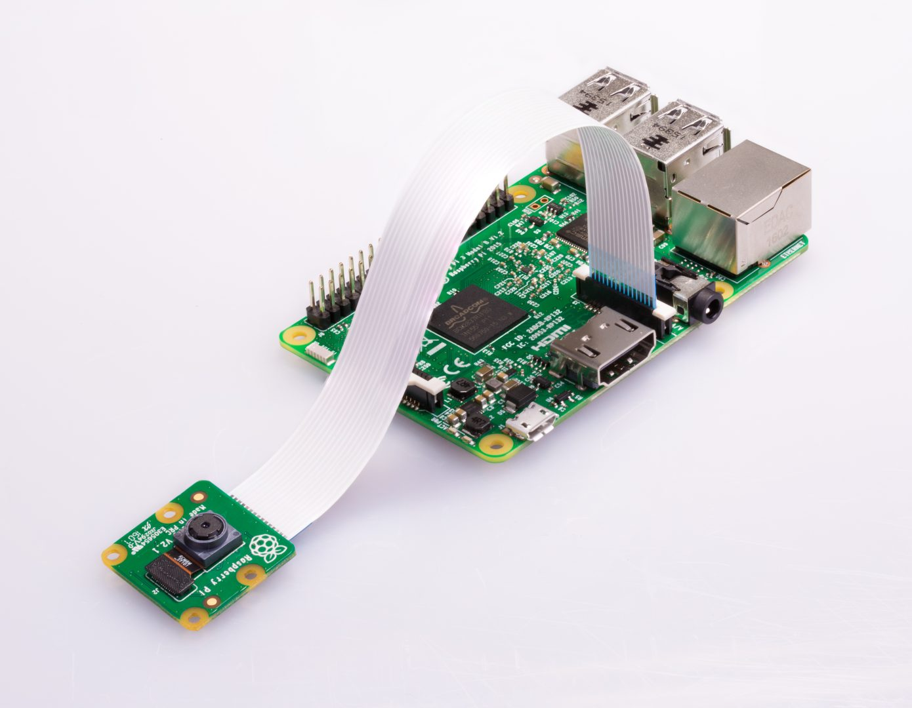Pi Camera Module Interface with Raspberry Pi using Python Introduction Pi Camera module is a camera which can be used to take pictures and high-definition video.

Raspberry Pi Board has CSI (Camera Serial Interface) interface to which we can attach Pi Camera module directly.

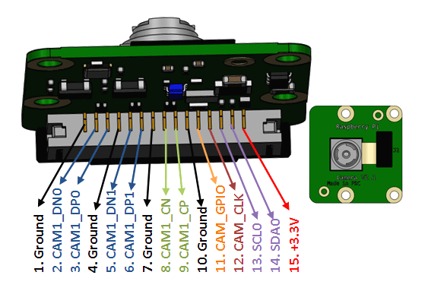

This Pi Camera module can attach to the Raspberry Pi’s CSI port using 15-pin ribbon cable.

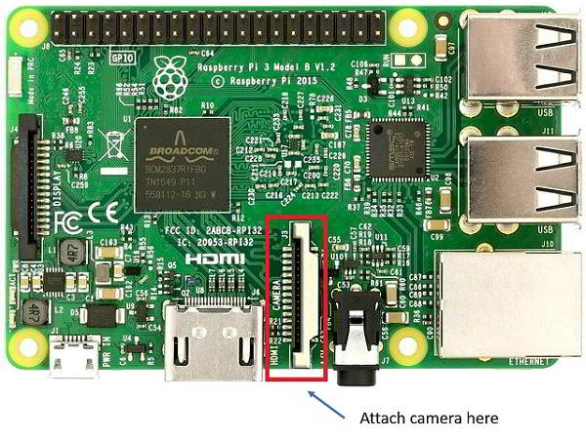How to attach Pi Camera to Raspberry Pi?

Connect Pi Camera to CSI interface of Raspberry Pi board as shown below,

Now, we can use Pi Camera for capturing images and videos using Raspberry Pi.

**Python Program for Image Capture & Store**

import picamera

from time import sleep

#create object for PiCamera class

camera = picamera.PiCamera()

#set resolution

camera.resolution = (1024, 768)

camera.brightness = 60

camera.start_preview()

#add text on image

camera.annotate_text = 'Hi Pi User' sleep(5)

#store image

camera.capture('image1.jpeg')

camera.stop_preview()

**CONCLUSION:** We were able to understand how to connectRaspberry-Pi with camera and perform operations on it.