**Assignment 6:**

**Roll No. 31164 Date: 22/05/21**

**Title**: Write a network application for communication between two devices using Zigbee.

**Problem Statement**: Understanding and connectivity of Raspberry-Pi /Beagle board with a Zigbee module. Write a network application for communication between two devices using Zigbee.

**Objective:**

* To understand functionalities of various single board embedded platforms fundamentals.
* Develop application for Communication between more raspberry pi hardware.

**Learning Outcomes**: The students will be able to

* Perform the connectivity with Raspberry-Pi, Beagle board, Arduino and other micro controller
* Implement transmitter and receiver program using python by using zigbee device

**S/W and H/W Apparatus**: Python, two Raspberry pi devices, Zigbee device, Latest Version of 64 bit Operating Systems, Open Source Fedora-GHz. 8 G.B. RAM, 500 G.B. HDD, 15"Color Monitor, Keyboard, Mouse

**Theory:**

ZigBee Communication Using Raspberry Pi

ZigBee is a communication device used for the data transfer between the controllers, computers, systems, really anything with a serial port. As it works with low power consumption, the transmission distances is limited to 10–100 meters line-of-sight. ZigBee devices can transmit data over long distances by passing data through a mesh network of intermediate devices to reach more distant ones. ZigBee is typically used in low data rate applications that require long battery life and secure networking. Its main applications are in the field of wireless sensor network based on industries as it requires short-range low-rate wireless data transfer. The technology defined by the ZigBee specification is intended to be simpler and less expensive than other wireless networks.

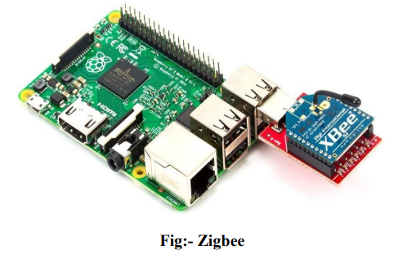

**Zigbee Technology**

Zigbee communication is specially built for control and sensor networks on IEEE 802.15.4 standard for wireless personal area networks (WPANs), and it is the product from Zigbee alliance. This communication standard defines physical and Media Access Control (MAC) layers to handle many devices at low-data rates. These Zigbee’s WPANs operate at 868 MHz, 902-928MHz and 2.4 GHz frequencies. The date rate of 250 kbps is best suited for periodic as well as intermediate two way transmission of data between sensors and controllers. Zigbee is low-cost and low-powered mesh network widely deployed for controlling and monitoring applications where it covers 10-100 meters within the range. This communication system is less expensive and simpler than the other proprietary short-range wireless sensor networks as Bluetooth and Wi-Fi. Zigbee supports different network configurations for master to master or master to slave communications. And also, it can be operated in different modes as a result the battery power is conserved. Zigbee networks are extendable with the use of routers and allow many nodes to interconnect with each other for building a wider area network.

**Zigbee Architecture**

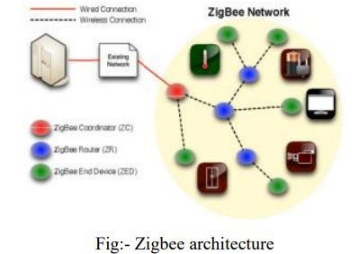

Zigbee system structure consists of three different types of devices such as Zigbee coordinator, Router and End device. Every Zigbee network must consist of at least one coordinator which acts as a root and bridge of the network. The coordinator is responsible for handling and storing the information while performing receiving and transmitting data operations. Zigbee routers act as intermediary devices that permit data to pass to and fro through them to other devices. End devices have limited functionality to communicate with the parent nodes such that the battery power is saved as shown in the figure. The number of routers, coordinators and end devices depends on the type of network such as star, tree and mesh networks.Zigbee protocol architecture consists of a stack of various layers where IEEE 802.15.4 is defined by physical and MAC layers while this protocol is completed by accumulating Zigbee’s own network and application layers.

**Physical Layer:**

This layer does modulation and demodulation operations up on transmitting and receiving signals respectively. This layer’s frequency, date rate and number of channels are given below

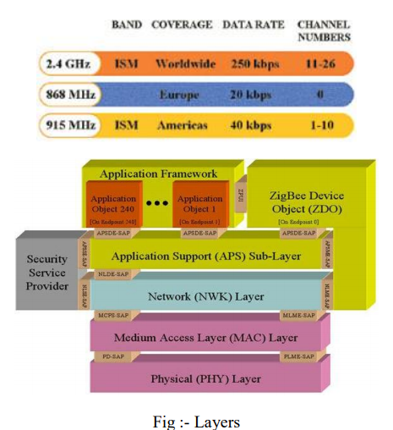

**MAC Layer**: This layer is responsible for reliable transmission of data by accessing different networks with the carrier sense multiple access collision avoidance (CSMA). This also transmits the beacon frames for synchronizing communication.

**Network Layer**: This layer takes care of all network related operations such as network setup, end device connection and disconnection to network, routing, device configurations, etc.

**Application Support Sub-Layer:** This layer enables the services necessary for Zigbee device object and application objects to interface with the network layers for data managing services. This layer is responsible for matching two devices according to their services and needs.

**Application Framework**: It provides two types of data services as key value pair and generic message services. Generic message is a developer defined structure, whereas the key value pair is used for getting attributes within the application objects. ZDO provides an interface between application objects and APS layer in Zigbee devices. It is responsible for detecting, initiating and binding other devices to the network. Zigbee Operating Modes and Its Topologies.

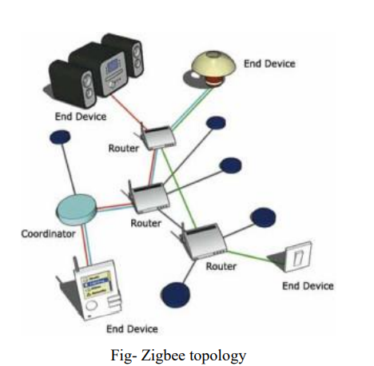

Zigbee two way data is transferred in two modes: Non-beacon mode and Beacon mode. In a beacon mode, the coordinators and routers continuously monitor active state of incoming data hence more power is consumed. In this mode, the routers and coordinators do not sleep because at any time any node can wake up and communicate. However, it requires more power supply and its overall power consumption is low because most of the devices are in an inactive state for over long periods in the network. In a beacon mode, when there is no data communication from end devices, then the routers and coordinators enter into sleep state. Periodically this coordinator wakes up and transmits the beacons to the routers in the network. These beacon networks are work for time slots which means, they operate when the communication needed results in lower duty cycles and longer battery usage. These beacon and non-beacon modes of Zigbee can manage periodic (sensors data), intermittent (Light switches) and repetitive data types.

**Program**

**Zigbee transmitter code:**

Import serial

Port=serial.Serial(“/dev/ttyUSB0”,baudrate=9600,timeout=3.0)

While True:

X=raw_input(‘pass your data’)

Port.write(x)

Rcv=port.read(1)

Print(‘received data:’,rcv)

**Zigbee receiver code:**

Import serial

Import time

Port=serial.Serial(“/dev/ttyUSB0”, baudrate=9600,timeout=0.1)

While= True:

#x=raw_input(“pass your input”)

#port.write(x)

Rev=port.read(1)

Print(rev)

#time.sleep(1)

If(rev!=’’):

F=open(“log.txt”,’a’)

f.write(rev)

f.close()

)

**Conclusion**: - Thus the communication between two devices using Zigbee are successfully done.