**Subject : Embedded Systems and IoT Lab**

Batch : N1

**Mini Project Title : Health Monitoring Application**

----------------------------------------------------------------------------------------------------------------

**Group Members :**

1. Shreya Rani (31161)

2. Prathamesh Sonawane (31164)

3. Tanushree Patil (31168)

4. Prathamesh Thombre (31170)

---------------------------------------------------------------------------------------------------------------------------

**Design Steps**

1. **Purpose & Requirement Specification**

* Purpose : Monitor the patient’s body temperature and pulse which can be viewed and analyzed by authorized personnel remotely at any time.
* Behavior : Monitor the patient’s body temperature and pulse in real time. The system will alarm in emergency situations and notify the staff and relatives of the patient.

**Requirement :**

* System Management Requirement - Remote monitoring and control
* Data Analysis Requirement - Perform analysis of data and use graphical visualization
* Application Deployment Requirement - Deployed locally on the device and monitored remotely.
* System Requirements - Only Authorized users can access and control the Application

1. **Process model Specification**   
     
   The sensors read the information from the Human Body and store it in Database, when the values go beyond the threshold limit it sends alerts.

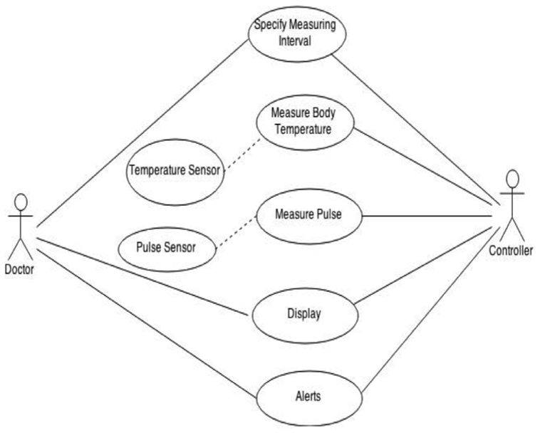

1. **Domain Model Specification**

* Physical Entity : Human Body
* Virtual Entity : Human Body
* Device : Arduino board that attaches the temperature and pulse sensors.
* Resource : Database, Memory
* Service : Retrieve current information

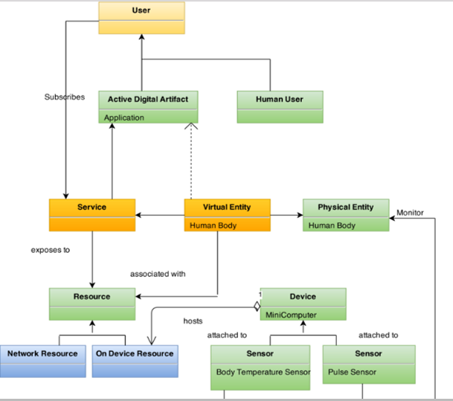

**4. Information Model Specification**  
  
 Class : Human Body Attributes : Name, Texture

Class : Temperature Attributes : TempVal, State

Class : Pulse Attributes : PulseVal, State

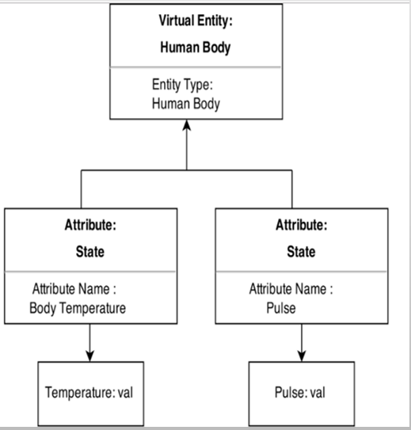

**5. Service Specification**  
  
 Controller Service :

This service is responsible to check the pulse and update the temperature and pulse rate of the patient after every 30 minutes.

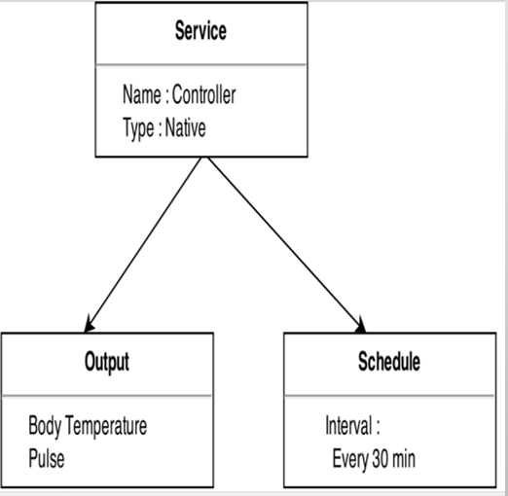

**6. IoT Level Specification**

The system has a single device that performs sensing, stores data, performs analysis and hosts the application. Thus, IoT Level 1.

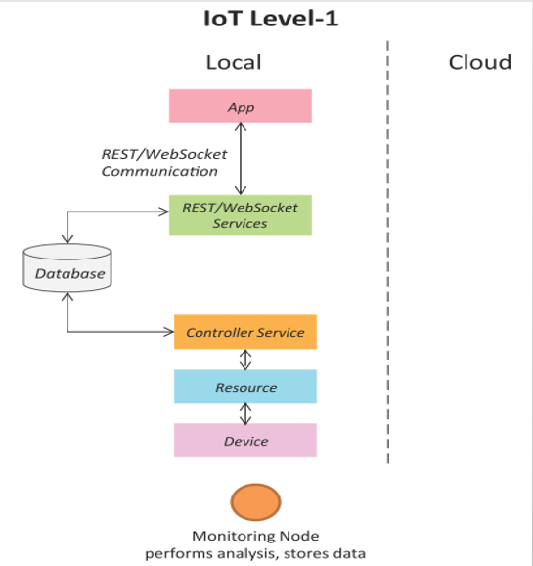

**7. Functional View Specification**

Various Functions in each Functional Groups are as follows :

* Application : Web Server, Application Server, Database Server is used to develop the application.
* Management : Application Mgmt, Database Management, Device Management is done Services: Will use Web Service, Controller Service
* Security : Perform Authentication and Authorization   
  Communication : Mention Protocols, APIs.
* Devices : Sensors, Actuators, Computing Devices.

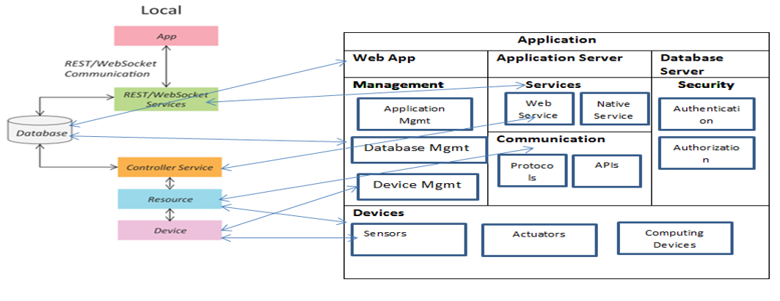

**8. Operational View Specification:**

* Application
  + Web App: PHP Webapp
  + Application Server: Google App Engine
  + Database Server: MySQL
  + Services:
    - Native: Controller Service
    - Web: REST
* Communication
  + Communication APIs: REST APIs
  + Communication Protocol:
    - Link Layer: 802.11
    - N/w: IPV6
    - Transport: TCP
    - Application: HTTP
* Management
  + Device Management: Aurdino device management
  + Application Management: PHP App Management
  + Database Management: MySQL Db Mgmt
  + Security: Login Management

**9. Device and Component Integration:**

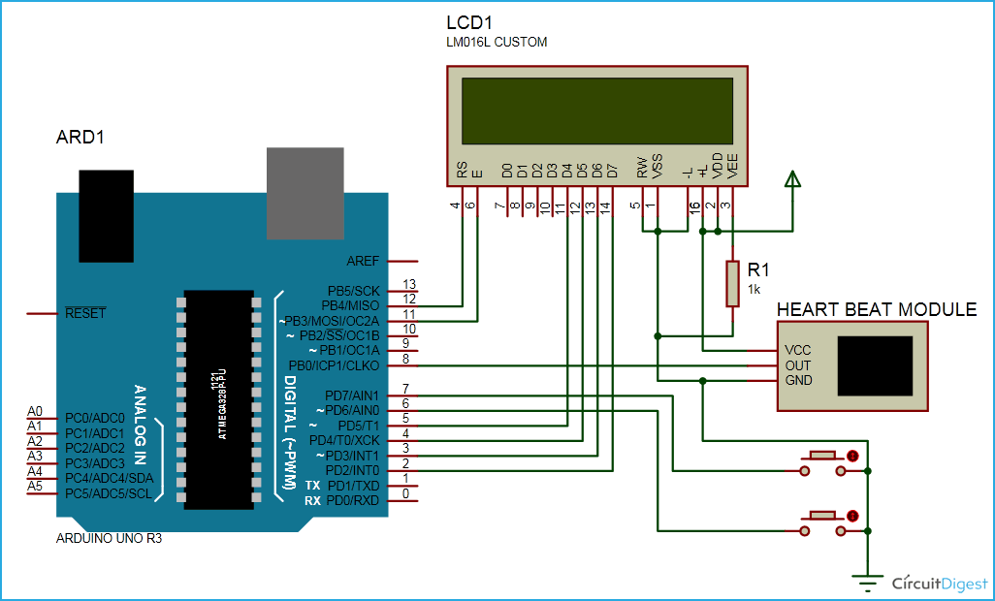

**10. Application Development**

This gives the Graphical User Interface

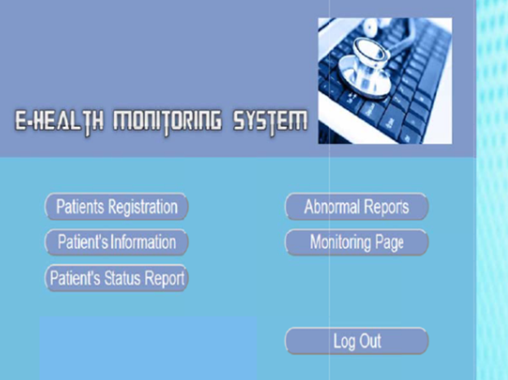

**CONCLUSION**  
We have successfully designed a Health Monitoring Application to monitor the patient’s body temperature and pulse rate remotely.