**Assignment A4**

Roll No. 31164 Date- 25/05/2021

Name: Prathamesh Sonawane

**Title**: Pass II of a two pass macro processor.

**Problem Statement:** Write a Java program for pass-II of a two-pass macro-processor. The output of assignment-3 (MNT, MDT and file without any macro definitions) should be input for this assignment.

**Objectives:**

* Understand the macro expansion in pass II.
* Replace the formal parameters with actual parameters.
* Understand the use of data structures developed in pass I.

**S/W Packages & Hardware required**:

64-bit open source Linux (Fedora 20)

Eclipse IDE, JAVA

I3 and I5 machines

**Theory:**

Macro processing feature allows the programmer to write shorthand version of a program (modular programming). The macro processor replaces each macro invocation with the corresponding sequence of statements i.e. macro expansion.

Tasks done by the macro processor

* Recognize macro definitions
* Save the macro definition recognize macro calls
* Expand macro calls

Tasks in pass I of a two pass macro processor

* Recognize macro definitions
* Save the macro definition(Create MDT,MNT,ALA)Perform processing of assembler directives(e.g. BYTE, RESW directives can affect address assignment)
* Create intermediate code file.

**Steps to do /algorithm:**

* Read .asm file.
* Create MNT and MDT.
* Create ALA.
* Create intermediate code file.

**State Diagram:**

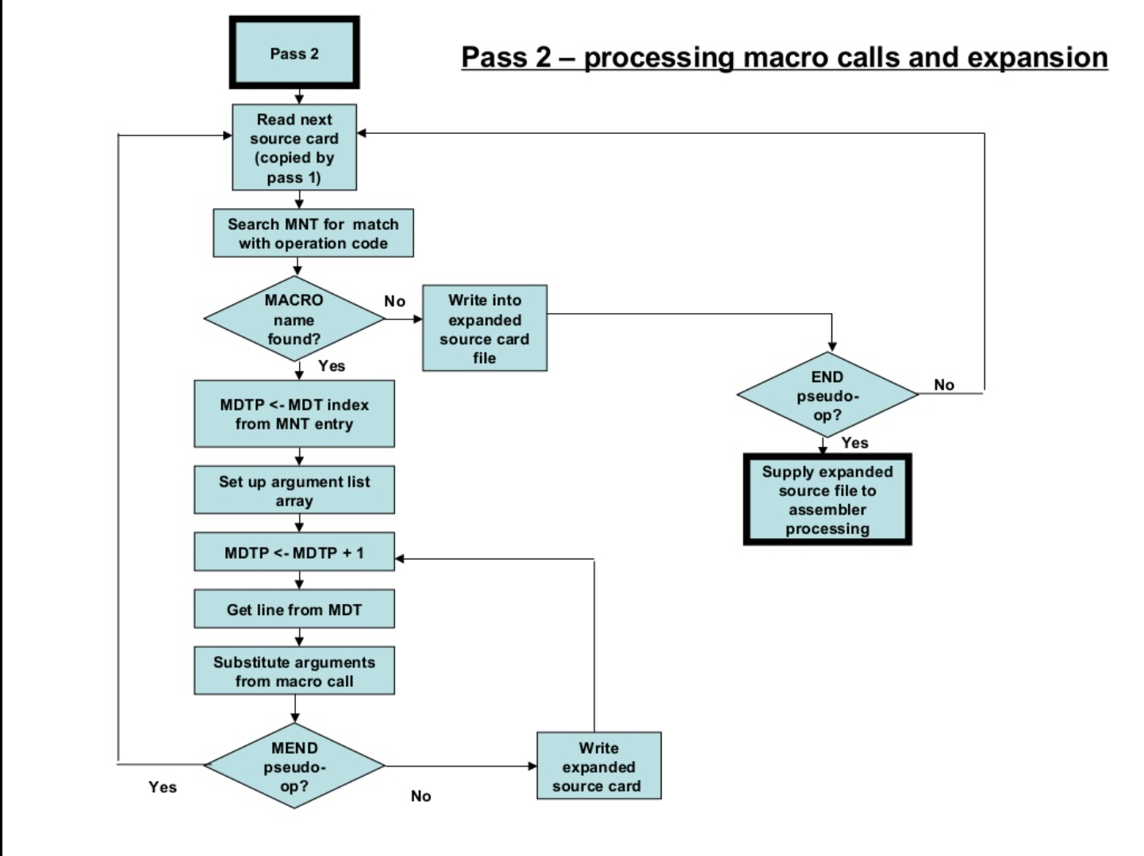

**Conclusion:**

Thus, we were able to implement pass II of two pass macro assembler.