Customer Segmentation Project
Car Sales — Behavioral Segmentation Using K-Means Clustering

1. Project Overview
This project segments customers based on purchasing behavior and demographics, using clustering techniques and Python (scikit-learn). Purchase patterns and preferences are analyzed, and the resulting segments and their key characteristics are visualized.

A note on the dataset
The provided dataset (Car_Sales_Dataset.csv) is a B2B sales transaction log recording car sales from multiple brands (Tata, Mahindra, Maruti Suzuki, Kia, Toyota, Honda, Hyundai) to dealership partners, across regions. It does not contain an individual end-consumer ID, age, or income column — the 'customer' in this dataset is the dealership buying channel.
To deliver a genuine, useful segmentation on this data, each (Dealer × Region) combination — e.g. 'Elite Auto - West' — is treated as one customer / account. This yields 24 customer units built from the 100 transactions in the file.

2. Methodology

2.1 Feature Engineering
For every (Dealer, Region) customer unit, the following behavioral features were computed from the raw transactions:
- Total Revenue — total monetary value purchased
- Total Units — total quantity of vehicles purchased
- Number of Transactions — purchase frequency
- Average Unit Price — price tier of vehicles typically bought
- Average Discount (%) — discount sensitivity
- Fuel-Type Diversity — number of distinct fuel types purchased (Petrol/Diesel/CNG/Electric)
- Average Order Value — Total Revenue / Number of Transactions

2.2 Preprocessing & Clustering
Features were standardized using StandardScaler (zero mean, unit variance) so high-magnitude features like Total Revenue don't dominate the distance calculation. K-Means clustering was then applied.
The optimal number of clusters (k) was tested for k = 2 to 7 using the Elbow Method and Silhouette Score:
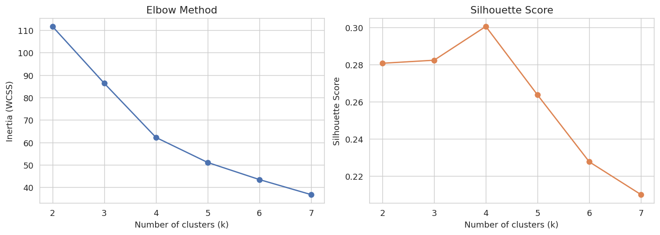
k = 3 was selected for business interpretability (High / Mid / Low value), consistent with the elbow curve's inflection point.

3. Customer Segments
K-Means with k = 3 was fit on the scaled features. Segments were ranked and labeled by average revenue:
Segment | Units | Avg Revenue (INR) | Avg Units | Avg Txns | Avg Unit Price | Avg Discount % | Fuel Diversity
High-Value | 3 | 56,563,333 | 44.7 | 4.3 | 1,362,500 | 4.5% | 3.3
Mid-Value | 9 | 32,930,500 | 37.7 | 5.7 | 973,704 | 4.6% | 3.3
Low-Value | 12 | 21,823,958 | 24.2 | 3.0 | 1,070,486 | 3.1% | 1.9

3.1 Segment Visualization (PCA Projection)
The 7 behavioral features were reduced to 2 principal components for visualization, showing clear separation between the three segments:
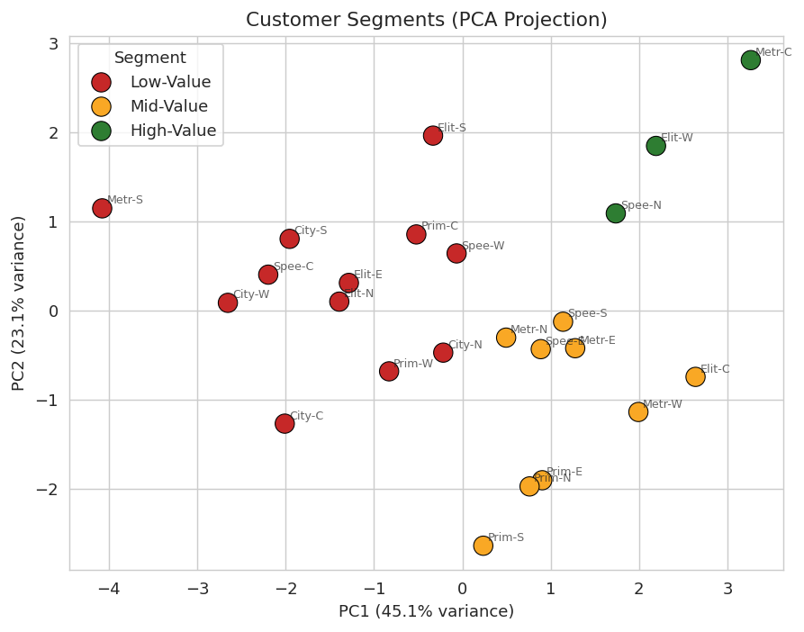

3.2 Segment Profiles
Average feature values per segment, visualized side by side:
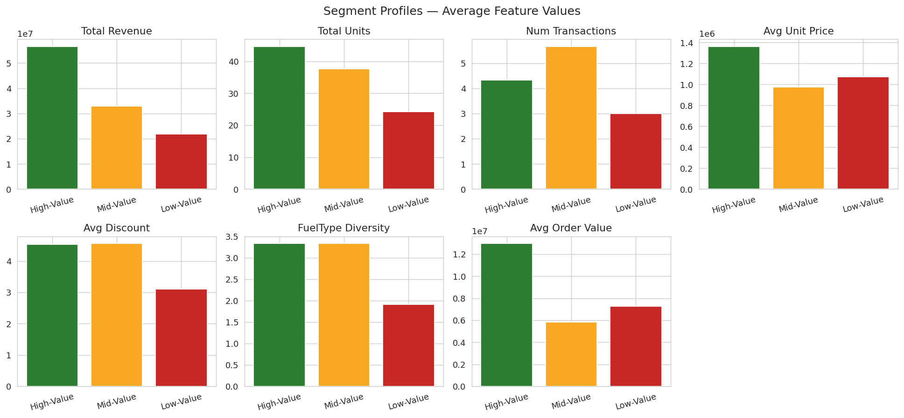

3.3 Segment Characteristics
High-Value (3 units): Elite Auto-West, Metro Cars-Central, Speedway Motors-North.
The strongest accounts — highest average revenue (₹5.66 Cr), largest order sizes (avg ₹1.36M unit price), and the widest fuel-type mix (3.3). These are premium, high-volume dealership relationships that should receive priority allocation of premium/SUV stock and dedicated account support.
Mid-Value (9 units) — the largest group.
Moderate revenue (₹3.29 Cr avg) but the highest transaction frequency (5.7 orders on average) of all segments. This is the volume-and-frequency segment — they order often but in smaller batches. Bundled multi-unit offers could raise their average order value and push them toward High-Value.
Low-Value (12 units): City Auto Hub (all 4 regions), Elite Auto-East/North/South, Metro Cars-South, Prime Motors-Central/West, Speedway Motors-Central/West.
Lower revenue (₹2.18 Cr avg), fewer transactions (3.0), and the narrowest fuel-type mix (1.9) — they tend to buy one or two fuel types repeatedly. Cross-selling other fuel-type models (e.g. introducing Electric/CNG options where only Petrol/Diesel is bought) is the clearest growth lever here.

4. Purchase Pattern Analysis

4.1 Revenue by Fuel Type
Diesel and CNG vehicles generate the most revenue overall, followed by Petrol and Electric — reflecting a market still led by traditional fuel types even as Electric gains share.
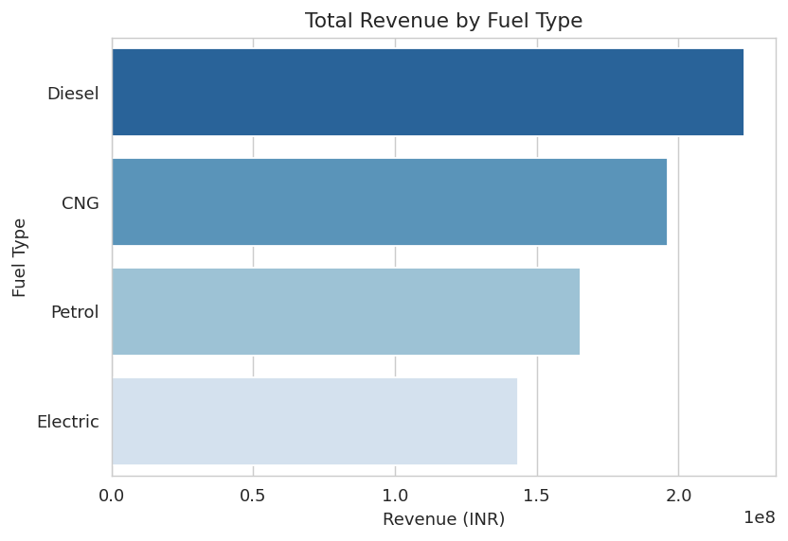

4.2 Monthly Revenue Trend
Revenue is driven by individual large-ticket transactions rather than a steady seasonal pattern, typical of big-ticket B2B vehicle sales.
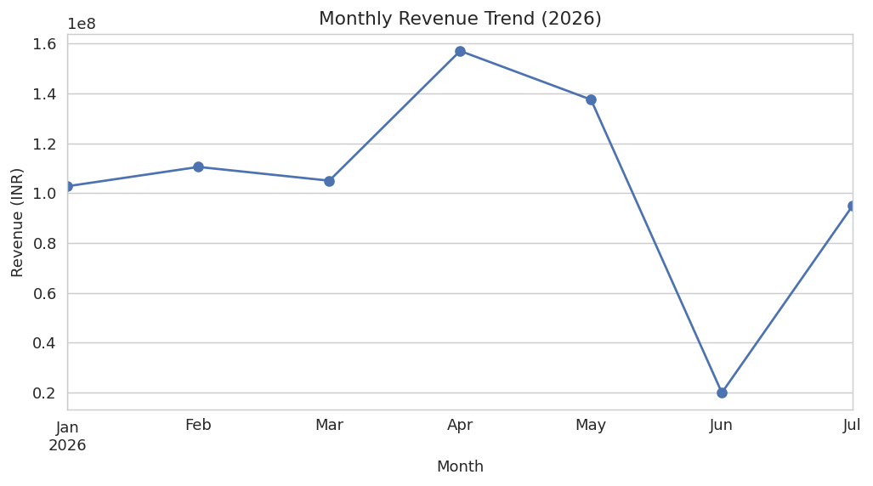

4.3 Fuel Type Preference by Segment
This heatmap shows what % of each segment's revenue comes from each fuel type — useful for tailoring fuel-type-specific offers per segment.
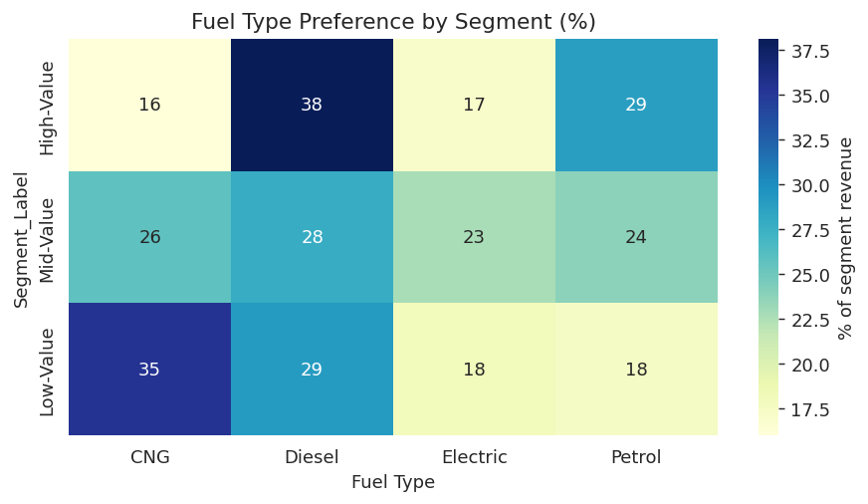

4.4 Discount Sensitivity vs Revenue
High-Value accounts generate strong revenue without needing heavy discounts, while Low-Value accounts show more scattered, lower-revenue behavior across discount levels.
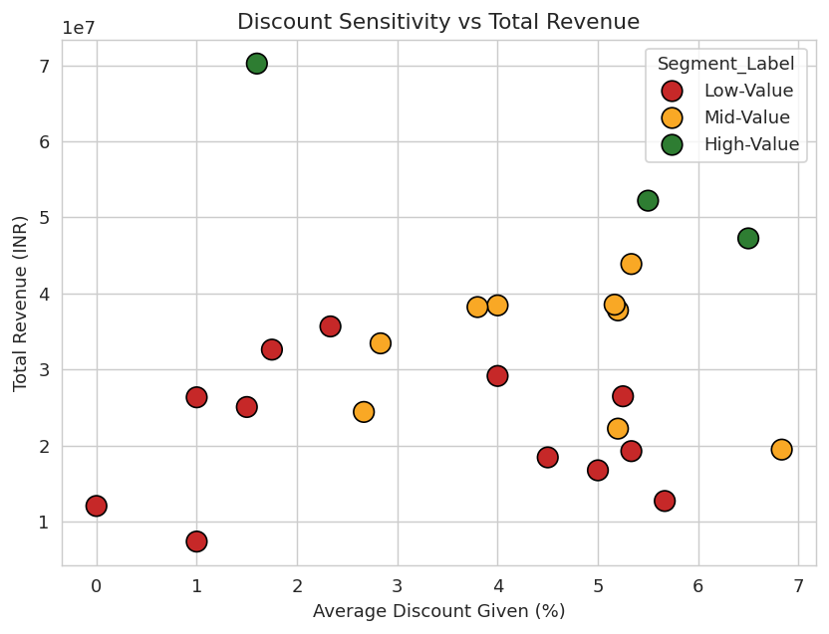

5. Expected Outcome & Recommendations
- Prioritize stock allocation and account management for the 3 High-Value dealer-region accounts, which generate the highest average revenue per unit.
- Run frequency-to-value conversion campaigns (bundled deals, fleet discounts) for the 9 Mid-Value accounts, who already order often but in smaller batches.
- Introduce cross-fuel-type promotions (e.g. Electric/CNG models) to the 12 Low-Value accounts to diversify their narrow purchasing pattern and lift order value.
- Continue strong Diesel and CNG assortment, which together drive over half of total revenue, while growing Electric share opportunistically.

This analysis demonstrates the full customer-analytics workflow requested: feature engineering from raw transactions, K-Means clustering with data-driven k selection, PCA-based segment visualization, and purchase-pattern analysis — delivering targeted insights for each customer segment.

