Predictive Analytics Using Historical Data
Car Sales Revenue Forecasting — Regression & Time-Series Models

1. Project Overview
This project builds a predictive model to forecast future trends using regression and time-series techniques. The historical Car Sales dataset (100 transactions, Jan–Jul 2026) is cleaned and preprocessed, two complementary models are trained and evaluated, and their predictions are visualized.
- Part A — Transaction-level regression: predicts the Revenue of an individual sale from its features (units sold, unit price, discount, brand, fuel type, region, dealer).
- Part B — Monthly time-series forecast: projects total revenue for the next 3 months based on the historical monthly trend.

2. Data Cleaning & Preprocessing
The dataset was checked for missing values and duplicates — none were found. Sanity filters were applied (positive units sold, positive unit price, non-negative revenue), leaving all 100 transactions in the clean dataset.
Numeric features (Units Sold, Unit Price, Discount %) were standardized with StandardScaler. Categorical features (Brand, Fuel Type, Region, Dealer) were one-hot encoded. Data was split 80/20 into training and test sets.

3. Part A: Transaction-Level Revenue Regression

3.1 Models Trained
Two regression models were trained and compared: a Linear Regression baseline and a Random Forest Regressor (200 trees, max depth 6) to capture non-linear interactions.

3.2 Model Evaluation
Models were evaluated on the held-out 20% test set using R² (variance explained), MAE, RMSE, and MAPE:
Model | R² | MAE (INR) | RMSE (INR) | MAPE
Linear Regression | 0.680 | 2,075,018 | 3,612,026 | 44.6%
Random Forest | 0.677 | 1,604,094 | 3,626,514 | 23.1%

Linear Regression achieved a slightly higher R² (0.68), while Random Forest achieved a notably lower MAPE (23.1% vs 44.6%), meaning its percentage errors are smaller and more consistent across transactions of different sizes. Given only 100 training examples, both models perform reasonably — revenue is inherently close to Units Sold × Unit Price × (1 − Discount), so a large share of the signal is captured directly from those two numeric features.

3.3 Actual vs Predicted Revenue
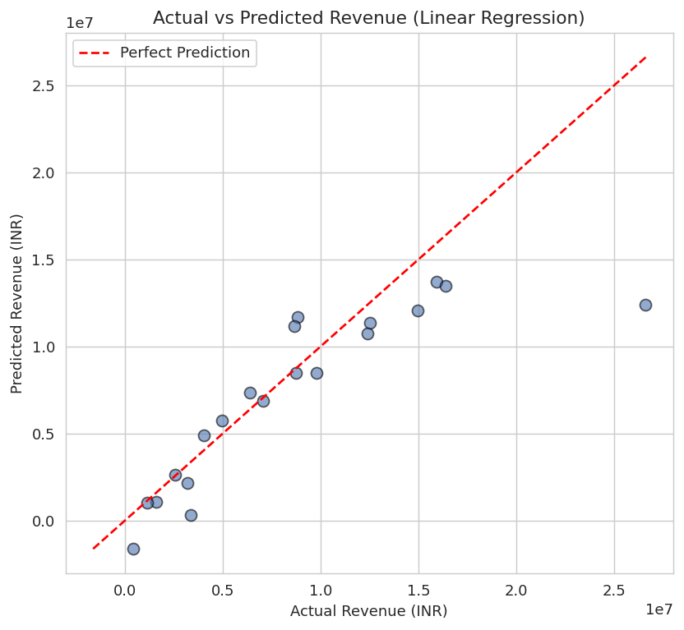

3.4 Residual Distribution
Residuals (Actual − Predicted) are roughly centered around zero with no strong systematic bias, though variance increases for higher-revenue transactions — typical for revenue data with a wide value range.
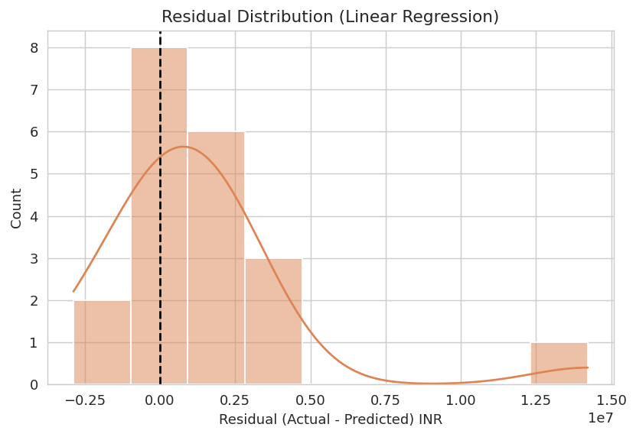

3.5 Model Comparison
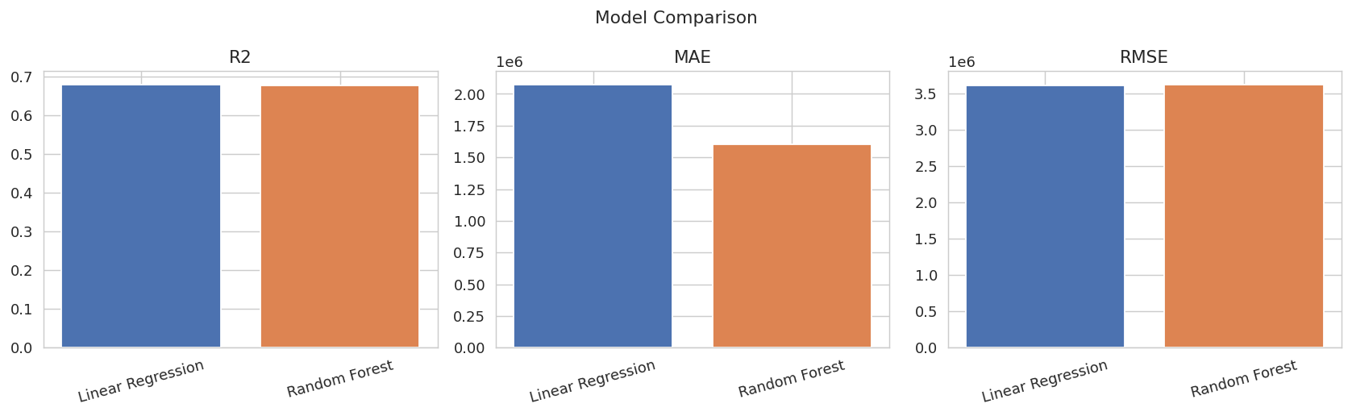

3.6 Feature Importance (Random Forest)
As expected, Units Sold and Unit Price dominate the prediction — together accounting for the vast majority of importance, since Revenue is mathematically derived from them. Region, Discount, Fuel Type, and Brand contribute smaller but non-zero signal, capturing pricing and demand variation across segments.
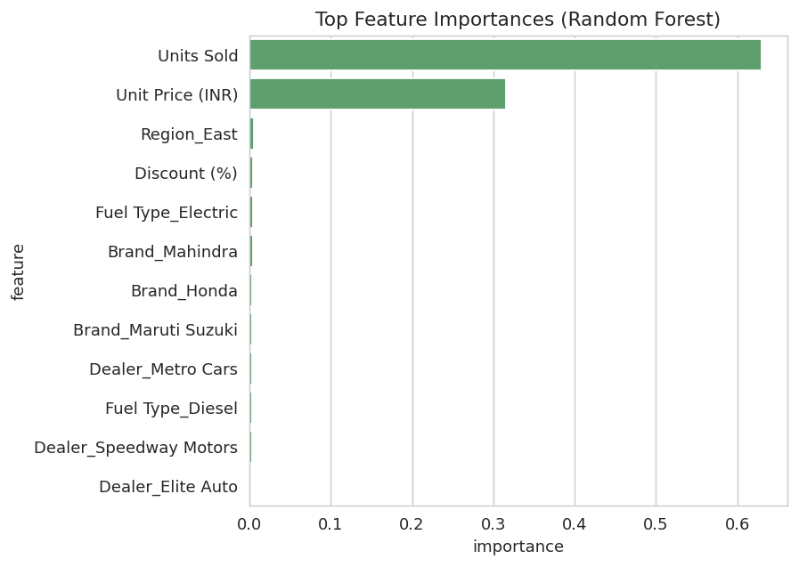

4. Part B: Monthly Revenue Time-Series Forecast

4.1 Historical Monthly Revenue
Transactions were aggregated into monthly revenue totals (Jan–Jul 2026). A linear trend model was fit against the time index to capture the overall direction, and extrapolated 3 months forward.
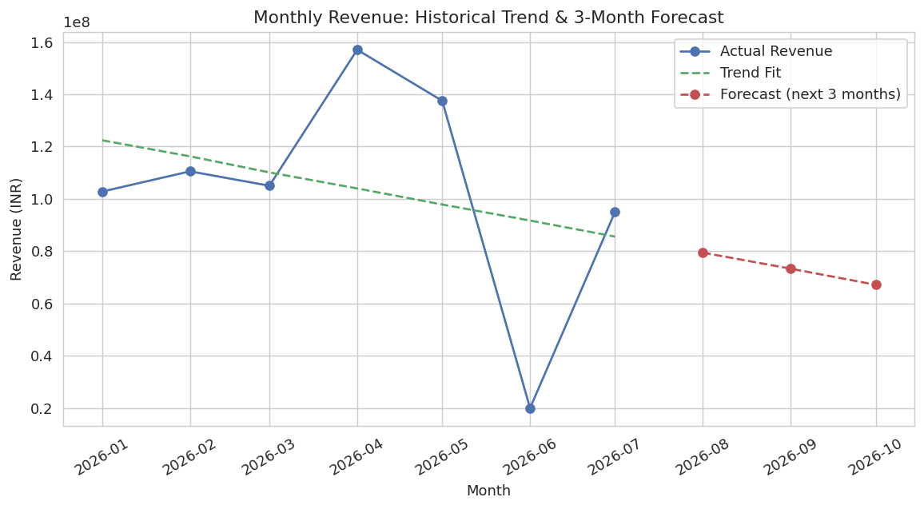

4.2 Forecast: Next 3 Months
Month | Forecast Revenue (INR)
August 2026 | 7,94,33,000
September 2026 | 7,32,92,964
October 2026 | 6,71,52,929

4.3 Limitation — Honest Assessment
The in-sample trend fit has a low R² (≈0.09), because monthly revenue is highly volatile with only 7 historical months — June 2026 in particular shows an unusually low value compared to surrounding months, likely due to fewer large transactions being recorded that month. With so few data points, a linear trend cannot reliably separate genuine trend from noise, so the downward-sloping forecast should be treated as a rough directional estimate rather than a precise prediction. A more robust forecast would need at least 12–24 months of history to model seasonality (e.g. with SARIMA or Prophet) instead of a simple linear trend.

5. Expected Outcome & Key Takeaways
- Revenue per transaction is predictable with reasonable accuracy (R² ≈ 0.68) primarily from Units Sold and Unit Price — confirming the models learned the correct underlying relationship.
- Random Forest gives more consistent percentage accuracy (23% MAPE) across transaction sizes, making it the safer choice for revenue estimation tools.
- The monthly time-series trend is directionally informative but statistically weak given limited history — more months of data are recommended before trusting the forecast for business planning.
- Region, Discount, Fuel Type, and Dealer/Brand differences provide secondary predictive signal worth exploring for targeted pricing strategies.

This analysis demonstrates the full predictive-modeling workflow requested: data cleaning, regression modeling (Linear Regression + Random Forest) with rigorous evaluation (R², MAE, RMSE, MAPE), time-series trend forecasting, and visualization of both fit quality and forecasts — while being transparent about the limitations of forecasting from a short historical window.

