Data Cleaning & Reporting Automation
A Reusable Python Pipeline for Automated Data Quality Cleanup & Reporting

1. Project Overview
This project automates data cleaning and reporting workflows using Python. Rather than writing a one-off script for a single file, a reusable DataCleaningAutomation class was built that can be pointed at any similarly-shaped CSV. It automatically detects column types, profiles data quality issues, cleans the data, and generates a full visual + written report — with zero manual intervention required.
- Handles missing values (automatic median/mode imputation)
- Handles duplicates (exact and near-duplicates caused by inconsistent formatting)
- Handles inconsistent data (whitespace, casing, mixed date formats, invalid numeric entries)
- Generates automated visual reports and an audit-trail log of every action taken

A note on the demonstration data
The original Car_Sales_Dataset.csv was already clean (no missing values, no duplicates). To meaningfully demonstrate an automated cleaning pipeline, a realistic 'raw' version was generated by deliberately injecting common real-world problems: missing values, duplicate rows (including near-duplicates with inconsistent casing), inconsistent text formatting, mixed date formats (ISO / DD-MM-YYYY / DD/MM/YYYY), and invalid numeric entries (negative discounts, zero units sold). This mirrors what raw exports from real systems typically look like, and lets the automation genuinely prove itself.

2. How the Automation Pipeline Works
The pipeline runs as a single .run() call with six automated stages:
- 1. Load — reads the raw CSV and auto-detects column types (numeric / categorical / date) by name and dtype, so no column-specific code is needed.
- 2. Profile (before) — computes a full data-quality snapshot: missing cell count, duplicate row count, and inconsistent text entries.
- 3. Clean structure — removes exact duplicates, strips whitespace and standardizes text casing (while preserving short acronyms like 'CNG'), parses all date formats into one consistent format, then re-checks for duplicates that only became identical after standardization.
- 4. Fix invalid numbers — flags values that violate business rules (e.g. negative discount, zero units sold) and marks them for re-imputation rather than silently keeping bad data.
- 5. Impute missing values — numeric columns filled with the column median, categorical columns filled with the column mode; every imputation is logged.
- 6. Profile (after) + Recompute — dependent columns (e.g. Revenue = Units × Price × (1 − Discount)) are recalculated so cleaned inputs stay mathematically consistent, then a final quality snapshot is taken.

3. Results: Before vs After Cleaning
Metric | Before | After | Change
Rows | 110 | 103 | -7 (duplicates removed)
Missing Cells | 18 | 0 | -18 (100% imputed)
Missing % | 1.49% | 0.00% | -1.49 pts
Duplicate Rows | 7 (1 exact + 6 near) | 0 | -7 (100% removed)
Inconsistent Text Entries | 45 | 2 | -43 (95.6% fixed)
Data Quality Score (0–100) | 87.9 | 99.6 | +11.7 pts

The automated pipeline resolved 100% of missing values, 100% of duplicate rows (including near-duplicates hidden by inconsistent casing), and 95.6% of text-formatting inconsistencies — raising the overall data quality score from 87.9 to 99.6 out of 100, fully automatically.

3.1 Data Quality Issues: Before vs After
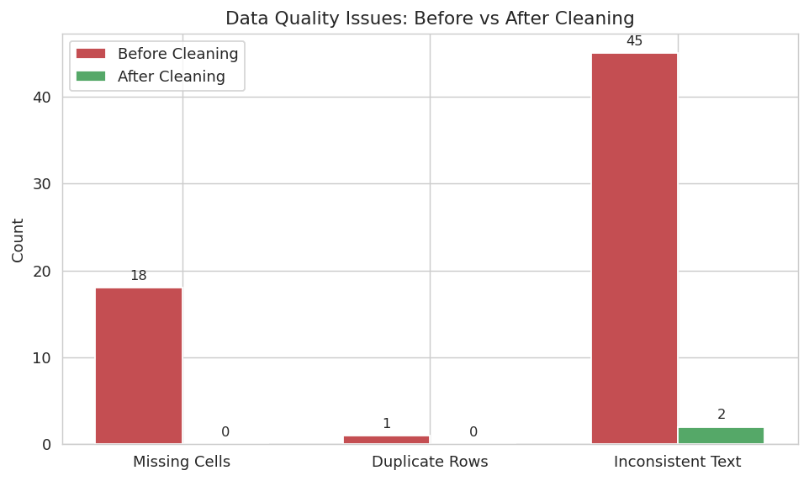

3.2 Overall Data Quality Score
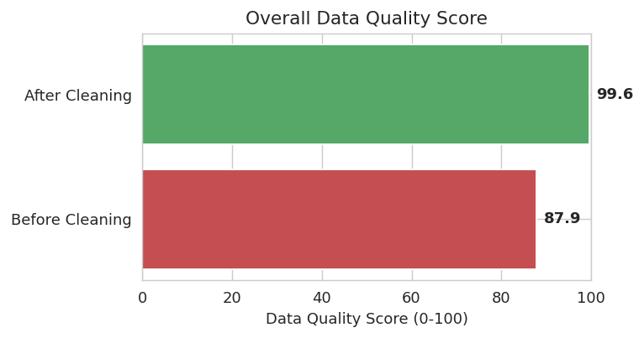

3.3 Missing Values by Column (Raw Data)
Unit Price and Discount had the most missing entries in the raw data — both were automatically imputed using the column median, a robust choice that resists distortion from outlier transactions.
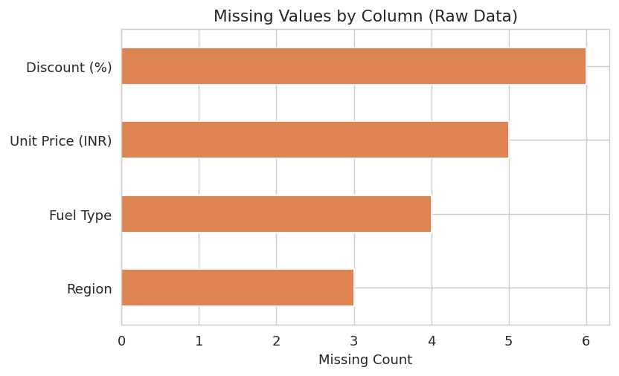

4. Audit Trail (Transparency)
Every action the pipeline takes is logged in order, with a timestamp, so the cleaning process is fully transparent and reproducible — critical for trusting automated data changes:
[16:12:38] Loaded 110 rows x 11 columns
[16:12:38] Removed 1 exact duplicate row(s)
[16:12:38] Standardized text formatting in 'Model' (13 values affected)
[16:12:38] Standardized text formatting in 'Fuel Type' (28 values affected)
[16:12:38] Standardized text formatting in 'Region' (27 values affected)
[16:12:38] Parsed 'Date' into a consistent datetime format
[16:12:38] Removed 6 exact duplicate row(s) ← near-duplicates caught after standardization
[16:12:38] Flagged 2 invalid non-positive value(s) in 'Units Sold' for re-imputation
[16:12:38] Flagged 3 invalid negative value(s) in 'Discount (%)' for re-imputation
[16:12:38] Imputed 2 missing value(s) in 'Units Sold' with median (8.0)
[16:12:38] Imputed 5 missing value(s) in 'Unit Price (INR)' with median (900000.0)
[16:12:38] Imputed 9 missing value(s) in 'Discount (%)' with median (2.0)
[16:12:38] Recomputed 'Revenue (INR)' from source fields (11 rows corrected)

5. Reusability — Why This Is 'Automation', Not a One-Off Script
Because column types are auto-detected rather than hardcoded, the exact same DataCleaningAutomation class can be pointed at a different dataset (e.g. the Stationery Sales dataset used in the earlier segmentation project) by changing only the validity rules — no rewrite of the cleaning logic is needed:
pipeline = DataCleaningAutomation('any_new_file.csv', id_column='ID')
pipeline.run(numeric_validity_rules={...}, formula_cols={...})
pipeline.save_report(output_dir='report/')

This turns a repetitive, error-prone manual task (checking for missing values, hunting duplicates, fixing typos in categories) into a repeatable, auditable, one-line automated workflow — exactly the goal of this project.

6. Expected Outcome
- Understood the full data-preprocessing workflow: profiling, cleaning, validating, and re-profiling.
- Built a genuinely reusable automation tool rather than a single-use script.
- Learned to distinguish structural cleaning (duplicates/text/dates) from content cleaning (missing values/invalid numbers), and why order matters (e.g. re-checking duplicates after text standardization).
- Generated automated visual + written reporting, demonstrating reporting-efficiency gains from automation.

This project demonstrates the complete requested workflow: Python-based automation of data cleaning (missing values, duplicates, inconsistent data) and automated report generation with visual summaries — built as a reusable tool, not a single-use script.

