Mini Project 2
Analysis of the IPL Dataset
Final Report — Data Wrangling, Visual Analysis & Strategic Insights

Dataset: matches.csv & deliveries.csv | IPL Seasons 2008–2017 (10 seasons)
636 matches • 150,460 deliveries • 461 batsmen • 35 venues

By Pratyaksh Kumar (2419922)

1. Project Overview
This report presents the findings of an end-to-end analysis of the Indian Premier League (IPL) dataset, covering match-level records (matches.csv) and ball-by-ball delivery records (deliveries.csv) for ten seasons (2008–2017). The two files were merged on match_id to create a single analytical dataset combining match context (season, venue, toss, result) with granular delivery-level detail (batsman, bowler, runs, dismissals).
The analysis followed a three-part structure:
- Part A — Data Wrangling & Exploration: loading and merging the datasets, treating missing values (e.g. imputing player_of_match, marking missing dismissal_kind as “not out”), and engineering new features such as total_runs, is_boundary, over_phase (Powerplay/Middle/Death), and season year/month.
- Part B — Visual Analysis & Pattern Discovery: exploring toss impact, top run-scorers and dismissal patterns, seasonal scoring trends, venue-based outcomes, and death-over performance using Matplotlib and Seaborn.
- Part C — Storytelling & Final Report: synthesising the above into the key insights and recommendations presented below.
The sections that follow present the executive summary, five key insights (each supported by a visualisation), a concrete strategic recommendation, and a reflection on the dataset's limitations.

2. Executive Summary
The single most important insight from this analysis is that winning the toss and choosing to field first gives a clear, if not universal, edge: across all ten seasons, toss-winning teams that chose to field went on to win 55.7% of matches, compared to 45.6% when choosing to bat first. This advantage is not constant across every season, which suggests it interacts with conditions such as pitch behaviour, dew, and chasing pressure rather than being a fixed rule.
Beyond the toss, three other patterns stand out. First, a small group of batsmen — led by SK Raina, V Kohli and RG Sharma — have combined longevity with consistency to dominate the all-time run charts, but all three are dismissed by catches roughly two-thirds of the time, exposing a shared vulnerability to aggressive field placements. Second, average runs per match have drifted gently upward over the decade (from roughly 309 in 2008 to 318 in 2017), indicating a slow but real shift toward higher-scoring cricket. Third, certain franchises show measurable home-ground dominance — most notably Kolkata Knight Riders at Eden Gardens and Mumbai Indians at Wankhede Stadium, each winning roughly 60% of matches hosted at their home venue.

3. Key Insights

3.1 Fielding first after winning the toss is the statistically better choice
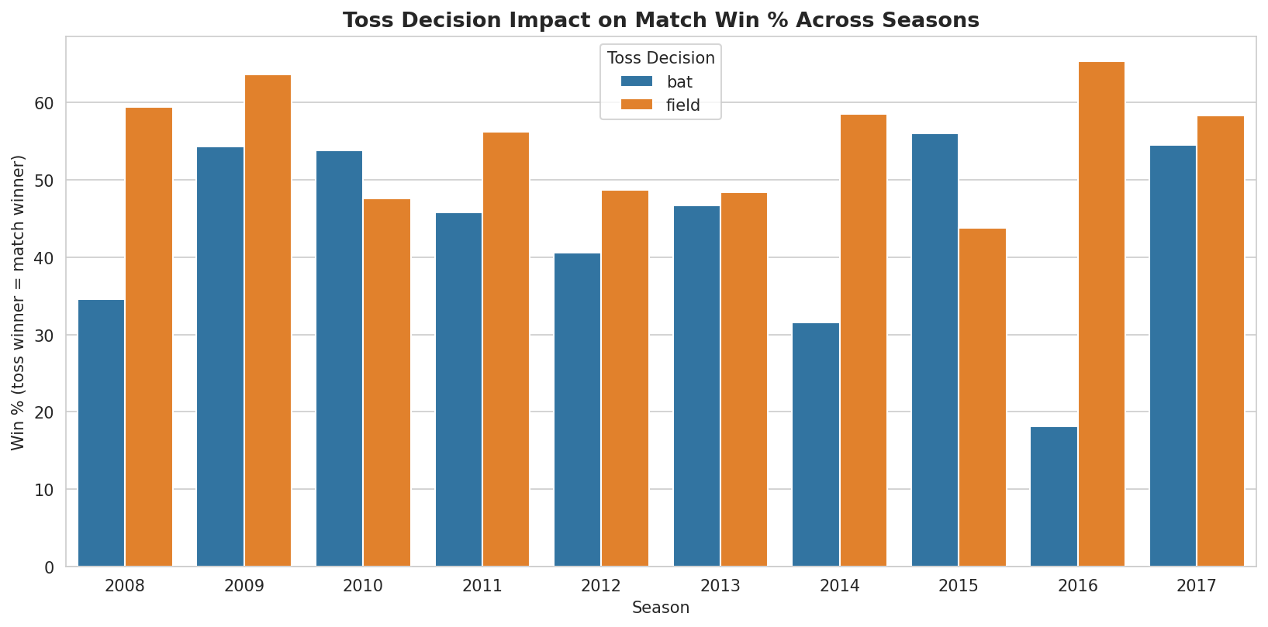
Figure 1: Win percentage of the toss-winning team, split by toss decision, across all ten seasons.
Across the full ten-season dataset, teams that won the toss and chose to field first went on to win the match 55.7% of the time, versus 45.6% for teams that chose to bat first. The advantage shows up in most seasons (2008, 2009, 2011, 2012, 2014, 2016, 2017) but reverses in others (2010, 2013, 2015), where bat-first sides did better. This tells us the toss decision is a meaningful but not deterministic factor — captains should weight it alongside pitch and weather conditions rather than treat it as an automatic choice.

3.2 Elite run-scorers share a common dismissal vulnerability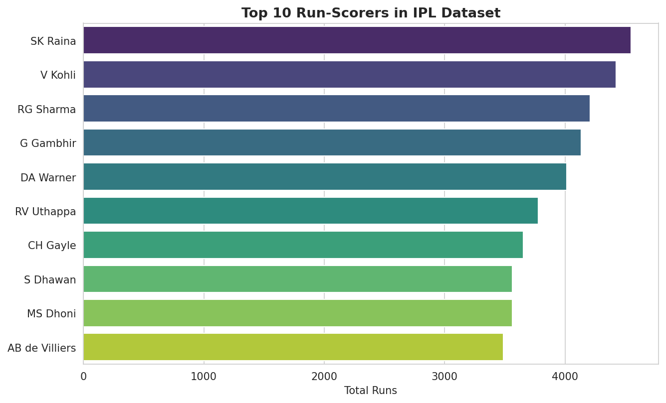
Figure 2: Top 10 batsmen by total runs scored, 2008–2017.
SK Raina (4,548 runs), V Kohli (4,423) and RG Sharma (4,207) lead the all-time run charts in this dataset, each comfortably ahead of the rest of the top ten. Their sustained run-scoring across many seasons points to both class and durability in the format.
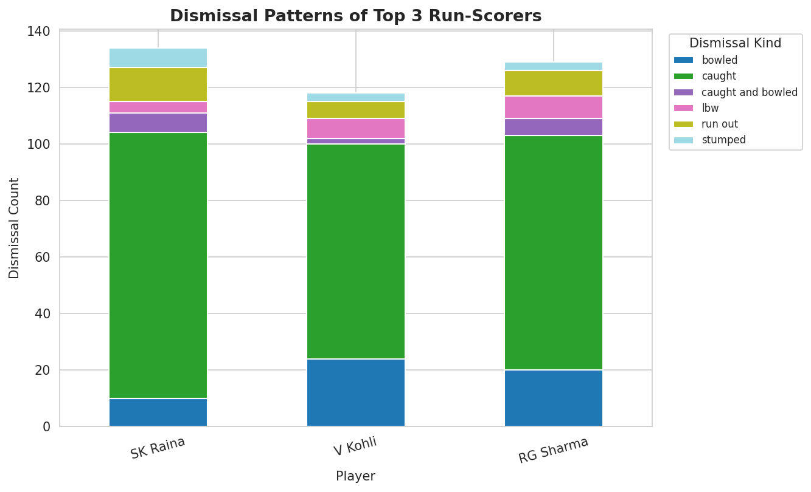
Figure 3: Breakdown of dismissal types for the top 3 run-scorers.
Despite their differing styles, all three are dismissed primarily by catches: 70% of Raina's dismissals, 64% of Kohli's, and 64% of Rohit Sharma's are caught (in the deep or in the infield). Bowled dismissals are the next most common for Kohli and Rohit Sharma, while run-outs feature more for Raina. This consistent pattern suggests that attacking, aerial strokeplay remains the primary risk even for the format's most prolific batsmen — useful intelligence for setting catching fielders and bowling plans against them.

3.3 IPL scoring has trended gently upward over the decade
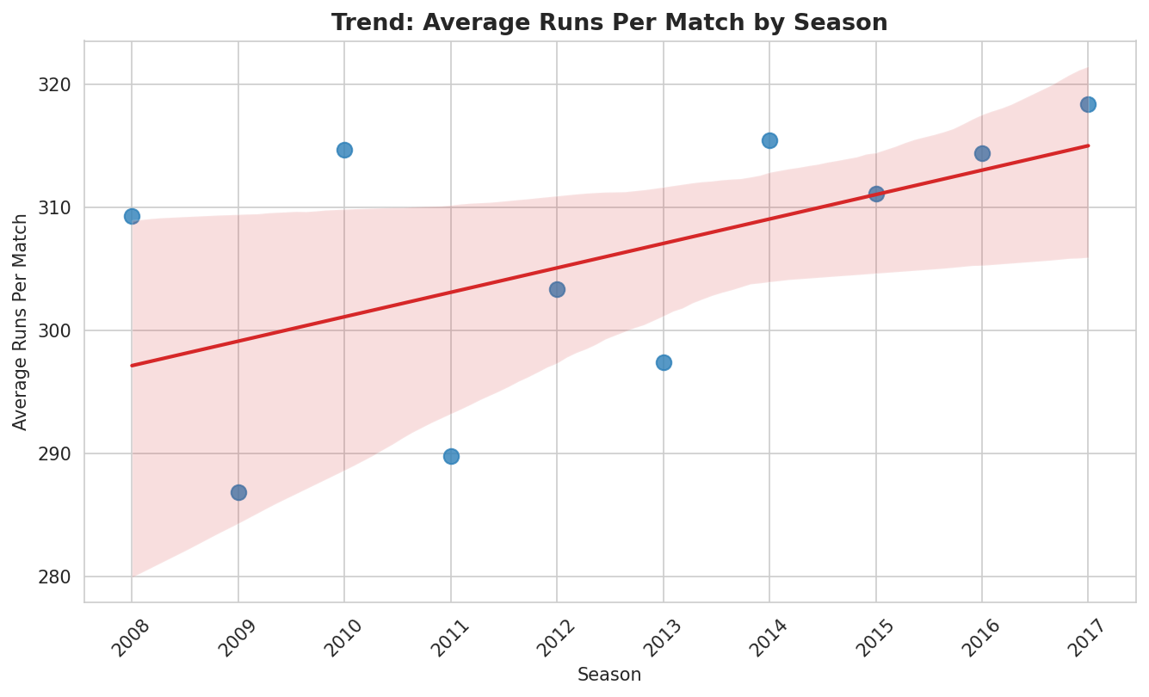
Figure 4: Average total runs per match by season, with a linear regression trend line.
Average runs scored per match ranged from a low of 286.9 in 2009 to a high of 318.4 in 2017. The 2009 dip coincides with that season being relocated to South Africa (due to general elections in India), which likely affected pitch and ground familiarity. Excluding that outlier, the regression line shows a modest but persistent upward drift in scoring — consistent with bats, boundary dimensions, and batting approaches gradually favouring more aggressive scoring through the 2010s.

3.4 Some franchises enjoy a real home-venue advantage
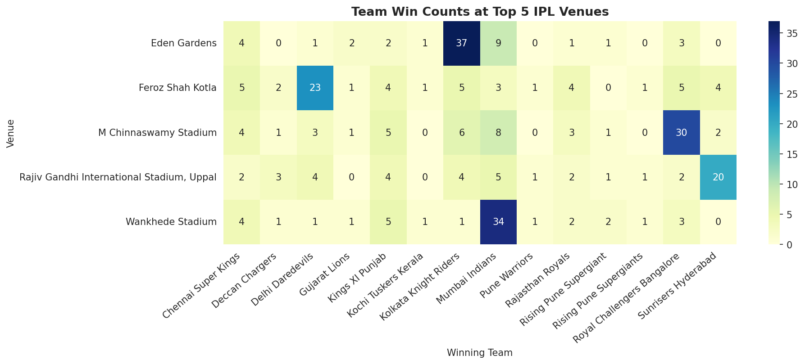
Figure 5: Win counts by team at the five most-used IPL venues.
Among the five most-used venues, Eden Gardens and Wankhede Stadium show the clearest home-ground effect: Kolkata Knight Riders have won roughly 61% of matches played at Eden Gardens (37 of 61), and Mumbai Indians have won roughly 60% of matches at Wankhede Stadium (34 of 57). By contrast, M Chinnaswamy Stadium, Feroz Shah Kotla and the Rajiv Gandhi International Stadium show flatter win distributions across teams, suggesting weaker home-ground effects there. Since the dataset does not explicitly tag a “home team” per venue, this reading is inferred from each venue's most frequent host franchise.

3.5 Death-over scoring separates explosive teams from consistent ones
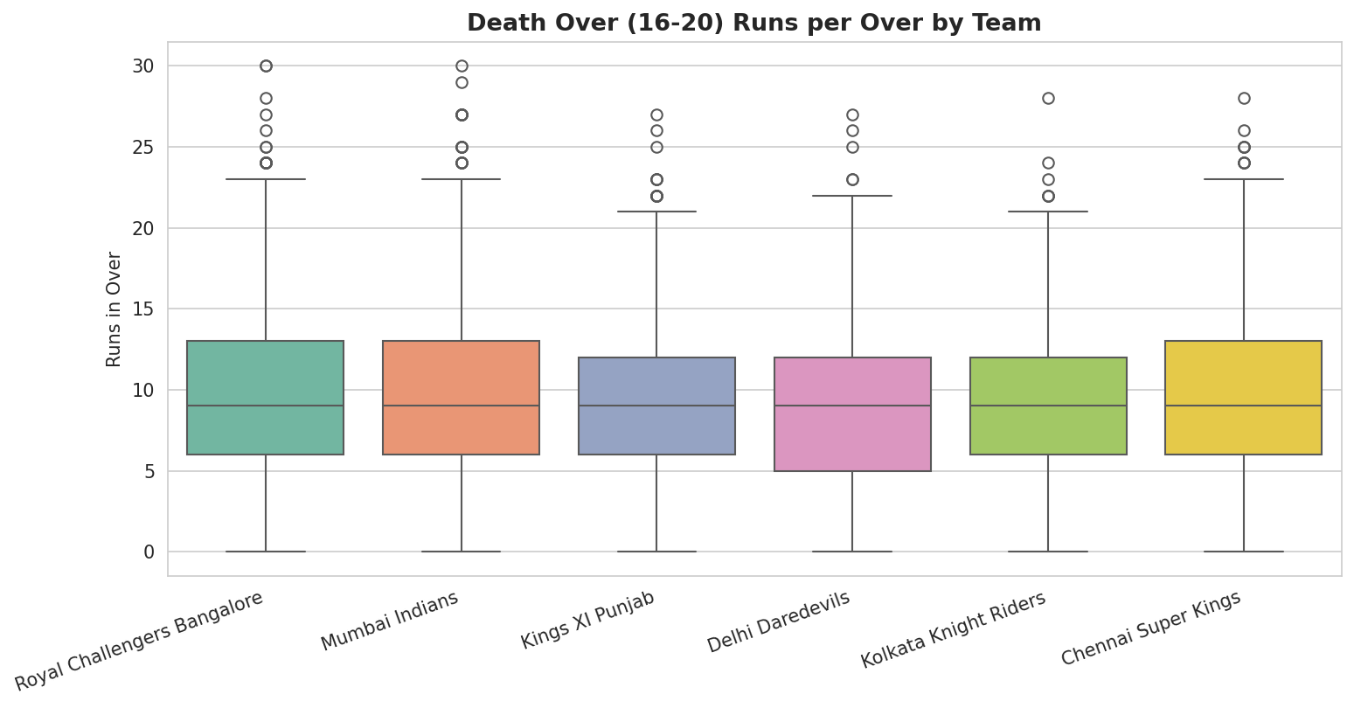
Figure 6: Distribution of runs scored per over during overs 16–20, for the six highest death-over-scoring teams.
Royal Challengers Bangalore post both the highest average (10.24 runs/over) and the highest variability (standard deviation 5.50) in death overs, marking them as the most explosive but least predictable side in the closing stages. Kolkata Knight Riders, by contrast, combine a respectable median with the lowest variability (4.59) of the six teams, making them the most consistent death-over batting unit, even if their ceiling is lower than RCB's. Chennai Super Kings and Mumbai Indians sit in between, with above-average means and moderate variance.

4. Supporting Data Tables
The tables below summarise the underlying aggregations referenced in the insights above and elsewhere in the Part A analysis.

4.1 Top 5 Run-Scorers (all seasons)
Rank | Batsman | Total Runs
1 | SK Raina | 4,548
2 | V Kohli | 4,423
3 | RG Sharma | 4,207
4 | G Gambhir | 4,132
5 | DA Warner | 4,014

4.2 Most Economical Bowlers (minimum 500 balls bowled)
Rank | Bowler | Economy Rate | Balls Bowled
1 | SP Narine | 6.34 | 1,931
2 | R Ashwin | 6.55 | 2,290
3 | A Kumble | 6.58 | 965
4 | M Muralitharan | 6.70 | 1,528
5 | DW Steyn | 6.75 | 2,064
Economy rate was computed as runs conceded per over bowled (excluding byes, leg-byes and penalty runs from the bowler's tally, and excluding wide/no-ball deliveries from the legal-ball count), restricted to bowlers with at least 500 legal balls (≈83+ overs) to ensure a stable sample.

4.3 Team with the Highest Win Percentage, by Season
Season | Top Team | Wins | Matches | Win %
2008 | Rajasthan Royals | 13 | 16 | 81.2%
2009 | Delhi Daredevils | 10 | 15 | 66.7%
2010 | Mumbai Indians | 11 | 16 | 68.8%
2011 | Chennai Super Kings | 11 | 16 | 68.8%
2012 | Kolkata Knight Riders | 12 | 17 | 70.6%
2013 | Mumbai Indians | 13 | 19 | 68.4%
2014 | Kings XI Punjab | 12 | 17 | 70.6%
2015 | Mumbai Indians | 10 | 16 | 62.5%
2016 | Sunrisers Hyderabad | 11 | 17 | 64.7%
2017 | Mumbai Indians | 12 | 17 | 70.6%
Mumbai Indians appear as the top regular-season performer in four of the ten seasons (2010, 2013, 2015, 2017) — more than any other franchise — reflecting sustained competitiveness rather than a single standout year.

5. Recommendation for Team Strategy
Based on the toss-impact finding (Section 3.1), the single most concrete, data-backed recommendation for a team captain or coach is:
Default to fielding first when winning the toss, unless there is a specific, known reason to bat first (e.g. forecast dew that will aid a chasing side even more, or a pitch historically known to deteriorate for batting).
Because the field-first advantage (55.7% vs. 45.6%) is consistent in most — but not all — seasons, this should be treated as a strong default rather than a rigid rule. Teams should pair it with venue-specific homework: at grounds like Eden Gardens and Wankhede Stadium (Section 3.4), the home side's own historical dominance may outweigh generic toss-based logic, and the chasing/fielding-first instinct should be reinforced rather than overridden. Captains should also factor in their own batting depth for chasing — sides with reliable finishers benefit more from setting up a target via bowling first than sides that rely on a settled, long batting innings.

6. Self-Reflection
The clearest limitation of this dataset is its temporal scope: it only covers ten seasons (2008–2017), so none of the trends identified — particularly the seasonal scoring trend in Section 3.3 — can be extended to the present day, where bat technology, boundary sizes, and franchise rosters have continued to evolve. A second limitation is the absence of contextual variables that strongly influence outcomes: there is no pitch report, weather/dew data, or explicit “home team” flag per venue, which forced the venue analysis in Section 3.4 to infer home advantage indirectly from each venue's most frequent host.
Additional data that would have enabled deeper analysis includes: (1) ball-by-ball required run-rate and match-state data, to study pressure situations rather than raw death-over aggregates; (2) player roles and batting/bowling order, to separate top-order accumulation from lower-order hitting; (3) injury and player-availability records, which often explain unexpected dips in team or player performance within a season; and (4) more recent seasons' data, to test whether the toss and scoring trends identified here have persisted, strengthened, or reversed in the years since 2017.

