Table of Contents
Abstract 2
1. Introduction 3
2. Problem Statement 3
3. Objectives 4
4. Scope of the Project 4
4.1 Application Scope 4
4.2 DevOps Scope 4
4.3 Limitations of Scope 5
5. System Architecture 5
5.1 Components: 5
5.2 Working flow: 5
6. Technologies Used 5
7. Methodology 6
7.1 Application Development 6
7.2 Containerization 6
7.3 Kubernetes Deployment 6
7.4 Monitoring Setup (Prometheus) 6
7.5 Visualization (Grafana) 6
7.6 Custom Metrics 7
8. Kubernetes Implementation 7
8.1 Connectify Deployment 7
8.2 Connectify Service 8
8.3 MongoDB Deployment 8
8.4 MongoDB Service 9
9. Monitoring with Prometheus 9
10. Custom Metrics (prom-client) 10
11. Visualization with Grafana 11
12. Result and Discussion 12
13. Advantages and Limitations 12
Advantages 12
Limitations 13
14. Future Scope 13
15. Conclusion 13
16. Reference 14

Abstract
This report documents the development and DevOps-enhanced deployment of Connectify, a real-time chat application built with Node.js, Express.js, Socket.io, and MongoDB. The application is containerized using Docker, deployed on a Kubernetes cluster (Minikube) with separate pods for the app and database, and monitored using Prometheus and Grafana installed via Helm. Custom application metrics — http_requests_total, user_registrations_total, and messages_sent_total — are exposed via a /metrics endpoint using prom-client and visualized on Grafana dashboards alongside system-level CPU and memory metrics. The project demonstrates a complete DevOps lifecycle from code to container to cluster to observability.

Introduction
In the current era of software development, applications are expected to be highly scalable, reliable, and efficient. Traditional deployment methods often involve manual configuration, limited scalability, and lack of proper monitoring, which makes managing applications difficult. To overcome these challenges, modern DevOps practices utilize containerization, orchestration, and monitoring tools.
This project focuses on the deployment and monitoring of a real-time chat application named Connectify. The application is developed using Node.js and uses MongoDB as its database. To ensure portability and consistency, the application is containerized using Docker. Kubernetes is used as the container orchestration platform to manage deployments, scaling, and recovery of containers.
Monitoring plays a crucial role in ensuring application performance and reliability. In this project, Prometheus is used to collect metrics from the application and Kubernetes cluster, while Grafana is used to visualize these metrics through dashboards.
The project demonstrates how modern DevOps tools can be integrated to build a scalable, efficient, and monitored application system.

Problem Statement
Traditional application deployment systems suffer from multiple limitations:
- Applications are tightly coupled with the host system
- Lack of scalability and load balancing
- Difficult to monitor performance and detect issues
- Manual deployment increases chances of human error
- Limited fault tolerance and recovery mechanisms
There is a need for a system that can:
- Automate deployment
- Ensure scalability and reliability
- Provide real-time monitoring and visualization
This project addresses these issues by implementing a containerized and monitored application deployment using Kubernetes, Prometheus, and Grafana.

Objectives
The objectives of this project are carefully designed to achieve both functional and operational goals. They are outlined as follows:

- To design and develop a fully functional real-time chat application named Connectify using Node.js, Express.js, Socket.io, and MongoDB, supporting user registration, authentication, messaging, and online/offline presence.
- To containerize the Connectify application using Docker, ensuring that the application and its dependencies are packaged into a portable, consistent, and reproducible Docker image.
- To deploy the containerized application on a local Kubernetes cluster using Minikube, demonstrating the creation and management of Kubernetes Deployments, Services, and Pods.
- To deploy MongoDB as a separate containerized service within the Kubernetes cluster and establish reliable inter-service communication using Kubernetes internal DNS.
- To install and configure Prometheus using Helm, and configure it to scrape application metrics from the Connectify service's /metrics endpoint.
- To integrate the prom-client library into the Node.js application and define custom metrics including http_requests_total, user_registrations_total, and messages_sent_total.
- To install and configure Grafana using Helm, connect it to Prometheus as a data source, and build dashboards that visualize both system-level and application-level metrics.
- To document the entire implementation in a structured academic report that can serve as a reference for future projects combining full-stack development with DevOps engineering.

Scope of the Project
The scope of this project encompasses the full lifecycle of a web application — from development and containerization to orchestrated deployment and live monitoring. The following dimensions define the scope:

4.1 Application Scope
The Connectify application covers the core features of a real-time chat system. These include user registration with hashed password storage, session-based or token-based login, real-time bidirectional messaging between users using WebSocket technology, persistent storage of messages and user data in MongoDB, and dynamic display of online/offline user status. The application does not include group chat, file sharing, or mobile-native clients within the scope of this project.

4.2 DevOps Scope
On the DevOps side, the project covers the entire container lifecycle. Docker is used to build the application image from a Dockerfile. Kubernetes (via Minikube) is used for local cluster management. YAML manifests define the desired state of Deployments and Services for both the application and database. Helm is used as the Kubernetes package manager to install Prometheus and Grafana. The monitoring scope includes infrastructure metrics (CPU, memory) and custom application metrics (HTTP requests, user registrations, messages sent).

4.3 Limitations of Scope
This project is implemented in a local development environment using Minikube. It does not cover cloud-based Kubernetes deployments (such as GKE, EKS, or AKS), CI/CD pipeline integration, or multi-node cluster configurations. Alerting rules and notification channels in Prometheus Alertmanager are also outside the scope of this project. These aspects represent natural extensions for future work.

System Architecture
The system architecture consists of multiple components working together:

5.1 Components:
- User Interface (Browser)
- Kubernetes Cluster
- Connectify Application Pods
- MongoDB Database Pod
- Prometheus Monitoring System
- Grafana Dashboard System

5.2 Working flow:
- The user accesses the application via browser
- Requests are routed through Kubernetes Service
- Requests are handled by Connectify application pods
- Application interacts with MongoDB for data storage
- Prometheus collects metrics from the application
- Grafana visualizes these metrics

Technologies Used
Node.js + Express.js | Backend runtime and HTTP framework for REST APIs and static file serving.
Socket.io | Real-time bidirectional WebSocket communication between server and clients.
MongoDB + Mongoose | NoSQL document database for persisting users and messages; Mongoose as ODM.
Docker | Packages the application and its dependencies into a portable container image.
Kubernetes (Minikube) | Orchestrates containerized workloads; manages pods, services, and deployments.
Helm | Kubernetes package manager used to install Prometheus and Grafana charts.
Prometheus | Pull-based metrics collection; scrapes /metrics every 15 seconds.
Grafana | Visualization platform; queries Prometheus via PromQL to render dashboards.
prom-client | Node.js library for defining and exposing Prometheus metrics.

Methodology
The methodology of this project describes the step-by-step process followed to develop, deploy, and monitor the Connectify chat application using DevOps practices.

Application Development
The Connectify application was developed using Node.js and Express.js. It provides features such as user registration, login, and real-time messaging.
Real-time communication was implemented using Socket.io, allowing instant message exchange between users. MongoDB was used as the database to store user data and chat messages.

Containerization
The application was containerized using Docker to ensure portability and consistency. A Dockerfile was created to define the application environment, including dependencies, source code, and execution commands.
This allows the application to run uniformly across different environments without configuration issues.

Kubernetes Deployment
Kubernetes was used to deploy and manage the application. YAML configuration files were created for:
- Application Deployment
- Application Service (NodePort)
- MongoDB Deployment
- MongoDB Service
The application and database were deployed as separate pods. Kubernetes services enabled communication between them using internal DNS (e.g., mongodb-service). The application was exposed externally using a NodePort service.

Monitoring Setup (Prometheus)
Prometheus was used for monitoring system and application performance. It was installed using Helm and configured to collect metrics from the application.
A /metrics endpoint was added to the Node.js application using the prom-client library. Prometheus scrapes this endpoint to collect data such as CPU usage, memory usage, and application metrics.

Visualization (Grafana)
Grafana was used to visualize the metrics collected by Prometheus. It was connected to Prometheus as a data source and used to create dashboards.
The dashboards display system-level metrics such as CPU and memory usage, as well as application-level metrics, enabling real-time performance monitoring.

Custom Metrics
Custom metrics were implemented using the prom-client library to track application-specific data such as:
- Total HTTP requests
- Number of user registrations
- Number of messages sent
These metrics provide insights into application usage and were visualized in Grafana dashboards.

Kubernetes Implementation
Kubernetes manages workloads through declarative YAML manifests. A Deployment defines the desired number of pod replicas and replaces failed pods automatically. A Service provides a stable DNS name and virtual IP for accessing pods. ClusterIP is used for internal services (MongoDB) and NodePort for external access (Connectify).

Connectify Deployment
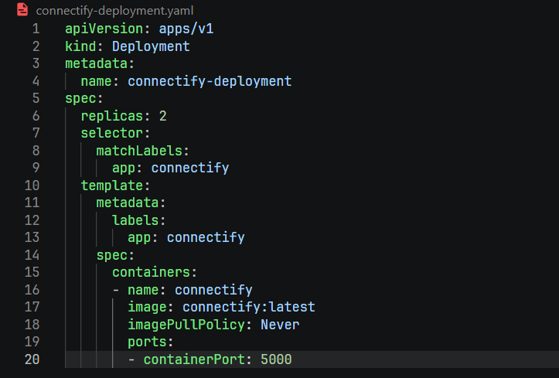
imagePullPolicy: Never uses the locally built Docker image within Minikube. MONGO_URI connects to MongoDB using its Kubernetes Service DNS name.

Connectify Service
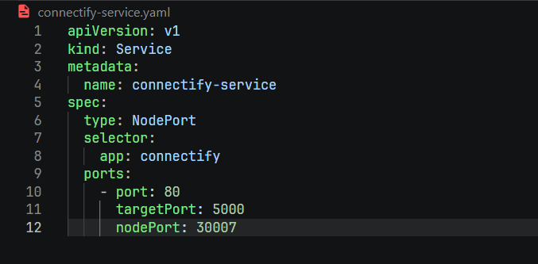

Traffic on Minikube node port 30007 routes to port 5000 on the application pod. The app is accessible at http://<minikube-ip>:30007.

MongoDB Deployment
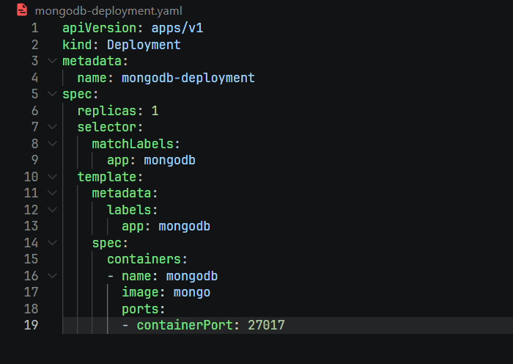

MongoDB Service
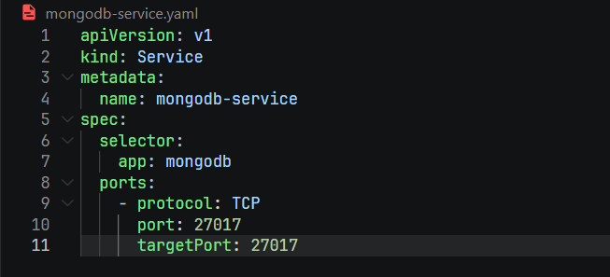
The ClusterIP Service keeps MongoDB accessible only within the cluster. Kubernetes DNS resolves mongodb-service to the pod automatically, so the application never needs a hardcoded IP address.

Monitoring with Prometheus
Prometheus is an open-source time-series monitoring system that collects metrics by scraping HTTP endpoints at regular intervals. It was installed using the kube-prometheus-stack Helm chart, which also deploys Alertmanager and cAdvisor exporters. The following scrape job was configured to collect metrics from the Connectify application:

scrape_configs:
- job_name: 'connectify'
static_configs:
- targets: ['connectify-service:80']

Prometheus resolves connectify-service via Kubernetes DNS and sends a GET request to /metrics every 15 seconds. The Prometheus targets page shows the connectify job as UP when scraping succeeds. All collected metrics are stored as time-series data and queryable via PromQL.

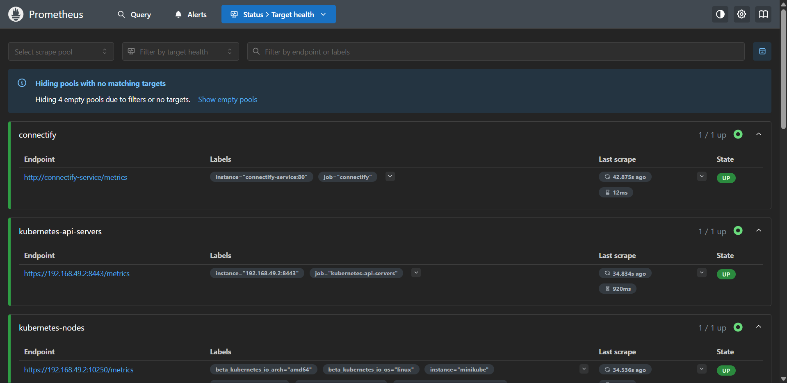

Custom Metrics (prom-client)
The prom-client library instruments the Node.js application to expose three custom Counter metrics and default process metrics (heap size, event loop lag, CPU time). Counters are cumulative values that only increase — ideal for tracking events like requests, registrations, and messages.
const client = require('prom-client');
client.collectDefaultMetrics();
// Increment on every HTTP request
app.use((req, res, next) => {
res.on('finish', () => {
httpRequestsTotal.inc({ method: req.method,
route: req.path, status_code: res.statusCode });
});
next();
});

// Expose metrics endpoint for Prometheus
app.get('/metrics', async (req, res) => {
res.set('Content-Type', client.register.contentType);
res.end(await client.register.metrics());
});

Visualization with Grafana
Grafana is deployed via Helm and accessed through port-forwarding. Prometheus is added as a data source using its internal cluster URL. Two dashboards are configured:
System Metrics Dashboard: Visualizes CPU usage rate (rate(node_cpu_seconds_total{mode!='idle'}[5m])), container memory per pod (container_memory_usage_bytes), and network I/O. These metrics are collected automatically by cluster exporters.
Application Metrics Dashboard: Visualizes HTTP request rate (rate(http_requests_total[5m])), total registrations (user_registrations_total), and total messages sent (messages_sent_total). These require deliberate instrumentation and reveal actual user behaviour.
System metrics show how resources are consumed; application metrics show what the application is doing. Both are required for complete observability — one without the other leaves significant blind spots in production monitoring.

Event Loop:
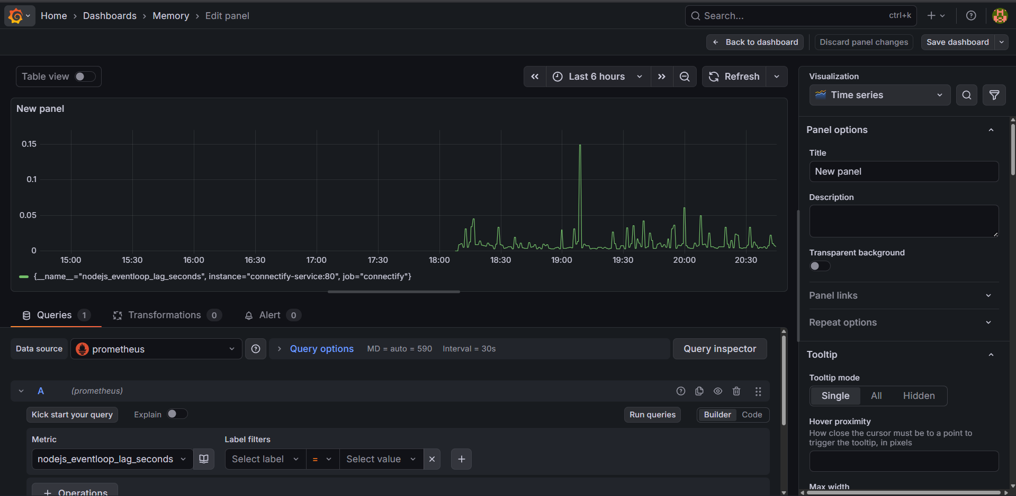
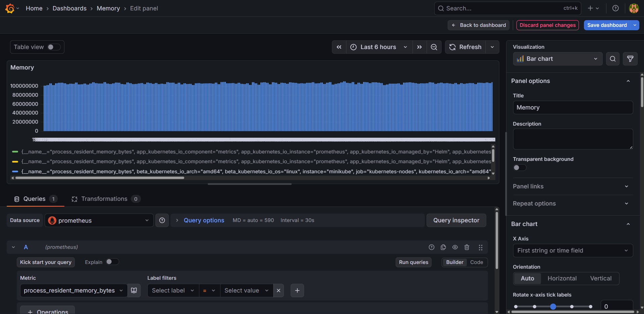
Memory:

CPU:

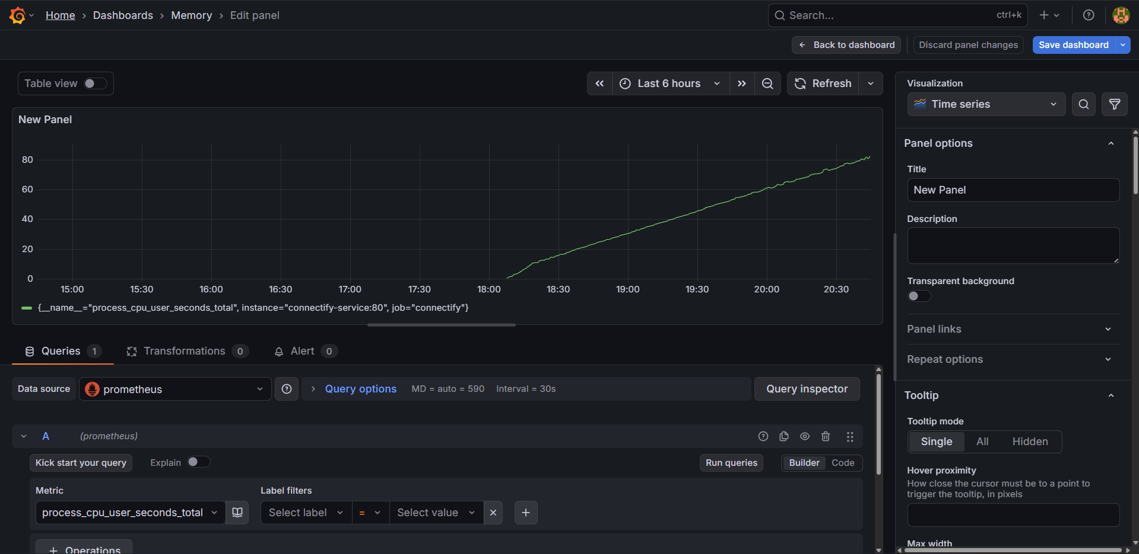

Result and Discussion
All project components were successfully implemented and verified. The Connectify application passed full functional testing — registration, login, real-time messaging, and online status all worked correctly. Messages persisted in MongoDB across page refreshes.
Kubernetes workloads reached Running state. Manually deleting the app pod confirmed self-healing — a replacement pod was scheduled within seconds. The NodePort Service correctly routed browser traffic to the application container.
Prometheus showed the connectify scrape target as UP. All three custom counters incremented correctly with each user action and were visible in the PromQL expression browser. Grafana dashboards rendered live data: CPU and memory panels showed stable resource usage, while app metric panels showed step-function increases in registrations and a steadily rising message count during testing.
The main challenge was Minikube's isolated Docker daemon. This was resolved by running eval $(minikube docker-env) before building the image, making the local image available inside the cluster.

Advantages and Limitations

Advantages
- Environment Consistency: Docker eliminates 'works on my machine' issues across all environments.
- Scalability: Kubernetes scales replicas with a single command; the Service load-balances automatically.
- Self-Healing: Failed pods are automatically replaced by the Deployment controller.
- Full Observability: System and application metrics together provide complete visibility into infrastructure and user behaviour.
- Infrastructure as Code: All configuration is in YAML — reproducible, reviewable, and version-controlled.

Limitations
- Local Minikube environment — not a multi-node production cluster.
- No PersistentVolumeClaim for MongoDB — data is lost on pod restart.
- No TLS/HTTPS — traffic is unencrypted.
- No Prometheus alerting rules or Alertmanager notification channels configured.

Future Scope
- Cloud Deployment: Migrate to GKE, EKS, or AKS for real-world multi-node cluster management.
- CI/CD Pipeline: Automate build, test, and rolling deployment on every Git commit using GitHub Actions.
- Persistent Storage: Add PersistentVolumes for MongoDB to preserve data across pod restarts.
- Prometheus Alerting: Define alert rules for pod failures and resource thresholds with Slack/email notifications.
- Group Chat & Media: Add room-based group chats, file sharing, and read receipts to enrich the application.
- Distributed Tracing: Integrate OpenTelemetry and Jaeger for request-level performance profiling.

Conclusion
This project demonstrates the full lifecycle of a modern web application — from development to containerized deployment to live monitoring. Connectify was built with a standard Node.js stack, containerized with Docker, orchestrated on Kubernetes, and made observable through Prometheus and Grafana.
The Kubernetes manifests define a clean, reproducible infrastructure where the application and database run as isolated, managed workloads with DNS-based connectivity. Custom prom-client metrics expose meaningful application-level signals beyond what system monitoring can provide, and Grafana dashboards make these signals actionable in real time.
The project achieves all stated objectives and provides a practical, fully documented reference for deploying cloud-native applications using open-source DevOps tools. The skills applied — containerization, orchestration, and observability — are directly relevant to professional software engineering and represent the end-to-end thinking required of modern developers.

Reference
- Burns, B. et al. (2016). Borg, Omega, and Kubernetes. ACM Queue, 14(1).
- Merkel, D. (2014). Docker: Lightweight Linux containers. Linux Journal, 239.
- Fette, I. & Melnikov, A. (2011). The WebSocket Protocol. RFC 6455. IETF.
- Tilkov, S. & Vinoski, S. (2010). Node.js: High-performance network programs. IEEE Internet Computing, 14(6).
- Richter, B. (2018). Monitoring with Prometheus. Leanpub.
- Prometheus Authors. (2023). Prometheus Documentation. https://prometheus.io/docs
- Grafana Labs. (2023). Grafana Documentation. https://grafana.com/docs
- Helm Authors. (2023). Helm Documentation. https://helm.sh/docs
- Kubernetes Authors. (2023). Kubernetes Documentation. https://kubernetes.io/docs
- prom-client. (2023). Prometheus client for Node.js. https://github.com/siimon/prom-client
- Chodorow, K. (2013). MongoDB: The Definitive Guide. O'Reilly Media.
- Socket.io Authors. (2023). Socket.io Documentation. https://socket.io/docs/v4

