
Weekly Savings Tracker
Mini Project Report
Submitted by: Pratyush Kumar Rout
Reg no: 25BCE11240
Under the guidance of:
Shri Moses Dian

- Problem Statement
Most People struggle to keep track of their weekly expenses and savings, Although they set goals but by building a dedicated Python program for the people we will not only help them but also optimize them to reach their goal quickly, Our Program keeps track of their starting money, savings goal, expenditure or income and create a graph showing financial activity and how far off they are being to achieving their goals or how successful they were in achieving their goal.
- Objectives
To help user monitor their weekly financial activity and how well has user met their savings target. The system aims to make the user more financially responsible so that they are able to take financially sound decisions and be vigilant of thrift shopping.
- Working and Explanation
Weekly savings tracker uses matplotlib , numpy and various other modules to visually demonstrate how user are taking their financial decisions. This program has the scalability factor because if scaled properly it can also aid people understand their financial activity through graphical way further helping people make sound financial decisions.
- Full source code
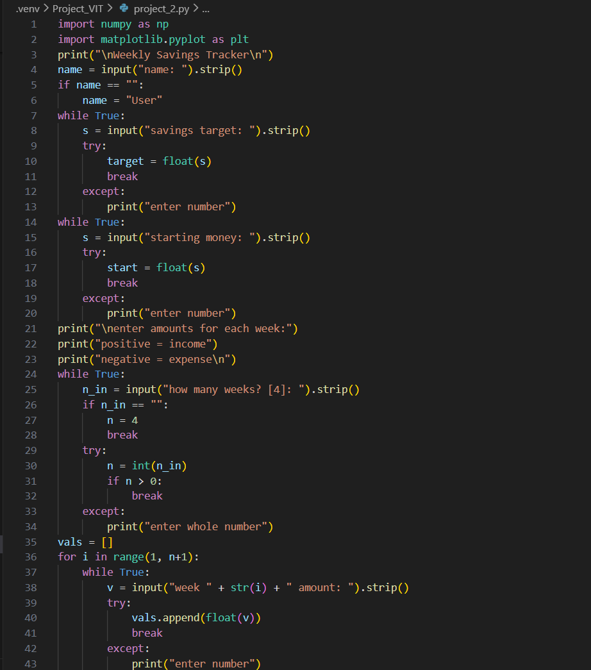
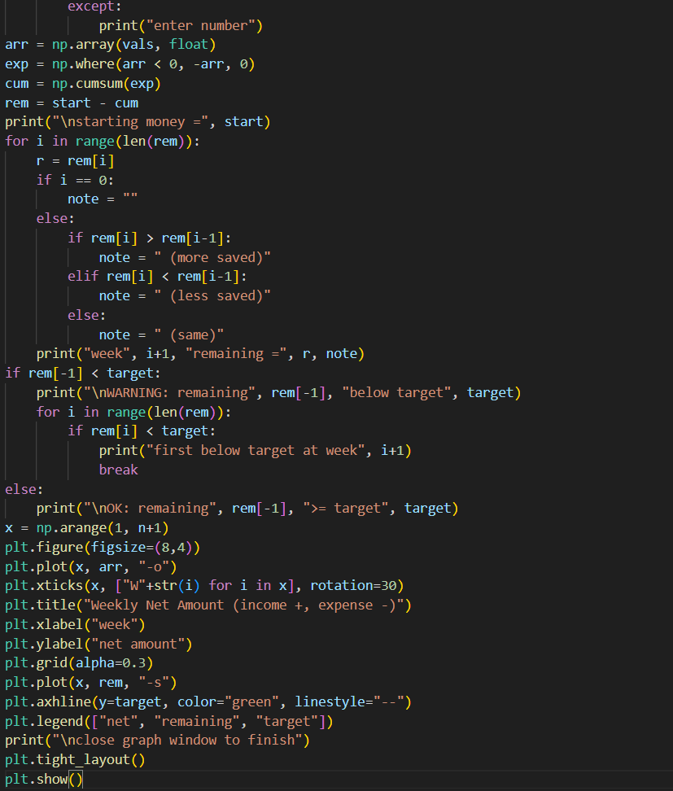
5. Conclusion
The weekly Savings Tracker successfully shows how python can be used to store, build a simple and practical financial monitoring tools they will give out graphs that can elevate the financial awareness and it has found in various educational reports that graphical method helps Brain understand abstract concepts in a better way.
- References
- Python Software Foundation. Python Documentation. Available at: https://www.python.org/doc/
- NumPy Developers. NumPy User Guide and Reference. Available at: https://numpy.org/doc/
- Matplotlib Developers. Matplotlib Documentation. Available at: https://matplotlib.org/stable/
- W3Schools. Python Tutorial. Available at: https://www.w3schools.com/python/, Discussion of matplotlib
- GeeksforGeeks. Python Programming Basics and Examples. Available at: https://www.geeksforgeeks.org/python-programming-language/
- Stack Overflow. Community Discussions on Python Input, Loops, and Lists. Available at: https://stackoverflow.com

