**MICRONCONTROLLERS AND ITS APPLICATIONS LAB**

## NAME: Pratyush Raj

## REG.N0: 20BEC1273

## DATE: 03-01-2022

**EXP– 1 Introduction to Keil IDE**

**LAB TASK 1**

**AIM:**

To write an 8051 asm program to perform

* Move operation between A and data.
* Move operation between Rn and data.
* Move operation between A and Rn

**SOFTWARE USED:**

Keil μvision 4 software

**PROGRAM:**

ORG 0000h

MOV A, #55H ;load 55 into A

MOV R0, #0D3H ;load D3 into R0

MOV A, R0 ;LOAD R0 VALUE TO A

MOV R1, A ;LOAD A TO R1 END

**OUTPUT: Screenshot taken from keil software**

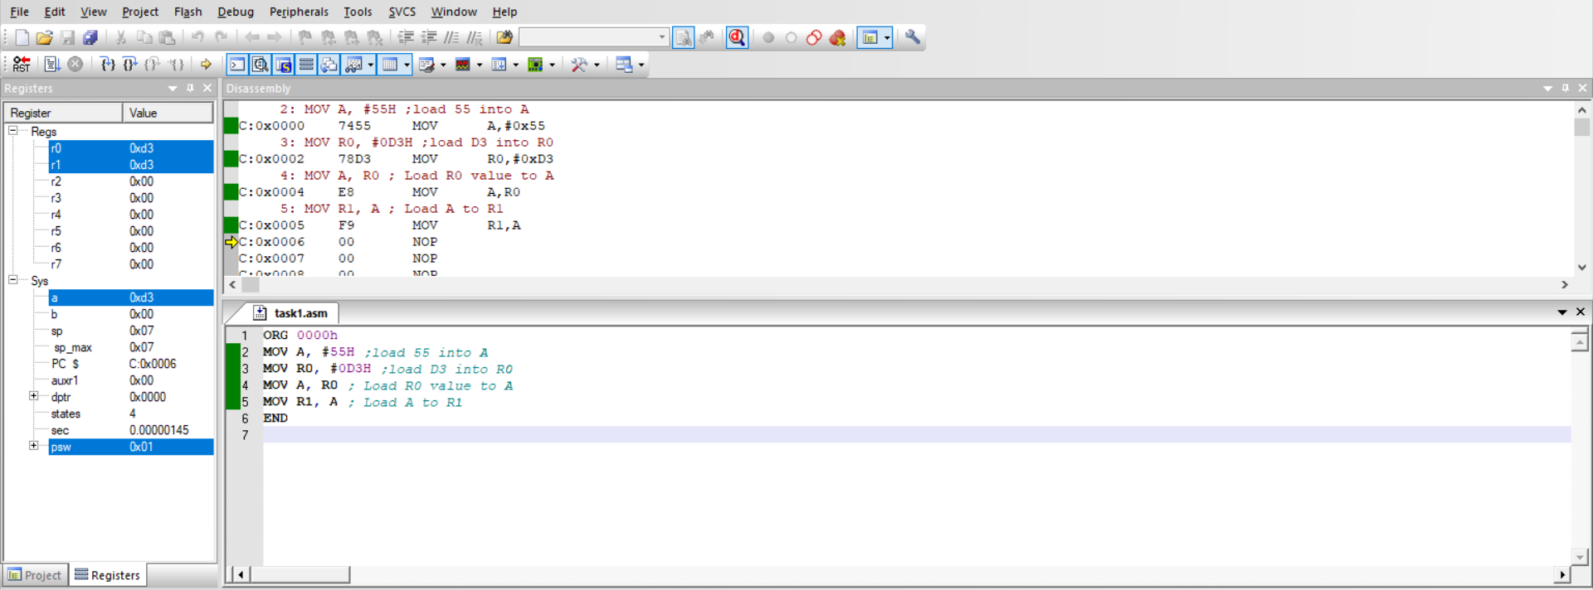

**RESULT:**

We have loaded a value into A register and another value into R0 register and replaced the A register value with R0 register value and loaded the R1 register with the R0 register value.

**---------------------------------------------------------------------------------------------------------**

**LAB TASK 2**

**AIM:**

To write a 8051 asm program to perform

* Move operation between direct address and data.
* Move operation between A and direct address.
* Move operation between Rn and direct address.

**SOFTWARE USED:**

Keil μvision 4 software

**PROGRAM:**

ORG 0000h

MOV 55H, #0AAH ;Move AHH to address location 55H

MOV A, 55H ;Move address location value 55H to A

MOV 33H, A ;Move A to address location 33H

MOV R0, 33H ;Move address location 33H value to R0

MOV 44H, R0 ;Move R0 value to address location 44H

END

**OUTPUT: Screenshot taken from keil software**

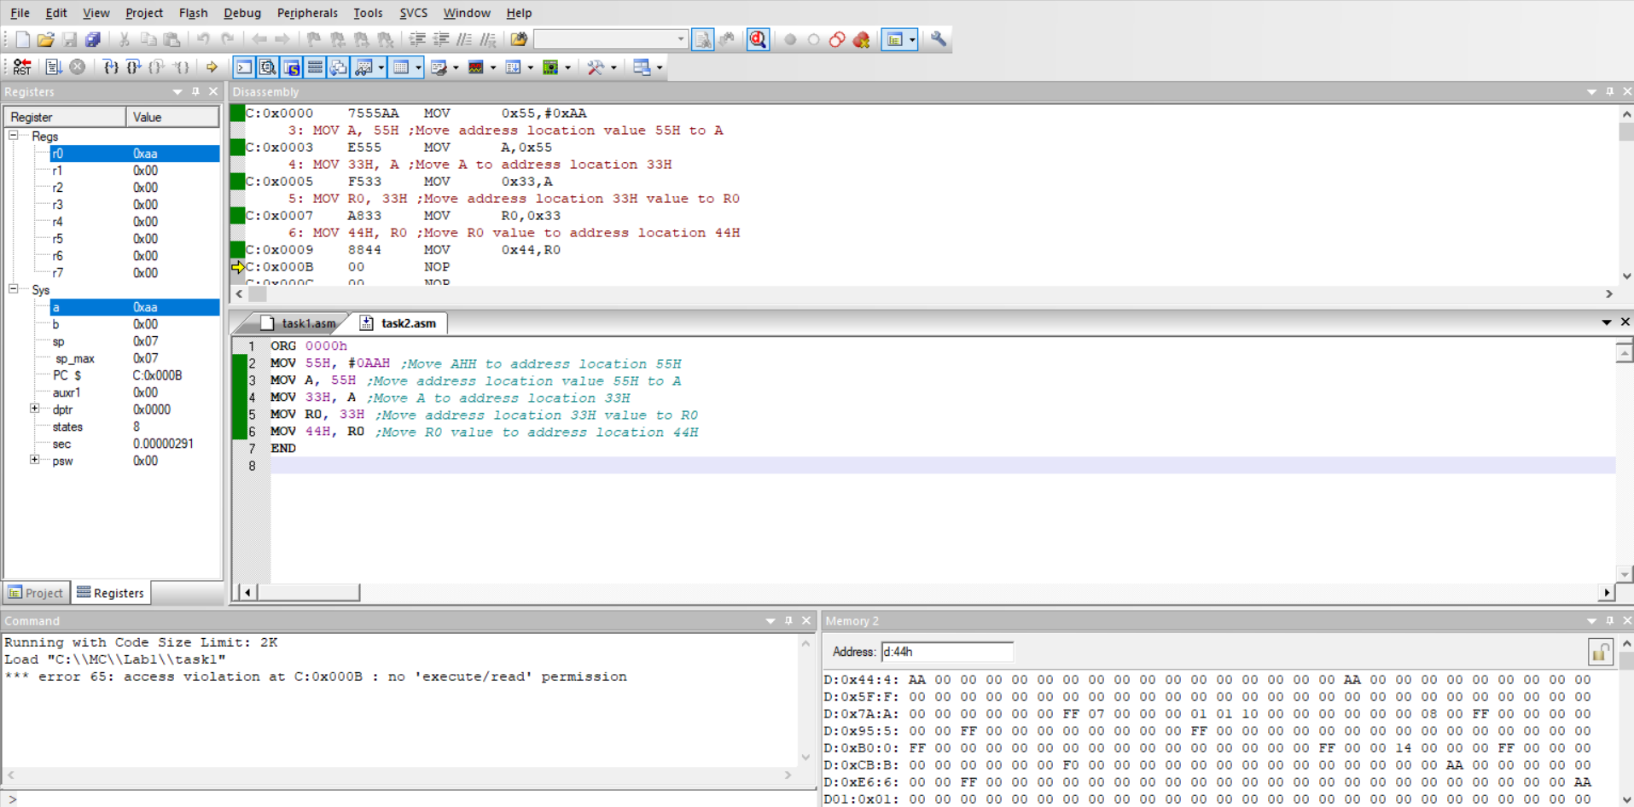

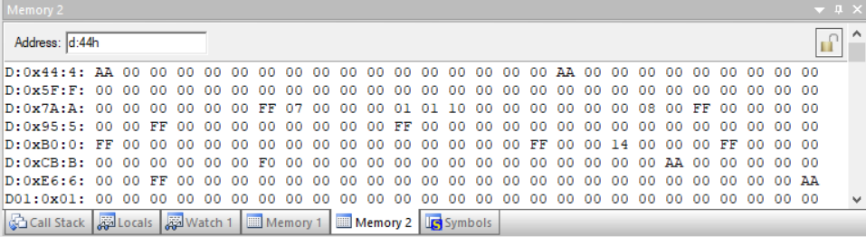

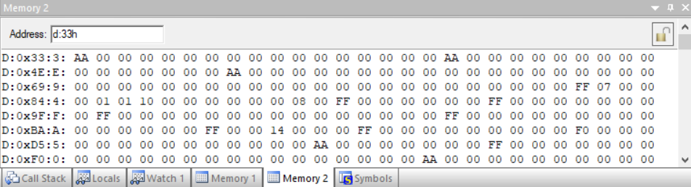

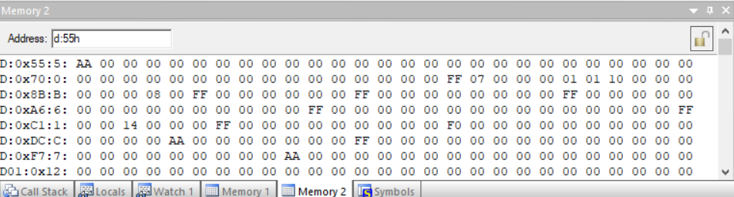

**Result :**

We have performed move operation between direct address and data, move operation between A and direct address and move operation between Rn and direct address.

**---------------------------------------------------------------------------------**