**MICRONCONTROLLERS AND ITS APPLICATIONS LAB**

## NAME: Pratyush Raj

## REG.N0: 20BEC1273

## DATE: 22-04-2022

**EXP– 10: LCD Interfacing 8051**

**LAB TASK 1**

**AIM:**

Write a 8051 asm program to

–Write an 8051 assembly language program to display the message VIT on LCD display.

–Write an 8051 assembly language program to display the message “VIT University” on LCD display using DPTR.

**SOFTWARE USED:**

Keil µVision5Task-1:

**PROGRAM:**

ORG 0000H MOV A, #38H

ACALL COMNWRT

ACALL DELAY

MOV A, #0FH

ACALL COMNWRT

ACALL DELAY

MOV A, #01

ACALL COMNWRT

ACALL DELAY

MOV A, #06H

ACALL COMNWRT

ACALL DELAY

MOV A, #84H

ACALL COMNWRT

ACALL DELAY

MOV A,#'V'

ACALL DATAWRT

ACALL DELAY

MOV A,#'I'

ACALL DATAWRT

ACALL DELAY

MOV A,#'T'

ACALL DATAWRT ACALL DELAY

AGAIN: SJMP AGAIN COMNWRT: MOV P2,A

CLR P3.7

CLR P3.6

SETB P3.5

ACALL DELAY

CLR P3.5

RET DATAWRT:

MOV P2,A

CLR P3.7

CLR P3.6

SETB P3.5

ACALL DELAY

CLR P3.5

RET

DELAY: MOV R3,#50

HERE2: MOV R4,#255

HERE: DJNZ R4,HERE

DJNZ R3,HERE2

RET

END

**OUTPUT: Taken from lab**

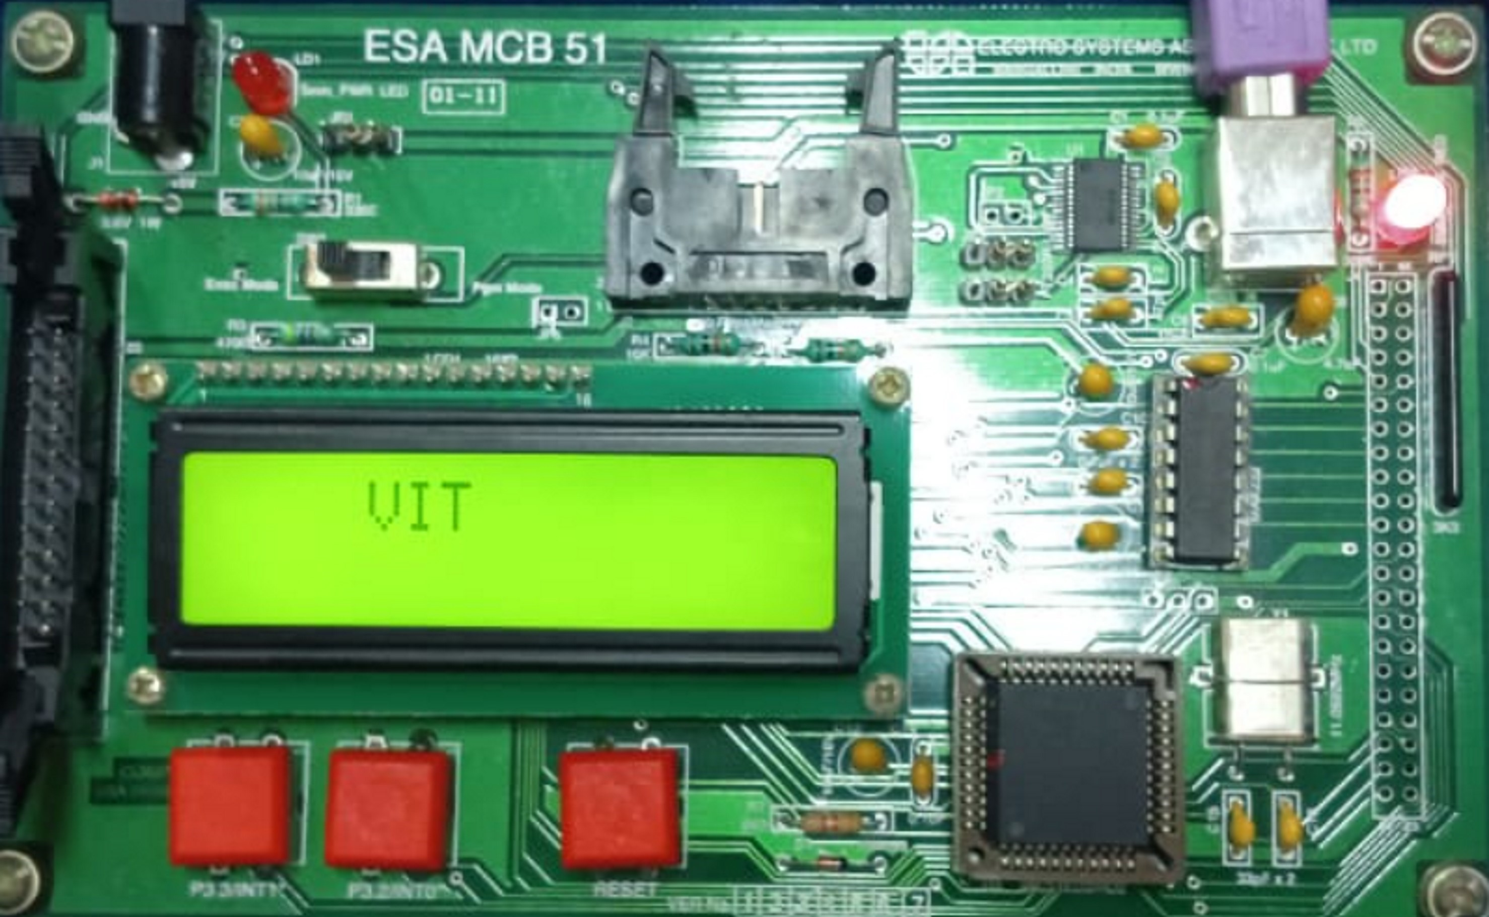

**------------------------------------------------------------------------------------------------------------------**

**LAB TASK 2**

**PROGRAM:**

ORG 0000H ; ORIGIN to load program in 0H

MOV A,#38H ; initialize 16x2 LCD

ACALL COMNWRT ; call command subroutine

ACALL DELAY ; give LCD sometime

MOV A,#0EH ; display on, cursor on

ACALL COMNWRT ; call command subroutine

ACALL DELAY ; give LCD sometime

MOV A,#01H ; clear LCD

ACALL COMNWRT ; call command subroutine

ACALL DELAY ; give LCD sometime

MOV A,#06H ; shift cursor right

ACALL COMNWRT ; call command subroutine

ACALL DELAY ; give LCD sometime

MOV A,#84H ; cursor at line 1, position 4

ACALL COMNWRT ; call command subroutine

MOV DPTR, #STRING

C1: CLR A

MOVC A,@A+DPTR

JZ EXIT

ACALL COMNWRT INC DPTR SJMP C1

EXIT:SJMP EXIT

COMNWRT: ; send command to LCD MOV P2, A ; copy reg A to P2

CLR P3.7 ; RS=0 for command CLR P3.6 ; R/W=0 for write

SETB P3.5 ; E=1 for high pulse

ACALL DELAY ; give LCD some time

CLR P3.5 ; E=0 for H-to-L pulse RET

DATAWRT: ; write data to LCD

MOV P2, A ; copy reg A to port 2

SETB P3.7 ; RS=1 for data

CLR P3.6 ; R/W=0 for write

SETB P3.5 ; E=1 for high pulse

ACALL DELAY ; give LCD some time

CLR P3.5 ; E=0 for H-to-L pulse

RET

DELAY: MOV R3, #255 ; 50 or higher for fast CPUs

L1: MOV R4, #255 ; R4 = 255

L2: DJNZ R4, L2 ; stay until R4 becomes 0

DJNZ R3, L1

RET

STRING: DB ‘VIT University’, 0

END

**OUTPUT: Taken from lab**



