**MICRONCONTROLLERS AND ITS APPLICATIONS LAB**

## NAME: Pratyush Raj

## REG.N0: 20BEC1273

## DATE: 22-04-2022

**EXP– 11 DAC programming of 8051**

**LAB TASK-1**

**AIM:**

Write a 8051 asm program to

–Write a program to send data to the DAC to generate a Square waveform.

–Write a program to send data to the DAC to generate a Sawtooth waveform.

–Write a program to send data to the DAC to generate a triangle waveform.

–Write an 8051 assembly language program for the rotation of a dc motor.

**SOFTWARE USED:**

Keil µVision5

**Task-1:**

**PROGRAM:**

SQUAREWAVE:

ORG 0000H

REPEAT: MOV A,#00H

MOV P1,A

ACALL DELAY

MOV A,#0FFH

MOV P1, A

ACALL DELAY

SJMP REPEAT

DELAY: MOV R2,#04H ;LOAD R2 WITH 07 HEX

HERE3: MOV R1,#0FFH ;LOAD R1 WITH 0FF HEX

HERE2: MOV R0,#0FFH ;LOAD R2 WITH 0FF HEX

HERE1: DJNZ R0,HERE1 ;DECREMENT R0

DJNZ R1,HERE2 ;DECREMENT R1

DJNZ R2,HERE3 ;DECREMENT R2

RET ;RETURN

END

**OUTPUT: Screenshot taken from keil software**

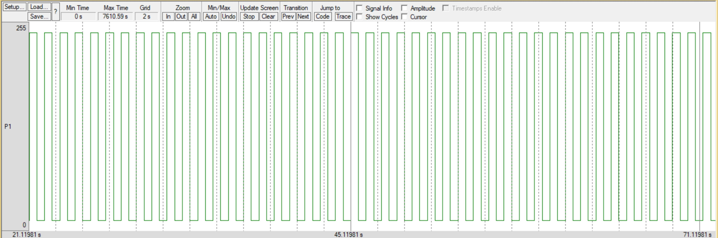

**Task-2:**

**PROGRAM:**

SAWTOOTH:

MOV A, #00H

BACK: MOV P0,A

INC A

CJNE A,#255, BACK

SJMP SAWTOOTH

DELAY: MOV R2,#04H ;LOAD R2 WITH 07 HEX

HERE3: MOV R1,#0FFH ;LOAD R1 WITH 0FF HEX

HERE2: MOV R0,#0FFH ;LOAD R2 WITH 0FF HEX

HERE1: DJNZ R0,HERE1 ;DECREMENT R0

DJNZ R1,HERE2 ;DECREMENT R1

DJNZ R2,HERE3 ;DECREMENT R2

RET ;RETURN

END

**OUTPUT: Screenshot taken from keil software**

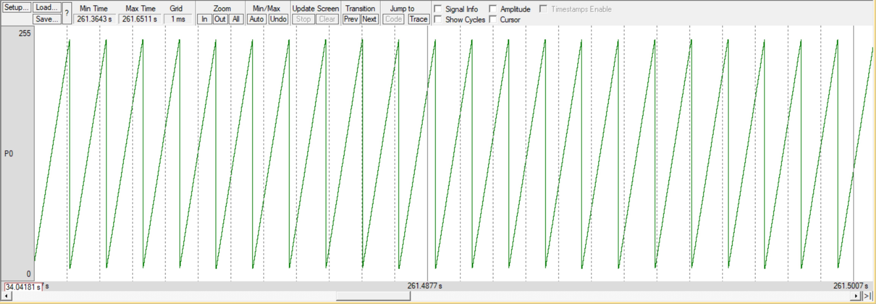

**------------------------------------------------------------------------------------------------------------**

**Task-3:**

**PROGRAM:**

TRIANGLE:

MOV A,#00

INCR: MOV P1,A

INC A

CJNE A,#255, INCR

DECR: MOV P1,A

DEC A

CJNE A,#00, DECR

SJMP TRIANGLE

DELAY: MOV R2,#04H ;LOAD R2 WITH 07 HEX

HERE3: MOV R1,#0FFH ;LOAD R1 WITH 0FF HEX

HERE2: MOV R0,#0FFH ;LOAD R2 WITH 0FF HEX

HERE1: DJNZ R0,HERE1 ;DECREMENT R0

DJNZ R1,HERE2 ;DECREMENT R1

DJNZ R2,HERE3 ;DECREMENT R2

RET ;RETURN

END

**OUTPUT: Screenshot taken from keil software**

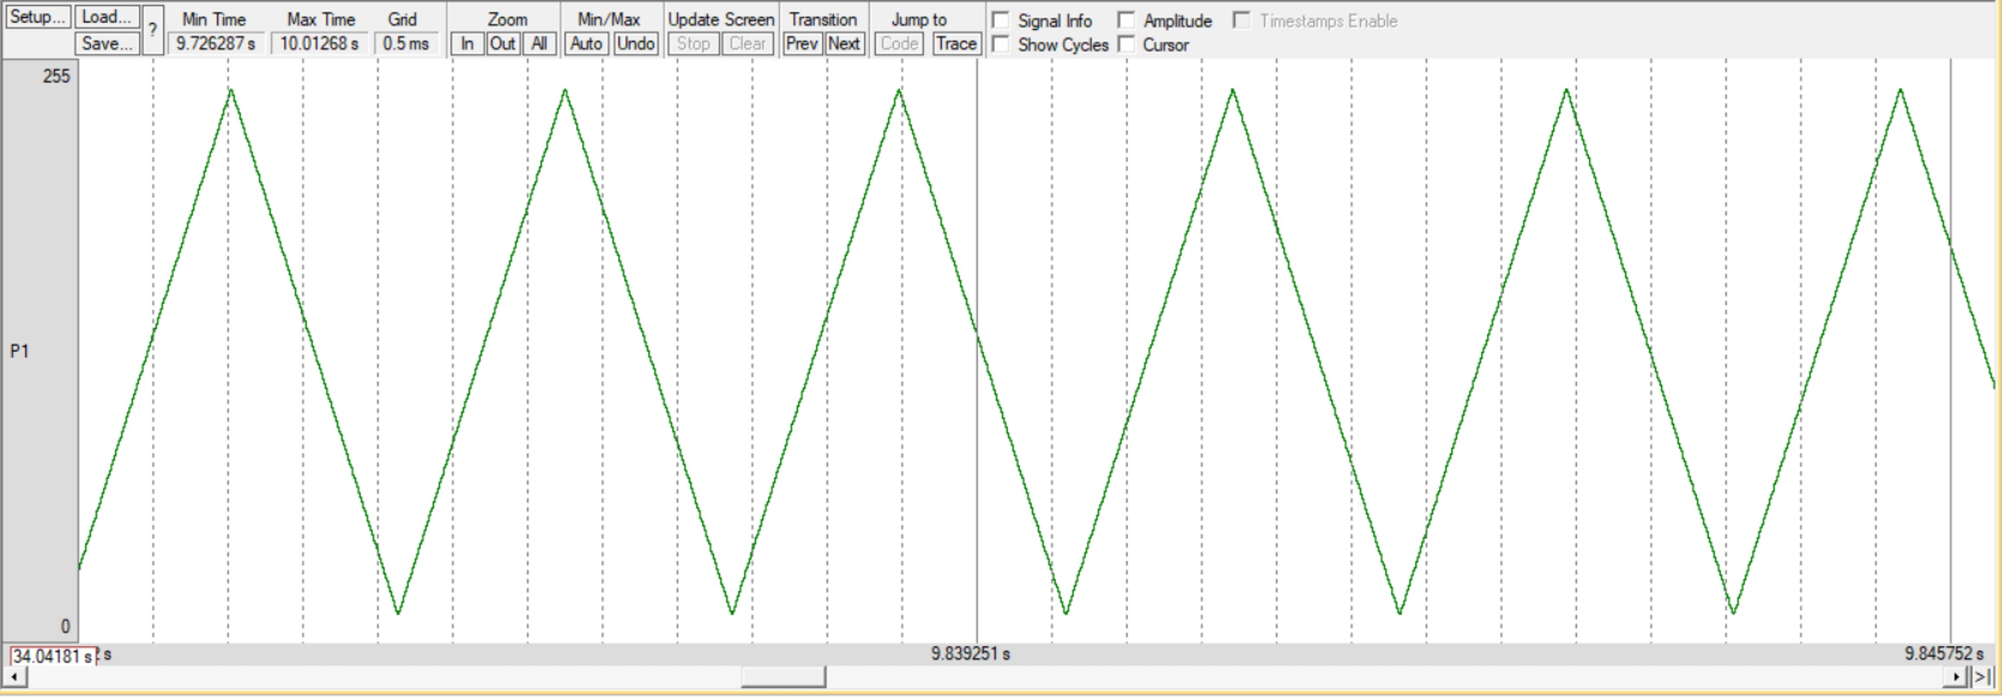

**EXPERIMENT-12: Stepper Motor**

**Task-1:**

**PROGRAM:**

**Code for Forward Rotation:**

ORG 0000H

MOV A,#00H

MOV P0,A

MOV A,#88H

LOOP1: MOV P0,A

ACALL DELAY

RLC A

SJMP LOOP1

DELAY:MOV R3,#255

HERE2: MOV R4,#255 HERE: DJNZ R4,HERE

DJNZ R3,HERE2

RET

END

**Code for Reverse Rotation:**

ORG 0000H

MOV A,#00H

MOV P0,A

MOV A,#88H

LOOP1: MOV P0,A ACALL DELAY

RRC A

SJMP LOOP1

DELAY:MOV R3,#255

HERE2: MOV R4,#255 HERE: DJNZ R4,HERE

DJNZ R3,HERE2 RET

END

**OUTPUT: Screenshot taken from keil software**



