**MICRONCONTROLLERS AND ITS APPLICATIONS LAB**

## NAME: Pratyush Raj

## REG.N0: 20BEC1273

## DATE: 10-01-2022

**EXP– 2 Assembly Programming with Arithmetic Instruction of 8051**

**Task 1**

**AIM:**

To write an 8051 ASM program to perform addition of two 8-bit numbers 97H and 76H and store the result at address location 55H.

**PROGRAM:**

ORG 0000H

MOV A, #97H

ADD A, #76H

MOV 55H, A

END

**OUTPUT:**

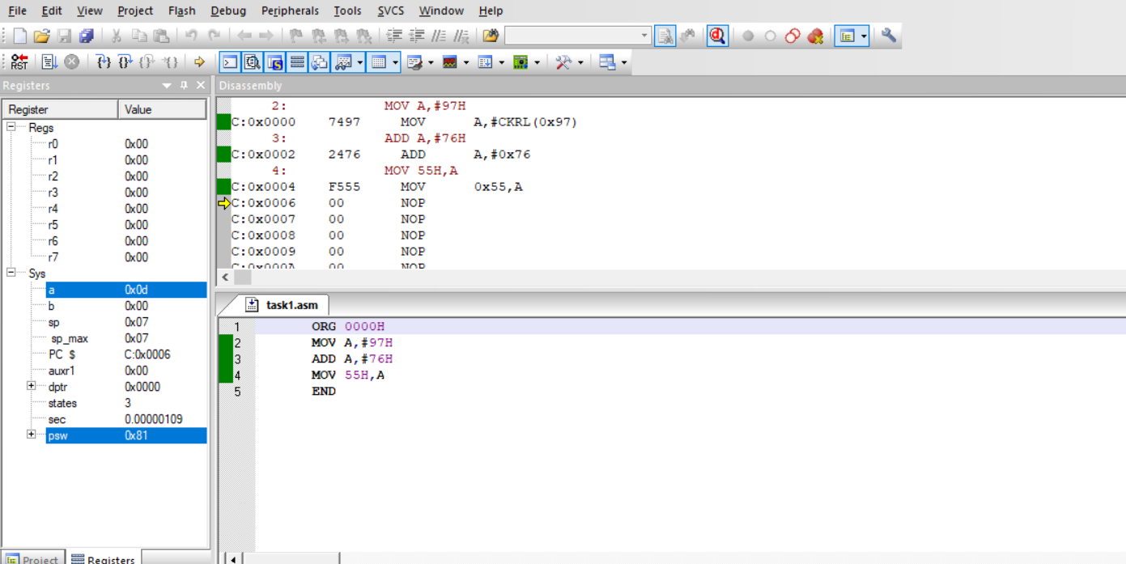

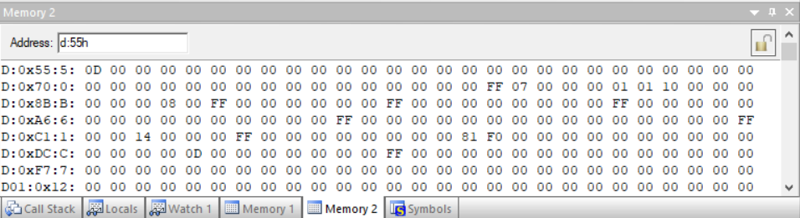

**RESULT:**

S0, 97 and 96 is added and the output is stored in 55H and the carry out is stored in 56H.Hence the program performed successfully.

---------------------------------------------------------------------------------------------------------

**Task 2**

**AIM:**

To write an 8051 ASM program to perform subtraction of two 8-bit numbers 76H and 97H and store the result at address location 55H.

**PROGRAM:**

ORG 0000H

MOV A, #97H

SUBB A, #76H

MOV 55H,A

END

**OUTPUT:**

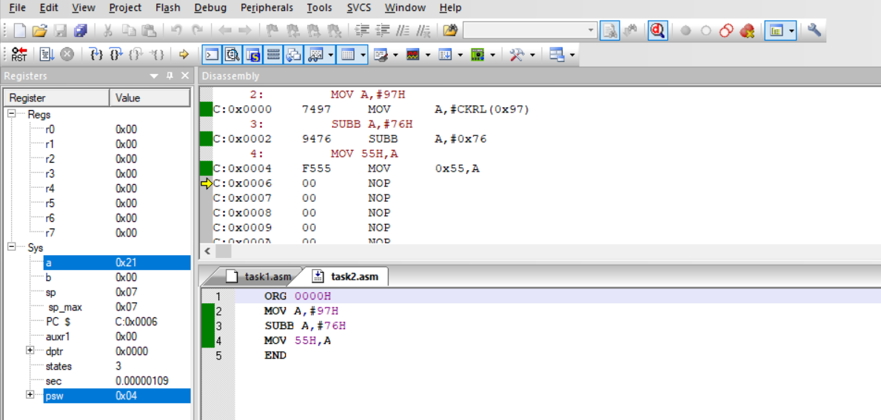

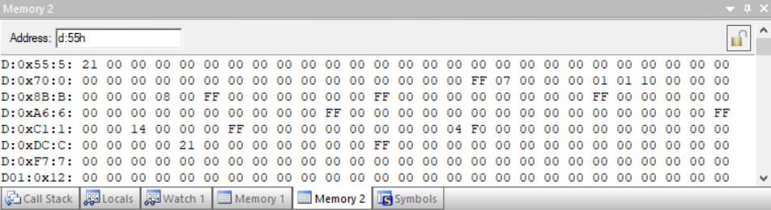

**RESULT:**

76 and 97 is subtracted and the result 21 is stored in 55H and the borrow is stored in 56H. Hence the program performed successfully.

---------------------------------------------------------------------------------------------------------

**Task 3**

**AIM:**

To write an 8051 ASM program to perform addition of two 16-bit numbers. The numbers are 3CE7H and 3B8DH. Place the sum in R7 and R6; R6 should have the lower byte.

**PROGRAM:**

ORG 0000H

MOV A, #0E7H

ADD A, #8DH

MOV R6, A

MOV A, #3CH

ADDC A, #3BH

MOV R7, A

END

**OUTPUT:**

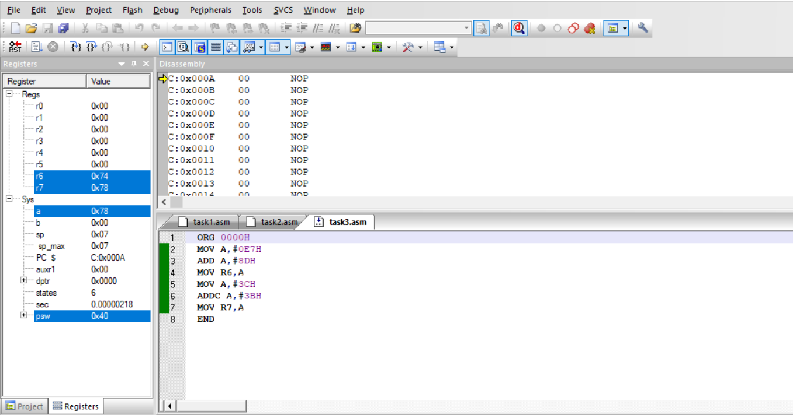

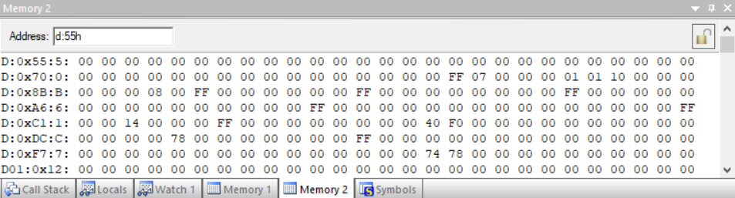

**RESULT:**

So, E7 and 8D is added using ADD keyword and stored in R6. 3C and 3B is added using ADDC keyword and stored in R7. Hence program performed successfully.

---------------------------------------------------------------------------------------------------------

**Task 4**

**AIM:**

To write an 8051 ASM program to perform subtraction of two 16-bit numbers. The numbers are 2762H and 1296H. Place the sum in R7 and R6; R6 should have the lower byte.

**PROGRAM:**

ORG 0000H

MOV A,#62H

SUBB A,#96H

MOV R6,A

MOV A,#27H

SUBB A,#12H

MOV R7,A

END

**OUTPUT:**

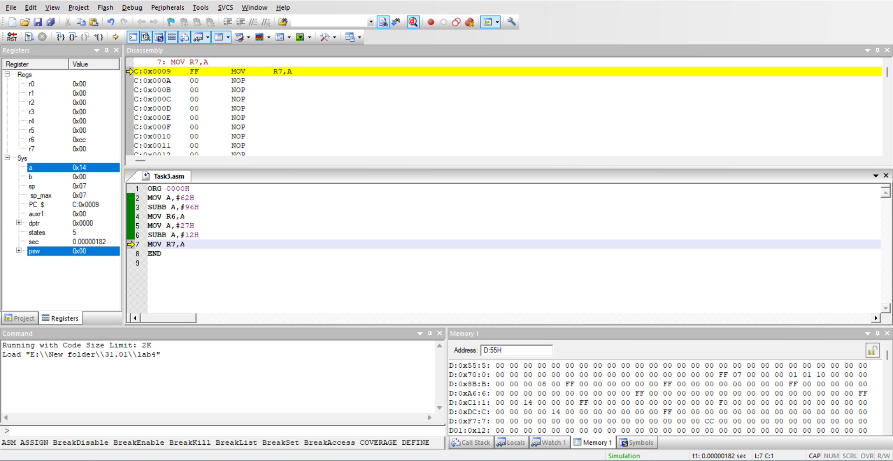



**RESULT:**

Using SUBB keyword 2762H and 1296H are subtracted and the sum is placed in R7 and R6.

---------------------------------------------------------------------------------------------------------

**Task 5**

**AIM:**

To write an 8051 ASM program to perform multiplication of two 8-bit numbers present in data memory address location 33H & 34H and store the result in 35H (higher byte) & 36H (Lower byte).

**PROGRAM:**

ORG 0000H

MOV A, #33H

MOV B, #34H

MUL AB

MOV 35H, B

MOV 36H, A

END

**OUTPUT:**

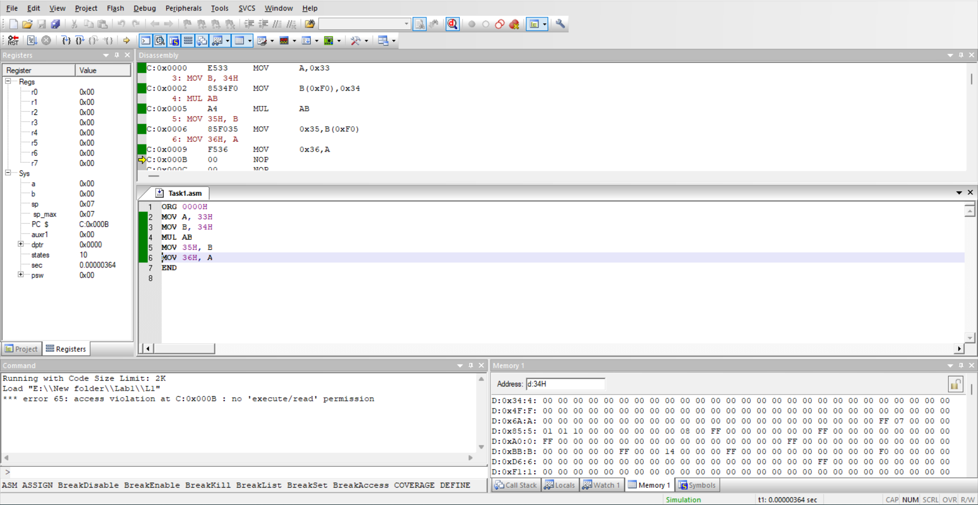



**RESULT:**

A and B are stored in 33H and 34H respectively. Using MUL keyword A and B are multiplied and higher byte is stored in 35H and lower byte is stored in 36H.

---------------------------------------------------------------------------------------------------------

**Task 6**

**AIM:**

Write an 8051 ASM program to perform division on 8-bit numbers and store the result in 35H (Reminder) and 36H (Quotient)

**PROGRAM:**

ORG 0000H

MOV 33H,#23H

MOV 34H,#42H

MOV A, 33H

MOV B, 34H

DIV AB

MOV 35H, B

MOV 36H, A

END

**OUTPUT:**

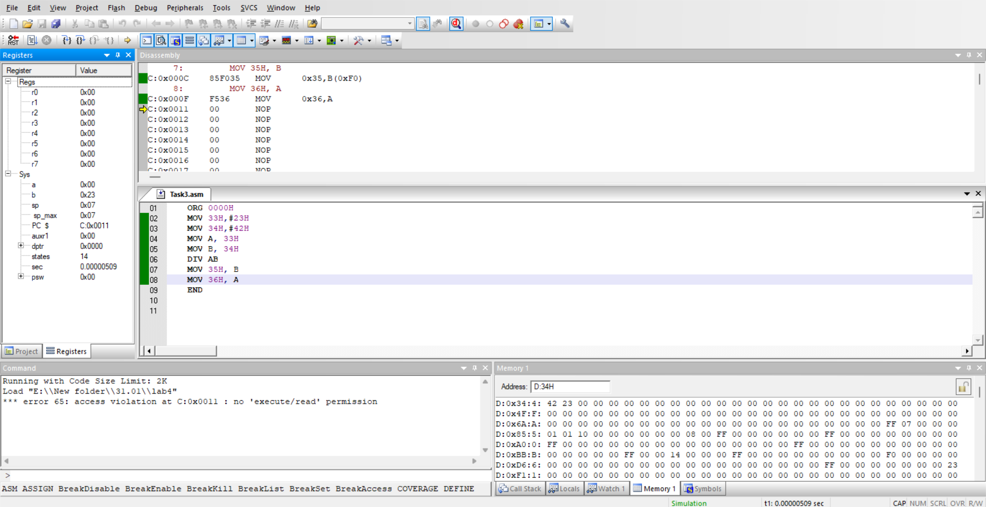



**RESULT:**

23 and 42 stored in 33H and 34H. Data in 33H and 34H is moved to A and B. A and B multiplied using MUL keyword Lower byte stored in A and that is stored in 36H Higher byte stored in B and that is stored in 35H.Hence the program performed successfully

**--------------------------------------------------------------------------------------------**

**Challenging Task 1**

**AIM:**

Write an 8051 ASM program to solve the following mathematical equation:

W=(Y+3Z-6X)/6D,

Where D=03H, X=02H, Y=25H and Z=12H.

**PROGRAM:**

ORG 0000H

MOV R4,#03H

MOV R3,#02H

MOV R2,#25H

MOV R1,#12H

MOV A,R1

MOV B,#03H

MUL AB

MOV R5,A

MOV A,R3

MOV B,#06H

MUL AB

MOV R6,A

MOV A,R4

MOV B,#06H

MUL AB

MOV R7,A

MOV A,R5

ADD A,R2

MOV R0,A

MOV A,R0

SUBB A,R6

MOV B,R7

DIV AB

MOV 40H,A

END

**OUTPUT:**

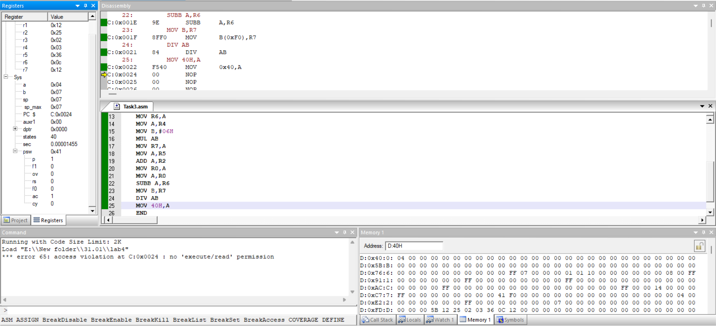



**RESULT:**

Using MUL command and DIV command multiplication and division takes place according to the given equation.

**--------------------------------------------------------------------------------------------------------------------------------------**